# 发送邮件

### 发送普通文本邮件

#!/usr/bin/python3

import smtplib

from email.mime.text import MIMEText

from email.header import Header

# 第三方 SMTP 服务

mail_host=**"smtp.126.com"** *# 设置服务器*mail_user=**"wave12@126.com"** *# 用户名*mail_pass=**"s23456"** *# 口令*sender = **'wave12@126.com'**receivers = [**'395702361@qq.com'**] *# 接收邮件，可设置为你的QQ邮箱或者其他邮箱*message = MIMEText(**'这里是邮件内容!'**, **'plain'**)  
message[**'From'**] = sender   
message[**'To'**] = **";"**.join(receivers)  
subject = **'今天开课,请及时报名'**message[**'Subject'**] = subject

try:

smtpObj = smtplib.SMTP()

smtpObj.connect(mail_host, 25) # 25 为 SMTP 端口

smtpObj.login(mail_user,mail_pass)

smtpObj.sendmail(sender, receivers, message.as_string())

print ("邮件发送成功")

except smtplib.SMTPException:

　 print ("Error: 无法发送邮件")

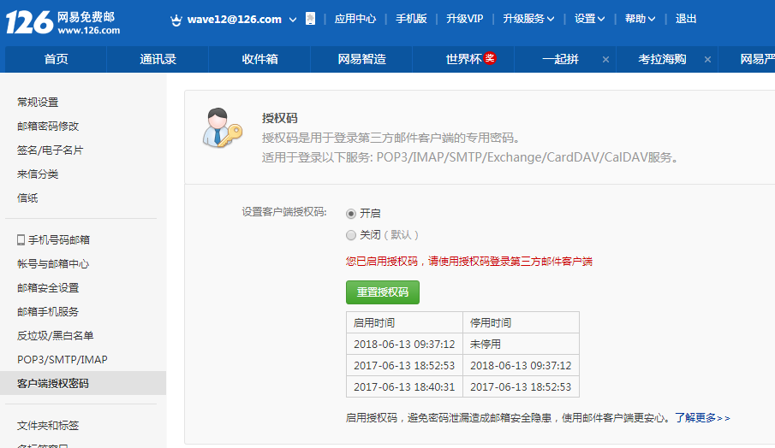

### 发送HTML邮件

*#!/usr/bin/python3***import** smtplib  
**from** email.mime.text **import** MIMEText  
  
*# 第三方 SMTP 服务*mail_host=**"smtp.126.com"** *# 设置服务器*mail_user=**"wave12@126.com"** *# 用户名*mail_pass=**"s23456"** *# 口令*sender = **'wave12@126.com'**receivers = [**'395702361@qq.com'**] *# 接收邮件，可设置为你的QQ邮箱或者其他邮箱*mailCon = **"""  
<p>Python 邮件发送测试...</p>  
<p><a href="http://www.wave12.com">这是一个链接</a></p>  
"""**message = MIMEText(mailCon, **'html'**)  
message[**'From'**] = sender  
message[**'To'**] = **";"**.join(receivers)  
subject = **'python课程开课通知!'**message[**'Subject'**] = subject  
  
**try**:  
 smtpObj = smtplib.SMTP()  
 smtpObj.connect(mail_host, 25) *# 25 为 SMTP 端口* smtpObj.login(mail_user,mail_pass)  
 smtpObj.sendmail(sender, receivers, message.as_string())  
 print (**"邮件发送成功"**)

### 发送带附件邮件

*#!/usr/bin/python3***import** smtplib  
**from** email.mime.text **import** MIMEText  
**from** email.mime.application **import** MIMEApplication  
**from** email.mime.multipart **import** MIMEMultipart  
  
*# 第三方 SMTP 服务*mail_host=**"smtp.126.com"** *# 设置服务器*mail_user=**"wave12@126.com"** *# 用户名*mail_pass=**"s23456"** *# 口令*sender = **'wave12@126.com'**receivers = [**'395702361@qq.com'**] *# 接收邮件，可设置为你的QQ邮箱或者其他邮箱*message = MIMEMultipart()  
  
message[**'From'**] = sender  
message[**'To'**] = **";"**.join(receivers)  
subject = **'python课程教学大纲7!'**message[**'Subject'**] = subject  
  
con = MIMEText(**"请查看附件"**, **'plain'**)  
message.attach(con)  
  
*# 构造附件1，传送当前目录下的 test.txt 文件*att1 = MIMEText(open(**'info.txt'**, **'rb'**).read(), **'base64'**, **'utf-8'**)  
att1[**"Content-Type"**] = **'application/octet-stream'***# 这里的filename可以任意写，写什么名字，邮件中显示什么名字*att1[**"Content-Disposition"**] = **'attachment; filename="info.txt"'**message.attach(att1)  
  
*# 构造附件2，传送当前目录下的 doc 文件*att2 = MIMEApplication(open(**'test.docx'**, **'rb'**).read())  
att2[**"Content-Type"**] = **'application/msword'**att2[**"Content-Disposition"**] = **'attachment; filename="test.docx"'**message.attach(att2)  
  
**try**:  
 smtpObj = smtplib.SMTP()  
 smtpObj.connect(mail_host, 25) *# 25 为 SMTP 端口* smtpObj.login(mail_user,mail_pass)  
 smtpObj.sendmail(sender, receivers, message.as_string())  
 print (**"邮件发送成功"**)  
**except** smtplib.SMTPException **as** e:  
 print (**"Error: 无法发送邮件"** + e.strerror())

文件类型查看：

<http://tool.oschina.net/commons>

### html邮件正文中显示图片

*#!/usr/bin/python3***import** smtplib  
**from** email.mime.text **import** MIMEText  
**from** email.mime.multipart **import** MIMEMultipart  
**from** email.mime.image **import** MIMEImage  
  
*# 第三方 SMTP 服务*mail_host=**"smtp.126.com"** *# 设置服务器*mail_user=**"wave12@126.com"** *# 用户名*mail_pass=**"s23456"** *# 口令*sender = **'wave12@126.com'**receivers = [**'395702361@qq.com'**] *# 接收邮件，可设置为你的QQ邮箱或者其他邮箱*msgRoot = MIMEMultipart(**'related'**)  
  
  
mailCon = **"""  
<p>Python 邮件发送测试...</p>  
<p><a href="http://www.wave12.com">这是一个链接</a></p>  
<p>图片演示：</p>  
<p><img src="cid:image1"></p>  
"""**con = MIMEText(mailCon, **'html'**)  
msgRoot.attach(con)  
  
*# 指定图片为当前目录*fp = open(**'python.png'**, **'rb'**)  
msgImage = MIMEImage(fp.read())  
fp.close()  
  
*# 定义图片 ID，在 HTML 文本中引用*msgImage.add_header(**'Content-ID'**, **'<image1>'**)  
msgRoot.attach(msgImage)  
  
message = MIMEText(mailCon, **'html'**)  
msgRoot[**'From'**] = sender   
msgRoot[**'To'**] = **";"**.join(receivers)  
subject = **'python课程开课通知ss!'**msgRoot[**'Subject'**] = subject  
  
**try**:  
 smtpObj = smtplib.SMTP()  
 smtpObj.connect(mail_host, 25) *# 25 为 SMTP 端口* smtpObj.login(mail_user,mail_pass)  
 smtpObj.sendmail(sender, receivers, msgRoot.as_string())  
 print (**"邮件发送成功"**) **except smtplib.SMTPException as e:  
 print ("Error: 无法发送邮件" + e.strerror())**