I know you are ready to learn when we have our Writer’s Notebook and something to write with…

Open your notebook to the next clear page and write the date at the top.

Today we are going to create a quicklist. 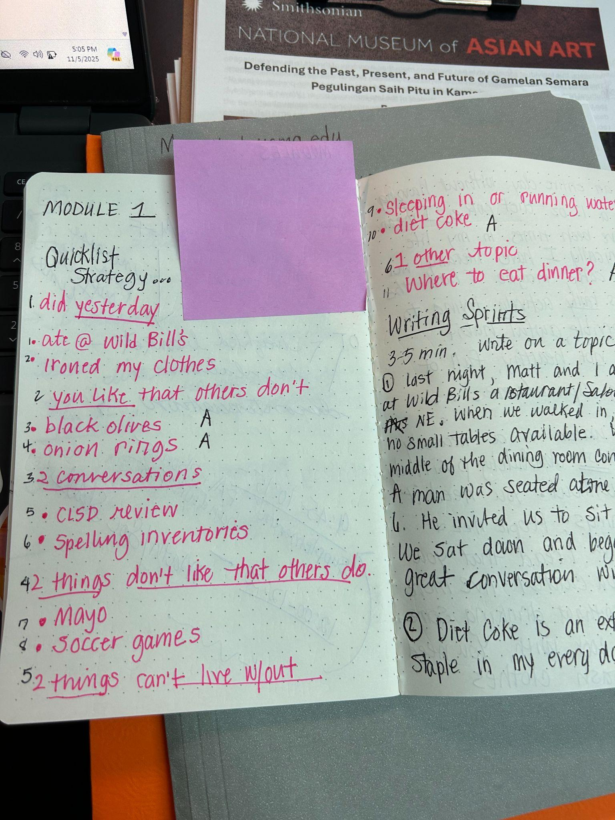
Quicklists are used to help us generate our ideas!

We will be writing 10 things and will number our paper to 10.
I’ll read the prompts for you as we go-
- 1–2 List two things you did yesterday
- 3–4 Two things you like that others might not
- 5–6 Two conversations you have had recently (in-person or text/social media)
- 7–8 Two things you don’t like that others do
- 9-10 Two things you don’t think you could live without

We are going to look through our list and put a star next to 2-3 ideas that you think were your best ideas!

