**Group**

Leader Name: COMIA, DHON AMADO L. Role:________________________

Member Name _____________________ Role: ________________________

Member Name _____________________ Role: ________________________

Member Name _____________________ Role: ________________________

Member Name _____________________ Role: ________________________

*\* UI designer *Backend programmer * Frontend Programmer * Quality Control * full stock developer*

**Title of the software: POS/CRUDE SYSTEM USING VB.NET AND C#**

**Agency Profile**

*A start up company where they mainly focus on manufacturing and distributing building materials.*

**Statement of the Problem**

* *Nothing to keep track on the in and outs of products*
* *No monitoring system*
* *Too complex when it comes to processing*

**Objective of the project**

*To develop a suitable and reliable system for them to handle their products*

**Scope of the project**

*The software focuses on mostly the back end of the company where they will handle the products by numbers*

**Limitation of the project**

*With the little to no basis and foundation the limitation of the project Is the data entries needed*

**Project Technicality**

*A simple POS/CRUDE system where it can monitor the products by quantities and being able to track and record it in the company’s databank*

**Details of the technologies to be used in the development**

* **Hardware**

*Desktop and Laptops*

* **Software**

*Developed in vb.net and c# as for the database*

**Details of the technologies to be used in the implantation**

* **Hardware**

*Desktop and Laptops*

* **Software**

*Mysql as the database and vb.net as the Gui*

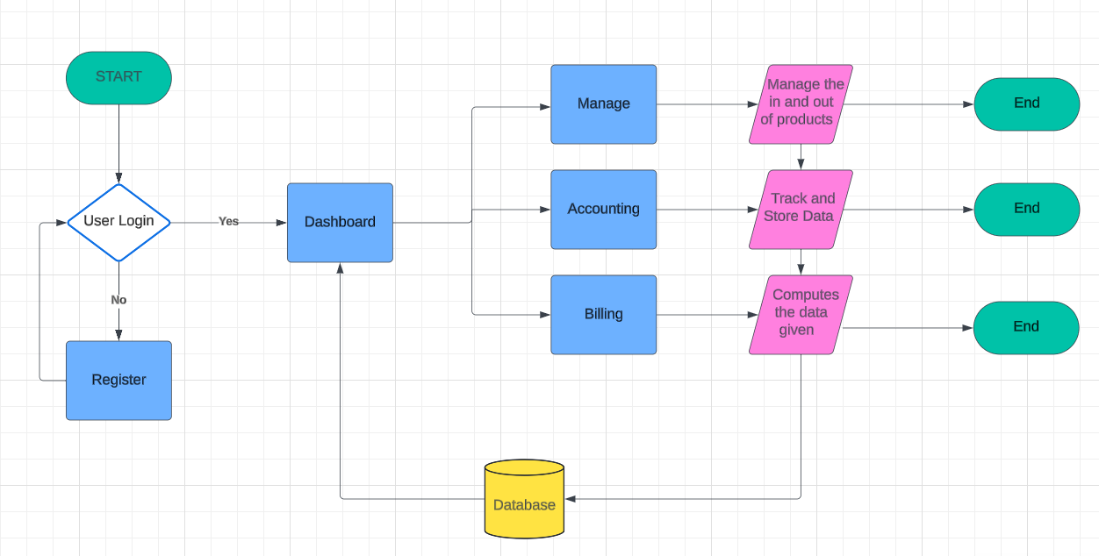**System Flowchart Illustration**