Πριν την εγκατάσταση

Στην κάρτα sd που θα περαστεί το rasbian image πρέπει να έχει format με filesystem FAT32 απαραίτητα. Αν η κάρτα έχει ξαναχρησιμοποιηθει για να περαστεί image για raspberry πρέπει να ανακτηθούν τα partition που έχει δημιουργήσει το image. Αυτό γίνεται με την χρήση του προγράμματος SDFormatter.

Στα options επιλέγουμε Format size adjustment ON

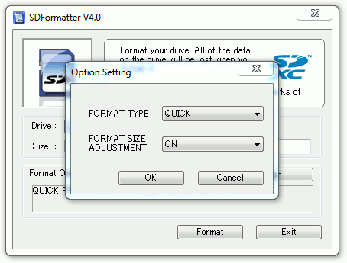

Με την ολοκλήρωση της διαδικασίας πρέπει να **ξανακάνουμε κανονικό φορματ στην sd card με FAT32 filesystem**.

Εγκατάσταση Hypriot Image σε Rasberry και testing Docker με Linux host

1. Download the Hypriot Docker SD card image from <http://blog.hypriot.com/downloads/>
2. Extract the zip file
3. Put your SD card into the computer
4. Type **lsblk** you should see a image like this

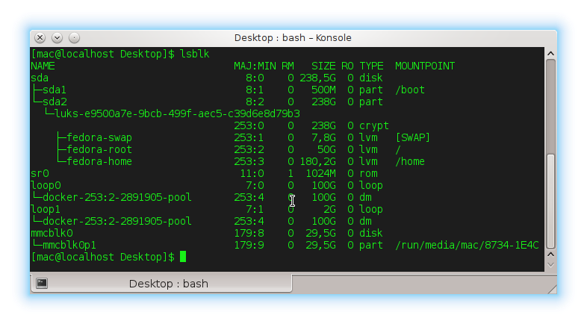

1. Identify the SD Card. Look at the fourth column which shows the size of the devices of your workstation. One item in the list should have a size that is very close to the size of your SD card. From there get the identifier which is shown in the first column. In this case the identifier is mmcblk0 and 29,5G refers to a 32 GB sized SD card.

Next you need to make sure that the partitions of the SD card are not mounted. Check the column MOUNTPOINT – if you have any entries in the row of your SD card you need to unmount them. If not you can skip the unmount command.

As you can see in the last screenshot we have to unmount one partition. Copy and paste the path you see in your own MOUNTPOINT column behind the unmount command.

**umount /run/media/mac/8734-1E4C**

1. Type **sudo dd if=hypriot-rpi-20150416-201537.img of=/dev/mmcblk0 bs=1M**

* replace the parameter if=hypriot-rpi... with the path to the downloaded image
* replace the parameter of=/dev/mmcblk0 with the identifier of your SD card

When dd is finished you should get an output like this:

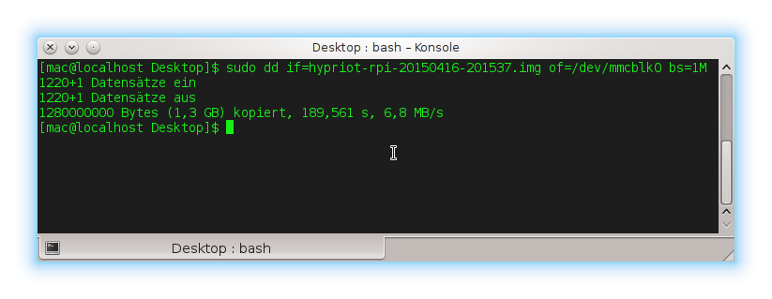

1. Boot your Raspberry Pi by

* connecting the Raspberry Pi to your local network via an ethernet cable
* putting the SD card into the designated slot
* plugging in the power adapter

1. Identify the IP address of your own workstation. Type **hostname –I**

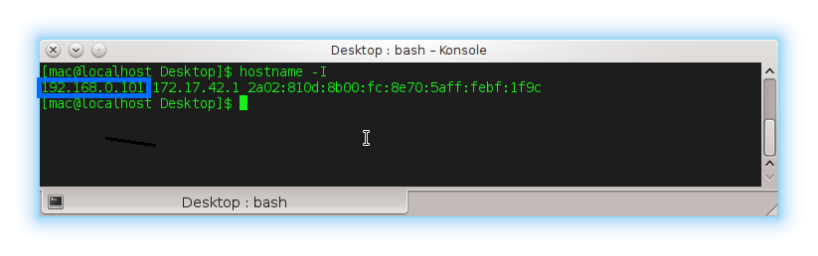

1. Τhen replace the IP address in front of the /24 with yours and type

**nmap -sP 192.168.0.101/24 | grep black-pearl**

(σημείωση το hostname δεν επαιξε καθόλου οπότε με την εντολη nmap -sP 192.168.0.101/24 είδαμε τις ip δικτύου και το βρήκαμε με δοκιμές.)

1. After you found out the IP address establish a connection to the Raspberry Pi with the ssh command. Replace the IP address after the @ with the one of your Raspberry Pi.

For example **ssh** [**root@192.168.0.27**](mailto:root@192.168.0.27)

1. When you are asked for the password type hypriot and hit Enter.

The first time you establish the connection you will be asked if you are sure that you want to connect to the Raspberry Pi - answer with yes.

If everything went fine you should now see the HypriotOS command line prompt waiting for your input.

