# **Types of Computers**

A computer is a device that transforms data into meaningful information. It processes the input according to the set of instructions provided to it by the user and gives the desired output. Computers are of various types and they can be categorized in two ways on the basis of size and on the basis of data handling capabilities.

So, on the basis of size, there are five types of computers:

1. Supercomputer
2. Mainframe computer
3. Minicomputer
4. Workstation
5. PC (Personal Computer)

**1. Supercomputer:**

When we talk about speed, then the first name that comes to mind when thinking of computers is supercomputers. They are the biggest and fastest computers(in terms of speed of processing data). Supercomputers are designed such that they can process a huge amount of data, like processing trillions of instructions or data just in a second. This is because of the thousands of interconnected processors in supercomputers. It is basically used in scientific and engineering applications such as weather forecasting, scientific simulations, and nuclear energy research. It was first developed by Roger Cray in 1976.

**Characteristics of supercomputers:**

* Supercomputers are the computers which are the fastest and they are also very expensive.
* It can calculate up to ten trillion individual calculations per second, this is also the reason which makes it even more faster.
* It is used in the stock market or big organizations for managing the online currency world such as bitcoin etc.
* It is used in scientific research areas for analyzing data obtained from exploring the solar system, satellites, etc.

**2. Mainframe computer:**

Mainframe computers are designed in such a way that it can support hundreds or thousands of users at the same time. It also supports multiple programs simultaneously. So, they can execute different processes simultaneously. All these features make the mainframe computer ideal for big organizations like banking, telecom sectors, etc., which process a high volume of data in general.

**Characteristics of mainframe computers:**

* It is also an expensive or costly computer.
* It has high storage capacity and great performance.
* It can process a huge amount of data (like data involved in the banking sector) very quickly.
* It runs smoothly for a long time and has a long life.

**3. Minicomputer:**

Minicomputer is a medium size multiprocessing computer. In this type of computer, there are two or more processors, and it supports 4 to 200 users at one time. Minicomputers are used in places like institutes or departments for different work like billing, accounting, inventory management etc. It is smaller than a mainframe computer but larger in comparison to the microcomputer.

**Characteristics of minicomputer:**

* Its weight is low.
* Because of its low weight, it is easy to carry anywhere.
* less expensive than a mainframe computer.
* It is fast.

**4. Workstation:**

Workstation is designed for technical or scientific applications. It consists of a fast microprocessor, with a large amount of RAM and high speed graphic adapter. It is a single-user computer. It generally used to perform a specific task with great accuracy.

**Characteristics of Workstation:**

* It is expensive or high in cost.
* They are exclusively made for complex work purposes.
* It provides large storage capacity, with better graphics, and a more powerful CPU when compared to a PC.
* It is also used to handle animation, data analysis, CAD, audio and video creation, and editing.

**5. PC (Personal Computer):**

It is also known as a microcomputer. It is basically a general-purpose computer and designed for individual use. It consists of a microprocessor as a central processing unit(CPU), memory,  input unit, and output unit. This kind of computer is suitable for personal work such as making an assignment, watching a movie, or at office for office work, etc. For example, Laptops and desktop computers.

**Characteristics of PC (Personal Computer):**

* In this limited number of software can be used.
* It is smallest in size.
* It is designed for personal use.
* It is easy to use.

**Hardware**

All physical components that make up a computer is known as computer hardware.

It includes all components that we can see and touch i.e. processor, input devices like keyboard, mouse, output devices like visual display unit (VDU), printer, speaker, connecting wires, casing, storage devices etc. Block diagram depicting major components of computer is shown below:

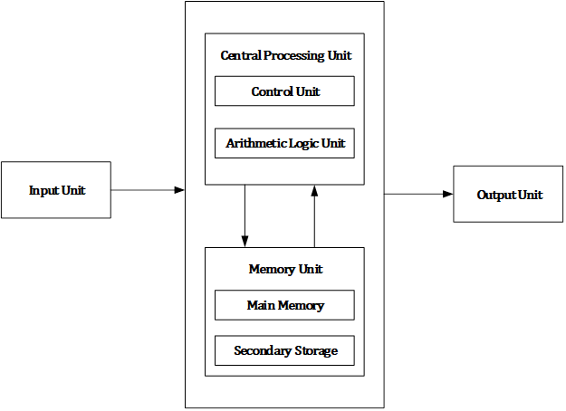Figure: Computer Block Diagram

Computer hardware consists of different functional units: input unit, central processing unit (CPU) which consists arithmetic logic unit (ALU) and control unit (CU), memory unit and output unit.

Computer accepts digital data from user with the help of input devices like mouse, keyboard, microphone etc. Received data from user is either stored in the memory for later use or immediately processed by the arithmetic and logic unit to carry out the desired operations. After processing, processed output known as information is either stored in memory for later use or sent to user with the help of output devices like monitor, printer, speaker etc. All the above mentioned activities are controlled and coordinated by the control unit.

**Motherboard**

The motherboard serves as a single platform to connect all of the parts of a computer together. It connects the CPU, memory, hard drives, optical drives, video card, sound card, and other ports and expansion cards directly or via cables. It can be considered as the backbone of a computer.

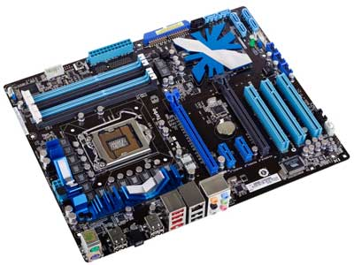

Features of Motherboard

A motherboard comes with following features −

* Motherboard varies greatly in supporting various types of components.
* Motherboard supports a single type of CPU and few types of memories.
* Video cards, hard disks, sound cards have to be compatible with the motherboard to function properly.
* Motherboards, cases, and power supplies must be compatible to work properly together.

Popular Manufacturers

Following are the popular manufacturers of the motherboard.

* Intel
* ASUS
* AOpen
* ABIT
* Biostar
* Gigabyte
* MSI

Description of Motherboard

The motherboard is mounted inside the case and is securely attached via small screws through pre-drilled holes. Motherboard contains ports to connect all of the internal components. It provides a single socket for CPU, whereas for memory, normally one or more slots are available. Motherboards provide ports to attach the floppy drive, hard drive, and optical drives via ribbon cables. Motherboard carries fans and a special port designed for power supply.

There is a peripheral card slot in front of the motherboard using which video cards, sound cards, and other expansion cards can be connected to the motherboard.

On the left side, motherboards carry a number of ports to connect the monitor, printer, mouse, keyboard, speaker, and network cables. Motherboards also provide USB ports, which allow compatible devices to be connected in plug-in/plug-out fashion. For example, pen drive, digital cameras, etc.

# **Random Access Memory**

RAM (Random Access Memory) is the internal memory of the CPU for storing data, program, and program result. It is a read/write memory which stores data until the machine is working. As soon as the machine is switched off, data is erased.

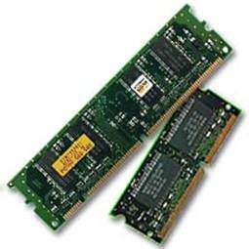

Access time in RAM is independent of the address, that is, each storage location inside the memory is as easy to reach as other locations and takes the same amount of time. Data in the RAM can be accessed randomly but it is very expensive.

RAM is volatile, i.e. data stored in it is lost when we switch off the computer or if there is a power failure. Hence, a backup Uninterruptible Power System (UPS) is often used with computers. RAM is small, both in terms of its physical size and in the amount of data it can hold.

RAM is of two types −

* Static RAM (SRAM)
* Dynamic RAM (DRAM)

## Static RAM (SRAM)

The word **static** indicates that the memory retains its contents as long as power is being supplied. However, data is lost when the power gets down due to volatile nature. SRAM chips use a matrix of 6-transistors and no capacitors. Transistors do not require power to prevent leakage, so SRAM need not be refreshed on a regular basis.

There is extra space in the matrix, hence SRAM uses more chips than DRAM for the same amount of storage space, making the manufacturing costs higher. SRAM is thus used as cache memory and has very fast access.

### **Characteristic of Static RAM**

* Long life
* No need to refresh
* Faster
* Used as cache memory
* Large size
* Expensive
* High power consumption

## Dynamic RAM (DRAM)

DRAM, unlike SRAM, must be continually **refreshed** in order to maintain the data. This is done by placing the memory on a refresh circuit that rewrites the data several hundred times per second. DRAM is used for most system memory as it is cheap and small. All DRAMs are made up of memory cells, which are composed of one capacitor and one transistor.

### **Characteristics of Dynamic RAM**

* Short data lifetime
* Needs to be refreshed continuously
* Slower as compared to SRAM
* Used as RAM
* Smaller in size
* Less expensive
* Less power consumption

**Daughter Card**

A daughter card or [**daughterboard**](https://www.easytechjunkie.com/what-is-a-daughterboard.htm) is a type of [**circuit board**](https://www.easytechjunkie.com/what-is-a-circuit-board.htm) that gets added to an existing one. Its name is appropriate for its use, since it is connected to a “[**motherboard**](https://www.easytechjunkie.com/what-is-a-motherboard.htm)” or “main board.” The motherboard is the primary circuit board for a device. It is usually in the device as it is shipped from the factory. A daughter card may be added later.

Some daughter card designs are made so that engineers can add functionality to a device without requiring a lot more room inside its housing. These kinds of items are often called riser boards or risers. Some might also call them “mezzanine boards.”

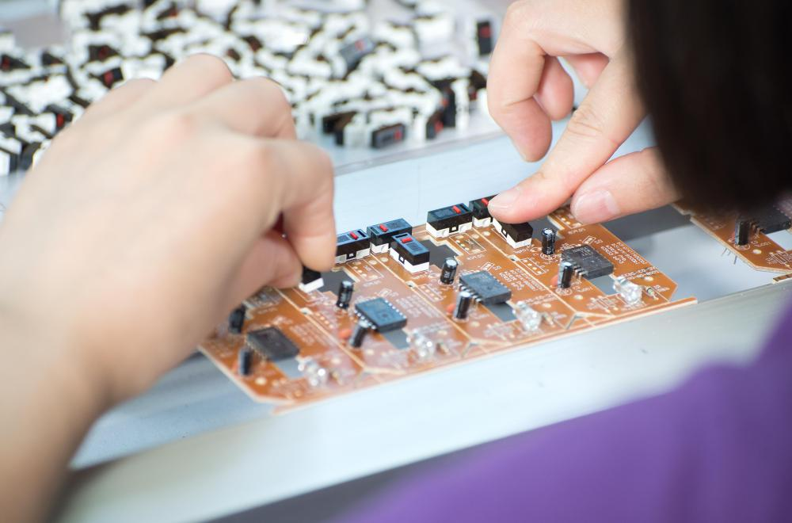

Daughter cards are different from some other types of additional circuit boards that tech enthusiasts call “expansion cards.” In expansion cards, the circuit board is often plugged in through a gap in the housing of a computer or device. These expansion boards help to give a device more functionality, often for additional sound play or for better visuals on a high-tech monitor or screen.

In contrast to the way expansion boards are used, a daughter card can be a more fundamental enhancement for a device. Adding a daughter card often requires getting into the guts of a device. That’s why some users might hire a professional to install it. Companies that make an electronic device might offer a daughter card as part of an essential upgrade that allows the product to be used in more various ways.

With the rise of connective USB ports and other technology, it has become less necessary to upgrade devices with daughter cards or daughter boards. A lot of advanced use can be built into a wireless connection and “outsourced” to a remote server, rather than adding it physically into a desktop or laptop computer. However, some types of equipment might still get these kinds of additions as provided by the manufacturer. Computer and electronics makers choose the best ways of offering upgrades that they feel will match the needs and desires of their customer base. Since not a lot of laptop or computer users want to wrestle a daughter card into an existing circuit board design, companies that sell to a consumer market will probably choose alternatives, or offer professional installation as a free service if they are offering a daughter card as a way to upgrade a device.

# Expansion slot (Bus Slots)

# Alternatively known as a **bus slot** or **expansion port**, an **expansion slot** is a connection or port inside a [computer](https://www.computerhope.com/jargon/c/computer.htm) on the [motherboard](https://www.computerhope.com/jargon/m/mothboar.htm) or [riser card](https://www.computerhope.com/jargon/r/risecard.htm). It provides an installation point for a hardware expansion card to be connected. For example, if you wanted to install a new video card in the computer, you'd purchase a video expansion card and install that card into the compatible expansion slot.

## Computer expansion slots

## Below is a listing of expansion slots commonly found in a computer and the devices associated with those slots.

* [**AGP**](https://www.computerhope.com/jargon/a/agp.htm) - [Video card](https://www.computerhope.com/jargon/v/video-card.htm).

Short for **accelerated graphics port**, **AGP** is an advanced port designed for [video cards](https://www.computerhope.com/jargon/v/video-card.htm) and 3D accelerators. Developed by [Intel](https://www.computerhope.com/comp/intel.htm) and introduced in August [1997](https://www.computerhope.com/history/1997.htm), AGP introduces a dedicated point-to-point channel that allows the graphics controller direct access to the system [memory](https://www.computerhope.com/jargon/m/memory.htm). Below is an illustration of what the AGP slot may look like on your [motherboard](https://www.computerhope.com/jargon/m/mothboar.htm).

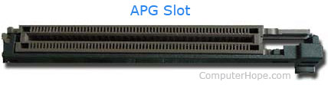

The AGP channel is [32-bits](https://www.computerhope.com/jargon/num/32bit.htm) wide and runs at 66 [MHz](https://www.computerhope.com/jargon/m/mhz.htm), which is a total bandwidth of 266 MBps and much greater than the [PCI](https://www.computerhope.com/jargon/p/pci.htm) bandwidth (up to 133 [MBps](https://www.computerhope.com/jargon/m/mbps.htm)). AGP also supports two optional faster modes, with a throughput of 533 MBps and 1.07 GBps. It also allows 3-D textures to be stored in main memory rather than video memory.

AGP is available in three different versions, the original AGP version mentioned above, **AGP 2.0** that was introduced in May [1998](https://www.computerhope.com/history/1998.htm), and **AGP 3.0** (**AGP 8x**) that was introduced in November [2000](https://www.computerhope.com/history/2000.htm). AGP 2.0 added 4x signaling and was capable of operating at 1.5V, and AGP 3.0 was capable of double the transfer speeds.

* [**AMR**](https://www.computerhope.com/jargon/a/amr.htm) - [Modem](https://www.computerhope.com/jargon/m/modem.htm), [sound card](https://www.computerhope.com/jargon/s/souncard.htm).

Released September 8, [1998](https://www.computerhope.com/history/1998.htm), **AMR**, short for **audio/modem riser**, allows [OEMs](https://www.computerhope.com/jargon/o/oem.htm) to make one card with the functionality of either a Modem or audio or both as one card. This specification allows for the [motherboard](https://www.computerhope.com/jargon/m/mothboar.htm) to be manufactured at a lower cost and free up industry standard expansion slots in the system for other additional plug-in peripherals.

With modems and sound cards being [integrated](https://www.computerhope.com/jargon/i/integrat.htm) into the motherboard, more people using [broadband](https://www.computerhope.com/jargon/b/broadban.htm), and better technologies like [PCIe](https://www.computerhope.com/jargon/p/pciexpre.htm), AMR never gained mass adoption. Today, AMR is no longer found or used with any modern motherboard.

* [**CNR**](https://www.computerhope.com/jargon/c/cnr.htm) - Modem, [network card](https://www.computerhope.com/jargon/n/nic.htm), sound card.

Short for **Communication and Network Riser**, **CNR** is a specification that supports [Audio](https://www.computerhope.com/jargon/a/audio.htm), [Modem](https://www.computerhope.com/jargon/m/modem.htm), [USB](https://www.computerhope.com/jargon/u/usb.htm), and [LAN](https://www.computerhope.com/jargon/l/lan.htm) interfaces of core logic chipsets. **CNR slot** technology was introduced by Intel on February 7, [2000](https://www.computerhope.com/history/2000.htm). It was mainly developed by leading hardware and software developers who helped release the [AMR](https://www.computerhope.com/jargon/a/amr.htm) (Audio Modem Riser) slot. The picture below is an example of a CNR slot, which is labeled as "CNR_SLOT" on this [motherboard](https://www.computerhope.com/jargon/m/mothboar.htm).

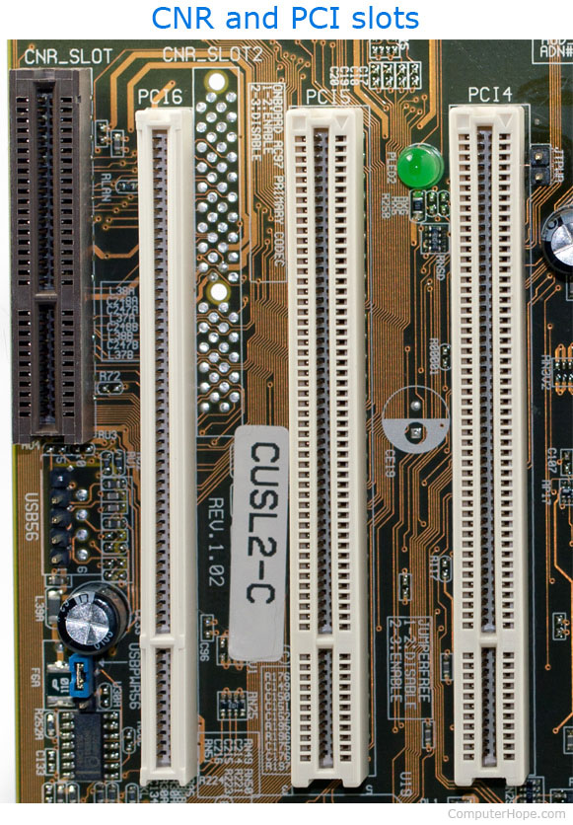

Today, this slot is no longer found on motherboards and was replaced with [PCI](https://www.computerhope.com/jargon/p/pci.htm) only motherboards and motherboards with [PCIe](https://www.computerhope.com/jargon/p/pciexpre.htm).

* [**EISA**](https://www.computerhope.com/jargon/e/eisa.htm) - [SCSI](https://www.computerhope.com/jargon/s/scsi.htm), network card, video card.

Short for **Extended Industry Standard Architecture**, **EISA** or **Extended ISA** is a standard first announced in September [1988](https://www.computerhope.com/history/1988.htm) for [IBM](https://www.computerhope.com/comp/ibm.htm) compatible computers that competed with the [MCA](https://www.computerhope.com/jargon/m/mca.htm) bus. The EISA bus is found on [Intel](https://www.computerhope.com/comp/intel.htm) [80386](https://www.computerhope.com/jargon/num/80386.htm), [80486](https://www.computerhope.com/jargon/num/80486.htm) and early [Pentium](https://www.computerhope.com/jargon/p/pentium.htm) computers and was designed by nine competitors. These competitors were [AST Research](https://www.computerhope.com/comp/ast.htm), [Compaq](https://www.computerhope.com/comp/compaq.htm), [Epson](https://www.computerhope.com/comp/epson.htm), [Hewlett Packard](https://www.computerhope.com/comp/hp.htm), [NEC](https://www.computerhope.com/comp/nec.htm), [Olivetti](https://www.computerhope.com/comp/olivetti.htm), [Tandy](https://www.computerhope.com/comp/tandy.htm), [WYSE](https://www.computerhope.com/comp/wyse.htm), and [Zenith Data Systems](https://www.computerhope.com/comp/zenith.htm).

The EISA bus provided [32-bit](https://www.computerhope.com/jargon/num/32bit.htm) slots at an 8.33 [MHz](https://www.computerhope.com/jargon/m/mhz.htm) cycle rate for use with 386DX or higher processors. EISA can also accommodate a [16-bit](https://www.computerhope.com/jargon/num/16bit.htm) [ISA](https://www.computerhope.com/jargon/i/isa.htm) card in the first row.

Although the EISA bus is [backward compatible](https://www.computerhope.com/jargon/b/backcomp.htm) and not a proprietary bus, it never became widely used and is no longer found in computers today.

* [**ISA**](https://www.computerhope.com/jargon/i/isa.htm) - Network card, sound card, video card.

Short for **Industry Standard Architecture**, **ISA** was introduced by [IBM](https://www.computerhope.com/comp/ibm.htm) and headed by [Mark Dean](https://www.computerhope.com/people/mark_dean.htm). ISA was originally an [8-bit](https://www.computerhope.com/jargon/num/8bit.htm) computer [bus](https://www.computerhope.com/jargon/b/bus.htm) that was later expanded to a [16-bit](https://www.computerhope.com/jargon/num/16bit.htm) bus in [1984](https://www.computerhope.com/history/1984.htm). When this bus was originally released, it was a [proprietary](https://www.computerhope.com/jargon/p/propriet.htm) bus, which allowed only IBM to create peripherals and the actual interface. However, in the early 1980s other manufacturers were creating the bus.

In [1993](https://www.computerhope.com/history/1993.htm), [Intel](https://www.computerhope.com/comp/intel.htm) and [Microsoft](https://www.computerhope.com/comp/msoft.htm) introduced a [PnP](https://www.computerhope.com/jargon/p/pnp.htm) ISA bus that allowed the computer to automatically detect and setup computer ISA peripherals, such as a [modem](https://www.computerhope.com/jargon/m/modem.htm) or [sound card](https://www.computerhope.com/jargon/s/souncard.htm). Using the PnP technology, an end-user would have the capability of connecting a device and not having to configure the device using [jumpers](https://www.computerhope.com/jargon/j/jumper.htm) or [dip switches](https://www.computerhope.com/jargon/d/dipswitc.htm).

All modern computers no longer have ISA slots and instead utilizing [PCI](https://www.computerhope.com/jargon/p/pci.htm) slots. Below is an example an ISA expansion card and ISA slot it connects into on the [motherboard](https://www.computerhope.com/jargon/m/mothboar.htm).

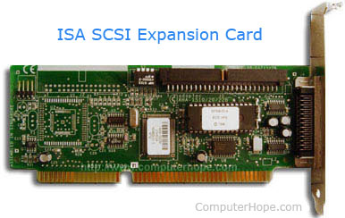

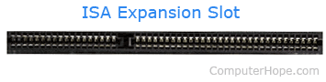

* [**PCI**](https://www.computerhope.com/jargon/p/pci.htm) - Network card, SCSI, sound card, video card.

Short for **peripheral component interconnect**, **PCI** was introduced by [Intel](https://www.computerhope.com/comp/intel.htm) in [1992.](https://www.computerhope.com/history/1992.htm) The PCI [bus](https://www.computerhope.com/jargon/b/bus.htm) came in both [32-bit](https://www.computerhope.com/jargon/num/32bit.htm) (speed of 133 [MBps](https://www.computerhope.com/jargon/m/mbps.htm)) and [64-bit](https://www.computerhope.com/jargon/num/64bit.htm) versions and was used to attach hardware to a computer. Although commonly used in computers from the late 1990s to the early 2000s, PCI has since been replaced with [PCI Express](https://www.computerhope.com/jargon/p/pciexpre.htm).

Revisions came in [1993](https://www.computerhope.com/history/1993.htm) to version 2.0, and in [1995](https://www.computerhope.com/history/1995.htm) to PCI 2.1, as an expansion to the [ISA](https://www.computerhope.com/jargon/i/isa.htm) bus. Unlike ISA and other earlier expansion cards, PCI follows the [PnP](https://www.computerhope.com/jargon/p/pnp.htm) specification and therefore did not require any [jumpers](https://www.computerhope.com/jargon/j/jumper.htm) or [dip switches](https://www.computerhope.com/jargon/d/dipswitc.htm).

The picture below shows an example of what PCI slots look like on a [motherboard](https://www.computerhope.com/jargon/m/mothboar.htm). As you can see, there are three PCI slots: PCI4, PCI5, and PCI6, and a [CNR](https://www.computerhope.com/jargon/c/cnr.htm) slot.



## Examples of PCI devices

[Modem](https://www.computerhope.com/jargon/m/modem.htm)

[Network card](https://www.computerhope.com/jargon/n/nic.htm)

[Sound card](https://www.computerhope.com/jargon/s/souncard.htm)

[Video card](https://www.computerhope.com/jargon/v/video-card.htm)

* [**PCI Express**](https://www.computerhope.com/jargon/p/pciexpre.htm) - Video card, modem, sound card, network card.

Originally known as **3rd Generation I/O** (**3GIO**), **PCI Express**, or **PCIe**, was approved in July [2002](https://www.computerhope.com/history/2002.htm) as a serial computer expansion [bus](https://www.computerhope.com/jargon/b/bus.htm) standard. PCI Express was designed as a high-speed replacement for the aging [PCI](https://www.computerhope.com/jargon/p/pci.htm) and [AGP](https://www.computerhope.com/jargon/a/agp.htm) standards and is available in different formats. The data transmitted over PCI Express is sent over wires (called lanes) in [full duplex](https://www.computerhope.com/jargon/f/fulldupl.htm) mode (both directions at the same time). Each lane is capable of transfer speeds around 250 MB/s and each slot can be scaled from 1 to 32 lanes. With 16 lanes, PCI Express supports a bandwidth of up to 4,000 MB/s. The following images show what the PCI Express slots look like on a [motherboard](https://www.computerhope.com/jargon/m/mothboar.htm).

* 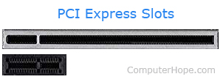
* [**VESA**](https://www.computerhope.com/jargon/v/vesa.htm) - Video card.

Short for **Video Electronics Standard Association**, **VESA** is a group of monitor and video card manufacturers that set video display and bus standards. VESA was originally founded by [NEC](https://www.computerhope.com/comp/nec.htm) and is most known for the [VL bus](https://www.computerhope.com/jargon/v/vlbus.htm) standard.

Many of the expansion card slots above are obsolete. You're most likely only going to encounter AGP, PCI, and PCI Express when working with computers today. The picture below is an example of what expansion slots may look like on a motherboard. In this picture, there are three different types of expansion slots: PCI Express, PCI, and AGP.

[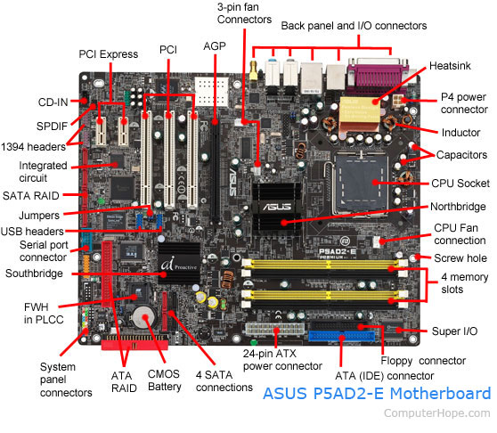](https://www.computerhope.com/cdn/bigmb.jpg)

**SMPS: Switched-Mode Power Supply/ Switching Mode Power Supply**

SMPS stands for Switched-Mode Power Supply. It is an electronic power supply that uses a switching regulator to convert electrical power efficiently. It is also known as Switching Mode Power Supply. It is power supply unit (PSU) generally used in computers to convert the voltage into the computer acceptable range.

This device has the power handling electronic components that converts electrical power efficiently. Switched Mode Power Supply uses a great power conversion technique to reduce overall power loss.

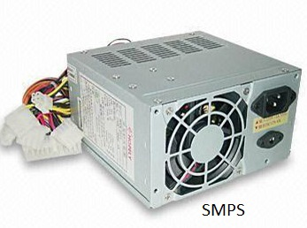

**How does SMPS work**

The SMPS device uses switching regulators that switches the load current on and off to regulate and stabilize the output voltage. The average of the voltage between the off and on produces the appropriate power for a device. Unlike the linear power supply, the pass transistor of SMPS switches between low dissipation, full-on and full-off mode, and spends very less time in the high-dissipation transitions, which minimizes wasted energy.

**Internal Storage Devices**

Some storage devices are classed as 'internal' which means they are inside the computer case.

Most computers have some form of internal storage. The most common type of internal storage is the hard disk.

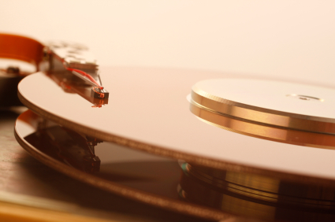

At the most basic level, internal storage is needed to hold the operating system so that the computer is able to access the input and output devices.

It will also be used to store the applications software that you use and more than likely, the original copies of your data files.

Internal storage allows the data and applications to be loaded very rapidly into memory, ready for use. The data can be accessed much faster than data which is stored on an external storage device. This is because internal storage devices are connected directly to the motherboard and its data bus whereas external devices are connected through a hardware interface such as USB, which means they are considerably slower to access.

Internal storage also means that if the computer is moved around, it will still retain its most commonly used data.

The main disadvantage of internal storage is that when the hard disk fails (and it will), all the data and applications may be lost.

This can be avoided to some extent by using more than one hard disk within the machine. Each hard disk has a copy of all the data, so if one fails the other can carry on. This is called a RAID array. An alternative is to use external drives for backup

**Ports and Interfaces**

The Motherboard of a computer has many I/O sockets that are connected to the ports and interfaces found on the rear side of a computer (Figure 3.13). The external devices can be connected to the ports and interfaces. The various types of ports are given below:

**Serial Port:**To connect the externaldevices, found in old computers.

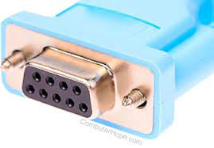

**Parallel Port:**To connect the printers,found in old computers.

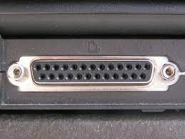

**USB Ports:**To connect external deviceslike cameras, scanners, mobile phones, external hard disks and printers to the computer.

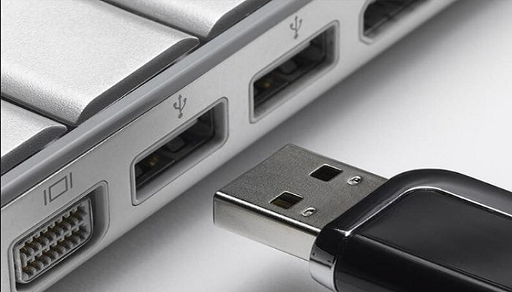

**USB 3.0**is the third major version of theUniversal Serial Bus (USB) standard to connect computers with other electronic gadgets as shown in Figure 3.13. USB 3.0 can transfer data up to 5 Giga byte/second. USB3.1 and USB 3.2 are also released.

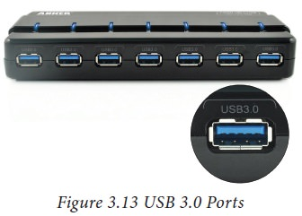

. **VGA Connector:**To connect a monitor orany display device like LCD projector

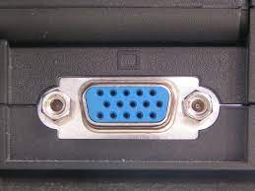

**Audio Plugs:**To connect sound speakers,microphone and headphones.

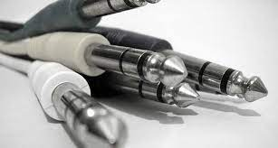

**PS/2 Port:**To connect mouse andkeyboard to PC.

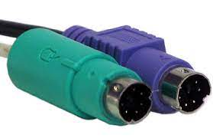

**SCSI Port:**To connect the hard diskdrives and network connectors.

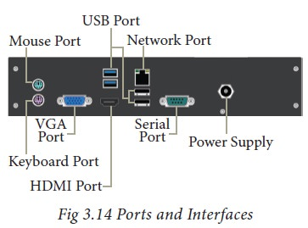

## High Definition Multimedia Interface (HDMI)

High-Definition Multimedia Interface is an audio/video interface which transfers the uncompressed video and audio data from a video controller, to a compatible computer monitor, LCD projector, digital television etc.

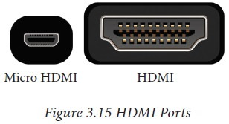

**SPECIFICATION OF DESKTOP AND SERVER CLASS COMPUTERS**

Here is a sample desktop computer specification if you are searching for a good desktop computer to buy. I have listed the most component features you should check when you buy desktop computer.

Actually, the intended usage of a computer should be your first step to answer. Why are you going to buy? What are you going to do with it? I say this because you don’t have to buy a high-end pc for tasks such as word processing, spreadsheet, web browsing or e-mail.

If you do have enough budgets, go for it. For the future it will serve you well for graphical and design works too.

This is a typical desktop computer specification, this doesn’t mean you should buy this computer. It is just a guide to help you.

|  |  |  |
| --- | --- | --- |
| Component | | Specification |
| Processor: | 10th or 11th Gen Intel Core i5, i7 or i9 Processor,  or Apple M1 Processor (CPU) | | |
| Operating System: | Microsoft Windows 10 Home, Pro, Enterprise or Education version *or* macOS 10.15.X “Catalina” or 11.X “Big Sur.” | | |
| Memory (RAM): | 8-16 GB of RAM | | |
| Storage: | 240 GB solid state drive, or larger. | | |
| Video/Graphics: | Integrated or Discrete graphics processor capable of 1440 X 900  resolution, or better (1920 X 1080 *or* 1200 ideal). | | |
| Monitor: | for notebook: 13″ – 17″ display for desktop: 19″ – 27″ widescreen flat-panel display | | |
| Mouse: | Built-in or external trackpad, wireless and/or USB, 2-button, optical mouse | | |
| Sound: | Sound card or built-in audio, and speakers | | |
| Headphones: | Headphones or Earbuds, with Built-in Microphone | | |
| Webcam: | Either external USB device or built-in | | |
| Network: | 802.11ac Wi-Fi capability. | | |

*Intel i5 & i7*

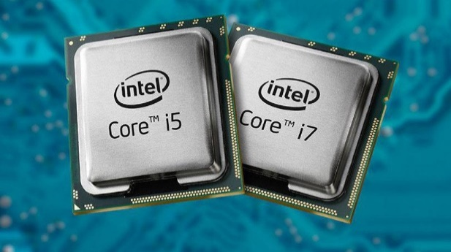

*Ryzen*

