

**BSc. (Hons) Software Design (Cloud Computing)**

**Databases 4**

**Assignment Report**

**Year 4**

**2017 – 2018**

Donal Crotty - A00216737

James Nicholson - A00219437

Table of Contents

Introduction 3

Wireframes 4

Database Schema 4

Store Procedures 4

Triggers 4

Reports 4

Conclusion 4

# Introduction

As part of our Databases 4 module we were required to develop an online system of our choice that uses a suitable framework and a MySQL database. The system was required to have several elements of functionality; allowing new users to register on the system, have multiple user types on the system with different privileges, generate reports that combine data from a number of tables within the database and use Highcharts to visualize the reports or site activity for a proportion of our Computer Graphics module. Another requirement was that the MySQL database must be in 3rd Normal Form and that the database should display Store Procedures and Triggers to execute queries.

As this is a significant system to develop, James and I decided to join up to complete the assignment. Next, we started to plan our idea and we decided to create a whiskey blogging site called ‘The Coopers Stash’. This website would have both administrative and user driven functionality. The administrator is able to create new blog posts about certain whiskey products and publish them. Registered users are then able to view the blog posts and comment on these posts should they wish to do so.

Another decision that was required to be made during the planning process was what framework we would work with. We were required to choose a suitable PHP or Python framework. We considered PHP frameworks such as Slim, Lumen and Laravel and researched Python frameworks such as Django and Flask. After some considerable research, we chose to use PHP’s Laravel Framework.

We then decided to divide out the work evenly to get maximum efficiency during the development process of the online system. Below is a breakdown of the work we each undertook:

|  |  |
| --- | --- |
| **Donal Crotty** | **James Nicholson** |
| Create Post Functionality | Wireframes and DB schema diagrams |
| Store Procedures | Highcharts visualization |
| Triggers | Reporting Functionality |
| Commenting on Posts | Routing of pages |
| Written Report (50%) | Written Report (50%) |
| Admin privileges environment | User privileges environment |
| DB Set up (50%) | DB Set up (50%) |

# Wireframes

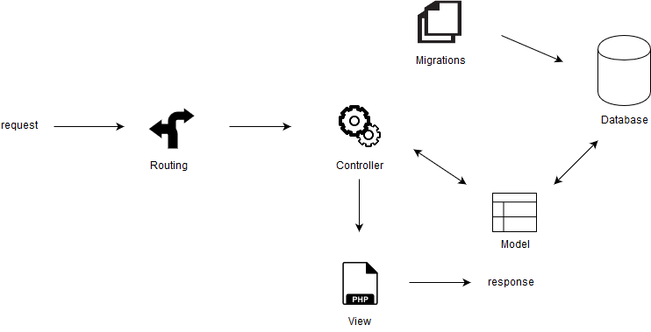

Figure 1 - Client Server Model View Controller

# Database Schema

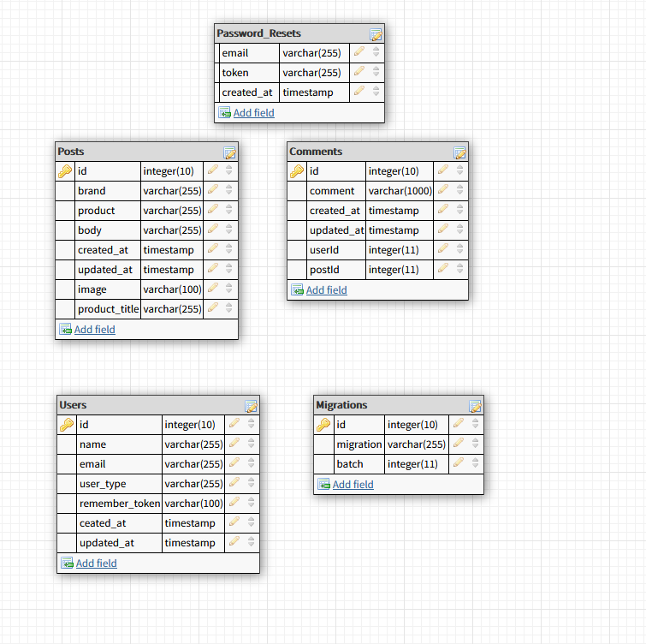

Figure 2 - Database Schema

CREATE TABLE `users` (

`id` int(10) unsigned NOT NULL AUTO_INCREMENT,

`name` varchar(255) COLLATE utf8mb4_unicode_ci NOT NULL,

`email` varchar(255) COLLATE utf8mb4_unicode_ci NOT NULL,

`password` varchar(255) COLLATE utf8mb4_unicode_ci NOT NULL,

`user_type` varchar(255) COLLATE utf8mb4_unicode_ci NOT NULL DEFAULT '1',

`remember_token` varchar(100) COLLATE utf8mb4_unicode_ci DEFAULT NULL,

`created_at` timestamp NULL DEFAULT NULL,

`updated_at` timestamp NULL DEFAULT NULL,

PRIMARY KEY (`id`),

UNIQUE KEY `users_email_unique` (`email`)

)

CREATE TABLE `posts` (

`id` int(10) unsigned NOT NULL AUTO_INCREMENT,

`brand` varchar(255) COLLATE utf8mb4_unicode_ci NOT NULL,

`product` varchar(255) COLLATE utf8mb4_unicode_ci NOT NULL,

`body` varchar(1000) COLLATE utf8mb4_unicode_ci NOT NULL,

`created_at` timestamp NULL DEFAULT NULL,

`updated_at` timestamp NULL DEFAULT NULL,

`image` varchar(100) COLLATE utf8mb4_unicode_ci DEFAULT NULL,

`product_title` varchar(255) COLLATE utf8mb4_unicode_ci DEFAULT NULL,

PRIMARY KEY (`id`)

)

CREATE TABLE `comments` (

`id` int(10) unsigned NOT NULL AUTO_INCREMENT,

`comment` varchar(1000) COLLATE utf8mb4_unicode_ci NOT NULL,

`created_at` timestamp NULL DEFAULT NULL,

`updated_at` timestamp NULL DEFAULT NULL,

`userId` int(11) NOT NULL,

`postId` int(11) NOT NULL,

PRIMARY KEY (`id`)

)

CREATE TABLE `password_resets` (

`email` varchar(255) COLLATE utf8mb4_unicode_ci NOT NULL,

`token` varchar(255) COLLATE utf8mb4_unicode_ci NOT NULL,

`created_at` timestamp NULL DEFAULT NULL,

KEY `password_resets_email_index` (`email`),

KEY `password_resets_token_index` (`token`)

)

CREATE TABLE `migrations` (

`id` int(10) unsigned NOT NULL AUTO_INCREMENT,

`migration` varchar(255) COLLATE utf8mb4_unicode_ci NOT NULL,

`batch` int(11) NOT NULL,

PRIMARY KEY (`id`)

)

# Store Procedures

# Triggers

# Functionality

Within this online system there are various pieces of functionality. Each user with different administrative rights can access different pieces of functionality. Below we will take you through the three different scenarios below;

* when no user is logged in
* when an administrator is logged in
* when a regular user is logged in

## No user is Logged In

In this scenario, no user is logged into the online system, therefore they should only see limited functionality. They will be able to view the Home, About and Contact Pages below.

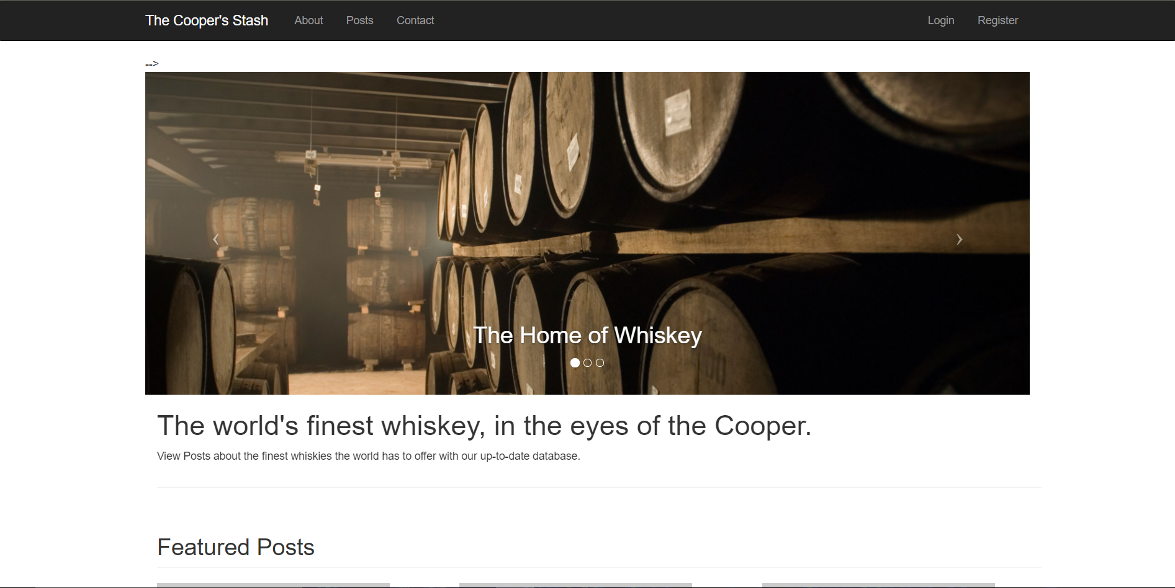

Figure 3- Home Page

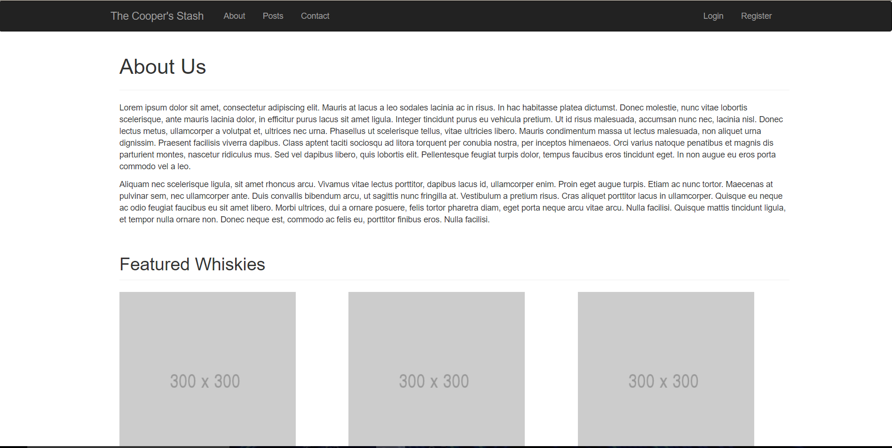

Figure 4- About Page

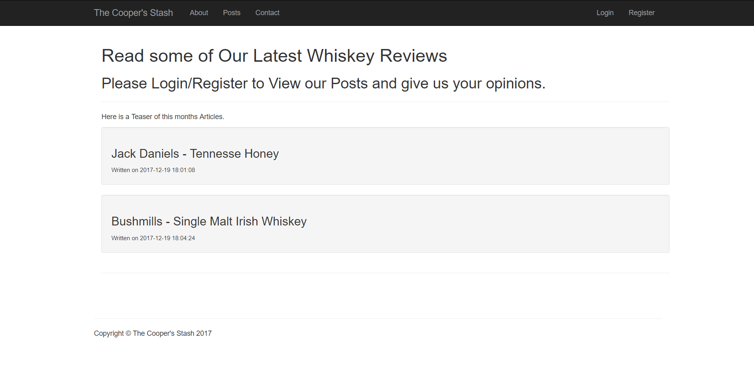

Figure 5- Posts Page

As the user has no created an account yet or registered to Coopers Stash, they will only see headings of each Post available to view should they sign up. Once they have registered and logged in, they will be able to click on the heading links and view each post available to them.

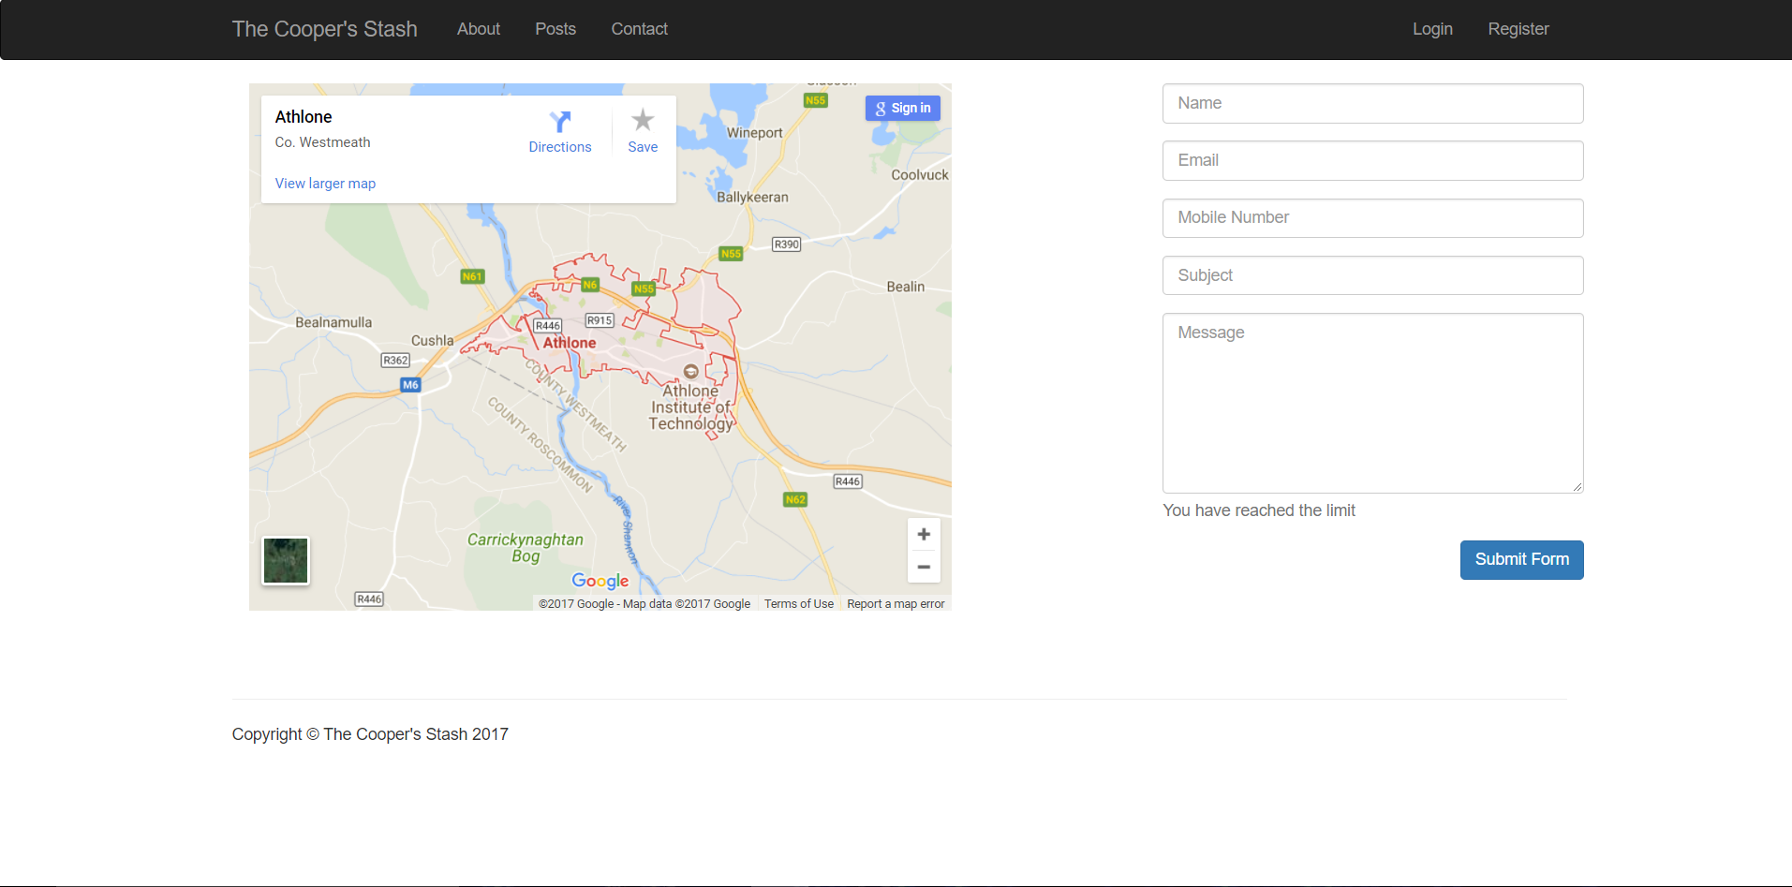

Figure 6- Contact Page

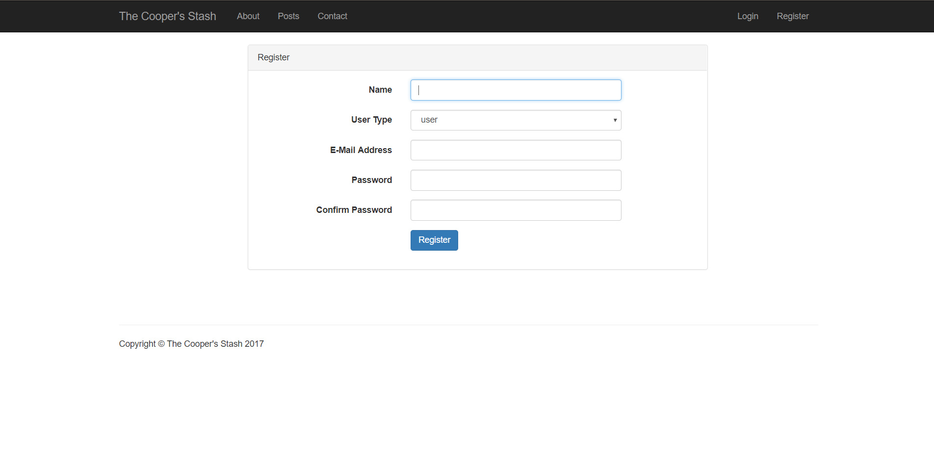

Figure 7- Registration Page

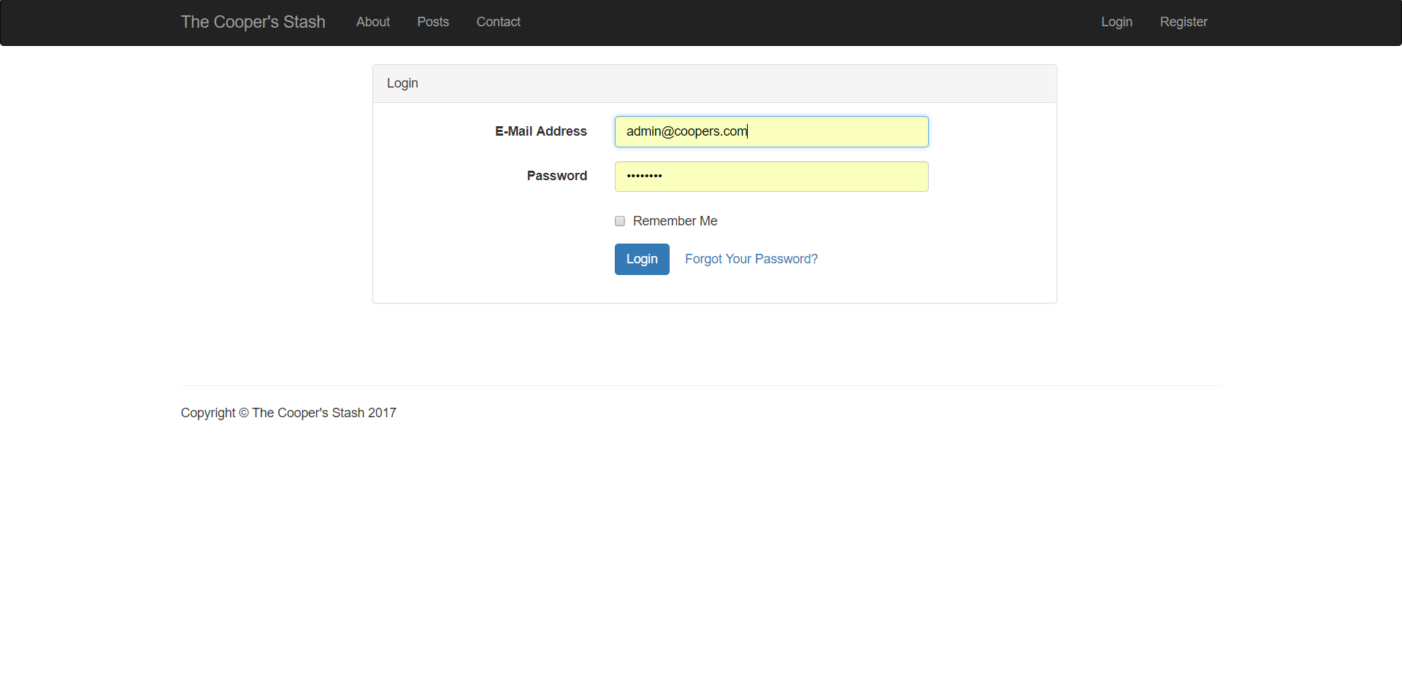

Figure 8- Login Page

## Administrator is Logged In

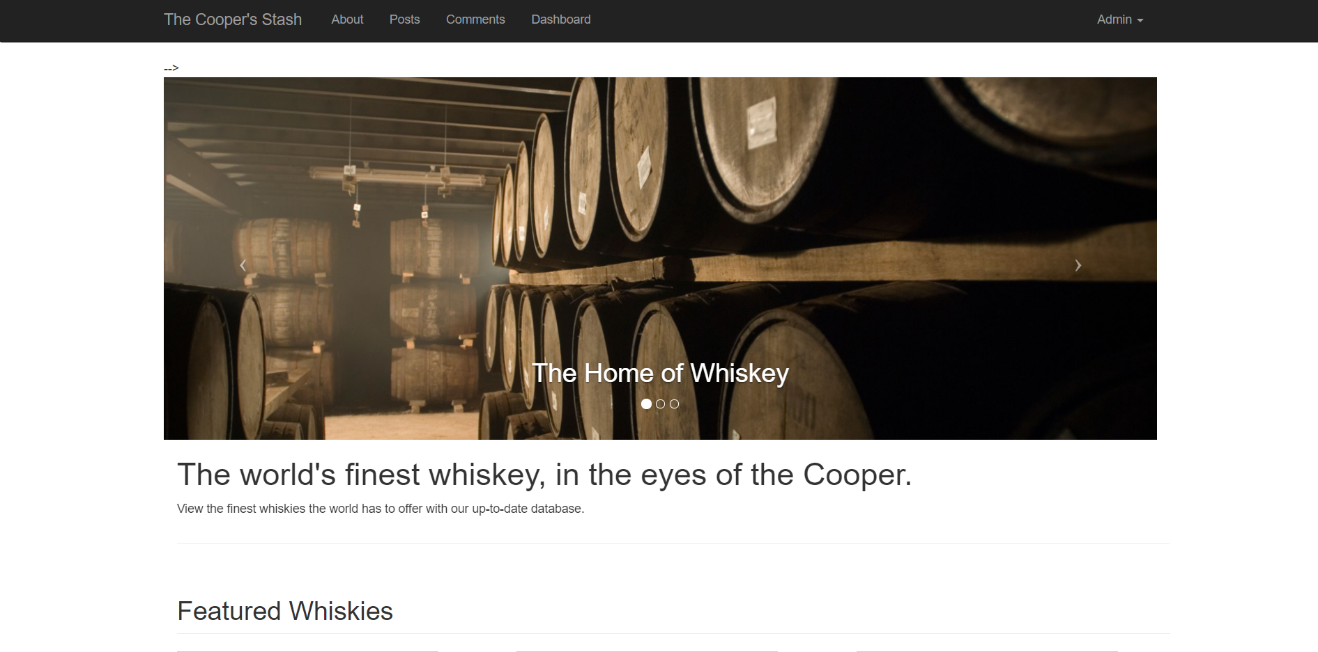

Figure 9- Admin Home Page

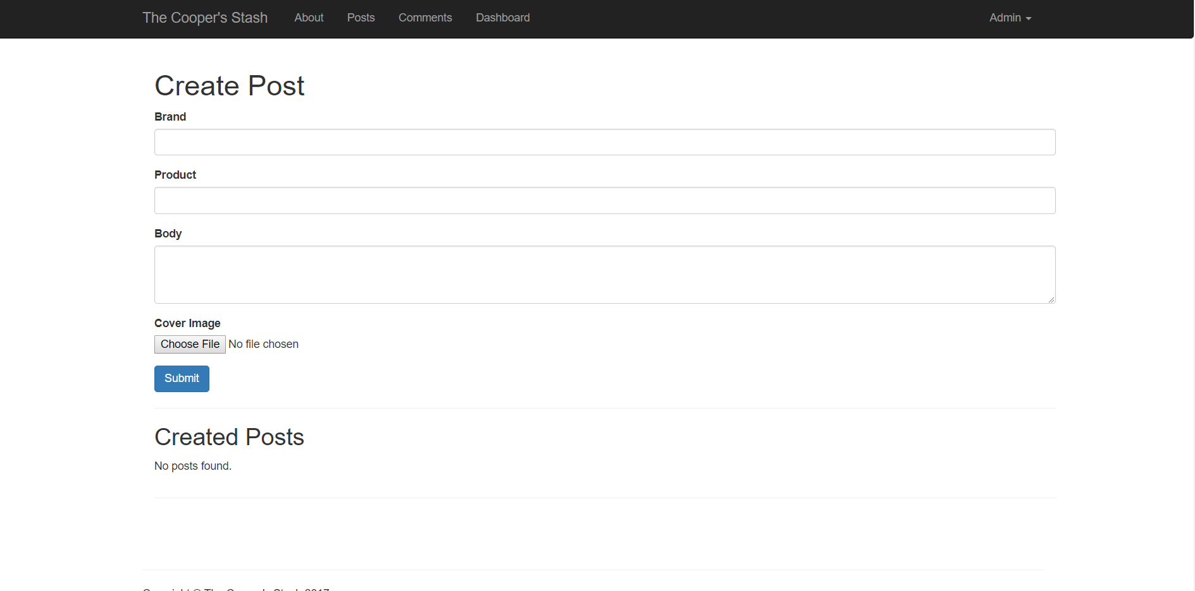

Figure 10- Admin Post Page (Create Post Functionality)

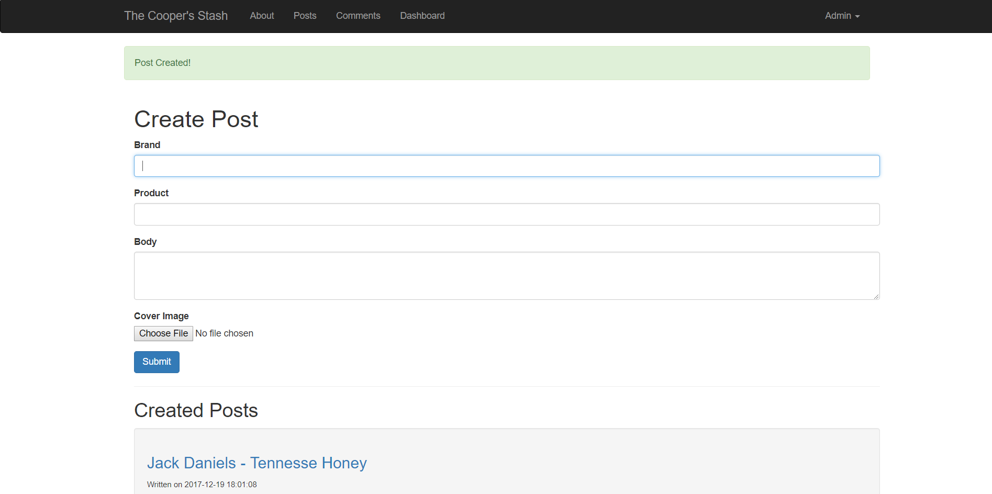

Figure 11- Admin Post Page (Post Created)

## Regular User Logged In

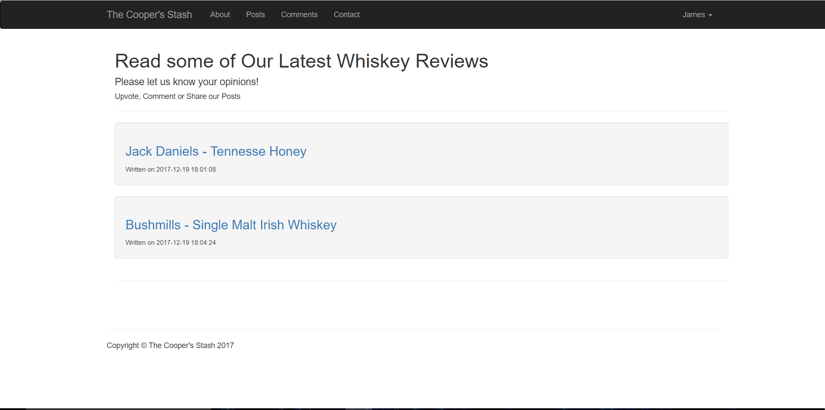

Figure 12- Posts Page (Regular User)

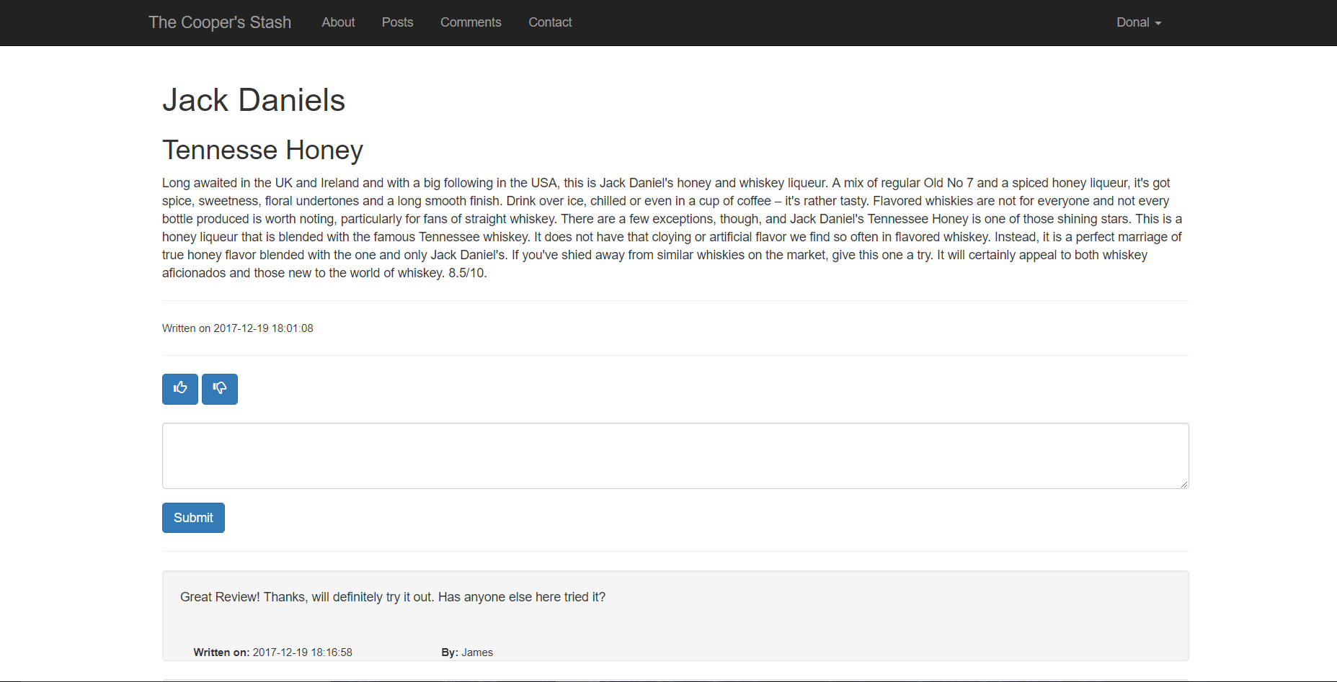

Figure 13- Viewing and Commenting Posts (Regular User)

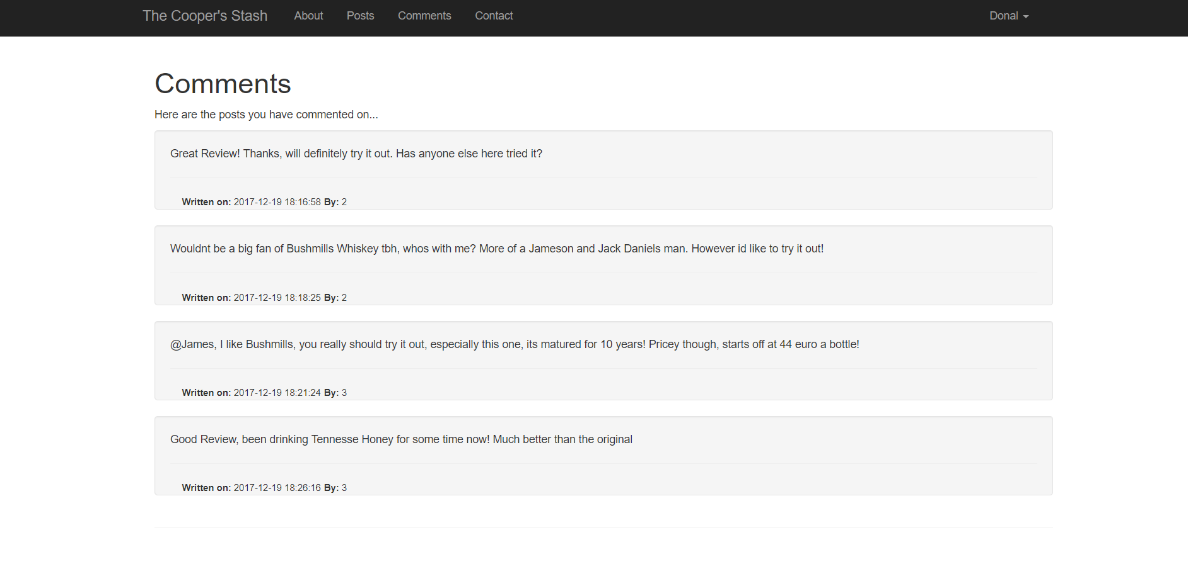

Figure 14 - List of comments on different posts

# Reports

# Conclusion