BUGS-Issues.

Focus Mode. When Focus Mode is enabled, if connection is lost to the server, no indication that tracking/ current positions are current. Great visual indication when Tracking is selected and connection lost—tested ok.

Not Fully Tested

Mapping. Ideally need full OS maps and Hiker mapping installed for testing, Harvey can come at a later date. Interaction with the different maps vital

Just a thought. Tony when he was developing QGIS app for phone use, he degraded the OS maps in areas clear of the upland areas to increase speed. Just a thought.

User Experience Improvements.
(1) Device Panel Layout. Zoom covered, modify panel to show zoom fully,
possibly by reducing width of selected device panel eg Aiden Forde ie narrow
width between status and offline to generate width for zoom
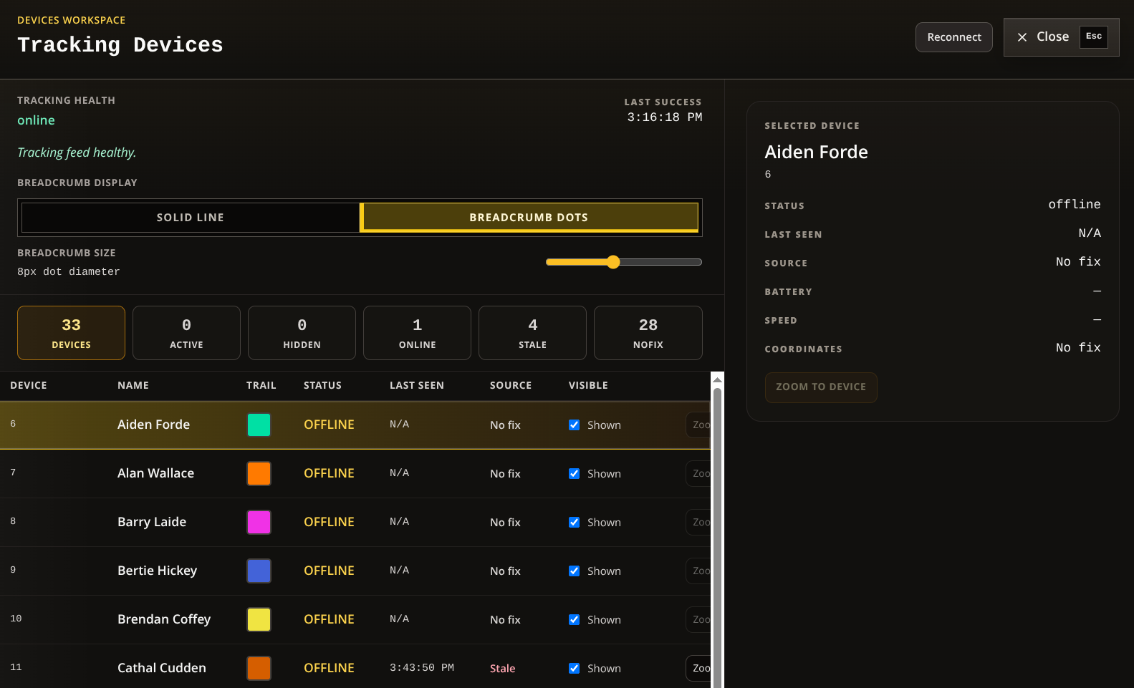

(2) Mission Minimized. When Mission is minimized and Focus Mode selected no need to display Mission control in RHS panel. No requirement to Pause or Finish a mission when in this mode.

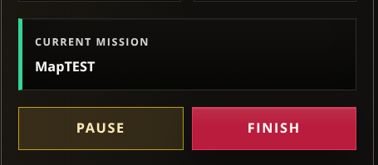

Remove above from RHS panel when Mission is minimized and focus Mode selected.

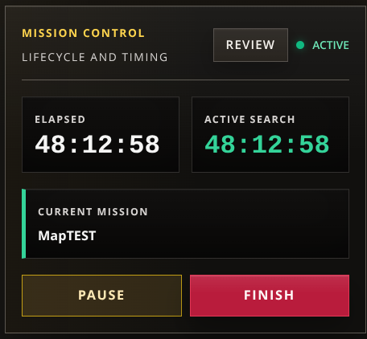

Again to maximize space on RHS panel and simplify display, maybe Review could be moved to Top panel, put just active search timer in it’s place to confirm mission is visually active and remove the rest.

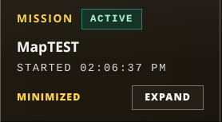
(4) Mission Minimized.

When Mission is Minimizes, all top panel increases in dept to accommodate Minimized and Expand reducing map viewing area unnecessarily.

Could panel be expanded length wise and have Minimized and Expand vertically over each other?

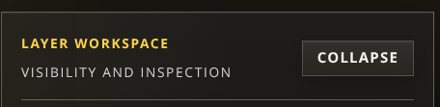
(4) Layer Workspace.

This is function almost dublicated by the layers Expand all and Collapse all.

Instead of Collapsing the layer Tree from here, hide the panel to show the map.

Ideally aim would be to have RHS of map similar to left hand side with few minor panels visible, so map could be viewed in it’s entirety.

Believe with above mods this is achievable.

(5) Focus Mode. Focus Coordinates overlay map scale. Possible to move them down to
bottom of displayed map, this would maximize map view

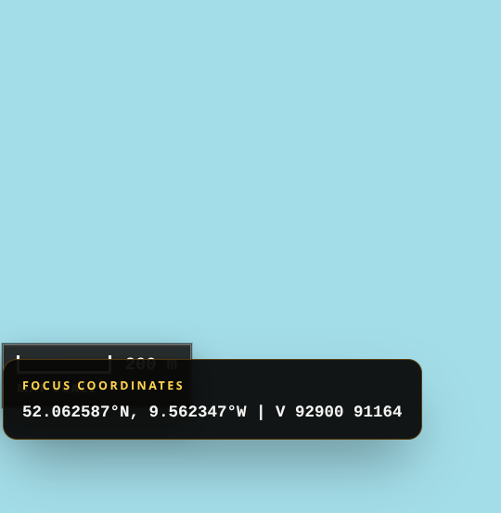

(6) Breadcrumbs / Current location. Following applies to both. Selecting Breadcrumbs turns all ON or OFF. When OFF, individually selecting person should turn that person ON / OFF, needed when you need to show only a few people.

(7) Map Tools. Selecting panel drop down ( V ) on map tools open marker panel. Maps panel drop down ( V ) work perfect. See 3 below.

(8) Map grid for OS maps. Option to turn ON / OFF grid for OS and imported maps.

Non Urgent.
(1) Search Area Labels. Labels for search areas move outside designated area when map is zoomed out. This does not happen for casualty etc. Is it possible to select text and position it manually? Non Urgent.

(2) Text Labels. Select and move text labels pointing to a location.

(3) Mission Name. Would it be possible for admins to edit name of working mission.

(4) Full OS mapping

(5) East West Mapping

(6) Harvey Mapping.

(2) Colour Scheme not suitable for all. Possible to have "Theme" button which can change to different colour layout. Change colour scheme to something like we had in QGIS, something with more contrast. Very difficult to make out the selection panels. Has improved somewhat.
Following example from Sean where he used this format.

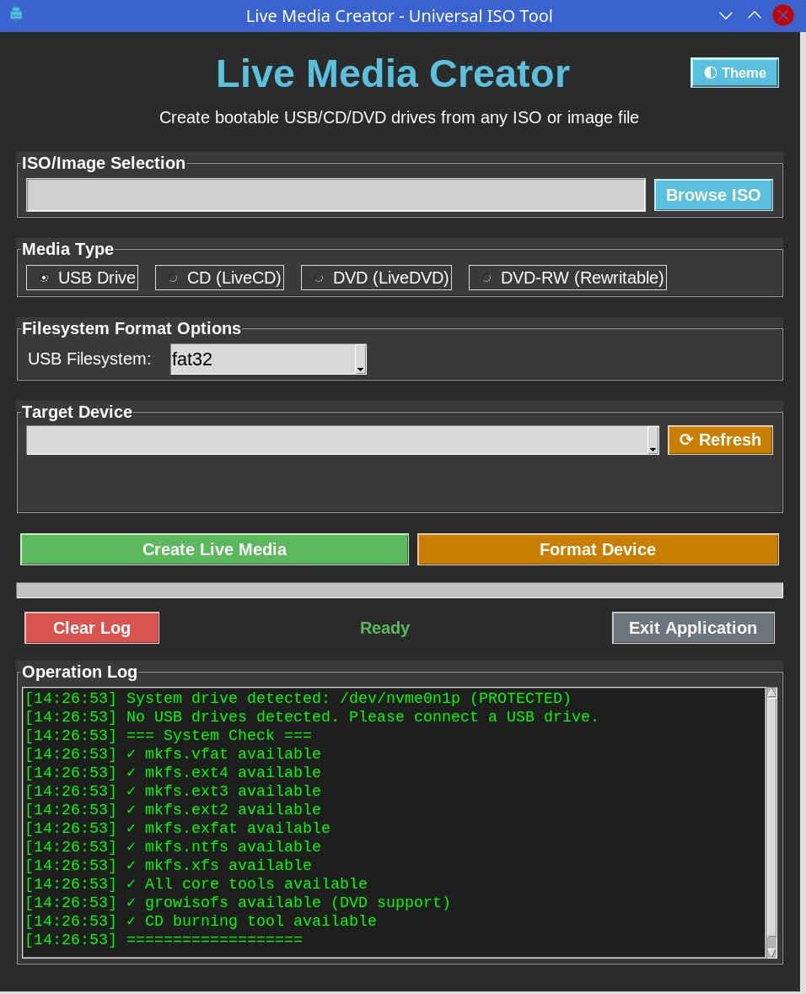

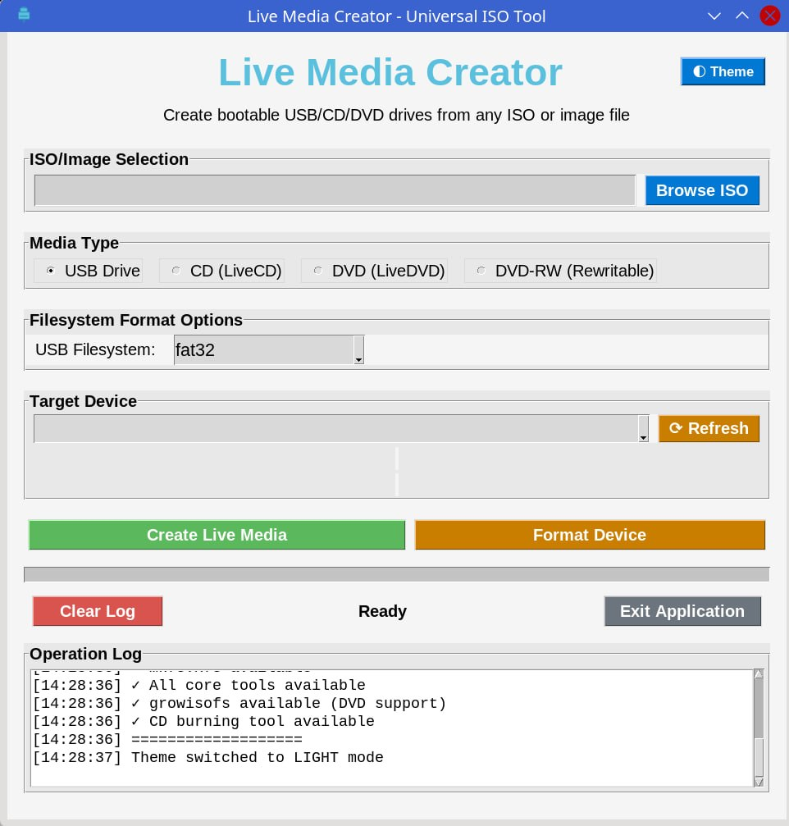

(3) Need some security for entering coordinators or maybe settings in general. Very easy at present for anyone to add a new admin to the list to enable them to unlock a mission.

(4) Preview Mission. With preview, tracks, GPX imported files,, markers etc should be shown on map---unable to see how this is done at present. This needs discussion.

(5) When using Sartracker on smaller displays (pics below from 24” display)
panels do not scale appropriately.
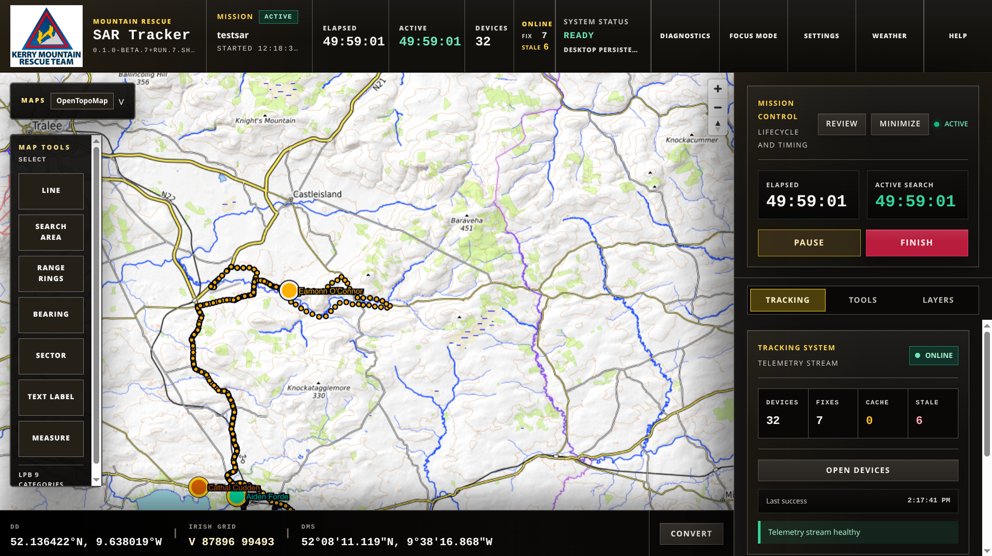

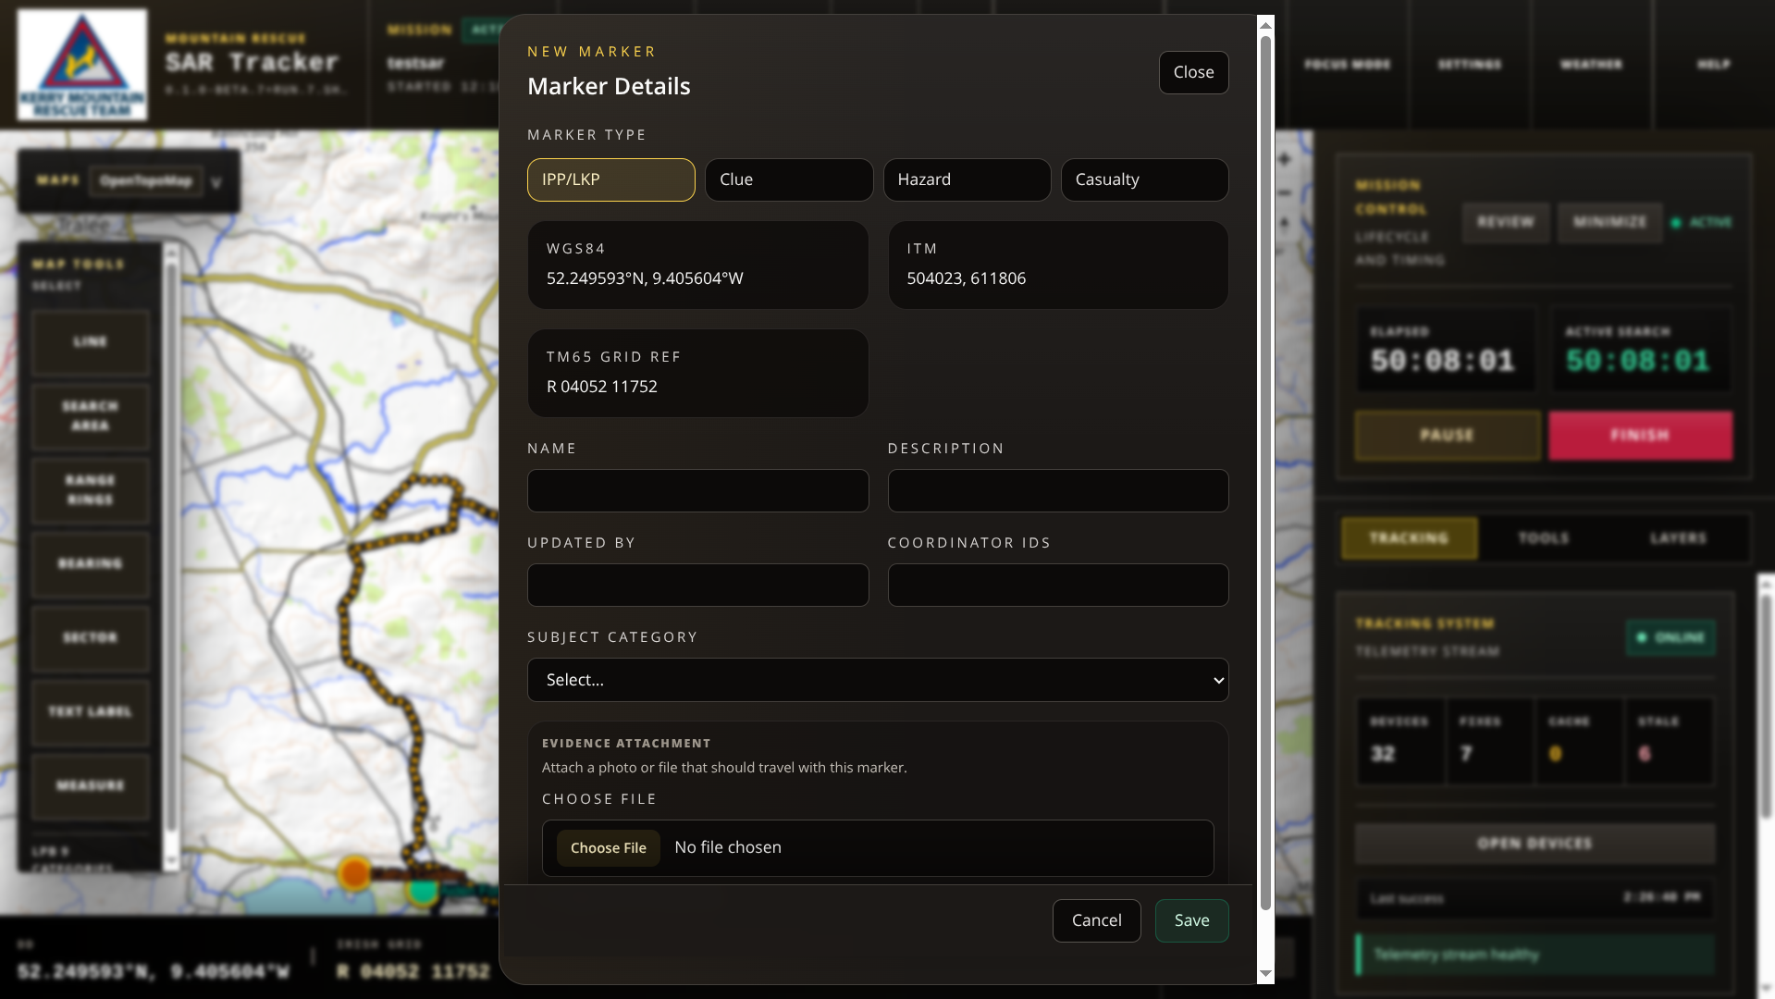

(6) Background Text. Difficult to see background text, could it be made brighter same
as text on RHS or try some other solution!. Apply globally.

For Discussion.
(1) Display Groups. Discuss how do we accommodate for non team members. Galway,
SEMRA etc

(a) Put them on Traccar in a different group, delete group when finished.
OR
(b) have them record their track separately for each search area and import their GPX
files. Naming track is important eg!!
No live tracking for 2nd. Option but less setup work,
How to deal with importing drone footage

(2) How to incorporate KMRT Evac log book especially gear log

For Later , confirmation needed with coordinators.

(1) In “Marker Details”, are GR WG84, ITM and TM65 needed to be shown, I believe
not. Again to simplify panel.

(2) Multi Day Mission--Unforeseen Problem. As a test, I simulated a multi day search we
conducted recently. Following that exercise it became readily apparent that a multi day
layer structure was needed. One solution, when asked to resume a mission which will
usually be on another day, prompt to confirm if new day and date needed for layer system
for that day. Layer for first day available if needed. Solution needs Discussing.

(3) Gear Record. How best to incorporate.

(4) Print / what’s app map image to team members

