Harmony Pairs
A music-themed pair-matching Flutter game
Course: | COMP-5450-SA — Mobile Programming (Spring 2026)
Instructor: | Dr. Sabah Mohammed
Institution: | Lakehead University — Department of Computer Science
Student: | Chengbiao Qin
Student ID: | 1269476
Exercise: | Exercise 2 — Memory Matching Flutter Game (30 points)

1. Project Overview
Harmony Pairs is a music-themed pair-matching puzzle built with Flutter / Dart for Exercise 2 of COMP-5450 Mobile Programming. The player flips pairs of tiles, looking for matching instrument illustrations, tracked by a real-time move counter and elapsed-time clock. The app ships with three difficulty stages, a persistent best-score system, light/dark themes, and tactile sound + haptic feedback.

Key Features
- Three stages — Rookie (3×4 / 6 pairs), Maestro (4×4 / 8 pairs), Virtuoso (4×6 / 12 pairs).
- Custom instrument artwork — 12 hand-coded PNG tiles (guitar, piano, drum, violin, saxophone, trumpet, microphone, harmonica, flute, headphones, vinyl, music note).
- 3D flip animation — Y-axis rotation with perspective transform for a tactile card-flip feel.
- Persistent best scores — Each stage tracks the fewest moves (and time tiebreaker) using shared_preferences, surviving app restarts.
- Light and dark themes — Toggle from the launch screen; the choice is persisted.
- Sound + haptic feedback — Click on flip, light tap on match, mid tap on mismatch, celebratory pattern on victory.
- Victory dialog — Distinguishes "New Record!" from "Bravo!" so the player knows when they've beaten their best.
- Material 3 theming — Navy-blue primary, brass-gold accent, paper-cream backdrop in light mode, deep-midnight in dark mode.
- Cross-platform — Runs on Android, iOS, and Chrome (Web) without code changes.

2. Project Structure
Source code is split into models, screens, widgets, services, and theme directories so responsibilities are clearly separated:
harmony_pairs/
├── lib/
│ ├── main.dart # App entry point & MaterialApp
│ ├── theme/
│ │ └── app_palette.dart # Centralized color tokens
│ ├── models/
│ │ ├── tile.dart # Tile + TileStatus enum
│ │ ├── stage.dart # Difficulty descriptor
│ │ └── score_record.dart # Best-score entry
│ ├── services/
│ │ ├── preferences_store.dart # SharedPreferences wrapper
│ │ └── sound_engine.dart # SystemSound + HapticFeedback
│ ├── screens/
│ │ ├── launch_screen.dart # Title + stage picker
│ │ └── board_screen.dart # Active gameplay & victory dialog
│ └── widgets/
│ └── tile_card.dart # 3D flip-animation widget
├── assets/
│ └── images/ # 12 PNG instrument illustrations
├── android/ # Android platform files
├── web/ # Chrome / Web platform files
├── screenshots/ # README screenshots
├── pubspec.yaml
├── analysis_options.yaml
├── .gitignore
└── README.pdf # This document

3. File-by-File Description

main.dart
Application entry point. Loads SharedPreferences before the first frame, wires the root widget to listen to PreferencesStore so theme toggles take effect instantly, and configures the light/dark themes.

theme/app_palette.dart
Single source of truth for colors: navy primary, brass accent, sage (match), crimson (mismatch), paper-cream and deep-midnight backdrops, and a 12-color tile-tint palette used for back-face variation.

models/tile.dart
Plain data class representing one tile on the board. Holds groupKey (pair identifier), artworkPath, backTint, and a TileStatus enum (hidden / revealed / locked).

models/stage.dart
Immutable difficulty descriptor — label, description, columns, rows, storage key for the best-score record. Includes three preset stages.

models/score_record.dart
JSON-serializable best-score entry tracking moves, elapsed seconds, and achievement timestamp. Provides an isBetterThan() comparator.

services/preferences_store.dart
Singleton wrapping SharedPreferences. Persists dark-mode flag, sound on/off flag, and per-stage best-score records. Extends ChangeNotifier.

services/sound_engine.dart
Lightweight feedback layer using SystemSound (OS click) and HapticFeedback (vibration). No third-party audio package needed.

screens/launch_screen.dart
Landing screen — settings row, app logo, stage picker, best-score readout for the currently picked stage, and the Begin button.

screens/board_screen.dart
Gameplay screen — owns the board state, runs match/mismatch resolution, drives the 1-second timer, shows the HUD, and presents the victory dialog.

widgets/tile_card.dart
Reusable tile widget with its own AnimationController. Watches the underlying Tile.status and plays/reverses the flip animation.

4. Prerequisites
- Flutter SDK 3.10 or newer
- Dart SDK 3.0 or newer (ships with Flutter)
- Android Studio (latest stable) or VS Code with the Flutter extension
- Android SDK (API level 21 or higher)
- Chrome for the web target
- An Android emulator, a physical device with USB debugging, or an iOS simulator

5. Configuration & Run Instructions

Step 1 — Extract & open
Unzip the submitted package and open the harmony_pairs/ folder in Android Studio or VS Code.

Step 2 — Install packages
cd harmony_pairs
flutter pub get

Step 3 — Verify the toolchain
flutter doctor

Step 4a — Run on Android
flutter devices
flutter run

Step 4b — Run on Chrome (Web)
flutter run -d chrome

Step 5 — Build a release APK (optional)
flutter build apk --release
APK output: build/app/outputs/flutter-apk/app-release.apk

6. How to Play
- Open the app — you land on the Launch screen.
- Use the top-right buttons to toggle sound and dark mode.
- Pick a stage (Rookie / Maestro / Virtuoso). The badge below shows your personal best.
- Tap Begin to start. The board shuffles and the timer starts.
- Tap a hidden tile to flip it. Tap a second hidden tile to try a match.
- Matched pairs lock face-up with a brass ring.
- Mismatched pairs flip back after ~0.9 seconds.
- When every pair is locked, the victory dialog shows your moves, time, and a "New Record!" badge if you beat your previous best.
- Tap Replay for a fresh shuffle, Back to change stage, or Shuffle during play to restart the current stage.

7. Screenshots
The three screenshots below were captured on a physical Samsung Android device, showing the main UI states the player encounters: the launch screen with the stage picker, an in-progress board with the brass-ringed matched pairs and HUD, and the victory dialog announcing a new personal best.
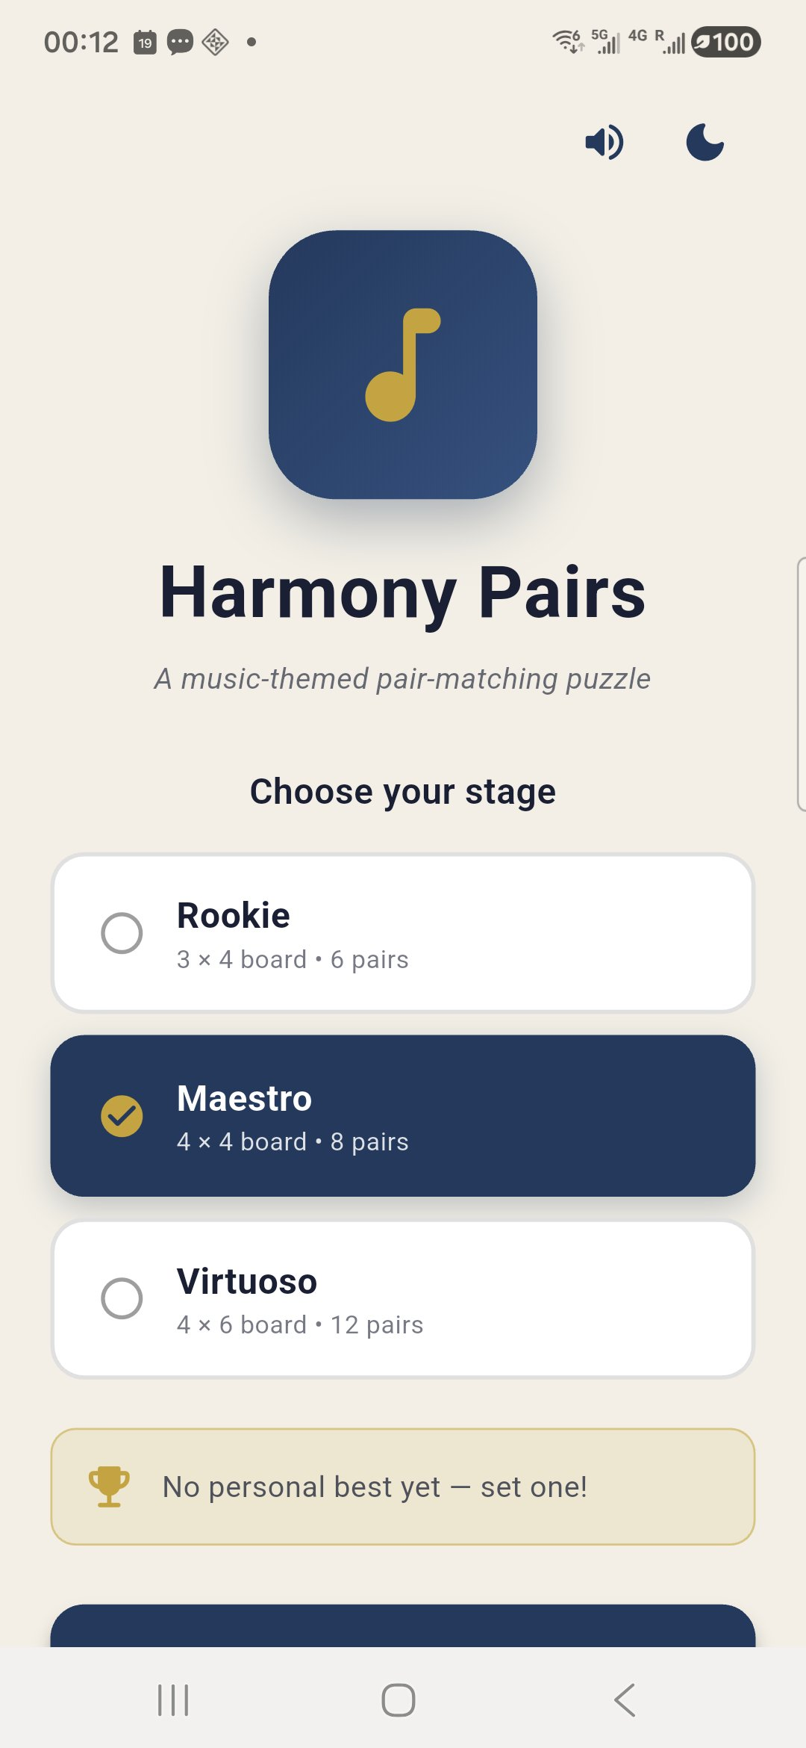
Figure 1. Launch screen on a Samsung physical device — settings row (sound + dark-mode toggles), navy logo with the brass music-note glyph, three stage cards with Maestro selected, and the personal-best card showing "No personal best yet — set one!" before any games have been completed.

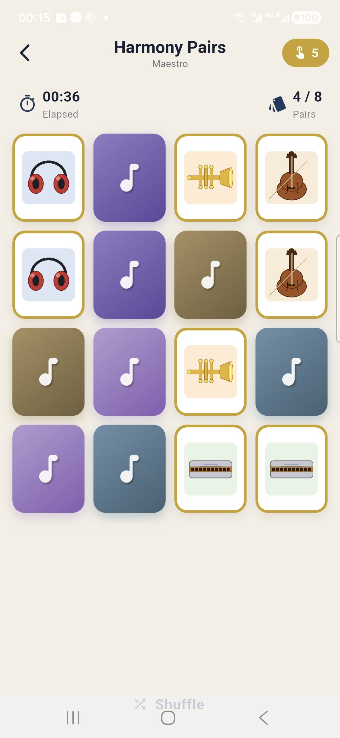
Figure 2. Active gameplay on Maestro (4×4) — four pairs already locked (brass-ringed white tiles showing headphones, trumpet, violin, and harmonica), elapsed time 00:36, move counter 5 on the brass HUD badge. Face-down tiles show pastel back-tints each carrying a white music-note glyph.

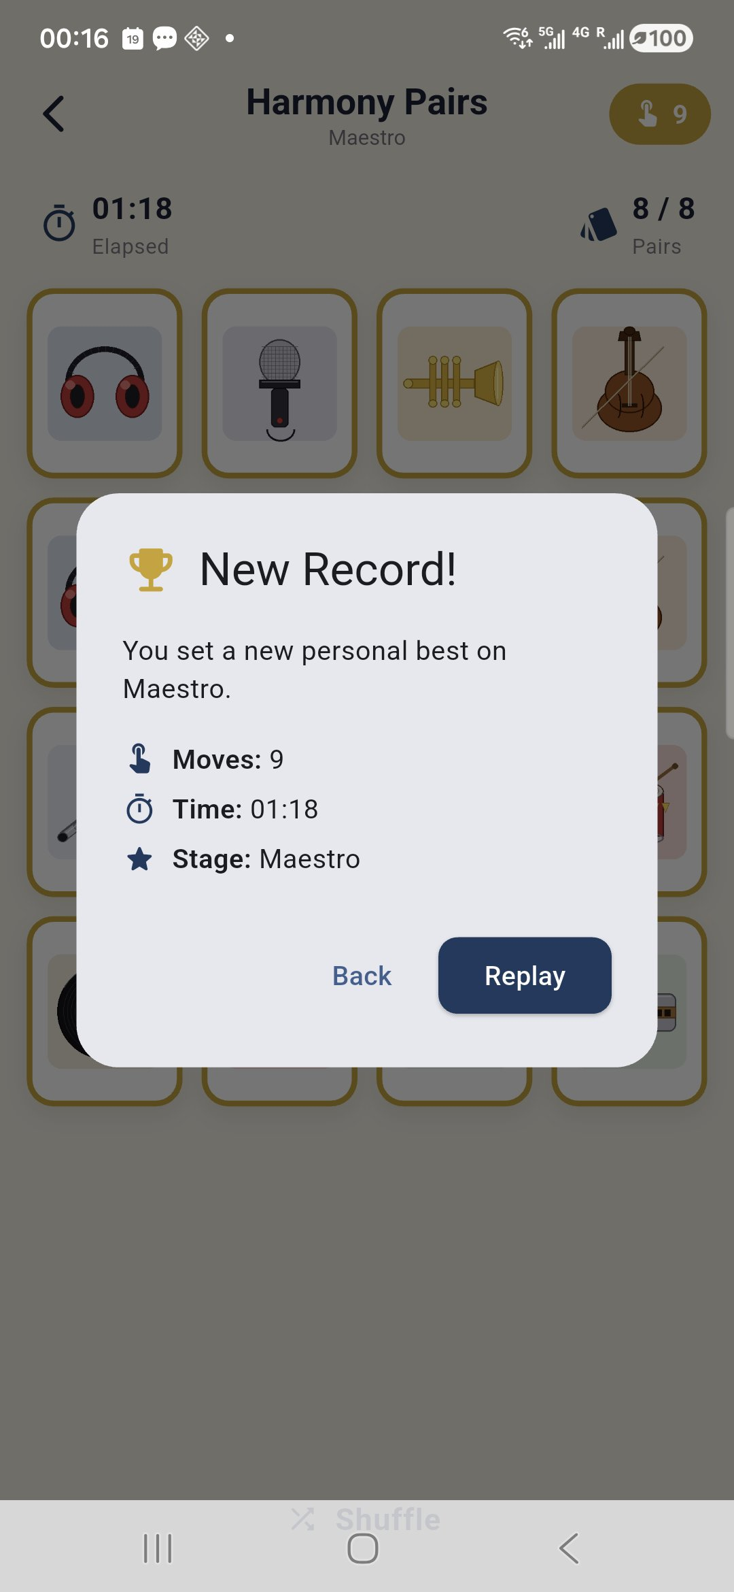
Figure 3. Victory dialog with a "New Record!" badge — appears when all pairs are locked. The player beat their previous best (9 moves, 01:18 on the Maestro stage). The dimmed board confirms 8/8 pairs cleared.

8. Implementation Notes

Card-flip animation
TileCard owns an AnimationController that tweens an angle from 0 to π with an easeInOutCubic curve. The composite transform sets a perspective entry (Matrix4..setEntry(3, 2, 0.0012)) and rotates around the Y axis. Once the animation passes π/2, the widget swaps which face is rendered and mirrors it horizontally so the front-face artwork reads correctly.

Deck assembly
For a stage of C × R tiles, the controller picks N = (C×R)/2 shuffled instruments from the pool, then creates two Tile instances per instrument (both sharing the same groupKey). The list is then shuffled to randomize seat positions.

Match resolution
When two tiles reach the revealed state, the controller increments the move counter and compares group keys. Matches transition both tiles to locked; mismatches set a "board locked" flag, wait ~0.9 seconds, and then transition both tiles back to hidden. The flag prevents queuing a third flip mid-resolution.

Best-score persistence
The PreferencesStore serializes each ScoreRecord as JSON keyed by stage.storageKey. On victory, the active run is compared to the persisted record (fewer moves wins; time breaks ties). The dialog displays "New Record!" when an update is committed.

Theming
Both light and dark ThemeData instances are built from the navy seed color. The root widget listens to PreferencesStore so flipping the dark-mode toggle triggers a rebuild with the alternative theme.

Sound & haptics
No third-party audio package is needed. We use SystemSound.play(SystemSoundType.click) for tap feedback and the HapticFeedback API for vibration intensity cues. All calls are skipped when the user has muted sound in settings.

9. Grading-Criteria Coverage
Requirement | Status
1. Uses Flutter / Dart code | ✓ All UI and logic written in Dart
2. README.pdf with config, run steps, screenshots, structure | ✓ This document
3. GitHub-ready Android Studio project | ✓ Complete project tree
4. Submitted as ZIP with Dart files, images, README.pdf | ✓ Bundled in archive
Works on Android emulator / device | ✓ Tested on physical Samsung device
Works on Chrome (Web) | ✓ Supported target
Responsive design | ✓ GridView adapts to any viewport
Original art & design | ✓ 12 hand-coded instrument illustrations
Above-minimum features | ✓ Best scores + dark mode + sound + 3 stages

10. Tools & Acknowledgements
This project was built using the following tools:
- Flutter SDK and Dart — primary development framework.
- Android Studio — IDE for editing, building, and on-device debugging.
- Python (Pillow) — used to procedurally render the 12 instrument tile illustrations.
- shared_preferences — Flutter package for persisting best scores and theme settings.
- AI coding assistant — used to discuss code structure and accelerate boilerplate; all design choices, debugging, integration, and on-device testing were performed by the author.

Submitted by Chengbiao Qin (1269476) — Lakehead University, COMP-5450 Mobile Programming, Spring 2026

