This is a challenge hosted by vulnhub. (See link below)
https://www.vulnhub.com/entry/mr-robot-1,151/

For this vulnerable machine, our goal is to collect 3 flags, that will require an understanding, in web applications, suid exploitation, and various shells.

Initially the MR.Robot VM boots up and requests a password.

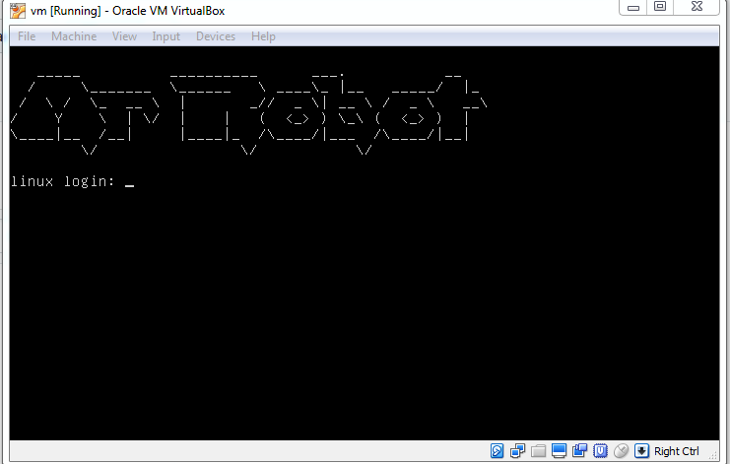
Initial attempts using defaults did not work.

The next step is to discover what ip address has been assigned to this VM, which indeed has DHCP enabled.

Using the “netdiscover” tool in Kali Linux, we are able to identity this vm as the PCS Systemtechnik GmbH.

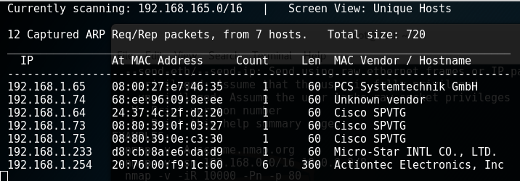
The next step was to run a basic scan with nmap

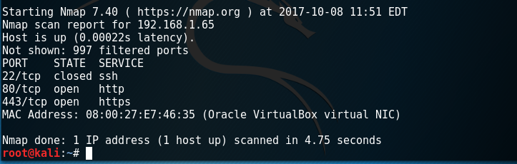
Here we see that ports 80 and 443 are open, and we can infer a likelihood that these ports are hosting a web server of some type.

If it is a web server or site of some sort, browsing to it may provide further information.

Here is what came up

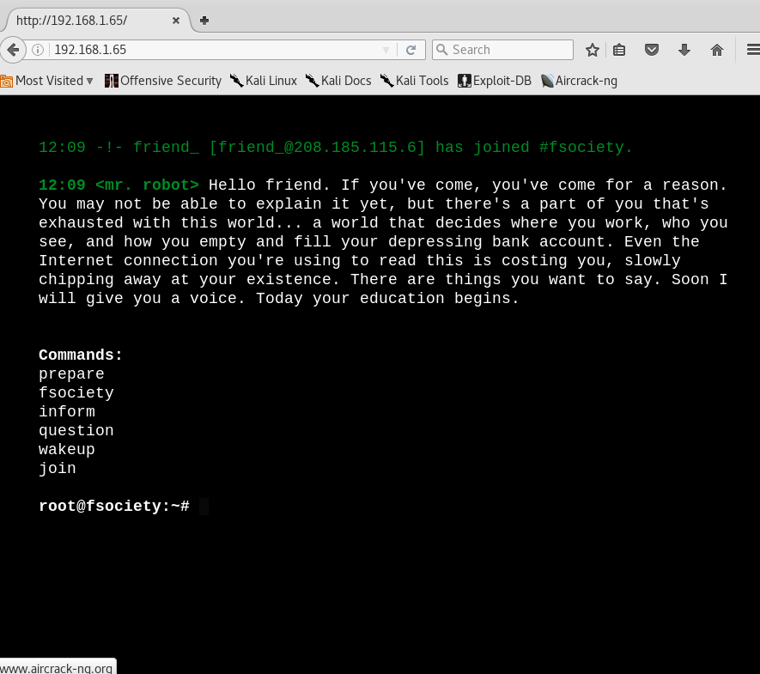

After attempting to run several of the commands, unsuccessfully, I concluded the list was a red herring.

The next surface to check, was for a published robots.txt file.
Which, being an introductory walk through, allow me to explain.
The robots.txt is a file created by website developers that responds to internet bots crawling the net, typically to index information within search engines.
The responses recorded in these robots.txt files are either “allowed” or “disallow”.

I navigated to this file simply by typing into the url http://(Host IP Address)/robots.txt
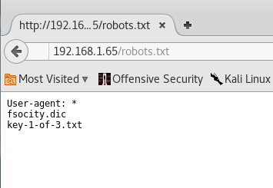
Well this is fantastic, we see key-1-of-3.txt and a dictionary file.
First I navigate to the key-1-of-3.txt by placing it in the url and we get the key.

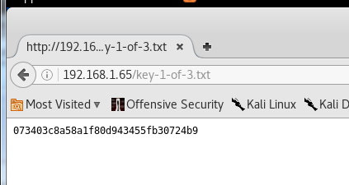
Back to the robots.txt, I navigate to the fsociety.dic which appears to be a file.
Http://(Host ip address)/fsocity.dic

Upon downloading, it appears to be a dictionary with over 800,000 words.
We will likely need this for later, and will come back.

At this point we want to scan for vulnerabilities and flaws using the vulnerability scanner “nikto” in Kali linux.

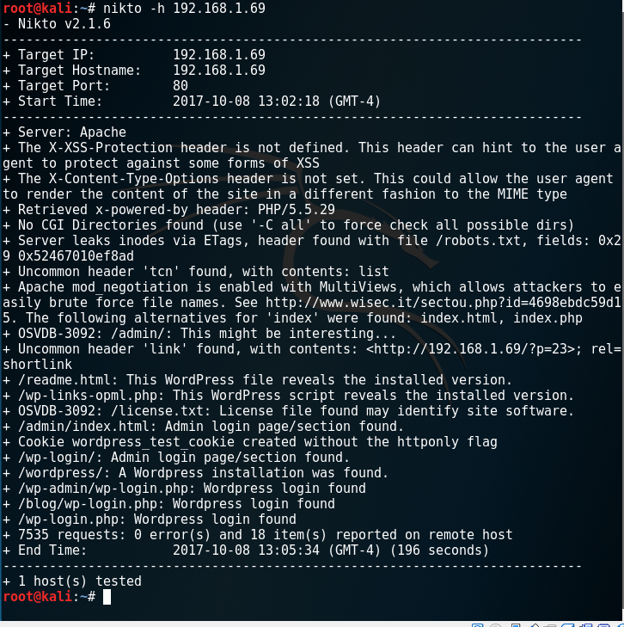
Initially I see the following;
An apache server, running wordpress, with multiple opportunities to exploit.
Including, a path for admin login, likely where the dictionary file will be utilized.
I reviewed the read me and license files which had nothing of interest.
The next stop was wp-login – (host ip address)/wp-login.php

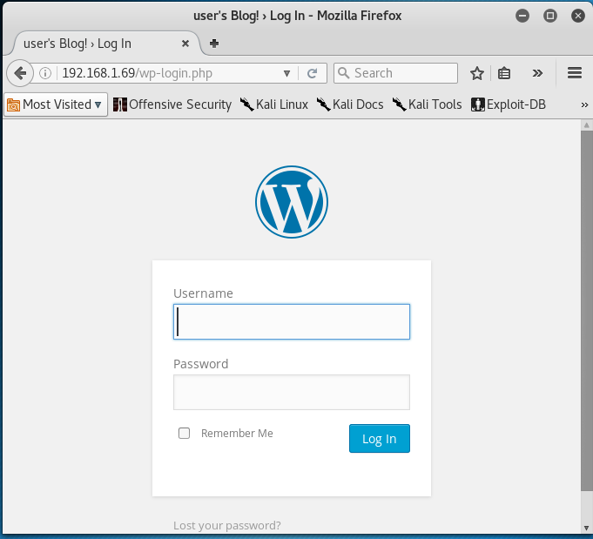
A few obvious login attempts including admin, Admin, robot, we get invalid username prompts, indicating the general verification of credentials.

How ever,
Username “Elliot” and an arbitrary password produces this.
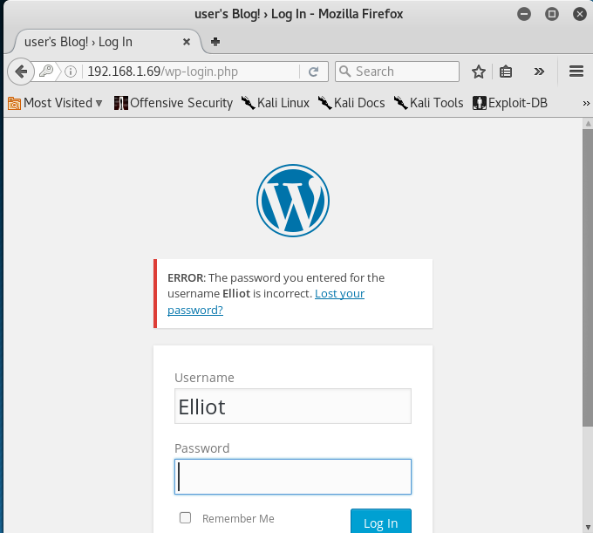

Fantastic. We have the wrong password for the username. We indeed hav a valid username.
Immediately I drew a connection back to that 800000 word dictionary.
There is an opportunity to brute force here, either with hydra or wpscan.

Firstly, with a dictionary of 800000 words, however, I soon realized a brute force could take a really long time.

I parsed the dictionary using a command to only show lines that appeared once in the file, as many duplicates appeared. The wordlist was reduced to 10 words.

The command I used in particular was; sort fsocity.dic | uniq -u >fsocity2.dic

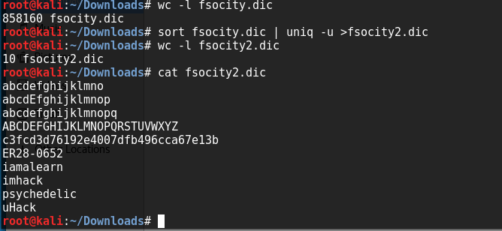
Here we can set up a brute force attack with this 10 word file, which will unlikely contain the correct password as it would be to easy, in which case we will try the full word list, and maybe consider reducing it in other ways.

Initially I tried to use Wpscan as my instrument of brute force, but the check sum failed upon update, it appears the host is offline, so we will use hydra for this brute force.

Here, I will write a brief description on Hydra.

Ultimately we need to know what type of form submission we will be brute forcing. How we determine this, is by navigating to the login page and “viewing the page source”.
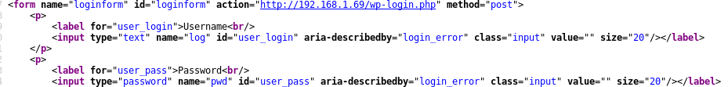

Particularly we are looking for any “Form”, which we see at the top of this page source, on the left, “form name=loginform”. At the end of the line it displays method=post.

This tells us that there is a login form (which we could visually see as a credentials prompt). In the middle of this string we see action=”http://192.168.1.69/wp-login.php” this is the path to the form submission. Following is “method=”post:”” which is a request method that submits data. This confirms that we can attempt a brute force on the POST function, through the form submission path.

The following command was entered to run hydra, and for your instructions, I will attempt to illustrate.

Hydra -vV -l elliot -P fsocity2.dic 192.168.1.69 http-post-form '/wp-login.php:log=^USER^&pwd=^PASS^&wp-submit=log+In:F=is incorrect'

-vV verbose – returns the outcome
-l (L) elliot – username (or word list name), we know the username, and will specify, Elliot
-P fsocity2.dic – Represents file name of the password list to run against the POST form submission. (you have to be in current directory of any lists you want to use).
192.168.1.69 – the ip address of this mr.robot machine.
http-post-form – this is the request method we are going to brute force.
'/wp-login-php:log=^USER^&pwd=^PASS^&wp-submit=Log+In:F=invalid username'

Firstly - /wp-login.php: is the path to this form which is then posted.
Secondly – log=^USER^&pwd=^PASS^&wp-submit=Log+In: is the POST parameter for the form, combined with the USER and psw separated with ^ carrots, to pass along the input or word lists strings.
Thirdly – F=invalid username: If the attempt is a failure, it will respond invalid username so we know.

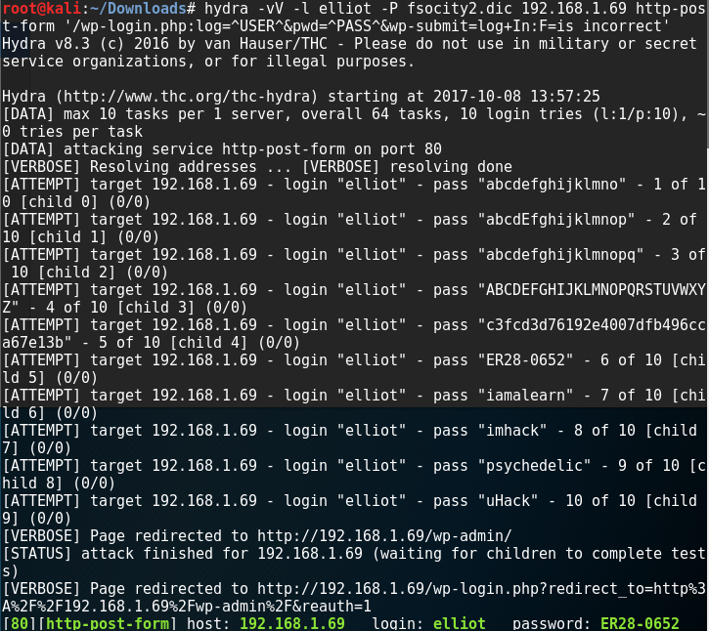

Here is our password at the bottom.

The list of 10 contained a matching password.

This allows us to log in to the wordpress admin console.

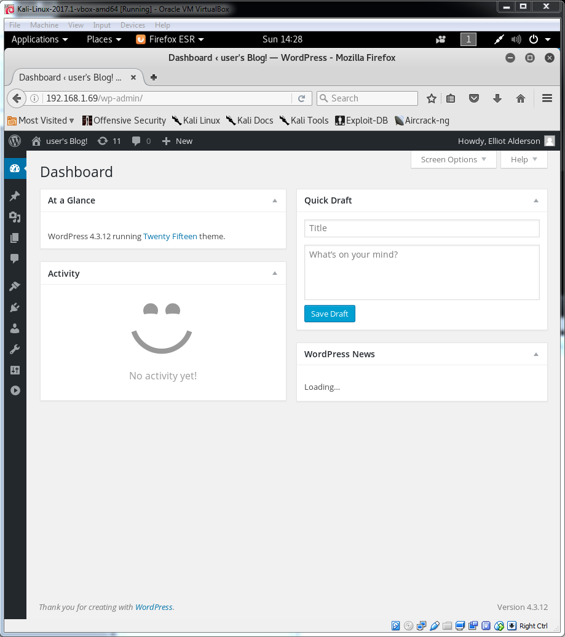
My intuition tells me that the second flag, is likely on the server itself, and we are going to want to access this host, and to do that we can possibly use some shell creation, strategies.
Initially my gut feeling is to get a reverse shell script from the website pentestmonkey, that we can potentially upload in the website.

After some browsing around on the word press page, in an attempt, to find real estate for our reverse. shell code, I found that, under appearance > editor, we can select pages and view the source code.
Here I found a 404.php page that I decided would be my target for a php reverse shell, script.
Taking the php reverse shell script, from pentest monkey, with the only change I made, of pointing the ip address for the shell to listen for my linux machine.
Back in the word press page, in particular, in the 404.php page, I pasted this script at the bottom and saved changes.

Back into Kali linux, the following net cat command established a listening port, for the shell.

Nc -v -n -l -p (any)

-n = don't perform dns look up
﻿-l = listen mode
-v = verbose
-p = port (any by default)
In order to now activate the script we have just uploaded.
We actually browse to the page that contains the script,

(host ip address)/404.php

This executes the script, and nc (net cat) will pick it up immediately, as the script broadcasts to the configured host and port, that we earlier set.

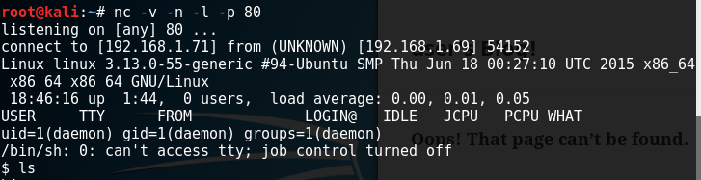
Note that I ran the ls command to view directories on the host.

Assuming the flag is in one of these directories.
Eventually, after much looking around, under the home directory, there was a folder named robot.
In this home/robots/ folder we find the following.

key-2-of-3.txt - denies us permission.
Password.raw - md5 we can cat and read the file.

c3fcd3d76192e4007dfb496cca67e13b
Ran this through an online m5d hash table, that cracked it.
The key-2-of-3.txt denies us permissions, but indicates that a user named robot has permissions.

The next step is to login and gain elevated permissions via the “robot” user.
The command for this process, is Su (substitute user) and it demands a terminal to be run.

I made multiple attempts to substitute the user, and all failed, indicating that there was either no tty shell present, or that the command needed to run from a shell.
So I performed some research and came across this site
http://netsec.ws/?p=337
which talks about escalating a simple shell, to tty – allowing further interaction with the system.

I prepared and ran the following
python -c 'import pty; pty.spawn("/bin/sh")'

This popped a tty shell, which sits closer to the kernal than our ssh shell, and passes elevated commands. (Fun fact, a tty shell was used for linux machines to operate on type writers in its early developments)

This then allowed us to run su robot
Enter the password from the md5 hash, and cat the key-2-of-3.txt file.

Next we will as the title suggests, gain root access for our 3rd flag.
So lets start simple, and scan for SUID exploitation by running

find / -perm -4000 (this command reveals files with permissions 4000, also known as SUID permissions, standing for, set owner user id – upon execution)

Which reveals an older version of nmap, having interactive mode, where we can pass commands with the permissions of the nmap owner, being root.

What will happen next, is we will use nmap, and enter into interactive mode, where we gain the permissions of the owner, being root, we can pass any command.
From nmap line, type “nmap –interactive” and from there our next command gives us a root shell being; !sh

Run the ls command and the 3rd flag is found.

Congratulations.
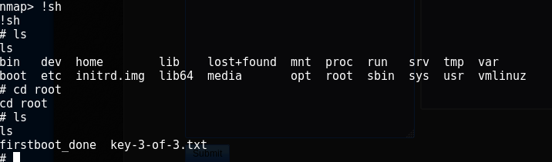
From there you can cat the key.

