Med Connect AI - Project
System Architecture Detail Technical Document

Client Information
Version #: | 0.0.2
Ticket #: | 10196
Last Updated: | 05/04/2026
Client Name/ID: | Brayard Gordon
Client Phone: | 860-655-9564
Project Email: | info@softwareyourway.com
Client Web Site:

Table of Contents

Table of Contents 1
Table of Contents 7
Executive Summary 8
Architecture Scope 9
Requirements Baseline 10
Architecture Decision Summary 11
Architecture Diagram 1: Context 12
Architecture Diagram 2: Container 13
Architecture Diagram 3: Layers 14
Architecture Diagram 4: Azure 15
Architecture Diagram 5: Dataflow 16
Architecture Diagram 6: Sequence 17
Architecture Diagram 7: Erd 18
Architecture Diagram 8: Rbac 19
Architecture Diagram 9: Cicd 20
Architecture Diagram 10: Observability 21
Architecture Diagram 11: Security 22
Architecture Diagram 12: Scaling 23
Architecture Diagram 13: Risk Matrix 24
Architecture Diagram 14: Roadmap Chart 25
Architecture Diagram 15: Capacity Chart 26
Architecture Diagram 16: Domain Map 27
Architecture Diagram 17: Api Map 28
Architecture Diagram 18: Notification Flow 29
Domain Module 1: Identity and Access 30
Identity and Access - Key Workflows 31
Domain Module 2: Patient Management 32
Patient Management - Key Workflows 33
Domain Module 3: Doctor Management 34
Doctor Management - Key Workflows 35
Domain Module 4: Appointment Scheduling 36
Appointment Scheduling - Key Workflows 37
Domain Module 5: Telemedicine 38
Telemedicine - Key Workflows 39
Domain Module 6: Payments 40
Payments - Key Workflows 41
Domain Module 7: Medical Records 42
Medical Records - Key Workflows 43
Domain Module 8: Administration 44
Administration - Key Workflows 45
Domain Module 9: Notifications 46
Notifications - Key Workflows 47
Domain Module 10: Audit and Compliance 48
Audit and Compliance - Key Workflows 49
Data Architecture: Users 50
Data Architecture: Doctors 51
Data Architecture: Patients 52
Data Architecture: Appointments 53
Data Architecture: AvailabilitySlots 54
Data Architecture: Payments 55
Data Architecture: MedicalRecords 56
Data Architecture: Prescriptions 57
Data Architecture: Notifications 58
Data Architecture: AuditLogs 59
Data Architecture: Countries 60
Data Architecture: Specialties 61
API Architecture: Auth API 62
API Architecture: Doctors API 63
API Architecture: Appointments API 64
API Architecture: Telemedicine API 65
API Architecture: Payments API 66
API Architecture: Medical Records API 67
API Architecture: Admin API 68
API Architecture: Notification API 69
API Architecture: Audit API 70
API Architecture: Reporting API 71
Security Architecture: Identity and Authentication 72
Security Architecture: Authorization and RBAC 73
Security Architecture: Medical Record Access Controls 74
Security Architecture: Encryption and Key Management 75
Security Architecture: API Threat Protection 76
Security Architecture: Audit Logging 77
Security Architecture: Secure SDLC 78
Security Architecture: Data Privacy 79
Security Architecture: Incident Response 80
Security Architecture: Third-Party Risk 81
Environment Architecture: Local Development 82
Environment Architecture: Shared Development 83
Environment Architecture: QA/Staging 84
Environment Architecture: Production 85
Environment Architecture: Disaster Recovery 86
Environment Architecture: Future Multi-Region 87
Operational Architecture: CI/CD Pipeline 88
Operational Architecture: Branching Strategy 89
Operational Architecture: Code Review Gates 90
Operational Architecture: Automated Testing 91
Operational Architecture: Release Management 92
Operational Architecture: Rollback Strategy 93
Operational Architecture: Monitoring Dashboards 94
Operational Architecture: Alerting Rules 95
Operational Architecture: Backup and Restore 96
Operational Architecture: Operational Runbooks 97
Operational Architecture: Support Model 98
Operational Architecture: Change Management 99
Role Architecture: Project Manager / Technical Lead 100
Role Architecture: Backend Developer (.NET) 101
Role Architecture: Frontend Developer (React + MUI) 102
Role Architecture: QA Engineer 103
Role Architecture: DevOps Engineer 104
Role Architecture: UI/UX Designer 105
Role Architecture: Healthcare App Consultant Kenya 106
Role Architecture: Country Manager Kenya 107
Role Architecture: Security / Compliance Advisor 108
Role Architecture: Product Owner 109
Non-Functional Requirement: Performance 110
Non-Functional Requirement: Scalability 111
Non-Functional Requirement: Availability 112
Non-Functional Requirement: Reliability 113
Non-Functional Requirement: Maintainability 114
Non-Functional Requirement: Testability 115
Non-Functional Requirement: Usability 116
Non-Functional Requirement: Accessibility 117
Non-Functional Requirement: Localization 118
Non-Functional Requirement: Cost Optimization 119
Non-Functional Requirement: Compliance 120
Non-Functional Requirement: Interoperability 121
ADR-001: Modular monolith first 122
ADR-002: Microsoft Azure as primary cloud 123
ADR-003: SQL Server as primary database 124
ADR-004: React + MUI for frontend 125
ADR-005: ASP.NET Core Web API 126
ADR-006: Azure DevOps for CI/CD 127
ADR-007: Azure Communication Services for video 128
ADR-008: External payment provider abstraction 129
ADR-009: Application Insights for observability 130
ADR-010: Policy-based authorization 131
Appendix: Glossary 132
Appendix: Open Questions 133
Appendix: Launch Readiness Checklist 134
Appendix: Technical Debt Register 135
Appendix: Future Microservice Extraction Plan 136
Appendix: Kenya Localization Considerations 137
Appendix: Provider Onboarding Architecture 138
Appendix: Payment Provider Selection Criteria 139
Appendix: Video Quality Validation Plan 140
Appendix: Data Migration Plan 141
Appendix: Reporting and Analytics Roadmap 142
Appendix: Architecture Review Agenda 143

Technical Architecture
React + MUI | ASP.NET Core | SQL Server | Microsoft Azure | Modular Monolith | 100k User Scale Target
This document is designed to be a comprehensive technical architecture package. It includes diagrams, role definitions, charts, architecture decisions, implementation guidance, and operational checklists.

Executive Summary
The Healthcare App MVP will provide patient registration, doctor discovery, appointment booking, telemedicine, medical records, payments, and administrative capabilities. The architecture is designed to launch quickly while remaining secure and extensible.
The selected stack is React with MUI, ASP.NET Core, SQL Server, Microsoft Azure, and Azure DevOps. This supports a Microsoft-aligned implementation with strong operational tooling and developer productivity.
- Use modular monolith first
- Design for eventual service extraction
- Protect healthcare data from day one
- Optimize for Kenya launch and future African expansion

Architecture Scope
The architecture covers frontend, backend, data, integrations, deployment, security, observability, scalability, and team roles. It focuses on production readiness for an MVP that can grow to 100,000 registered users.
- Includes functional and non-functional design
- Includes diagrams and operational guidance
- Does not replace detailed implementation tickets
- Should be reviewed before sprint execution

Requirements Baseline
The baseline requirements are inherited from the prior SRS, LLD, PMP, and user stories. Core MVP functionality remains intentionally focused so the product can validate demand before expanding.
- Patients can register, search, book, pay, consult, and view records
- Doctors can manage availability, consult, and create records
- Admins can manage users, doctors, approvals, and operations
- Platform integrates video, payments, and notifications

Architecture Decision Summary
The most important architectural decision is to avoid premature microservices. The MVP should be a modular monolith with strict module boundaries and a clean deployment model.
- Single ASP.NET Core API deployable
- Feature modules inside the backend
- SQL Server as transactional system of record
- Azure managed services for hosting and monitoring

Architecture Diagram 1: Context
This diagram is part of the architecture baseline for the healthcare app. It should be reviewed with engineering, product, operations, and security stakeholders before implementation begins.
- Use this diagram to validate scope and responsibilities
- Capture deviations as Architecture Decision Records
- Update after major sprint or infrastructure changes
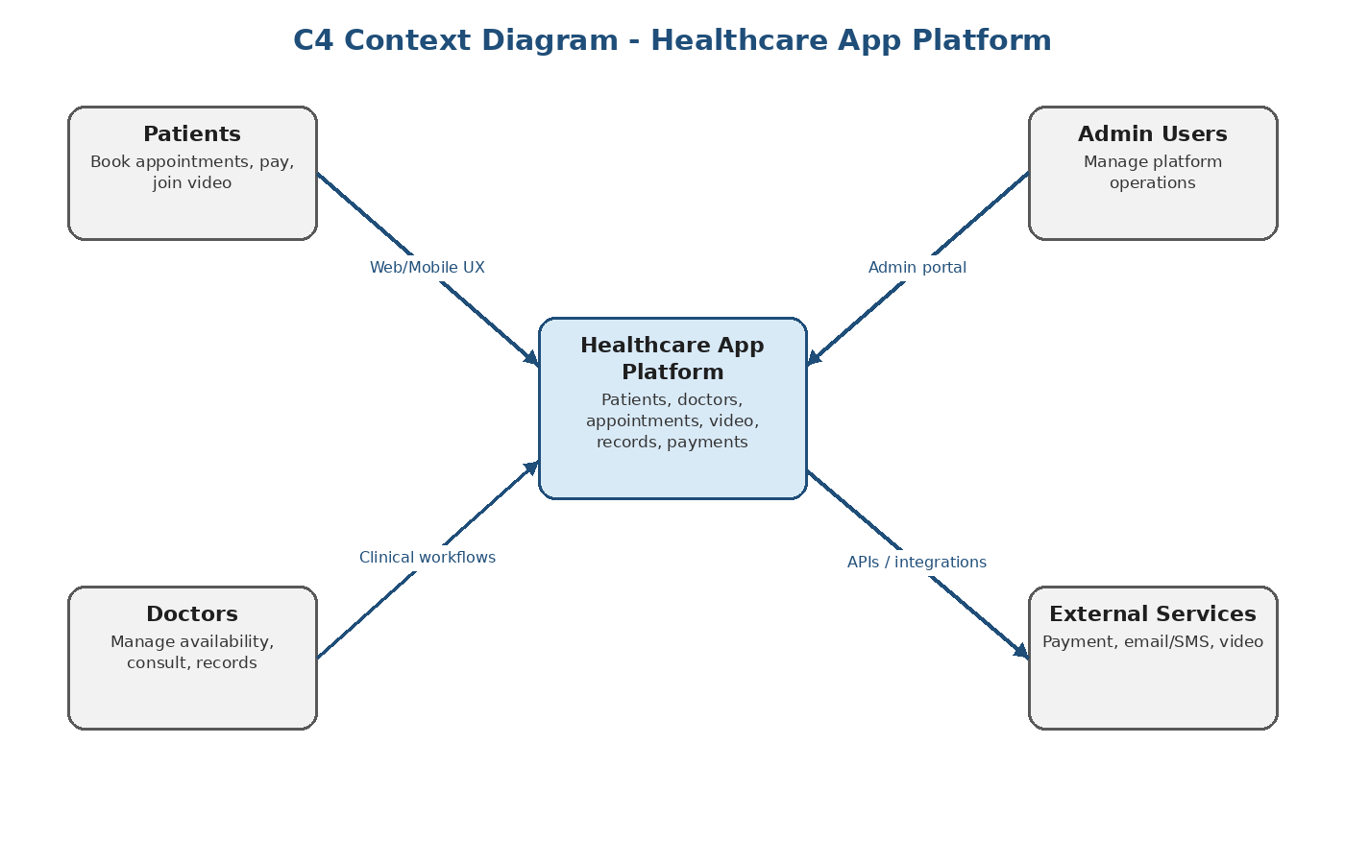

Architecture Diagram 2: Container
This diagram is part of the architecture baseline for the healthcare app. It should be reviewed with engineering, product, operations, and security stakeholders before implementation begins.
- Use this diagram to validate scope and responsibilities
- Capture deviations as Architecture Decision Records
- Update after major sprint or infrastructure changes
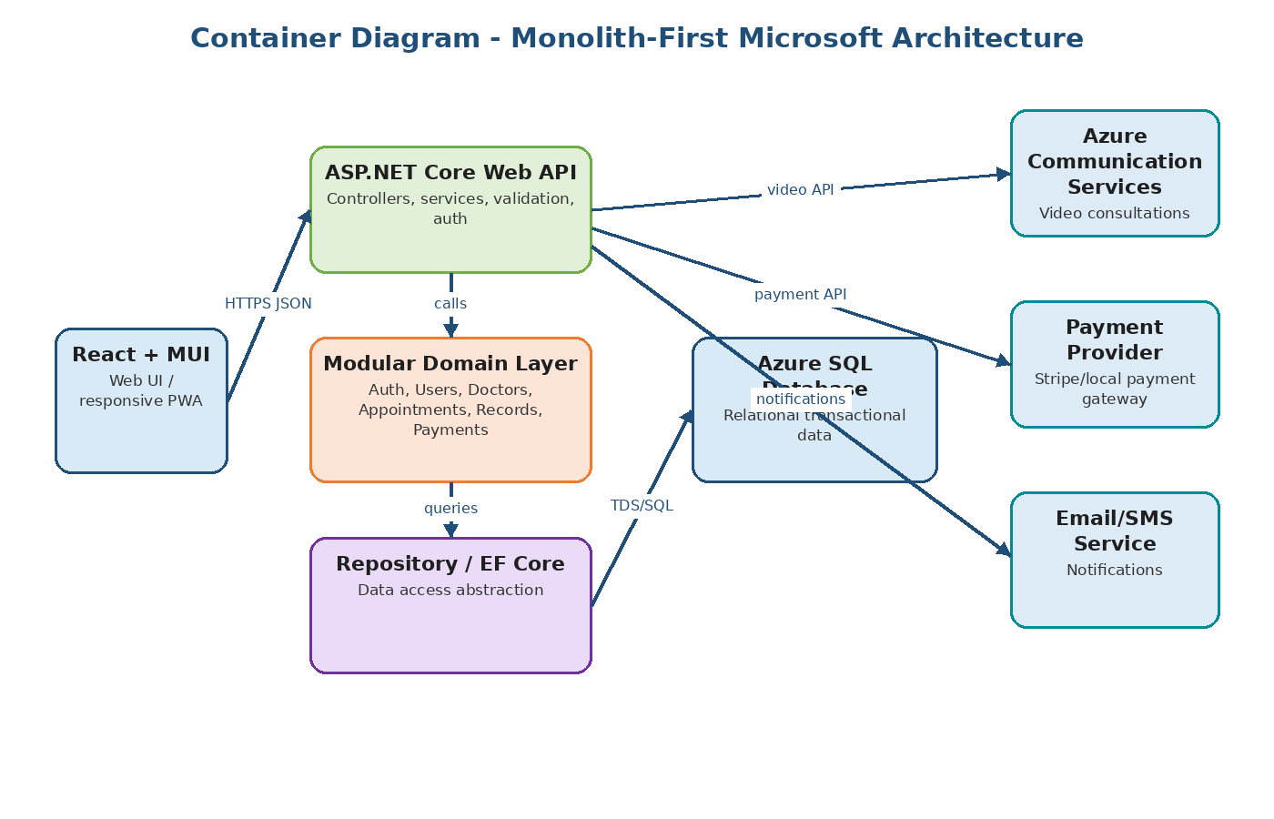

Architecture Diagram 3: Layers
This diagram is part of the architecture baseline for the healthcare app. It should be reviewed with engineering, product, operations, and security stakeholders before implementation begins.
- Use this diagram to validate scope and responsibilities
- Capture deviations as Architecture Decision Records
- Update after major sprint or infrastructure changes
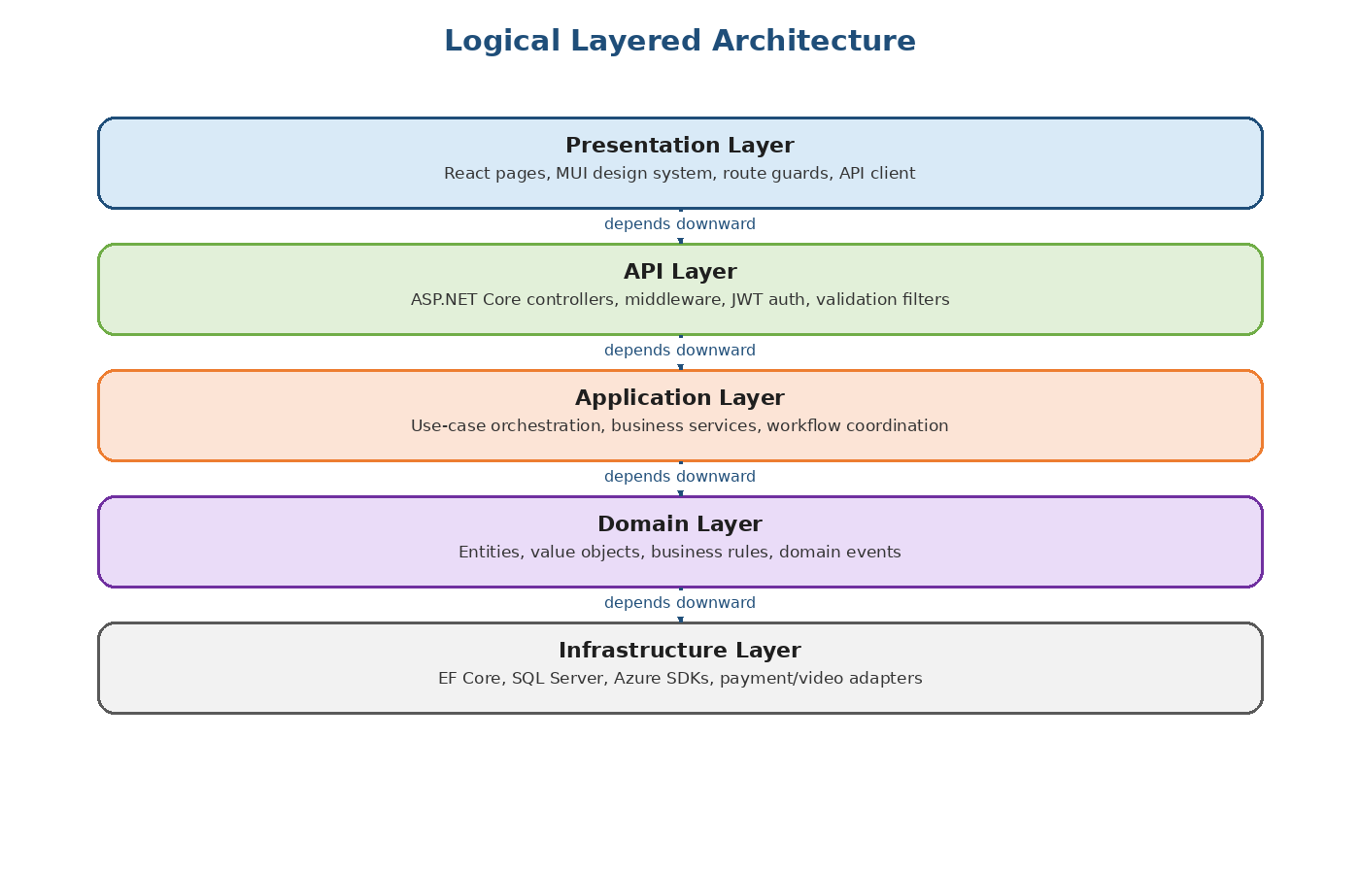

Architecture Diagram 4: Azure
This diagram is part of the architecture baseline for the healthcare app. It should be reviewed with engineering, product, operations, and security stakeholders before implementation begins.
- Use this diagram to validate scope and responsibilities
- Capture deviations as Architecture Decision Records
- Update after major sprint or infrastructure changes
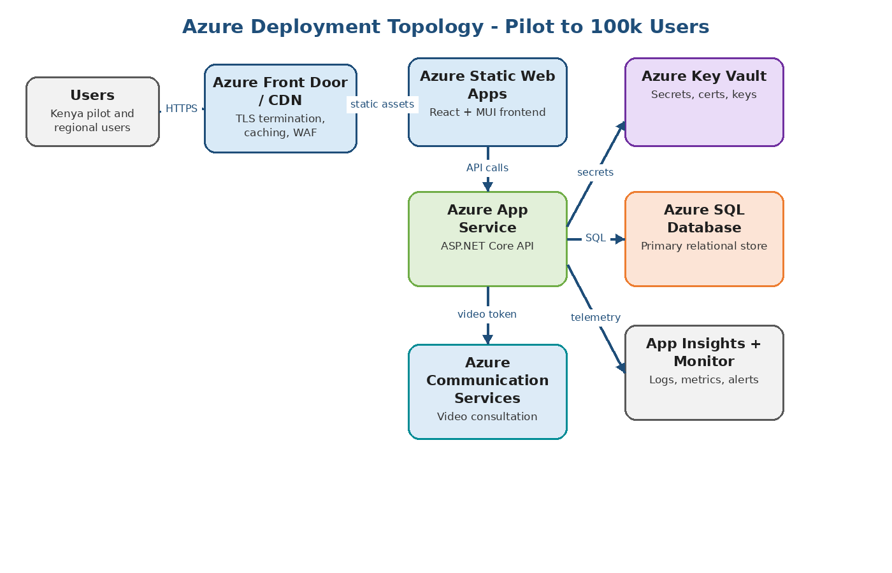

Architecture Diagram 5: Dataflow
This diagram is part of the architecture baseline for the healthcare app. It should be reviewed with engineering, product, operations, and security stakeholders before implementation begins.
- Use this diagram to validate scope and responsibilities
- Capture deviations as Architecture Decision Records
- Update after major sprint or infrastructure changes
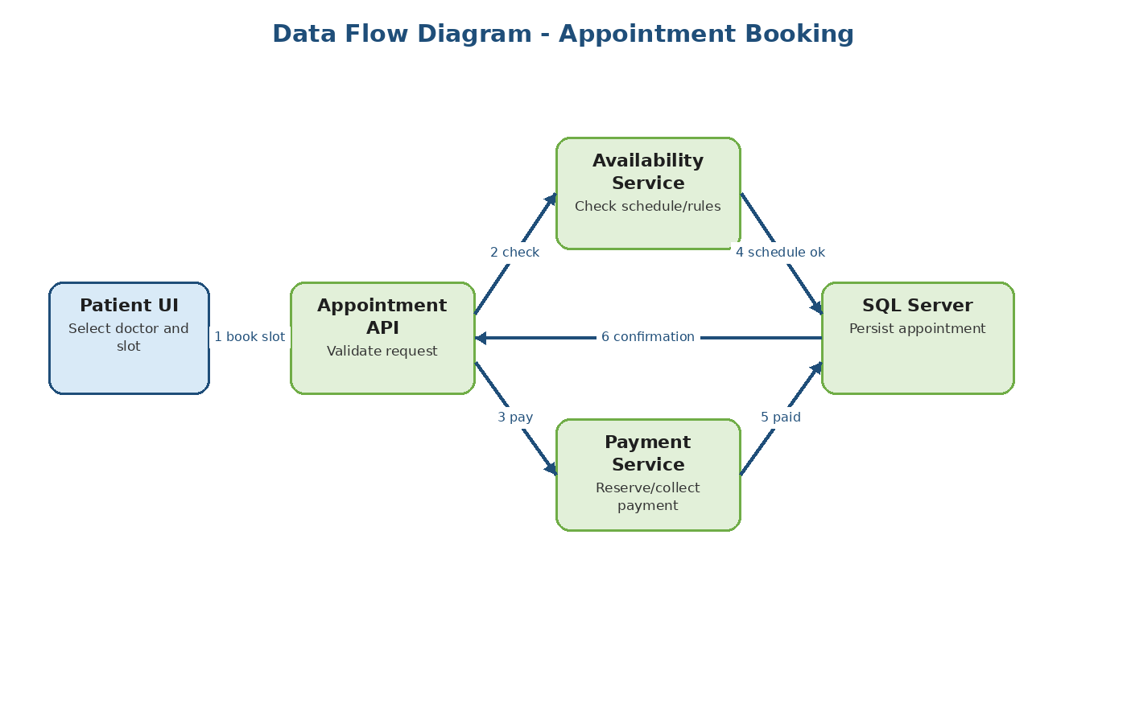

Architecture Diagram 6: Sequence
This diagram is part of the architecture baseline for the healthcare app. It should be reviewed with engineering, product, operations, and security stakeholders before implementation begins.
- Use this diagram to validate scope and responsibilities
- Capture deviations as Architecture Decision Records
- Update after major sprint or infrastructure changes
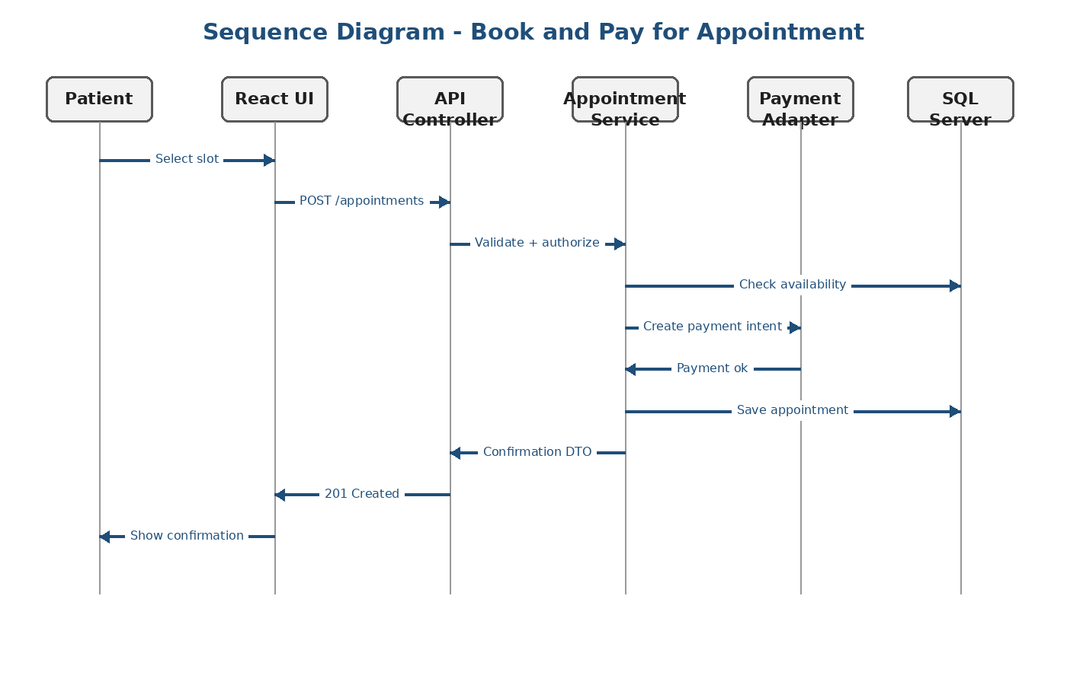

Architecture Diagram 7: Erd
This diagram is part of the architecture baseline for the healthcare app. It should be reviewed with engineering, product, operations, and security stakeholders before implementation begins.
- Use this diagram to validate scope and responsibilities
- Capture deviations as Architecture Decision Records
- Update after major sprint or infrastructure changes
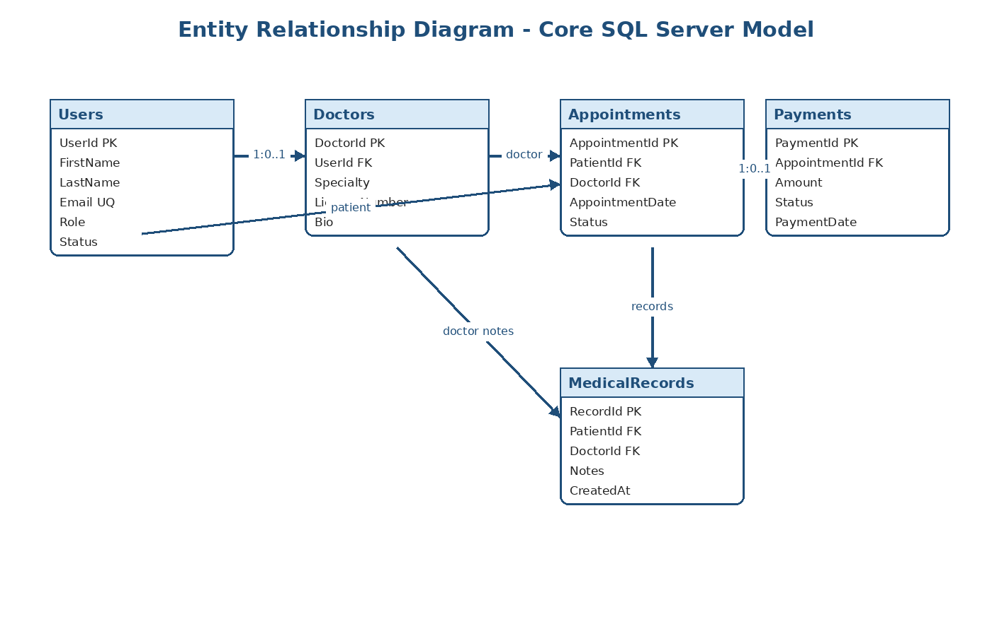

Architecture Diagram 8: Rbac
This diagram is part of the architecture baseline for the healthcare app. It should be reviewed with engineering, product, operations, and security stakeholders before implementation begins.
- Use this diagram to validate scope and responsibilities
- Capture deviations as Architecture Decision Records
- Update after major sprint or infrastructure changes
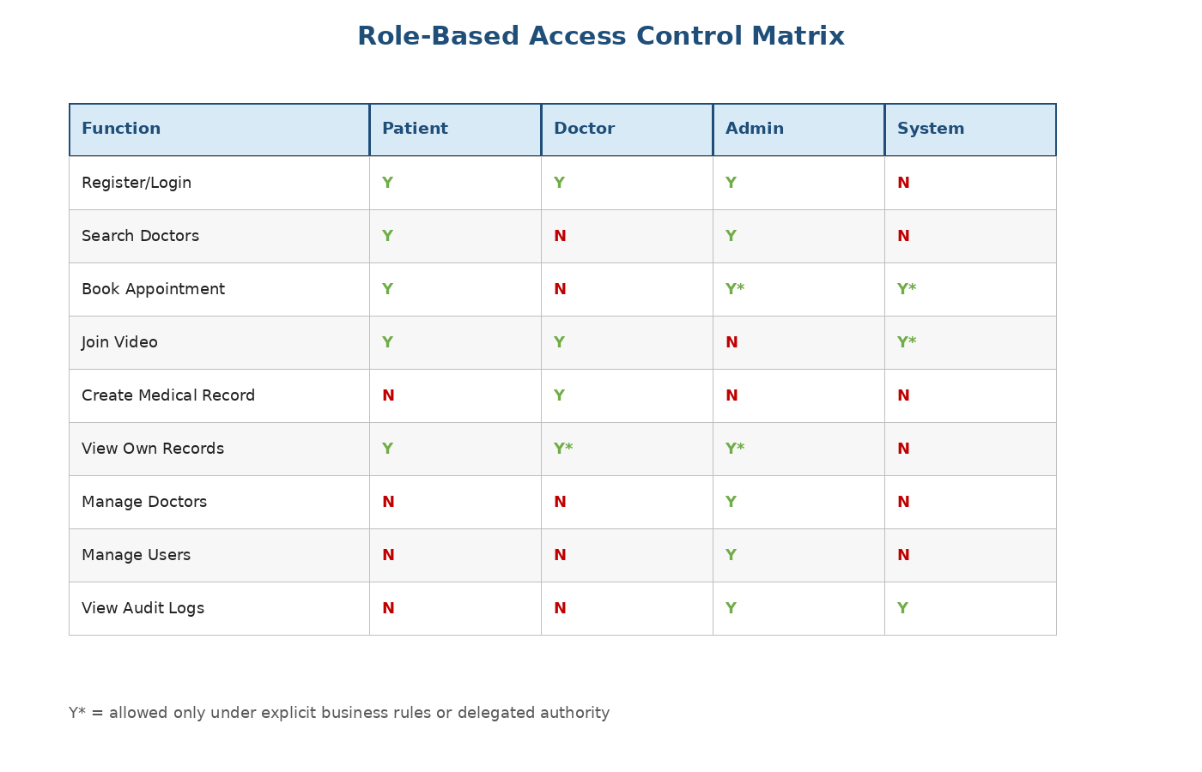

Architecture Diagram 9: Cicd
This diagram is part of the architecture baseline for the healthcare app. It should be reviewed with engineering, product, operations, and security stakeholders before implementation begins.
- Use this diagram to validate scope and responsibilities
- Capture deviations as Architecture Decision Records
- Update after major sprint or infrastructure changes
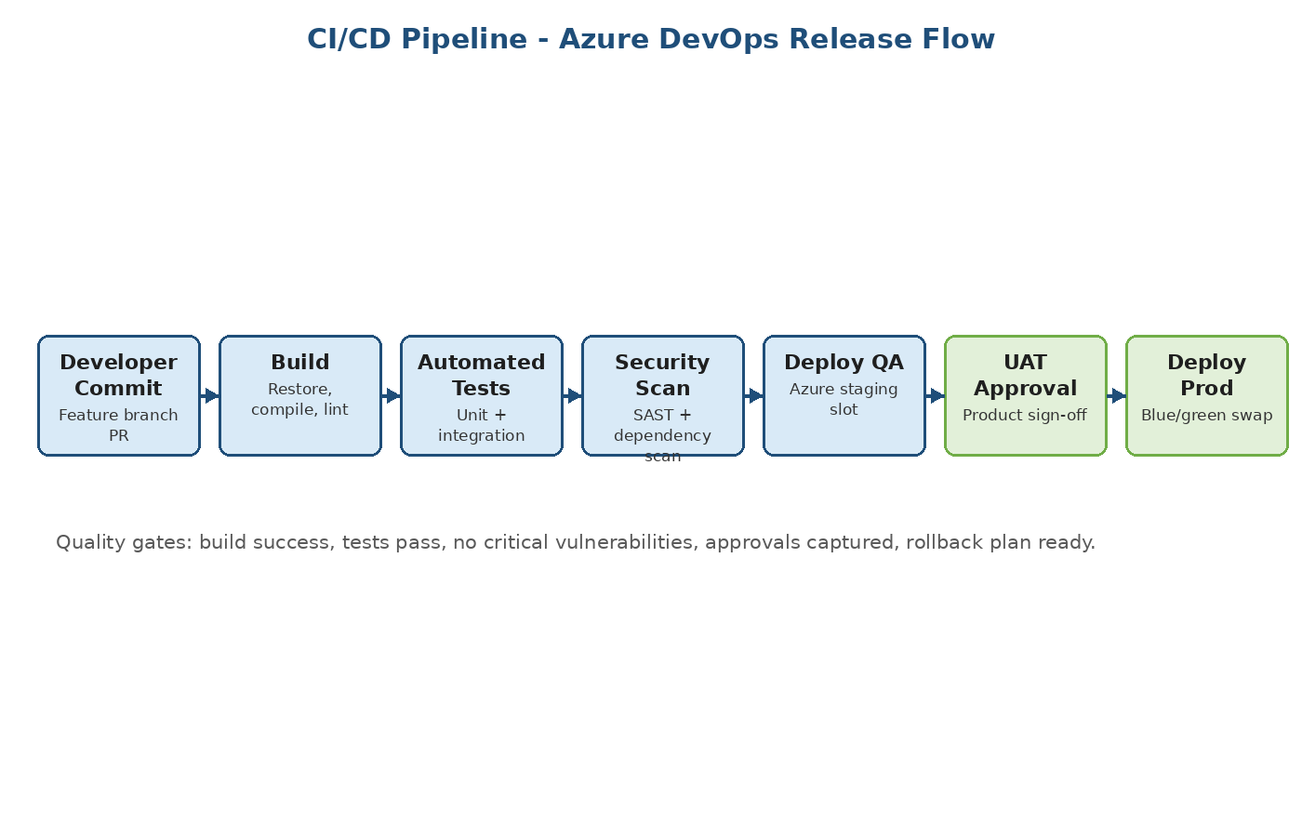

Architecture Diagram 10: Observability
This diagram is part of the architecture baseline for the healthcare app. It should be reviewed with engineering, product, operations, and security stakeholders before implementation begins.
- Use this diagram to validate scope and responsibilities
- Capture deviations as Architecture Decision Records
- Update after major sprint or infrastructure changes
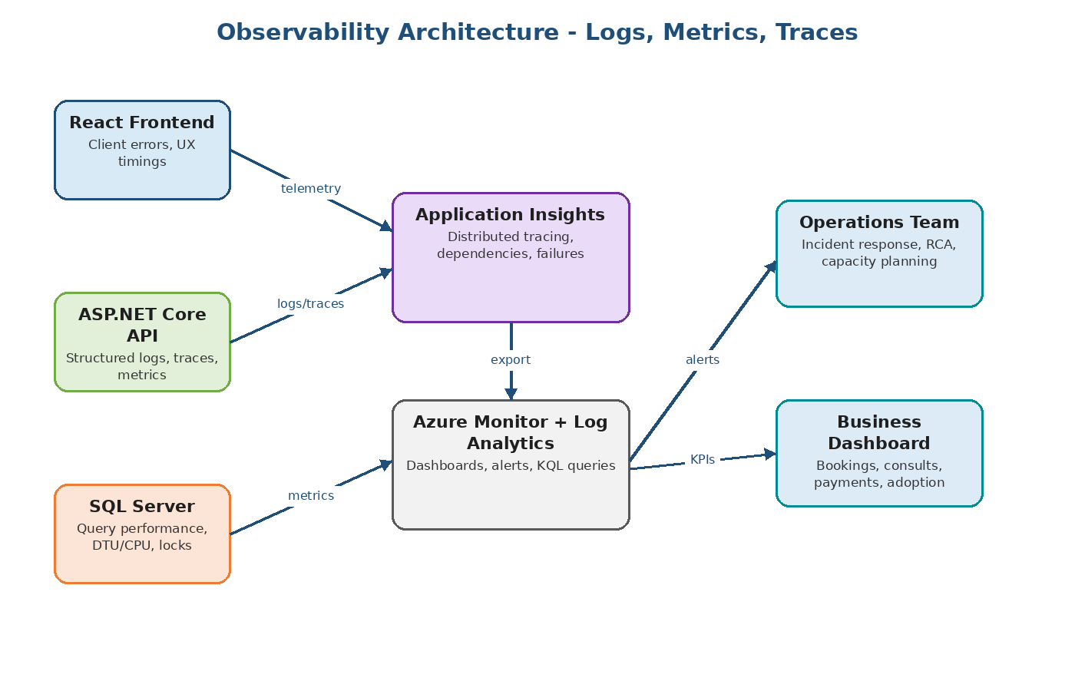

Architecture Diagram 11: Security
This diagram is part of the architecture baseline for the healthcare app. It should be reviewed with engineering, product, operations, and security stakeholders before implementation begins.
- Use this diagram to validate scope and responsibilities
- Capture deviations as Architecture Decision Records
- Update after major sprint or infrastructure changes
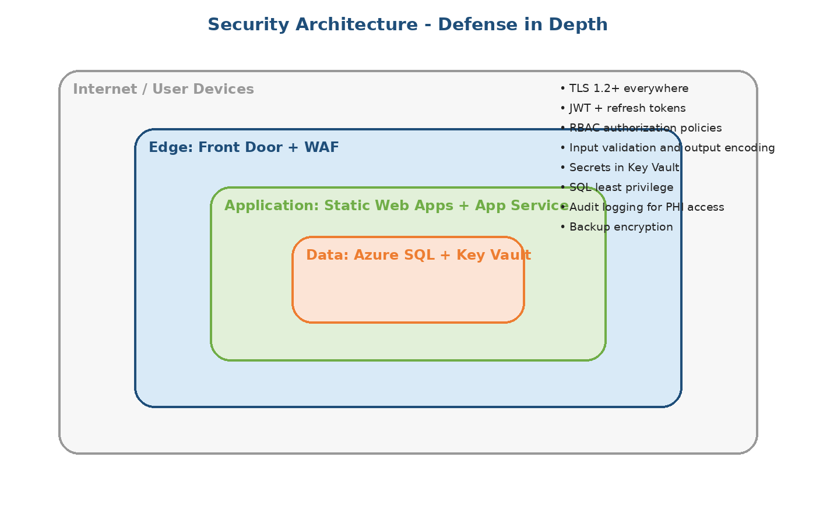

Architecture Diagram 12: Scaling
This diagram is part of the architecture baseline for the healthcare app. It should be reviewed with engineering, product, operations, and security stakeholders before implementation begins.
- Use this diagram to validate scope and responsibilities
- Capture deviations as Architecture Decision Records
- Update after major sprint or infrastructure changes
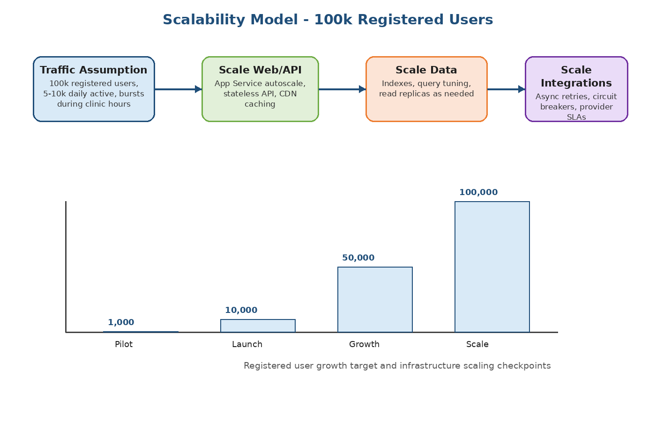

Architecture Diagram 13: Risk Matrix
This diagram is part of the architecture baseline for the healthcare app. It should be reviewed with engineering, product, operations, and security stakeholders before implementation begins.
- Use this diagram to validate scope and responsibilities
- Capture deviations as Architecture Decision Records
- Update after major sprint or infrastructure changes
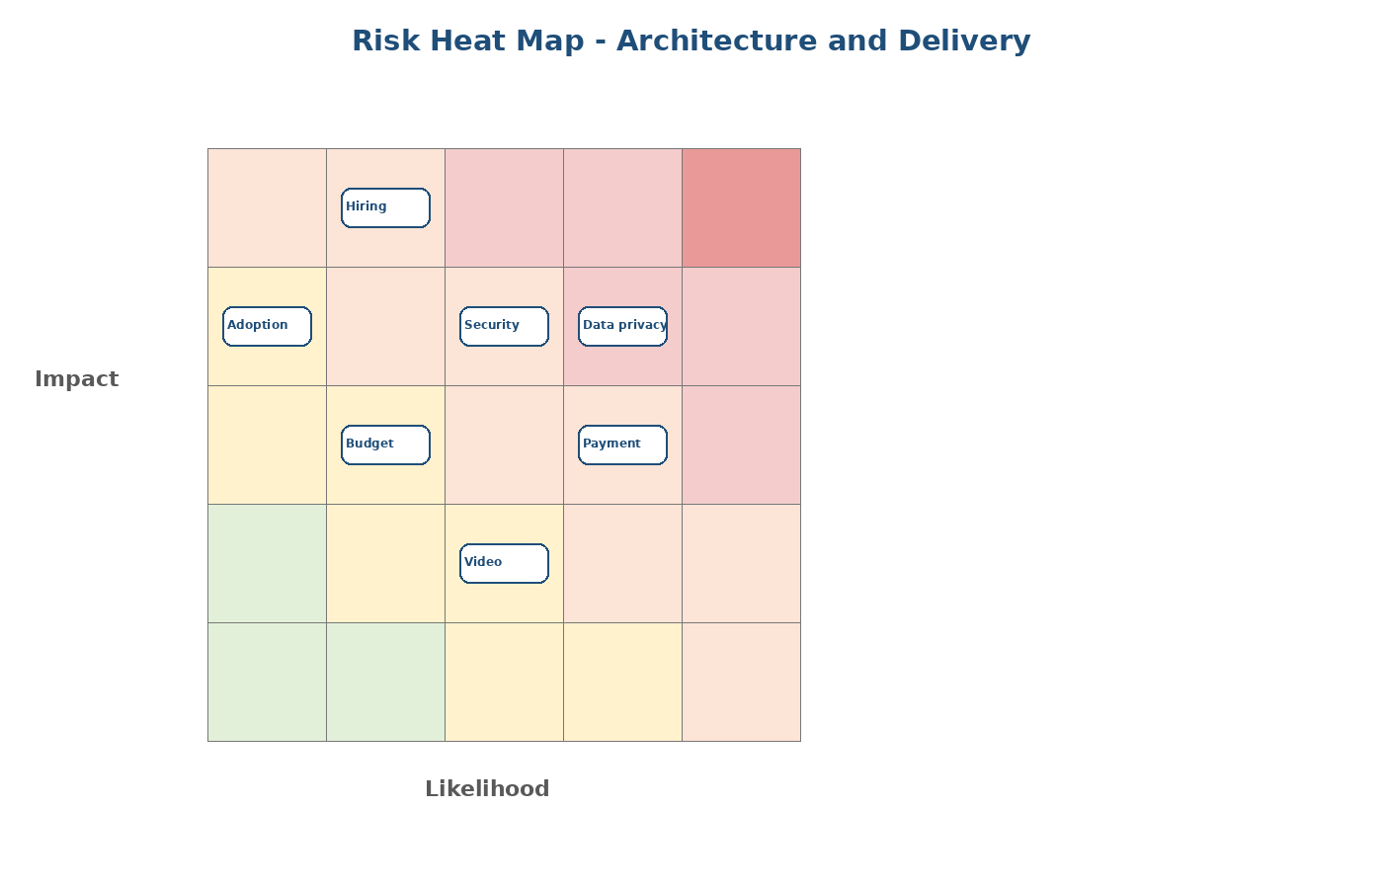

Architecture Diagram 14: Roadmap Chart
This diagram is part of the architecture baseline for the healthcare app. It should be reviewed with engineering, product, operations, and security stakeholders before implementation begins.
- Use this diagram to validate scope and responsibilities
- Capture deviations as Architecture Decision Records
- Update after major sprint or infrastructure changes
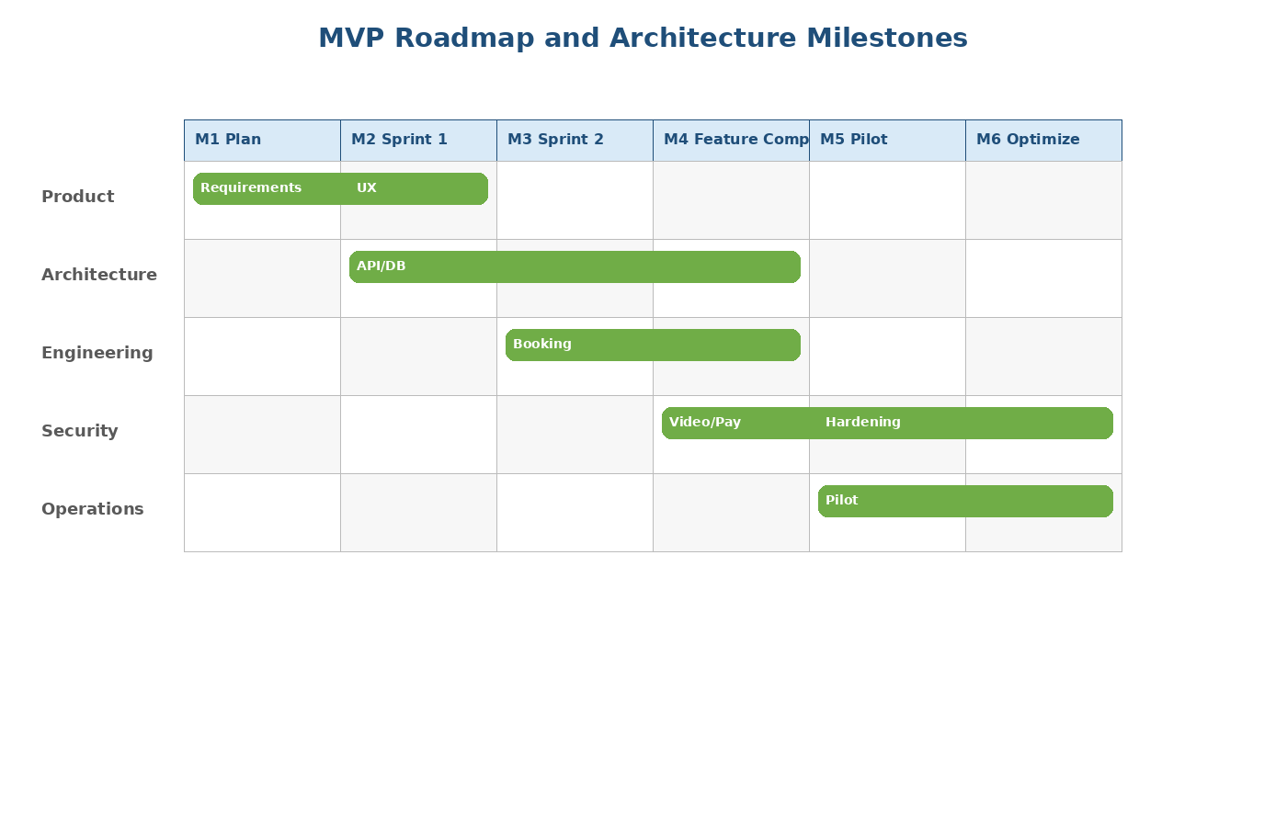

Architecture Diagram 15: Capacity Chart
This diagram is part of the architecture baseline for the healthcare app. It should be reviewed with engineering, product, operations, and security stakeholders before implementation begins.
- Use this diagram to validate scope and responsibilities
- Capture deviations as Architecture Decision Records
- Update after major sprint or infrastructure changes
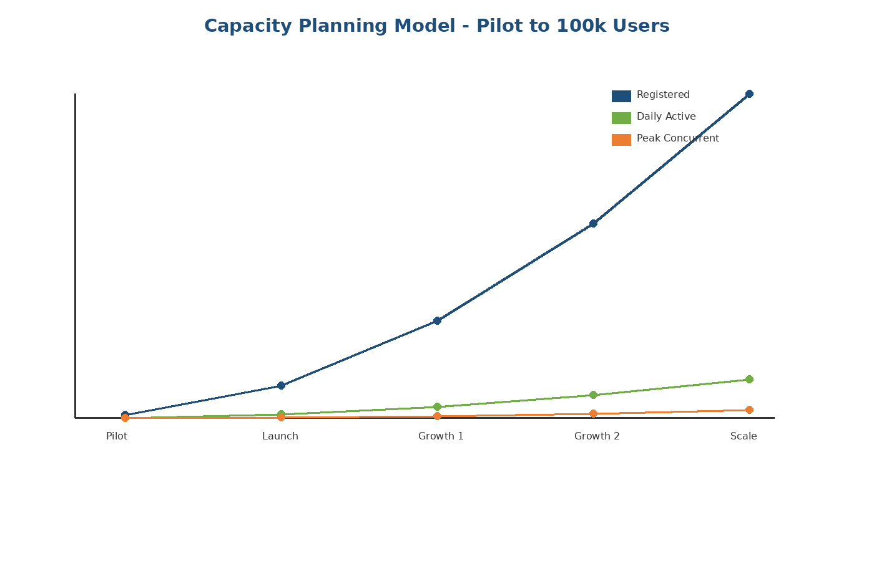

Architecture Diagram 16: Domain Map
This diagram is part of the architecture baseline for the healthcare app. It should be reviewed with engineering, product, operations, and security stakeholders before implementation begins.
- Use this diagram to validate scope and responsibilities
- Capture deviations as Architecture Decision Records
- Update after major sprint or infrastructure changes
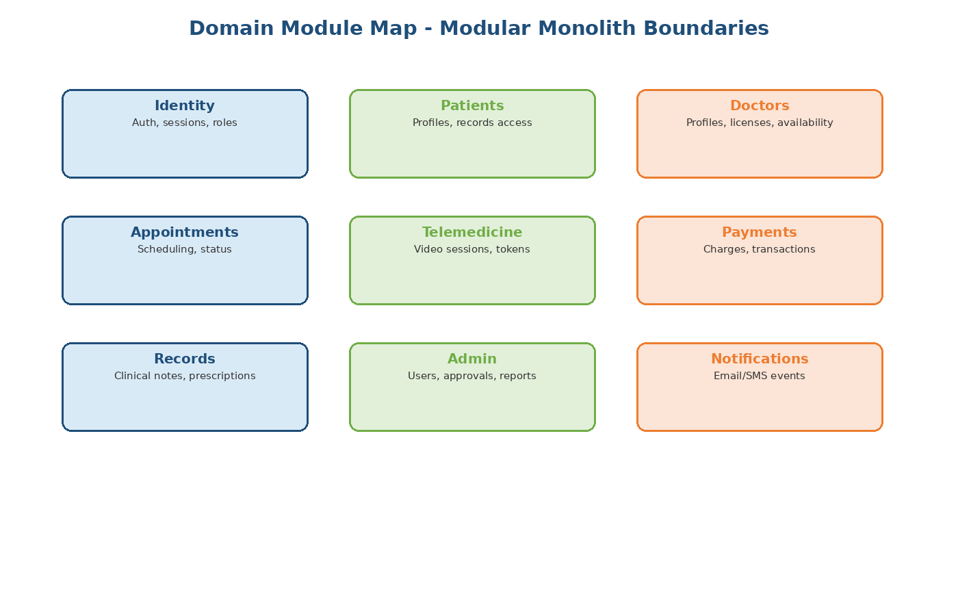

Architecture Diagram 17: Api Map
This diagram is part of the architecture baseline for the healthcare app. It should be reviewed with engineering, product, operations, and security stakeholders before implementation begins.
- Use this diagram to validate scope and responsibilities
- Capture deviations as Architecture Decision Records
- Update after major sprint or infrastructure changes
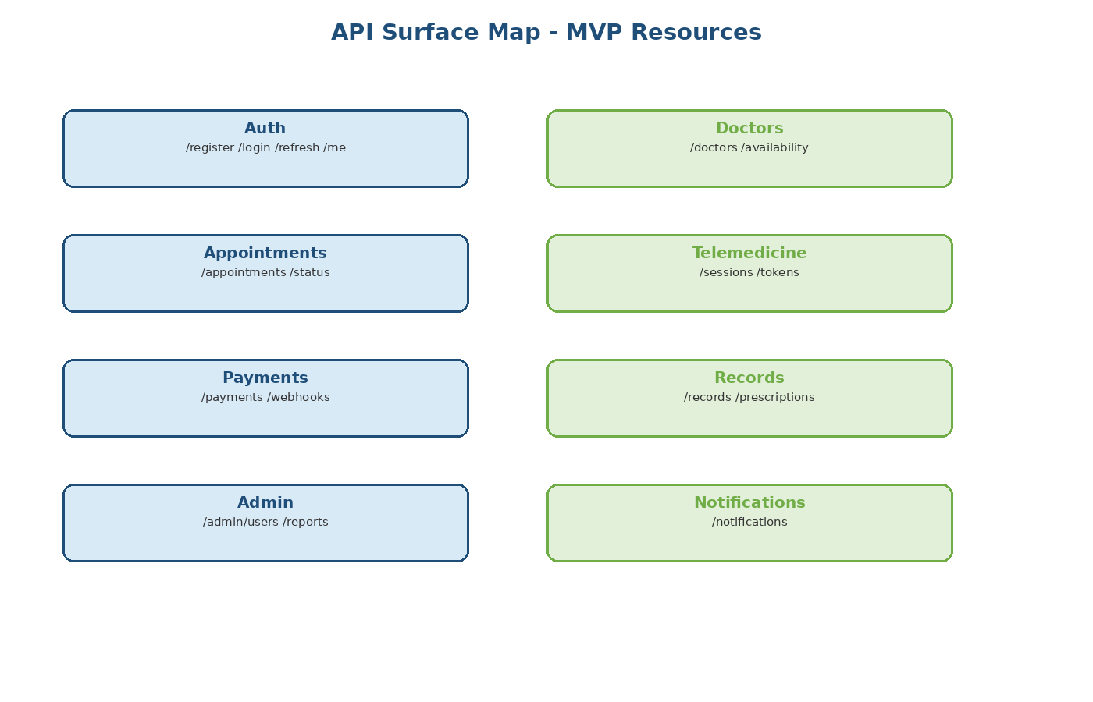

Architecture Diagram 18: Notification Flow
This diagram is part of the architecture baseline for the healthcare app. It should be reviewed with engineering, product, operations, and security stakeholders before implementation begins.
- Use this diagram to validate scope and responsibilities
- Capture deviations as Architecture Decision Records
- Update after major sprint or infrastructure changes
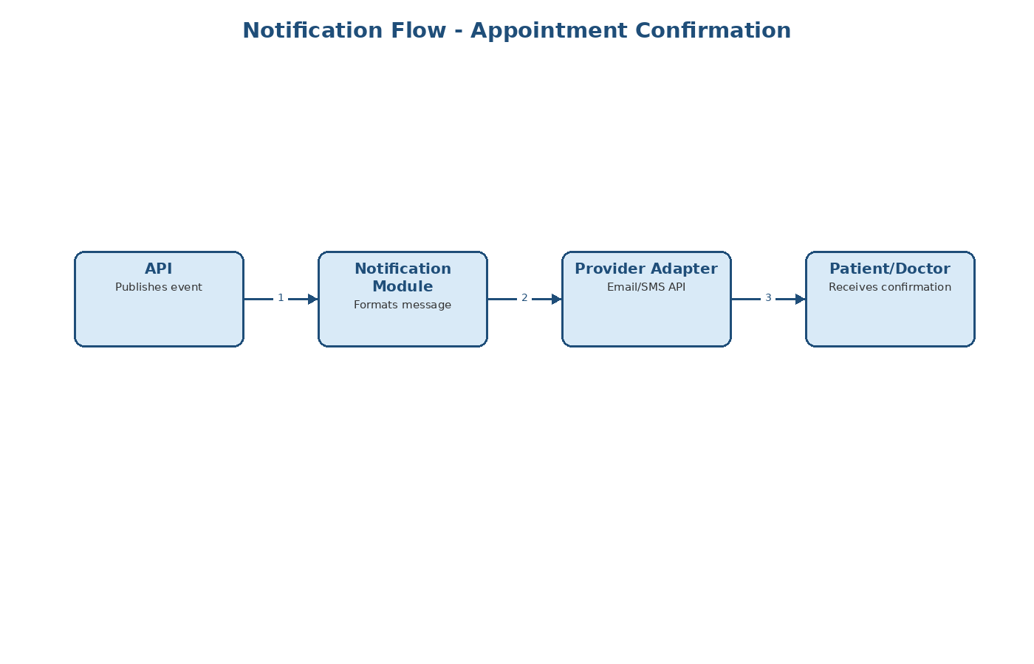

Domain Module 1: Identity and Access
The Identity and Access module owns registration, login, JWT, refresh tokens, password reset, role claims. It should be implemented with a clear application service boundary and minimal coupling to other modules.
- Define DTOs for module APIs
- Keep business rules in services/domain layer
- Avoid direct cross-module database assumptions
- Add unit and integration tests for critical workflows
Concern | Recommended Design
Primary owner | Backend developer with technical lead review
Data access | EF Core repository or query service
Security | Policy-based authorization
Observability | Structured logs with correlation ID

Identity and Access - Key Workflows
This page identifies the main workflows for the Identity and Access module and how they should be validated during implementation.
- Create request/command handler for Identity and Access
- Validate required fields and authorization for Identity and Access
- Persist transactional data safely for Identity and Access
- Publish audit or notification events where required
Workflow | Expected Result | Test Type
Create/update | Valid data is persisted | Functional + integration
Read/search | Authorized users can retrieve expected data | Functional
Unauthorized access | Blocked with safe error response | Security
Failure path | Error logged and returned consistently | Negative test

Domain Module 2: Patient Management
The Patient Management module owns patient profile, demographics, contact information, record access. It should be implemented with a clear application service boundary and minimal coupling to other modules.
- Define DTOs for module APIs
- Keep business rules in services/domain layer
- Avoid direct cross-module database assumptions
- Add unit and integration tests for critical workflows
Concern | Recommended Design
Primary owner | Backend developer with technical lead review
Data access | EF Core repository or query service
Security | Policy-based authorization
Observability | Structured logs with correlation ID

Patient Management - Key Workflows
This page identifies the main workflows for the Patient Management module and how they should be validated during implementation.
- Create request/command handler for Patient Management
- Validate required fields and authorization for Patient Management
- Persist transactional data safely for Patient Management
- Publish audit or notification events where required
Workflow | Expected Result | Test Type
Create/update | Valid data is persisted | Functional + integration
Read/search | Authorized users can retrieve expected data | Functional
Unauthorized access | Blocked with safe error response | Security
Failure path | Error logged and returned consistently | Negative test

Domain Module 3: Doctor Management
The Doctor Management module owns doctor profile, specialty, license information, availability. It should be implemented with a clear application service boundary and minimal coupling to other modules.
- Define DTOs for module APIs
- Keep business rules in services/domain layer
- Avoid direct cross-module database assumptions
- Add unit and integration tests for critical workflows
Concern | Recommended Design
Primary owner | Backend developer with technical lead review
Data access | EF Core repository or query service
Security | Policy-based authorization
Observability | Structured logs with correlation ID

Doctor Management - Key Workflows
This page identifies the main workflows for the Doctor Management module and how they should be validated during implementation.
- Create request/command handler for Doctor Management
- Validate required fields and authorization for Doctor Management
- Persist transactional data safely for Doctor Management
- Publish audit or notification events where required
Workflow | Expected Result | Test Type
Create/update | Valid data is persisted | Functional + integration
Read/search | Authorized users can retrieve expected data | Functional
Unauthorized access | Blocked with safe error response | Security
Failure path | Error logged and returned consistently | Negative test

Domain Module 4: Appointment Scheduling
The Appointment Scheduling module owns availability lookup, booking, rescheduling, cancellation, status changes. It should be implemented with a clear application service boundary and minimal coupling to other modules.
- Define DTOs for module APIs
- Keep business rules in services/domain layer
- Avoid direct cross-module database assumptions
- Add unit and integration tests for critical workflows
Concern | Recommended Design
Primary owner | Backend developer with technical lead review
Data access | EF Core repository or query service
Security | Policy-based authorization
Observability | Structured logs with correlation ID

Appointment Scheduling - Key Workflows
This page identifies the main workflows for the Appointment Scheduling module and how they should be validated during implementation.
- Create request/command handler for Appointment Scheduling
- Validate required fields and authorization for Appointment Scheduling
- Persist transactional data safely for Appointment Scheduling
- Publish audit or notification events where required
Workflow | Expected Result | Test Type
Create/update | Valid data is persisted | Functional + integration
Read/search | Authorized users can retrieve expected data | Functional
Unauthorized access | Blocked with safe error response | Security
Failure path | Error logged and returned consistently | Negative test

Domain Module 5: Telemedicine
The Telemedicine module owns video token creation, session access, waiting room, session close. It should be implemented with a clear application service boundary and minimal coupling to other modules.
- Define DTOs for module APIs
- Keep business rules in services/domain layer
- Avoid direct cross-module database assumptions
- Add unit and integration tests for critical workflows
Concern | Recommended Design
Primary owner | Backend developer with technical lead review
Data access | EF Core repository or query service
Security | Policy-based authorization
Observability | Structured logs with correlation ID

Telemedicine - Key Workflows
This page identifies the main workflows for the Telemedicine module and how they should be validated during implementation.
- Create request/command handler for Telemedicine
- Validate required fields and authorization for Telemedicine
- Persist transactional data safely for Telemedicine
- Publish audit or notification events where required
Workflow | Expected Result | Test Type
Create/update | Valid data is persisted | Functional + integration
Read/search | Authorized users can retrieve expected data | Functional
Unauthorized access | Blocked with safe error response | Security
Failure path | Error logged and returned consistently | Negative test

Domain Module 6: Payments
The Payments module owns payment intent, payment confirmation, refunds, payment history. It should be implemented with a clear application service boundary and minimal coupling to other modules.
- Define DTOs for module APIs
- Keep business rules in services/domain layer
- Avoid direct cross-module database assumptions
- Add unit and integration tests for critical workflows
Concern | Recommended Design
Primary owner | Backend developer with technical lead review
Data access | EF Core repository or query service
Security | Policy-based authorization
Observability | Structured logs with correlation ID

Payments - Key Workflows
This page identifies the main workflows for the Payments module and how they should be validated during implementation.
- Create request/command handler for Payments
- Validate required fields and authorization for Payments
- Persist transactional data safely for Payments
- Publish audit or notification events where required
Workflow | Expected Result | Test Type
Create/update | Valid data is persisted | Functional + integration
Read/search | Authorized users can retrieve expected data | Functional
Unauthorized access | Blocked with safe error response | Security
Failure path | Error logged and returned consistently | Negative test

Domain Module 7: Medical Records
The Medical Records module owns clinical notes, prescriptions, access control, audit records. It should be implemented with a clear application service boundary and minimal coupling to other modules.
- Define DTOs for module APIs
- Keep business rules in services/domain layer
- Avoid direct cross-module database assumptions
- Add unit and integration tests for critical workflows
Concern | Recommended Design
Primary owner | Backend developer with technical lead review
Data access | EF Core repository or query service
Security | Policy-based authorization
Observability | Structured logs with correlation ID

Medical Records - Key Workflows
This page identifies the main workflows for the Medical Records module and how they should be validated during implementation.
- Create request/command handler for Medical Records
- Validate required fields and authorization for Medical Records
- Persist transactional data safely for Medical Records
- Publish audit or notification events where required
Workflow | Expected Result | Test Type
Create/update | Valid data is persisted | Functional + integration
Read/search | Authorized users can retrieve expected data | Functional
Unauthorized access | Blocked with safe error response | Security
Failure path | Error logged and returned consistently | Negative test

Domain Module 8: Administration
The Administration module owns user management, provider approvals, operational reports. It should be implemented with a clear application service boundary and minimal coupling to other modules.
- Define DTOs for module APIs
- Keep business rules in services/domain layer
- Avoid direct cross-module database assumptions
- Add unit and integration tests for critical workflows
Concern | Recommended Design
Primary owner | Backend developer with technical lead review
Data access | EF Core repository or query service
Security | Policy-based authorization
Observability | Structured logs with correlation ID

Administration - Key Workflows
This page identifies the main workflows for the Administration module and how they should be validated during implementation.
- Create request/command handler for Administration
- Validate required fields and authorization for Administration
- Persist transactional data safely for Administration
- Publish audit or notification events where required
Workflow | Expected Result | Test Type
Create/update | Valid data is persisted | Functional + integration
Read/search | Authorized users can retrieve expected data | Functional
Unauthorized access | Blocked with safe error response | Security
Failure path | Error logged and returned consistently | Negative test

Domain Module 9: Notifications
The Notifications module owns email, SMS, appointment reminders, payment notifications. It should be implemented with a clear application service boundary and minimal coupling to other modules.
- Define DTOs for module APIs
- Keep business rules in services/domain layer
- Avoid direct cross-module database assumptions
- Add unit and integration tests for critical workflows
Concern | Recommended Design
Primary owner | Backend developer with technical lead review
Data access | EF Core repository or query service
Security | Policy-based authorization
Observability | Structured logs with correlation ID

Notifications - Key Workflows
This page identifies the main workflows for the Notifications module and how they should be validated during implementation.
- Create request/command handler for Notifications
- Validate required fields and authorization for Notifications
- Persist transactional data safely for Notifications
- Publish audit or notification events where required
Workflow | Expected Result | Test Type
Create/update | Valid data is persisted | Functional + integration
Read/search | Authorized users can retrieve expected data | Functional
Unauthorized access | Blocked with safe error response | Security
Failure path | Error logged and returned consistently | Negative test

Domain Module 10: Audit and Compliance
The Audit and Compliance module owns security logs, PHI access logs, administrative action trails. It should be implemented with a clear application service boundary and minimal coupling to other modules.
- Define DTOs for module APIs
- Keep business rules in services/domain layer
- Avoid direct cross-module database assumptions
- Add unit and integration tests for critical workflows
Concern | Recommended Design
Primary owner | Backend developer with technical lead review
Data access | EF Core repository or query service
Security | Policy-based authorization
Observability | Structured logs with correlation ID

Audit and Compliance - Key Workflows
This page identifies the main workflows for the Audit and Compliance module and how they should be validated during implementation.
- Create request/command handler for Audit and Compliance
- Validate required fields and authorization for Audit and Compliance
- Persist transactional data safely for Audit and Compliance
- Publish audit or notification events where required
Workflow | Expected Result | Test Type
Create/update | Valid data is persisted | Functional + integration
Read/search | Authorized users can retrieve expected data | Functional
Unauthorized access | Blocked with safe error response | Security
Failure path | Error logged and returned consistently | Negative test

Data Architecture: Users
Users data should be modeled in SQL Server with explicit keys, constraints, audit timestamps, and indexes that support the expected access patterns.
- Use UNIQUEIDENTIFIER or identity keys consistently
- Add CreatedAt and UpdatedAt where operationally useful
- Define foreign keys for referential integrity
- Add indexes for search and high-frequency joins
Design Area | Guidance
Ownership | Owned by the relevant domain module
Validation | Application validation plus database constraints
Security | Restrict access through API and database roles
Reporting | Do not overload transactional queries for heavy reporting

Data Architecture: Doctors
Doctors data should be modeled in SQL Server with explicit keys, constraints, audit timestamps, and indexes that support the expected access patterns.
- Use UNIQUEIDENTIFIER or identity keys consistently
- Add CreatedAt and UpdatedAt where operationally useful
- Define foreign keys for referential integrity
- Add indexes for search and high-frequency joins
Design Area | Guidance
Ownership | Owned by the relevant domain module
Validation | Application validation plus database constraints
Security | Restrict access through API and database roles
Reporting | Do not overload transactional queries for heavy reporting

Data Architecture: Patients
Patients data should be modeled in SQL Server with explicit keys, constraints, audit timestamps, and indexes that support the expected access patterns.
- Use UNIQUEIDENTIFIER or identity keys consistently
- Add CreatedAt and UpdatedAt where operationally useful
- Define foreign keys for referential integrity
- Add indexes for search and high-frequency joins
Design Area | Guidance
Ownership | Owned by the relevant domain module
Validation | Application validation plus database constraints
Security | Restrict access through API and database roles
Reporting | Do not overload transactional queries for heavy reporting

Data Architecture: Appointments
Appointments data should be modeled in SQL Server with explicit keys, constraints, audit timestamps, and indexes that support the expected access patterns.
- Use UNIQUEIDENTIFIER or identity keys consistently
- Add CreatedAt and UpdatedAt where operationally useful
- Define foreign keys for referential integrity
- Add indexes for search and high-frequency joins
Design Area | Guidance
Ownership | Owned by the relevant domain module
Validation | Application validation plus database constraints
Security | Restrict access through API and database roles
Reporting | Do not overload transactional queries for heavy reporting

Data Architecture: AvailabilitySlots
AvailabilitySlots data should be modeled in SQL Server with explicit keys, constraints, audit timestamps, and indexes that support the expected access patterns.
- Use UNIQUEIDENTIFIER or identity keys consistently
- Add CreatedAt and UpdatedAt where operationally useful
- Define foreign keys for referential integrity
- Add indexes for search and high-frequency joins
Design Area | Guidance
Ownership | Owned by the relevant domain module
Validation | Application validation plus database constraints
Security | Restrict access through API and database roles
Reporting | Do not overload transactional queries for heavy reporting

Data Architecture: Payments
Payments data should be modeled in SQL Server with explicit keys, constraints, audit timestamps, and indexes that support the expected access patterns.
- Use UNIQUEIDENTIFIER or identity keys consistently
- Add CreatedAt and UpdatedAt where operationally useful
- Define foreign keys for referential integrity
- Add indexes for search and high-frequency joins
Design Area | Guidance
Ownership | Owned by the relevant domain module
Validation | Application validation plus database constraints
Security | Restrict access through API and database roles
Reporting | Do not overload transactional queries for heavy reporting

Data Architecture: MedicalRecords
MedicalRecords data should be modeled in SQL Server with explicit keys, constraints, audit timestamps, and indexes that support the expected access patterns.
- Use UNIQUEIDENTIFIER or identity keys consistently
- Add CreatedAt and UpdatedAt where operationally useful
- Define foreign keys for referential integrity
- Add indexes for search and high-frequency joins
Design Area | Guidance
Ownership | Owned by the relevant domain module
Validation | Application validation plus database constraints
Security | Restrict access through API and database roles
Reporting | Do not overload transactional queries for heavy reporting

Data Architecture: Prescriptions
Prescriptions data should be modeled in SQL Server with explicit keys, constraints, audit timestamps, and indexes that support the expected access patterns.
- Use UNIQUEIDENTIFIER or identity keys consistently
- Add CreatedAt and UpdatedAt where operationally useful
- Define foreign keys for referential integrity
- Add indexes for search and high-frequency joins
Design Area | Guidance
Ownership | Owned by the relevant domain module
Validation | Application validation plus database constraints
Security | Restrict access through API and database roles
Reporting | Do not overload transactional queries for heavy reporting

Data Architecture: Notifications
Notifications data should be modeled in SQL Server with explicit keys, constraints, audit timestamps, and indexes that support the expected access patterns.
- Use UNIQUEIDENTIFIER or identity keys consistently
- Add CreatedAt and UpdatedAt where operationally useful
- Define foreign keys for referential integrity
- Add indexes for search and high-frequency joins
Design Area | Guidance
Ownership | Owned by the relevant domain module
Validation | Application validation plus database constraints
Security | Restrict access through API and database roles
Reporting | Do not overload transactional queries for heavy reporting

Data Architecture: AuditLogs
AuditLogs data should be modeled in SQL Server with explicit keys, constraints, audit timestamps, and indexes that support the expected access patterns.
- Use UNIQUEIDENTIFIER or identity keys consistently
- Add CreatedAt and UpdatedAt where operationally useful
- Define foreign keys for referential integrity
- Add indexes for search and high-frequency joins
Design Area | Guidance
Ownership | Owned by the relevant domain module
Validation | Application validation plus database constraints
Security | Restrict access through API and database roles
Reporting | Do not overload transactional queries for heavy reporting

Data Architecture: Countries
Countries data should be modeled in SQL Server with explicit keys, constraints, audit timestamps, and indexes that support the expected access patterns.
- Use UNIQUEIDENTIFIER or identity keys consistently
- Add CreatedAt and UpdatedAt where operationally useful
- Define foreign keys for referential integrity
- Add indexes for search and high-frequency joins
Design Area | Guidance
Ownership | Owned by the relevant domain module
Validation | Application validation plus database constraints
Security | Restrict access through API and database roles
Reporting | Do not overload transactional queries for heavy reporting

Data Architecture: Specialties
Specialties data should be modeled in SQL Server with explicit keys, constraints, audit timestamps, and indexes that support the expected access patterns.
- Use UNIQUEIDENTIFIER or identity keys consistently
- Add CreatedAt and UpdatedAt where operationally useful
- Define foreign keys for referential integrity
- Add indexes for search and high-frequency joins
Design Area | Guidance
Ownership | Owned by the relevant domain module
Validation | Application validation plus database constraints
Security | Restrict access through API and database roles
Reporting | Do not overload transactional queries for heavy reporting

API Architecture: Auth API
Auth API should follow REST conventions, use JSON request/response bodies, enforce authentication where appropriate, and return consistent error payloads.
- Use /api/v1 versioning
- Validate all inputs
- Return standard HTTP status codes
- Do not expose internal entity models directly
- Document endpoints in OpenAPI/Swagger
Endpoint Pattern | Security | Notes
GET resource | Authenticated except public search where approved | Use pagination for lists
POST resource | Authenticated and authorized | Validate command payload
PUT/PATCH resource | Authenticated and authorized | Return updated state or 204
DELETE/cancel | Restricted by role and state | Prefer status changes for auditability

API Architecture: Doctors API
Doctors API should follow REST conventions, use JSON request/response bodies, enforce authentication where appropriate, and return consistent error payloads.
- Use /api/v1 versioning
- Validate all inputs
- Return standard HTTP status codes
- Do not expose internal entity models directly
- Document endpoints in OpenAPI/Swagger
Endpoint Pattern | Security | Notes
GET resource | Authenticated except public search where approved | Use pagination for lists
POST resource | Authenticated and authorized | Validate command payload
PUT/PATCH resource | Authenticated and authorized | Return updated state or 204
DELETE/cancel | Restricted by role and state | Prefer status changes for auditability

API Architecture: Appointments API
Appointments API should follow REST conventions, use JSON request/response bodies, enforce authentication where appropriate, and return consistent error payloads.
- Use /api/v1 versioning
- Validate all inputs
- Return standard HTTP status codes
- Do not expose internal entity models directly
- Document endpoints in OpenAPI/Swagger
Endpoint Pattern | Security | Notes
GET resource | Authenticated except public search where approved | Use pagination for lists
POST resource | Authenticated and authorized | Validate command payload
PUT/PATCH resource | Authenticated and authorized | Return updated state or 204
DELETE/cancel | Restricted by role and state | Prefer status changes for auditability

API Architecture: Telemedicine API
Telemedicine API should follow REST conventions, use JSON request/response bodies, enforce authentication where appropriate, and return consistent error payloads.
- Use /api/v1 versioning
- Validate all inputs
- Return standard HTTP status codes
- Do not expose internal entity models directly
- Document endpoints in OpenAPI/Swagger
Endpoint Pattern | Security | Notes
GET resource | Authenticated except public search where approved | Use pagination for lists
POST resource | Authenticated and authorized | Validate command payload
PUT/PATCH resource | Authenticated and authorized | Return updated state or 204
DELETE/cancel | Restricted by role and state | Prefer status changes for auditability

API Architecture: Payments API
Payments API should follow REST conventions, use JSON request/response bodies, enforce authentication where appropriate, and return consistent error payloads.
- Use /api/v1 versioning
- Validate all inputs
- Return standard HTTP status codes
- Do not expose internal entity models directly
- Document endpoints in OpenAPI/Swagger
Endpoint Pattern | Security | Notes
GET resource | Authenticated except public search where approved | Use pagination for lists
POST resource | Authenticated and authorized | Validate command payload
PUT/PATCH resource | Authenticated and authorized | Return updated state or 204
DELETE/cancel | Restricted by role and state | Prefer status changes for auditability

API Architecture: Medical Records API
Medical Records API should follow REST conventions, use JSON request/response bodies, enforce authentication where appropriate, and return consistent error payloads.
- Use /api/v1 versioning
- Validate all inputs
- Return standard HTTP status codes
- Do not expose internal entity models directly
- Document endpoints in OpenAPI/Swagger
Endpoint Pattern | Security | Notes
GET resource | Authenticated except public search where approved | Use pagination for lists
POST resource | Authenticated and authorized | Validate command payload
PUT/PATCH resource | Authenticated and authorized | Return updated state or 204
DELETE/cancel | Restricted by role and state | Prefer status changes for auditability

API Architecture: Admin API
Admin API should follow REST conventions, use JSON request/response bodies, enforce authentication where appropriate, and return consistent error payloads.
- Use /api/v1 versioning
- Validate all inputs
- Return standard HTTP status codes
- Do not expose internal entity models directly
- Document endpoints in OpenAPI/Swagger
Endpoint Pattern | Security | Notes
GET resource | Authenticated except public search where approved | Use pagination for lists
POST resource | Authenticated and authorized | Validate command payload
PUT/PATCH resource | Authenticated and authorized | Return updated state or 204
DELETE/cancel | Restricted by role and state | Prefer status changes for auditability

API Architecture: Notification API
Notification API should follow REST conventions, use JSON request/response bodies, enforce authentication where appropriate, and return consistent error payloads.
- Use /api/v1 versioning
- Validate all inputs
- Return standard HTTP status codes
- Do not expose internal entity models directly
- Document endpoints in OpenAPI/Swagger
Endpoint Pattern | Security | Notes
GET resource | Authenticated except public search where approved | Use pagination for lists
POST resource | Authenticated and authorized | Validate command payload
PUT/PATCH resource | Authenticated and authorized | Return updated state or 204
DELETE/cancel | Restricted by role and state | Prefer status changes for auditability

API Architecture: Audit API
Audit API should follow REST conventions, use JSON request/response bodies, enforce authentication where appropriate, and return consistent error payloads.
- Use /api/v1 versioning
- Validate all inputs
- Return standard HTTP status codes
- Do not expose internal entity models directly
- Document endpoints in OpenAPI/Swagger
Endpoint Pattern | Security | Notes
GET resource | Authenticated except public search where approved | Use pagination for lists
POST resource | Authenticated and authorized | Validate command payload
PUT/PATCH resource | Authenticated and authorized | Return updated state or 204
DELETE/cancel | Restricted by role and state | Prefer status changes for auditability

API Architecture: Reporting API
Reporting API should follow REST conventions, use JSON request/response bodies, enforce authentication where appropriate, and return consistent error payloads.
- Use /api/v1 versioning
- Validate all inputs
- Return standard HTTP status codes
- Do not expose internal entity models directly
- Document endpoints in OpenAPI/Swagger
Endpoint Pattern | Security | Notes
GET resource | Authenticated except public search where approved | Use pagination for lists
POST resource | Authenticated and authorized | Validate command payload
PUT/PATCH resource | Authenticated and authorized | Return updated state or 204
DELETE/cancel | Restricted by role and state | Prefer status changes for auditability

Security Architecture: Identity and Authentication
Identity and Authentication is a core control area for a healthcare platform. The MVP should implement a practical baseline while documenting future maturity needs.
- Define the control objective
- Assign technical owner
- Create test cases and evidence
- Review before pilot launch
Control | MVP Expectation | Evidence
Authentication | JWT/session controls configured | Login tests and config review
Authorization | Role policies enforced | RBAC test results
Logging | Sensitive actions logged | Audit log sample
Secrets | No secrets in source control | Key Vault configuration

Security Architecture: Authorization and RBAC
Authorization and RBAC is a core control area for a healthcare platform. The MVP should implement a practical baseline while documenting future maturity needs.
- Define the control objective
- Assign technical owner
- Create test cases and evidence
- Review before pilot launch
Control | MVP Expectation | Evidence
Authentication | JWT/session controls configured | Login tests and config review
Authorization | Role policies enforced | RBAC test results
Logging | Sensitive actions logged | Audit log sample
Secrets | No secrets in source control | Key Vault configuration

Security Architecture: Medical Record Access Controls
Medical Record Access Controls is a core control area for a healthcare platform. The MVP should implement a practical baseline while documenting future maturity needs.
- Define the control objective
- Assign technical owner
- Create test cases and evidence
- Review before pilot launch
Control | MVP Expectation | Evidence
Authentication | JWT/session controls configured | Login tests and config review
Authorization | Role policies enforced | RBAC test results
Logging | Sensitive actions logged | Audit log sample
Secrets | No secrets in source control | Key Vault configuration

Security Architecture: Encryption and Key Management
Encryption and Key Management is a core control area for a healthcare platform. The MVP should implement a practical baseline while documenting future maturity needs.
- Define the control objective
- Assign technical owner
- Create test cases and evidence
- Review before pilot launch
Control | MVP Expectation | Evidence
Authentication | JWT/session controls configured | Login tests and config review
Authorization | Role policies enforced | RBAC test results
Logging | Sensitive actions logged | Audit log sample
Secrets | No secrets in source control | Key Vault configuration

Security Architecture: API Threat Protection
API Threat Protection is a core control area for a healthcare platform. The MVP should implement a practical baseline while documenting future maturity needs.
- Define the control objective
- Assign technical owner
- Create test cases and evidence
- Review before pilot launch
Control | MVP Expectation | Evidence
Authentication | JWT/session controls configured | Login tests and config review
Authorization | Role policies enforced | RBAC test results
Logging | Sensitive actions logged | Audit log sample
Secrets | No secrets in source control | Key Vault configuration

Security Architecture: Audit Logging
Audit Logging is a core control area for a healthcare platform. The MVP should implement a practical baseline while documenting future maturity needs.
- Define the control objective
- Assign technical owner
- Create test cases and evidence
- Review before pilot launch
Control | MVP Expectation | Evidence
Authentication | JWT/session controls configured | Login tests and config review
Authorization | Role policies enforced | RBAC test results
Logging | Sensitive actions logged | Audit log sample
Secrets | No secrets in source control | Key Vault configuration

Security Architecture: Secure SDLC
Secure SDLC is a core control area for a healthcare platform. The MVP should implement a practical baseline while documenting future maturity needs.
- Define the control objective
- Assign technical owner
- Create test cases and evidence
- Review before pilot launch
Control | MVP Expectation | Evidence
Authentication | JWT/session controls configured | Login tests and config review
Authorization | Role policies enforced | RBAC test results
Logging | Sensitive actions logged | Audit log sample
Secrets | No secrets in source control | Key Vault configuration

Security Architecture: Data Privacy
Data Privacy is a core control area for a healthcare platform. The MVP should implement a practical baseline while documenting future maturity needs.
- Define the control objective
- Assign technical owner
- Create test cases and evidence
- Review before pilot launch
Control | MVP Expectation | Evidence
Authentication | JWT/session controls configured | Login tests and config review
Authorization | Role policies enforced | RBAC test results
Logging | Sensitive actions logged | Audit log sample
Secrets | No secrets in source control | Key Vault configuration

Security Architecture: Incident Response
Incident Response is a core control area for a healthcare platform. The MVP should implement a practical baseline while documenting future maturity needs.
- Define the control objective
- Assign technical owner
- Create test cases and evidence
- Review before pilot launch
Control | MVP Expectation | Evidence
Authentication | JWT/session controls configured | Login tests and config review
Authorization | Role policies enforced | RBAC test results
Logging | Sensitive actions logged | Audit log sample
Secrets | No secrets in source control | Key Vault configuration

Security Architecture: Third-Party Risk
Third-Party Risk is a core control area for a healthcare platform. The MVP should implement a practical baseline while documenting future maturity needs.
- Define the control objective
- Assign technical owner
- Create test cases and evidence
- Review before pilot launch
Control | MVP Expectation | Evidence
Authentication | JWT/session controls configured | Login tests and config review
Authorization | Role policies enforced | RBAC test results
Logging | Sensitive actions logged | Audit log sample
Secrets | No secrets in source control | Key Vault configuration

Environment Architecture: Local Development
Local Development environment supports a distinct stage of the software lifecycle and should be configured with least privilege, repeatability, and observability.
- Document environment variables
- Restrict access by role
- Use separate databases where practical
- Monitor health and deployment status
Component | Recommended Setup
Frontend | Azure Static Web Apps or local dev server
Backend | Azure App Service or local ASP.NET runtime
Database | Azure SQL or local SQL Server dev instance
Secrets | Azure Key Vault or secure local secrets store

Environment Architecture: Shared Development
Shared Development environment supports a distinct stage of the software lifecycle and should be configured with least privilege, repeatability, and observability.
- Document environment variables
- Restrict access by role
- Use separate databases where practical
- Monitor health and deployment status
Component | Recommended Setup
Frontend | Azure Static Web Apps or local dev server
Backend | Azure App Service or local ASP.NET runtime
Database | Azure SQL or local SQL Server dev instance
Secrets | Azure Key Vault or secure local secrets store

Environment Architecture: QA/Staging
QA/Staging environment supports a distinct stage of the software lifecycle and should be configured with least privilege, repeatability, and observability.
- Document environment variables
- Restrict access by role
- Use separate databases where practical
- Monitor health and deployment status
Component | Recommended Setup
Frontend | Azure Static Web Apps or local dev server
Backend | Azure App Service or local ASP.NET runtime
Database | Azure SQL or local SQL Server dev instance
Secrets | Azure Key Vault or secure local secrets store

Environment Architecture: Production
Production environment supports a distinct stage of the software lifecycle and should be configured with least privilege, repeatability, and observability.
- Document environment variables
- Restrict access by role
- Use separate databases where practical
- Monitor health and deployment status
Component | Recommended Setup
Frontend | Azure Static Web Apps or local dev server
Backend | Azure App Service or local ASP.NET runtime
Database | Azure SQL or local SQL Server dev instance
Secrets | Azure Key Vault or secure local secrets store

Environment Architecture: Disaster Recovery
Disaster Recovery environment supports a distinct stage of the software lifecycle and should be configured with least privilege, repeatability, and observability.
- Document environment variables
- Restrict access by role
- Use separate databases where practical
- Monitor health and deployment status
Component | Recommended Setup
Frontend | Azure Static Web Apps or local dev server
Backend | Azure App Service or local ASP.NET runtime
Database | Azure SQL or local SQL Server dev instance
Secrets | Azure Key Vault or secure local secrets store

Environment Architecture: Future Multi-Region
Future Multi-Region environment supports a distinct stage of the software lifecycle and should be configured with least privilege, repeatability, and observability.
- Document environment variables
- Restrict access by role
- Use separate databases where practical
- Monitor health and deployment status
Component | Recommended Setup
Frontend | Azure Static Web Apps or local dev server
Backend | Azure App Service or local ASP.NET runtime
Database | Azure SQL or local SQL Server dev instance
Secrets | Azure Key Vault or secure local secrets store

Operational Architecture: CI/CD Pipeline
CI/CD Pipeline defines how the system will be built, released, monitored, supported, and improved over time.
- Define owner and escalation path
- Automate repeatable steps
- Capture evidence for releases
- Review metrics after each sprint
Area | Standard
Owner | Technical lead or DevOps engineer
Tooling | Azure DevOps, Azure Monitor, Application Insights
Frequency | Per sprint and release candidate
Output | Checklist, report, or dashboard

Operational Architecture: Branching Strategy
Branching Strategy defines how the system will be built, released, monitored, supported, and improved over time.
- Define owner and escalation path
- Automate repeatable steps
- Capture evidence for releases
- Review metrics after each sprint
Area | Standard
Owner | Technical lead or DevOps engineer
Tooling | Azure DevOps, Azure Monitor, Application Insights
Frequency | Per sprint and release candidate
Output | Checklist, report, or dashboard

Operational Architecture: Code Review Gates
Code Review Gates defines how the system will be built, released, monitored, supported, and improved over time.
- Define owner and escalation path
- Automate repeatable steps
- Capture evidence for releases
- Review metrics after each sprint
Area | Standard
Owner | Technical lead or DevOps engineer
Tooling | Azure DevOps, Azure Monitor, Application Insights
Frequency | Per sprint and release candidate
Output | Checklist, report, or dashboard

Operational Architecture: Automated Testing
Automated Testing defines how the system will be built, released, monitored, supported, and improved over time.
- Define owner and escalation path
- Automate repeatable steps
- Capture evidence for releases
- Review metrics after each sprint
Area | Standard
Owner | Technical lead or DevOps engineer
Tooling | Azure DevOps, Azure Monitor, Application Insights
Frequency | Per sprint and release candidate
Output | Checklist, report, or dashboard

Operational Architecture: Release Management
Release Management defines how the system will be built, released, monitored, supported, and improved over time.
- Define owner and escalation path
- Automate repeatable steps
- Capture evidence for releases
- Review metrics after each sprint
Area | Standard
Owner | Technical lead or DevOps engineer
Tooling | Azure DevOps, Azure Monitor, Application Insights
Frequency | Per sprint and release candidate
Output | Checklist, report, or dashboard

Operational Architecture: Rollback Strategy
Rollback Strategy defines how the system will be built, released, monitored, supported, and improved over time.
- Define owner and escalation path
- Automate repeatable steps
- Capture evidence for releases
- Review metrics after each sprint
Area | Standard
Owner | Technical lead or DevOps engineer
Tooling | Azure DevOps, Azure Monitor, Application Insights
Frequency | Per sprint and release candidate
Output | Checklist, report, or dashboard

Operational Architecture: Monitoring Dashboards
Monitoring Dashboards defines how the system will be built, released, monitored, supported, and improved over time.
- Define owner and escalation path
- Automate repeatable steps
- Capture evidence for releases
- Review metrics after each sprint
Area | Standard
Owner | Technical lead or DevOps engineer
Tooling | Azure DevOps, Azure Monitor, Application Insights
Frequency | Per sprint and release candidate
Output | Checklist, report, or dashboard

Operational Architecture: Alerting Rules
Alerting Rules defines how the system will be built, released, monitored, supported, and improved over time.
- Define owner and escalation path
- Automate repeatable steps
- Capture evidence for releases
- Review metrics after each sprint
Area | Standard
Owner | Technical lead or DevOps engineer
Tooling | Azure DevOps, Azure Monitor, Application Insights
Frequency | Per sprint and release candidate
Output | Checklist, report, or dashboard

Operational Architecture: Backup and Restore
Backup and Restore defines how the system will be built, released, monitored, supported, and improved over time.
- Define owner and escalation path
- Automate repeatable steps
- Capture evidence for releases
- Review metrics after each sprint
Area | Standard
Owner | Technical lead or DevOps engineer
Tooling | Azure DevOps, Azure Monitor, Application Insights
Frequency | Per sprint and release candidate
Output | Checklist, report, or dashboard

Operational Architecture: Operational Runbooks
Operational Runbooks defines how the system will be built, released, monitored, supported, and improved over time.
- Define owner and escalation path
- Automate repeatable steps
- Capture evidence for releases
- Review metrics after each sprint
Area | Standard
Owner | Technical lead or DevOps engineer
Tooling | Azure DevOps, Azure Monitor, Application Insights
Frequency | Per sprint and release candidate
Output | Checklist, report, or dashboard

Operational Architecture: Support Model
Support Model defines how the system will be built, released, monitored, supported, and improved over time.
- Define owner and escalation path
- Automate repeatable steps
- Capture evidence for releases
- Review metrics after each sprint
Area | Standard
Owner | Technical lead or DevOps engineer
Tooling | Azure DevOps, Azure Monitor, Application Insights
Frequency | Per sprint and release candidate
Output | Checklist, report, or dashboard

Operational Architecture: Change Management
Change Management defines how the system will be built, released, monitored, supported, and improved over time.
- Define owner and escalation path
- Automate repeatable steps
- Capture evidence for releases
- Review metrics after each sprint
Area | Standard
Owner | Technical lead or DevOps engineer
Tooling | Azure DevOps, Azure Monitor, Application Insights
Frequency | Per sprint and release candidate
Output | Checklist, report, or dashboard

Role Architecture: Project Manager / Technical Lead
This role contributes to system success by owning delivery ownership, architecture review, sprint execution. The responsibilities should be included in recruiting, onboarding, and sprint planning.
- Participate in architecture review where relevant
- Maintain deliverables tied to the role
- Raise risks early
- Support pilot launch readiness
Responsibility | Deliverable
Planning | Input to sprint backlog and estimates
Execution | Role-specific work product
Quality | Review or test evidence
Operations | Launch and support readiness

Role Architecture: Backend Developer (.NET)
This role contributes to system success by owning API, services, database access, integration adapters. The responsibilities should be included in recruiting, onboarding, and sprint planning.
- Participate in architecture review where relevant
- Maintain deliverables tied to the role
- Raise risks early
- Support pilot launch readiness
Responsibility | Deliverable
Planning | Input to sprint backlog and estimates
Execution | Role-specific work product
Quality | Review or test evidence
Operations | Launch and support readiness

Role Architecture: Frontend Developer (React + MUI)
This role contributes to system success by owning UI implementation, routing, state, API client. The responsibilities should be included in recruiting, onboarding, and sprint planning.
- Participate in architecture review where relevant
- Maintain deliverables tied to the role
- Raise risks early
- Support pilot launch readiness
Responsibility | Deliverable
Planning | Input to sprint backlog and estimates
Execution | Role-specific work product
Quality | Review or test evidence
Operations | Launch and support readiness

Role Architecture: QA Engineer
This role contributes to system success by owning test cases, execution, regression, UAT support. The responsibilities should be included in recruiting, onboarding, and sprint planning.
- Participate in architecture review where relevant
- Maintain deliverables tied to the role
- Raise risks early
- Support pilot launch readiness
Responsibility | Deliverable
Planning | Input to sprint backlog and estimates
Execution | Role-specific work product
Quality | Review or test evidence
Operations | Launch and support readiness

Role Architecture: DevOps Engineer
This role contributes to system success by owning Azure environments, pipelines, monitoring, secrets. The responsibilities should be included in recruiting, onboarding, and sprint planning.
- Participate in architecture review where relevant
- Maintain deliverables tied to the role
- Raise risks early
- Support pilot launch readiness
Responsibility | Deliverable
Planning | Input to sprint backlog and estimates
Execution | Role-specific work product
Quality | Review or test evidence
Operations | Launch and support readiness

Role Architecture: UI/UX Designer
This role contributes to system success by owning Figma flows, MUI design system, usability. The responsibilities should be included in recruiting, onboarding, and sprint planning.
- Participate in architecture review where relevant
- Maintain deliverables tied to the role
- Raise risks early
- Support pilot launch readiness
Responsibility | Deliverable
Planning | Input to sprint backlog and estimates
Execution | Role-specific work product
Quality | Review or test evidence
Operations | Launch and support readiness

Role Architecture: Healthcare App Consultant Kenya
This role contributes to system success by owning clinical workflow and healthcare ecosystem guidance. The responsibilities should be included in recruiting, onboarding, and sprint planning.
- Participate in architecture review where relevant
- Maintain deliverables tied to the role
- Raise risks early
- Support pilot launch readiness
Responsibility | Deliverable
Planning | Input to sprint backlog and estimates
Execution | Role-specific work product
Quality | Review or test evidence
Operations | Launch and support readiness

Role Architecture: Country Manager Kenya
This role contributes to system success by owning market operations, partnerships, local execution. The responsibilities should be included in recruiting, onboarding, and sprint planning.
- Participate in architecture review where relevant
- Maintain deliverables tied to the role
- Raise risks early
- Support pilot launch readiness
Responsibility | Deliverable
Planning | Input to sprint backlog and estimates
Execution | Role-specific work product
Quality | Review or test evidence
Operations | Launch and support readiness

Role Architecture: Security / Compliance Advisor
This role contributes to system success by owning privacy, risk, security review. The responsibilities should be included in recruiting, onboarding, and sprint planning.
- Participate in architecture review where relevant
- Maintain deliverables tied to the role
- Raise risks early
- Support pilot launch readiness
Responsibility | Deliverable
Planning | Input to sprint backlog and estimates
Execution | Role-specific work product
Quality | Review or test evidence
Operations | Launch and support readiness

Role Architecture: Product Owner
This role contributes to system success by owning prioritization, acceptance criteria, UAT sign-off. The responsibilities should be included in recruiting, onboarding, and sprint planning.
- Participate in architecture review where relevant
- Maintain deliverables tied to the role
- Raise risks early
- Support pilot launch readiness
Responsibility | Deliverable
Planning | Input to sprint backlog and estimates
Execution | Role-specific work product
Quality | Review or test evidence
Operations | Launch and support readiness

Non-Functional Requirement: Performance
Performance must be treated as an architectural requirement, not an afterthought. MVP acceptance should include practical evidence that the requirement has been considered and tested.
- Define measurable acceptance criteria
- Assign owner
- Create test or review evidence
- Track exceptions and risks
Metric | MVP Target | Future Target
Baseline | Defined before launch | Continuously improved
Monitoring | Visible in dashboard | Automated alerting
Review | Sprint review | Quarterly architecture review

Non-Functional Requirement: Scalability
Scalability must be treated as an architectural requirement, not an afterthought. MVP acceptance should include practical evidence that the requirement has been considered and tested.
- Define measurable acceptance criteria
- Assign owner
- Create test or review evidence
- Track exceptions and risks
Metric | MVP Target | Future Target
Baseline | Defined before launch | Continuously improved
Monitoring | Visible in dashboard | Automated alerting
Review | Sprint review | Quarterly architecture review

Non-Functional Requirement: Availability
Availability must be treated as an architectural requirement, not an afterthought. MVP acceptance should include practical evidence that the requirement has been considered and tested.
- Define measurable acceptance criteria
- Assign owner
- Create test or review evidence
- Track exceptions and risks
Metric | MVP Target | Future Target
Baseline | Defined before launch | Continuously improved
Monitoring | Visible in dashboard | Automated alerting
Review | Sprint review | Quarterly architecture review

Non-Functional Requirement: Reliability
Reliability must be treated as an architectural requirement, not an afterthought. MVP acceptance should include practical evidence that the requirement has been considered and tested.
- Define measurable acceptance criteria
- Assign owner
- Create test or review evidence
- Track exceptions and risks
Metric | MVP Target | Future Target
Baseline | Defined before launch | Continuously improved
Monitoring | Visible in dashboard | Automated alerting
Review | Sprint review | Quarterly architecture review

Non-Functional Requirement: Maintainability
Maintainability must be treated as an architectural requirement, not an afterthought. MVP acceptance should include practical evidence that the requirement has been considered and tested.
- Define measurable acceptance criteria
- Assign owner
- Create test or review evidence
- Track exceptions and risks
Metric | MVP Target | Future Target
Baseline | Defined before launch | Continuously improved
Monitoring | Visible in dashboard | Automated alerting
Review | Sprint review | Quarterly architecture review

Non-Functional Requirement: Testability
Testability must be treated as an architectural requirement, not an afterthought. MVP acceptance should include practical evidence that the requirement has been considered and tested.
- Define measurable acceptance criteria
- Assign owner
- Create test or review evidence
- Track exceptions and risks
Metric | MVP Target | Future Target
Baseline | Defined before launch | Continuously improved
Monitoring | Visible in dashboard | Automated alerting
Review | Sprint review | Quarterly architecture review

Non-Functional Requirement: Usability
Usability must be treated as an architectural requirement, not an afterthought. MVP acceptance should include practical evidence that the requirement has been considered and tested.
- Define measurable acceptance criteria
- Assign owner
- Create test or review evidence
- Track exceptions and risks
Metric | MVP Target | Future Target
Baseline | Defined before launch | Continuously improved
Monitoring | Visible in dashboard | Automated alerting
Review | Sprint review | Quarterly architecture review

Non-Functional Requirement: Accessibility
Accessibility must be treated as an architectural requirement, not an afterthought. MVP acceptance should include practical evidence that the requirement has been considered and tested.
- Define measurable acceptance criteria
- Assign owner
- Create test or review evidence
- Track exceptions and risks
Metric | MVP Target | Future Target
Baseline | Defined before launch | Continuously improved
Monitoring | Visible in dashboard | Automated alerting
Review | Sprint review | Quarterly architecture review

Non-Functional Requirement: Localization
Localization must be treated as an architectural requirement, not an afterthought. MVP acceptance should include practical evidence that the requirement has been considered and tested.
- Define measurable acceptance criteria
- Assign owner
- Create test or review evidence
- Track exceptions and risks
Metric | MVP Target | Future Target
Baseline | Defined before launch | Continuously improved
Monitoring | Visible in dashboard | Automated alerting
Review | Sprint review | Quarterly architecture review

Non-Functional Requirement: Cost Optimization
Cost Optimization must be treated as an architectural requirement, not an afterthought. MVP acceptance should include practical evidence that the requirement has been considered and tested.
- Define measurable acceptance criteria
- Assign owner
- Create test or review evidence
- Track exceptions and risks
Metric | MVP Target | Future Target
Baseline | Defined before launch | Continuously improved
Monitoring | Visible in dashboard | Automated alerting
Review | Sprint review | Quarterly architecture review

Non-Functional Requirement: Compliance
Compliance must be treated as an architectural requirement, not an afterthought. MVP acceptance should include practical evidence that the requirement has been considered and tested.
- Define measurable acceptance criteria
- Assign owner
- Create test or review evidence
- Track exceptions and risks
Metric | MVP Target | Future Target
Baseline | Defined before launch | Continuously improved
Monitoring | Visible in dashboard | Automated alerting
Review | Sprint review | Quarterly architecture review

Non-Functional Requirement: Interoperability
Interoperability must be treated as an architectural requirement, not an afterthought. MVP acceptance should include practical evidence that the requirement has been considered and tested.
- Define measurable acceptance criteria
- Assign owner
- Create test or review evidence
- Track exceptions and risks
Metric | MVP Target | Future Target
Baseline | Defined before launch | Continuously improved
Monitoring | Visible in dashboard | Automated alerting
Review | Sprint review | Quarterly architecture review

ADR-001: Modular monolith first
Decision: Modular monolith first. This decision is part of the baseline architecture for the MVP and should be reviewed when scale, team size, or market requirements change.
- Context: MVP launch with small team and Microsoft stack
- Decision: adopt the stated baseline
- Consequence: faster delivery with documented tradeoffs
- Review trigger: scale, regulatory change, or major roadmap expansion
Field | Value
Status | Approved baseline
Owner | Technical Lead
Review Cycle | Quarterly or before major release
Related Artifacts | SRS, LLD, PMP, CI/CD plan

ADR-002: Microsoft Azure as primary cloud
Decision: Microsoft Azure as primary cloud. This decision is part of the baseline architecture for the MVP and should be reviewed when scale, team size, or market requirements change.
- Context: MVP launch with small team and Microsoft stack
- Decision: adopt the stated baseline
- Consequence: faster delivery with documented tradeoffs
- Review trigger: scale, regulatory change, or major roadmap expansion
Field | Value
Status | Approved baseline
Owner | Technical Lead
Review Cycle | Quarterly or before major release
Related Artifacts | SRS, LLD, PMP, CI/CD plan

ADR-003: SQL Server as primary database
Decision: SQL Server as primary database. This decision is part of the baseline architecture for the MVP and should be reviewed when scale, team size, or market requirements change.
- Context: MVP launch with small team and Microsoft stack
- Decision: adopt the stated baseline
- Consequence: faster delivery with documented tradeoffs
- Review trigger: scale, regulatory change, or major roadmap expansion
Field | Value
Status | Approved baseline
Owner | Technical Lead
Review Cycle | Quarterly or before major release
Related Artifacts | SRS, LLD, PMP, CI/CD plan

ADR-004: React + MUI for frontend
Decision: React + MUI for frontend. This decision is part of the baseline architecture for the MVP and should be reviewed when scale, team size, or market requirements change.
- Context: MVP launch with small team and Microsoft stack
- Decision: adopt the stated baseline
- Consequence: faster delivery with documented tradeoffs
- Review trigger: scale, regulatory change, or major roadmap expansion
Field | Value
Status | Approved baseline
Owner | Technical Lead
Review Cycle | Quarterly or before major release
Related Artifacts | SRS, LLD, PMP, CI/CD plan

ADR-005: ASP.NET Core Web API
Decision: ASP.NET Core Web API. This decision is part of the baseline architecture for the MVP and should be reviewed when scale, team size, or market requirements change.
- Context: MVP launch with small team and Microsoft stack
- Decision: adopt the stated baseline
- Consequence: faster delivery with documented tradeoffs
- Review trigger: scale, regulatory change, or major roadmap expansion
Field | Value
Status | Approved baseline
Owner | Technical Lead
Review Cycle | Quarterly or before major release
Related Artifacts | SRS, LLD, PMP, CI/CD plan

ADR-006: Azure DevOps for CI/CD
Decision: Azure DevOps for CI/CD. This decision is part of the baseline architecture for the MVP and should be reviewed when scale, team size, or market requirements change.
- Context: MVP launch with small team and Microsoft stack
- Decision: adopt the stated baseline
- Consequence: faster delivery with documented tradeoffs
- Review trigger: scale, regulatory change, or major roadmap expansion
Field | Value
Status | Approved baseline
Owner | Technical Lead
Review Cycle | Quarterly or before major release
Related Artifacts | SRS, LLD, PMP, CI/CD plan

ADR-007: Azure Communication Services for video
Decision: Azure Communication Services for video. This decision is part of the baseline architecture for the MVP and should be reviewed when scale, team size, or market requirements change.
- Context: MVP launch with small team and Microsoft stack
- Decision: adopt the stated baseline
- Consequence: faster delivery with documented tradeoffs
- Review trigger: scale, regulatory change, or major roadmap expansion
Field | Value
Status | Approved baseline
Owner | Technical Lead
Review Cycle | Quarterly or before major release
Related Artifacts | SRS, LLD, PMP, CI/CD plan

ADR-008: External payment provider abstraction
Decision: External payment provider abstraction. This decision is part of the baseline architecture for the MVP and should be reviewed when scale, team size, or market requirements change.
- Context: MVP launch with small team and Microsoft stack
- Decision: adopt the stated baseline
- Consequence: faster delivery with documented tradeoffs
- Review trigger: scale, regulatory change, or major roadmap expansion
Field | Value
Status | Approved baseline
Owner | Technical Lead
Review Cycle | Quarterly or before major release
Related Artifacts | SRS, LLD, PMP, CI/CD plan

ADR-009: Application Insights for observability
Decision: Application Insights for observability. This decision is part of the baseline architecture for the MVP and should be reviewed when scale, team size, or market requirements change.
- Context: MVP launch with small team and Microsoft stack
- Decision: adopt the stated baseline
- Consequence: faster delivery with documented tradeoffs
- Review trigger: scale, regulatory change, or major roadmap expansion
Field | Value
Status | Approved baseline
Owner | Technical Lead
Review Cycle | Quarterly or before major release
Related Artifacts | SRS, LLD, PMP, CI/CD plan

ADR-010: Policy-based authorization
Decision: Policy-based authorization. This decision is part of the baseline architecture for the MVP and should be reviewed when scale, team size, or market requirements change.
- Context: MVP launch with small team and Microsoft stack
- Decision: adopt the stated baseline
- Consequence: faster delivery with documented tradeoffs
- Review trigger: scale, regulatory change, or major roadmap expansion
Field | Value
Status | Approved baseline
Owner | Technical Lead
Review Cycle | Quarterly or before major release
Related Artifacts | SRS, LLD, PMP, CI/CD plan

Appendix: Glossary
This appendix supports the architecture package by documenting glossary in a way that can be updated as the project progresses.
- Assign owner
- Update during sprint planning
- Review before pilot launch
- Convert to backlog items where needed
Item | Status | Owner
Initial draft | Open | TBD
Review required | Open | TBD
Decision needed | As applicable | TBD

Appendix: Open Questions
This appendix supports the architecture package by documenting open questions in a way that can be updated as the project progresses.
- Assign owner
- Update during sprint planning
- Review before pilot launch
- Convert to backlog items where needed
Item | Status | Owner
Initial draft | Open | TBD
Review required | Open | TBD
Decision needed | As applicable | TBD

Appendix: Launch Readiness Checklist
This appendix supports the architecture package by documenting launch readiness checklist in a way that can be updated as the project progresses.
- Assign owner
- Update during sprint planning
- Review before pilot launch
- Convert to backlog items where needed
Item | Status | Owner
Initial draft | Open | TBD
Review required | Open | TBD
Decision needed | As applicable | TBD

Appendix: Technical Debt Register
This appendix supports the architecture package by documenting technical debt register in a way that can be updated as the project progresses.
- Assign owner
- Update during sprint planning
- Review before pilot launch
- Convert to backlog items where needed
Item | Status | Owner
Initial draft | Open | TBD
Review required | Open | TBD
Decision needed | As applicable | TBD

Appendix: Future Microservice Extraction Plan
This appendix supports the architecture package by documenting future microservice extraction plan in a way that can be updated as the project progresses.
- Assign owner
- Update during sprint planning
- Review before pilot launch
- Convert to backlog items where needed
Item | Status | Owner
Initial draft | Open | TBD
Review required | Open | TBD
Decision needed | As applicable | TBD

Appendix: Kenya Localization Considerations
This appendix supports the architecture package by documenting kenya localization considerations in a way that can be updated as the project progresses.
- Assign owner
- Update during sprint planning
- Review before pilot launch
- Convert to backlog items where needed
Item | Status | Owner
Initial draft | Open | TBD
Review required | Open | TBD
Decision needed | As applicable | TBD

Appendix: Provider Onboarding Architecture
This appendix supports the architecture package by documenting provider onboarding architecture in a way that can be updated as the project progresses.
- Assign owner
- Update during sprint planning
- Review before pilot launch
- Convert to backlog items where needed
Item | Status | Owner
Initial draft | Open | TBD
Review required | Open | TBD
Decision needed | As applicable | TBD

Appendix: Payment Provider Selection Criteria
This appendix supports the architecture package by documenting payment provider selection criteria in a way that can be updated as the project progresses.
- Assign owner
- Update during sprint planning
- Review before pilot launch
- Convert to backlog items where needed
Item | Status | Owner
Initial draft | Open | TBD
Review required | Open | TBD
Decision needed | As applicable | TBD

Appendix: Video Quality Validation Plan
This appendix supports the architecture package by documenting video quality validation plan in a way that can be updated as the project progresses.
- Assign owner
- Update during sprint planning
- Review before pilot launch
- Convert to backlog items where needed
Item | Status | Owner
Initial draft | Open | TBD
Review required | Open | TBD
Decision needed | As applicable | TBD

Appendix: Data Migration Plan
This appendix supports the architecture package by documenting data migration plan in a way that can be updated as the project progresses.
- Assign owner
- Update during sprint planning
- Review before pilot launch
- Convert to backlog items where needed
Item | Status | Owner
Initial draft | Open | TBD
Review required | Open | TBD
Decision needed | As applicable | TBD

Appendix: Reporting and Analytics Roadmap
This appendix supports the architecture package by documenting reporting and analytics roadmap in a way that can be updated as the project progresses.
- Assign owner
- Update during sprint planning
- Review before pilot launch
- Convert to backlog items where needed
Item | Status | Owner
Initial draft | Open | TBD
Review required | Open | TBD
Decision needed | As applicable | TBD

Appendix: Architecture Review Agenda
This appendix supports the architecture package by documenting architecture review agenda in a way that can be updated as the project progresses.
- Assign owner
- Update during sprint planning
- Review before pilot launch
- Convert to backlog items where needed
Item | Status | Owner
Initial draft | Open | TBD
Review required | Open | TBD
Decision needed | As applicable | TBD

