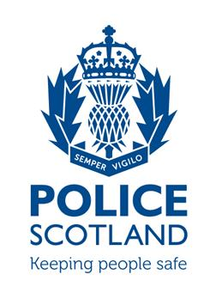

**COFFEE WITH COPS**

PC’s Ewan McIntosh and Peter Holmes will be attending at Leuchars Community Café between 10am and 11am on the following dates

Tues 23rd August Tues 29th November

Tues 20th September Tues 13th December

Tues 18th October

Your opportunity to come and meet your local Officers to discuss any concerns or worries regarding our community.

