Pellet Dispenser

Donaldson Lab, University of Colorado Boulder

Gabriel Chapel, Ryan Cameron

**Abstract**

This document details the pellet dispenser that is used for behavioral studies in the Donaldson Lab at the University of Colorado Boulder, specifically for the research of voles. This dispenser is currently used in operant training, where animals are rewarded with food pellets after successfully performing a task, such as pressing a lever. Using infrared sensing, it identifies the precise times at which a single pellet is dispensed into the trough and when the pellet is retrieved. It is also designed to accommodate different levels of accessibility, for example, when an exper- iment requires head-mounted animals. Here, we will discuss the pellet dispenser assembly, which was designed to perform reliably and consis- tently and be durable, modular, and easily and intuitively constructed.

# Introduction

In the Donaldson Lab, we often use food rewards for operant conditioning of voles, where the animal is rewarded with a food pellet after it performs a specific task, such as pressing a lever. To automate this reward system, we developed the food dispenser shown in Figure 1, which uses a motorized agitator to dispense a single food pellet to a trough. The trough was designed not only to allow the animals to easily retrieve the pellets, but also to help quantify the progress of the animal’s learning by housing an infrared (IR) sensor, which can identify the precise timestamps when the pellet is dispensed and retrieved.

The electronic components are controlled by an external computer or micro- controller, in our case a Raspberry Pi computer [1]. The IR sensor signals can be read directly from the GPIO pins on the Pi, but since it does not handle pulse width modulated (PWM) signals well, we pair the Raspberry Pi with an Adafruit Servo Hat [2] in order to control the speed and direction of the dispenser motor. When connected to an external computer, this dispenser can also be used with the lever, discussed in the Retractable Lever documen- tation. The system-wide electronic integration is discussed in further detail in a separate Operant Cage documentation.

2 *Pellet Dispenser*

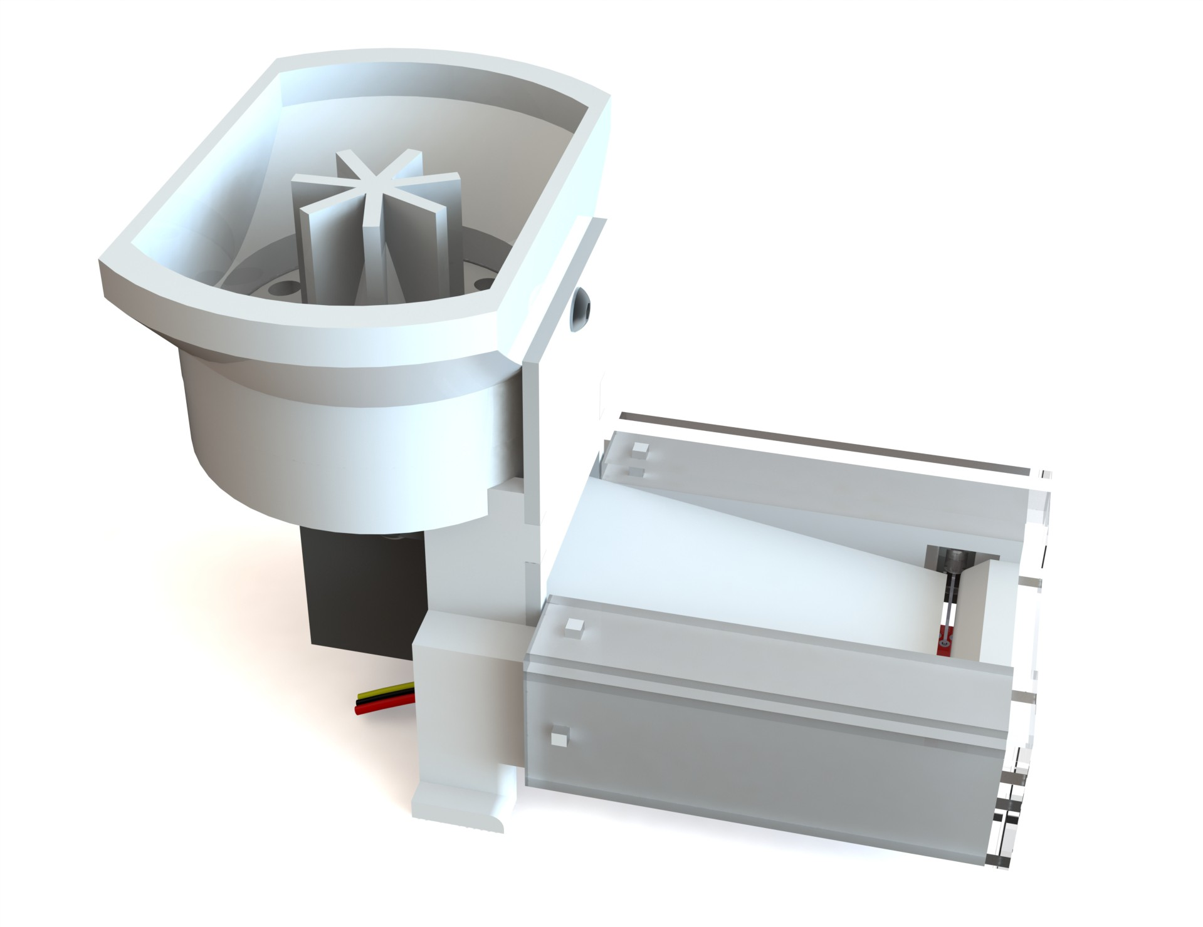

**Fig. 1**: Pellet dispenser 2021

The design discussed in this document was intended for use with voles, but can also be used with other small animals with little to no modification. The next section will detail the components that comprise the updated lever assembly and how they interface with one another. Following the component description, we provide a Bill of Materials (BOM) with resources for each of the components and their corresponding files, illustrate the most efficient assembly procedure, and then include a piece of sample code for simple operation of the dispenser using either an Arduino microntroller or Raspberry Pi.

# Design and Components

For easy and inexpensive construction, the dispenser is made up of off- the-shelf parts and components that can be fabricated in-house using laser cutters and 3D printers. This allows the features to be quickly modified or replaced if needed. Since the non-electronic components come in contact with the animal’s food and the animals themselves, they are also constructed out of materials that have low porosity and are easy to clean. We use Zortrax Z-ULTRAT filament [3], which is ABS-based, on a Zortrax M200 Plus FDM printer [4] and laser cut all of the shields out of acrylic sheets. The components are shown in Figure 2 to illustrate how they interface between one another.

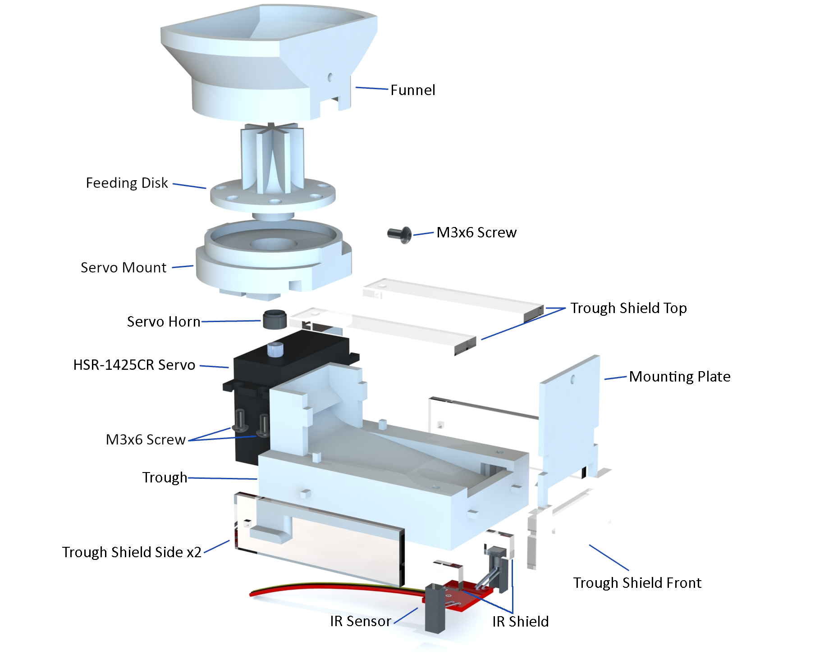*Pellet Dispenser* 3

**Fig. 2**: Exploded view of dispenser components

To begin using the dispenser, the user first fills the funnel with food pel- lets. This dispenser was designed using 0.25cm (20mg) Dustless Precision Pellets[5], but can be adjusted for larger or smaller pellets, as discussed fur- ther in the Feeding Disk section. When dispensing, the servo motor, attached to the servo mount, rotates the feeding disk to stir the pellets until one falls through the servo mount and rolls to the end of the trough. Once it reaches the end of the trough, the pellet obstructs an IR break beam sensor, which can be used to stop the rotation of the feeding disk.

When assembled, most of the important dispensing features are internal and difficult to see, so a split view is provided in Figure 3 for a more clear under- standing. For ease of fabrication on a 3D printer and to allow for simple modifications, we divided this dispenser into two subassemblies, the Hopper Subassembly and Trough Subassembly, and since the IR sensor is a standalone

component, it acts as its own IR Sensor subassembly. A more detailed expla- nation of the assembly process is provided later but a description of each component is given in the next sections.

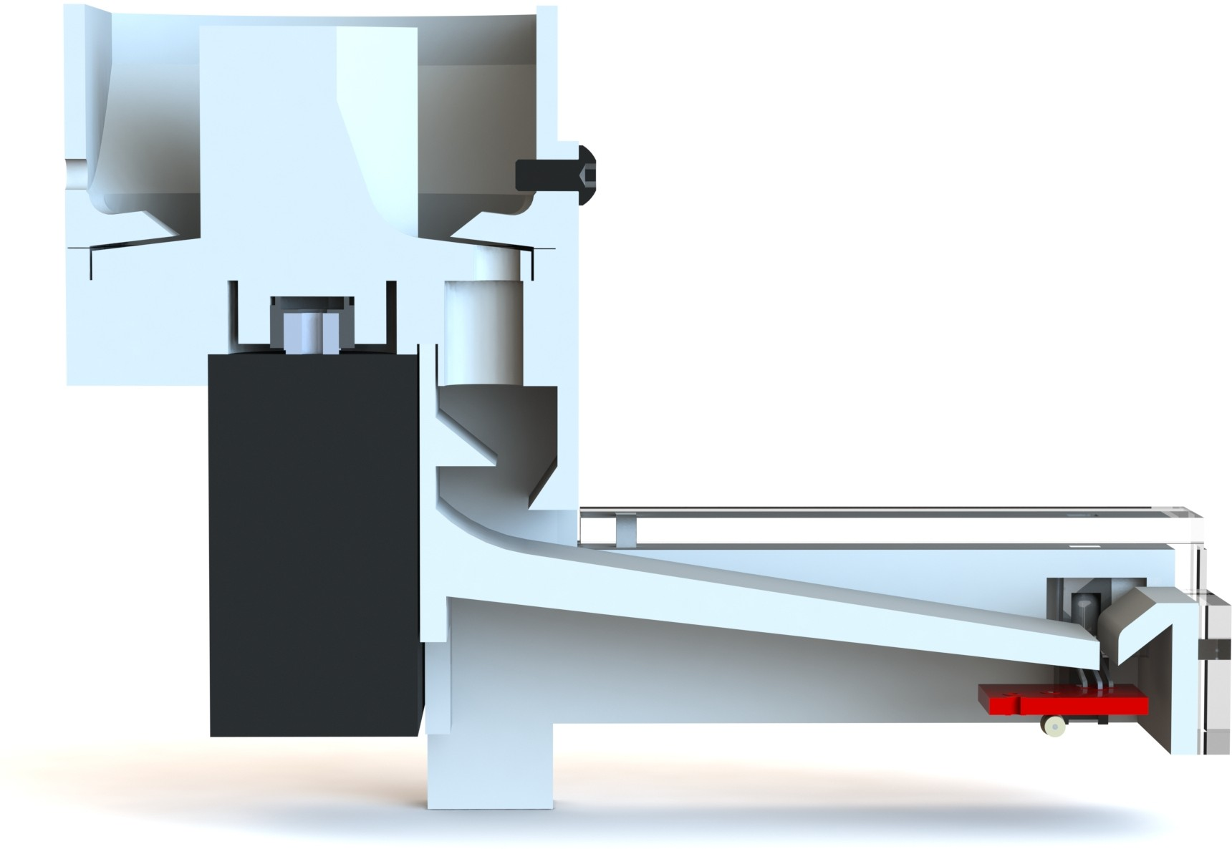

**Fig. 3**: Section view of dispenser

## Hopper Subassembly

The hopper subassembly consists of every component involved with releasing a pellet into the trough, including the funnel, feeding disk, servo mount, servo horn, servo motor, and two M3x6 mounting screws. This is shown in Figure 4, followed by a description of each component.

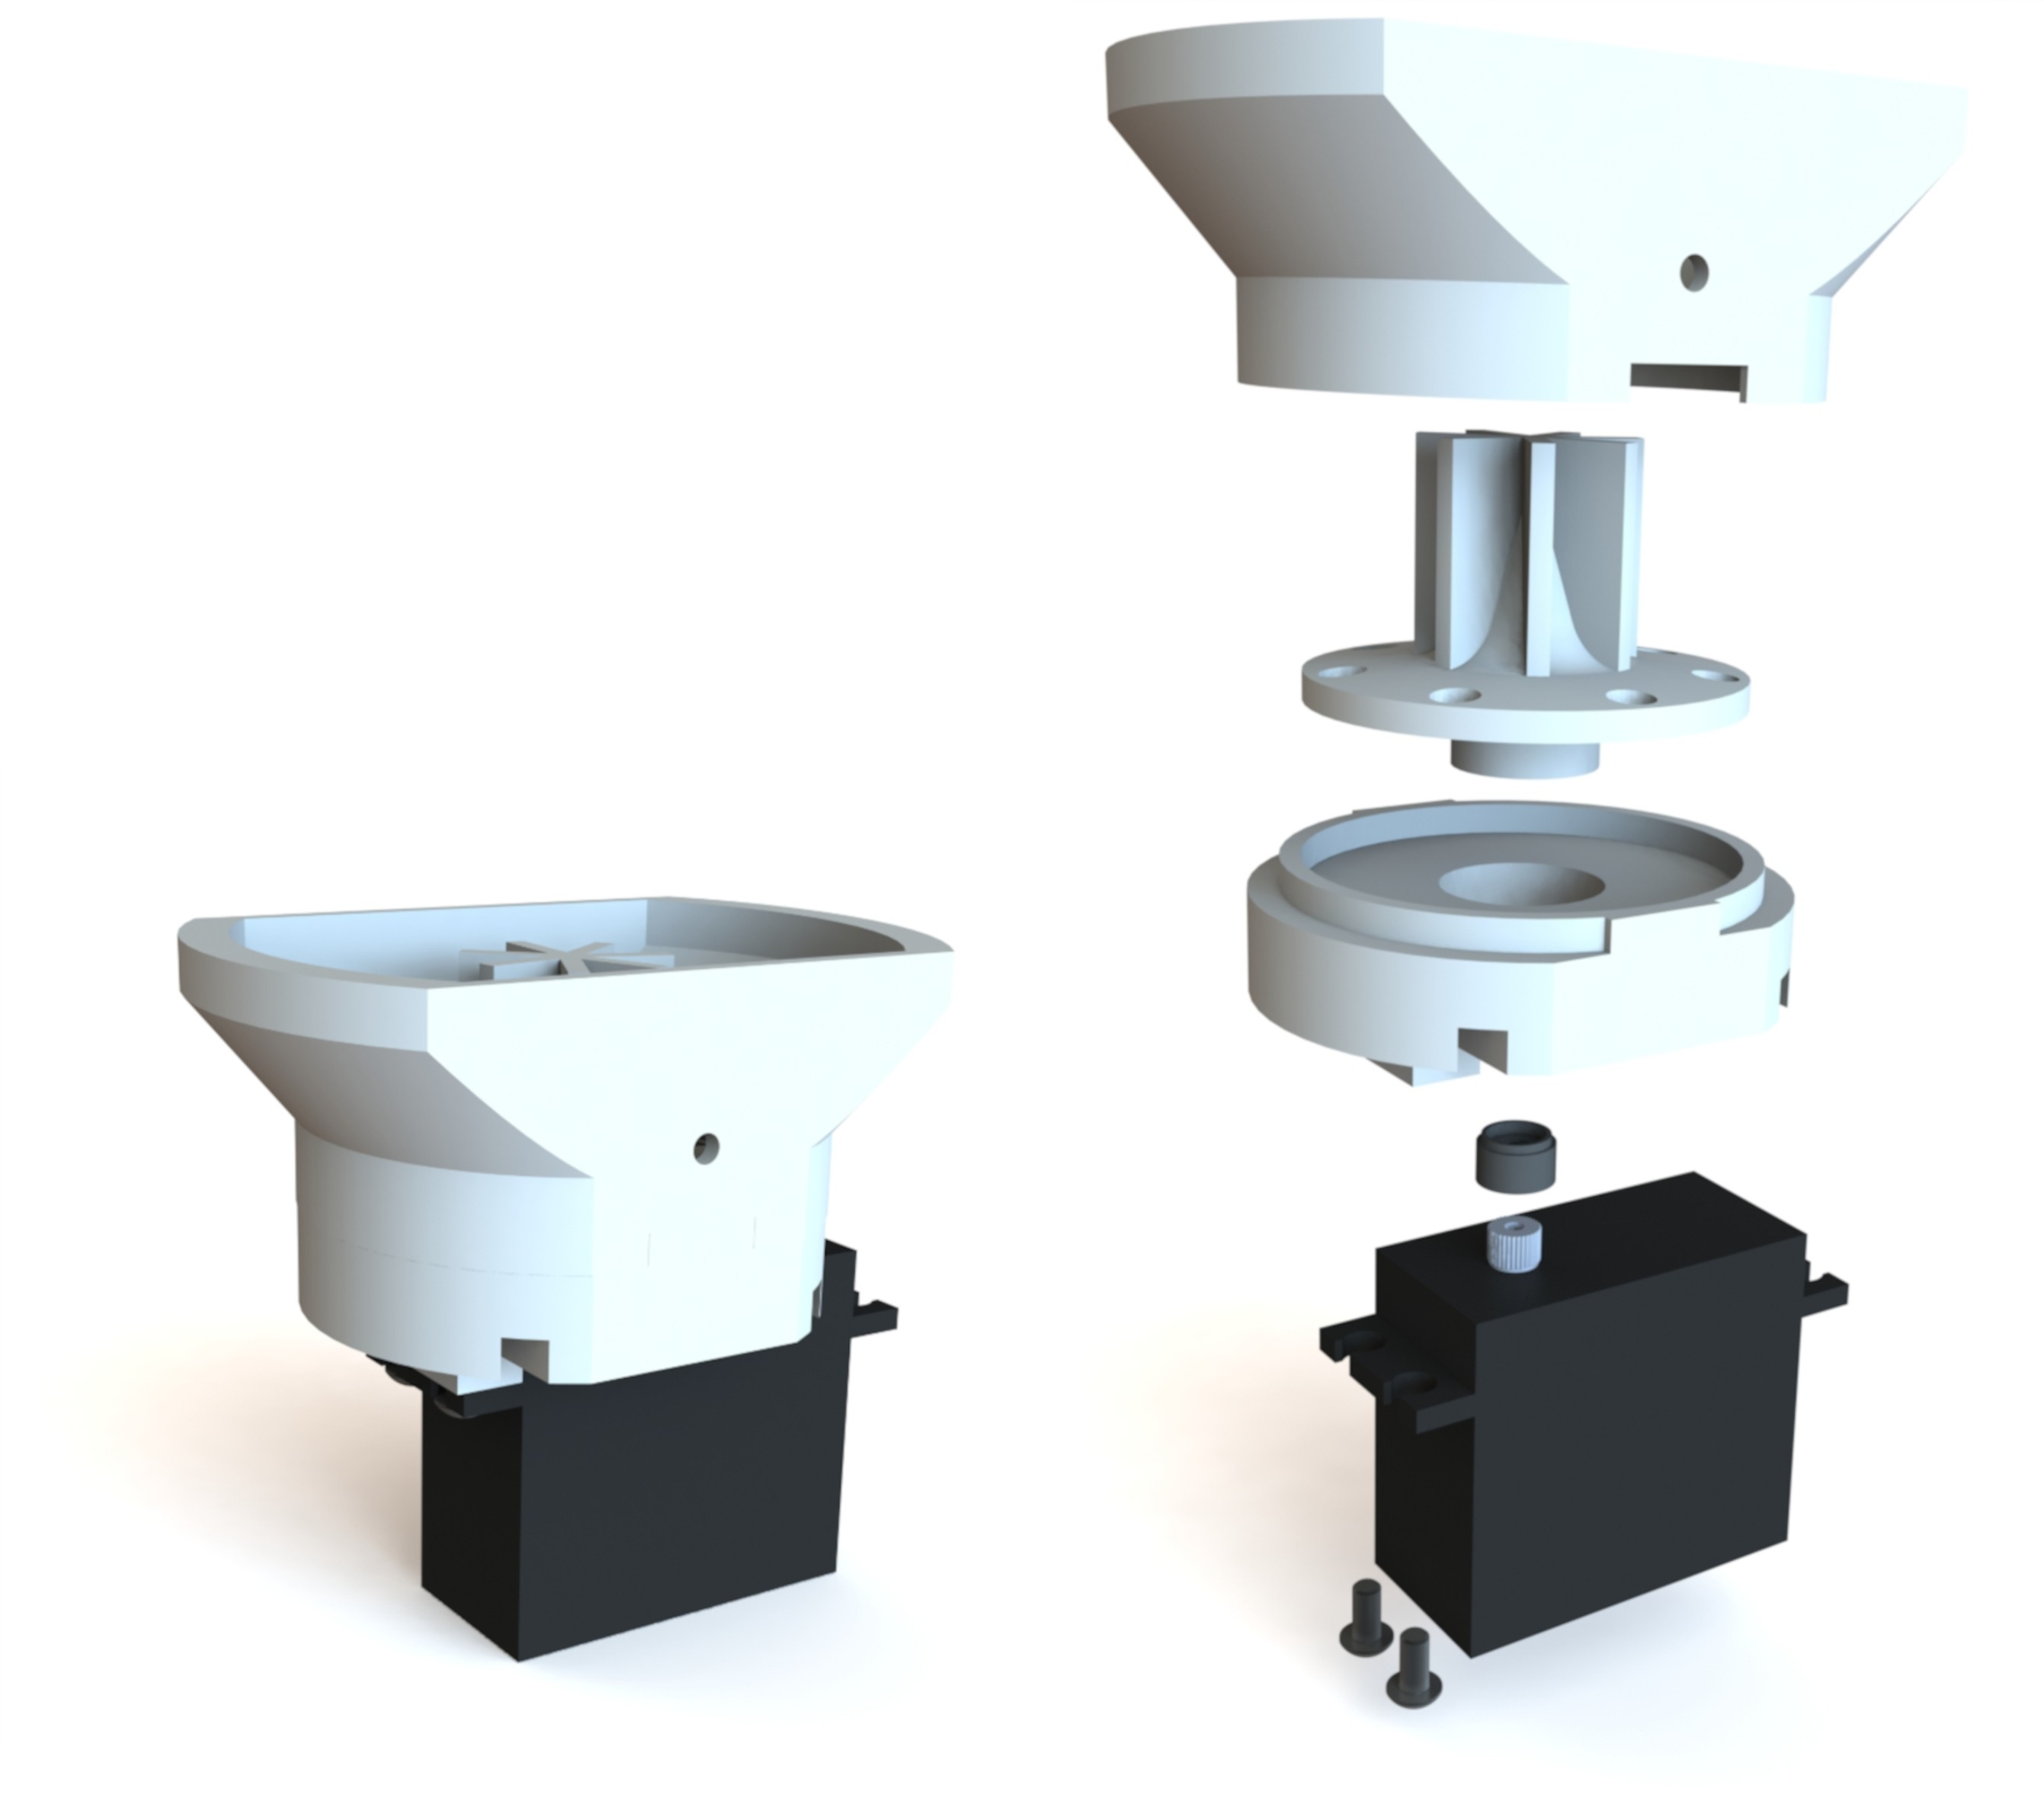

**Fig. 4**: Hopper subassembly

### Funnel

The funnel, shown in Figure 5 is the part that contains the food pellets within the dispenser and interfaces directly with the servo mount, creating an enclo- sure for the feeding disk. For simple alignment and to prevent the funnel from rotating, the funnel is symmetric and the interfaces on both the funnel and the servo mount have two rectangular features that mesh. Internally, it fea- tures two extruded tabs, as can be seen in Figure 3, that help guide the pellets into the holes of the feeding disk as it rotates. These tabs were designed to be angled parallel to the feeding disk and provide a space of about 0.5mm between the two components when assembled. To provide a tight fit between the funnel and servo mount, the tolerance between the two is 0.1mm, which is shown by the drawings in Appendix A. This funnel holds roughly 40mL but can be eas- ily adjusted to a different volume as long as the bottom circumference remains the same to fit with the servo mount.

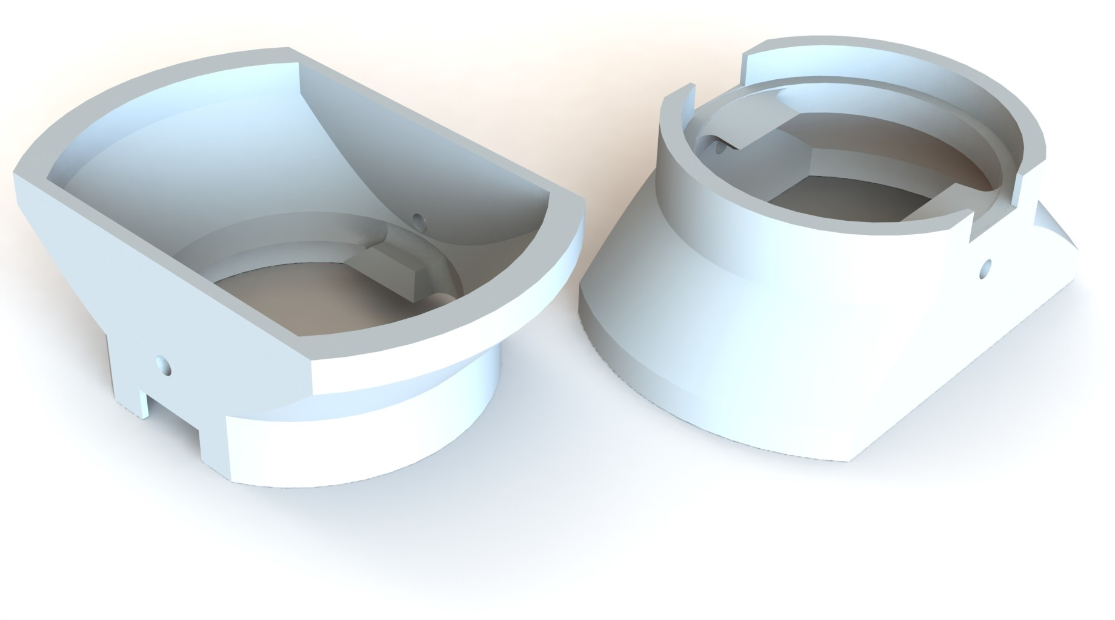

**Fig. 5**: Funnels with 40mL internal volume

### Feeding Disk

The feeding disk is used to dispense only one pellet at a time when one of its seven holes is aligned with the hole in the servo mount. It is rotated by a continuous servo motor until achieving this alignment, and if further rotation is permitted, more pellets are dispensed. The holes on the feeding disk are 4.5mm in diameter and have a minimum depth of 2.88mm. This, with the 0.5mm spacing between the disk and internal funnel extrusions, as discussed in the previous Funnel section, provides enough space for each hole to house one 2.5mm food pellet as the disk rotates. This diameter and that of the hole in the servo mount, as well as the spacing between feeding disk and funnel extrusions must be adjusted for the use of different sized pellets. As shown in Figure 6, the feeding disk is also equipped with an agitator to more effectively stir the pellets when the hopper is full. The disk also has a sloped top face,

which ensures that the pellets are directed to the holes near its perimeter. These modifications were made after testing showed inconsistent dispensing and their dimensions are given in Appendix A.

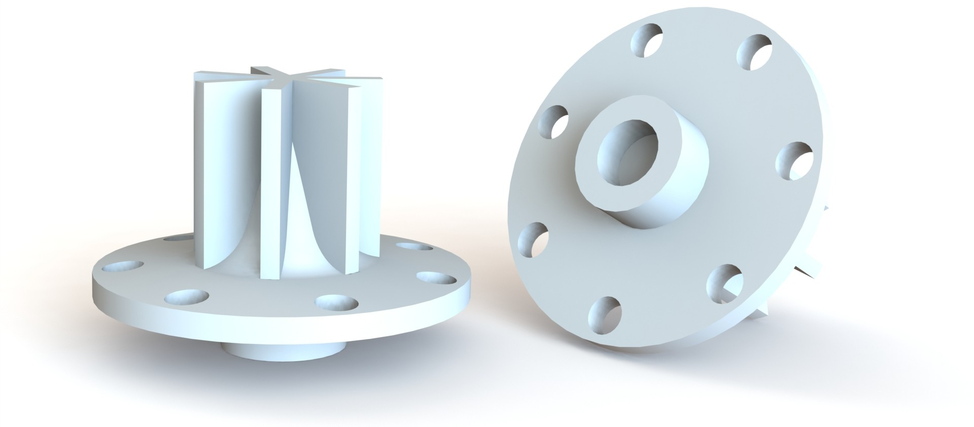

**Fig. 6**: Feeding disks with agitator and 4.5mm holes for 2.5mm pellets

### Servo Mount

The servo mount supports the servo motor and contains the feeding disk and food pellets within the funnel. It is designed to support an HSR-1425CR servo, but can be modified to accommodate different sizes. The mount provides an opening for the pellets as the feeding disk is rotated. As described in the previous Feeding Disk section, the opening is designed for permitting one pellet with a diameter of 2.5mm through at a time and can be easily adjusted for different pellet sizes. The servo mount also serves as a mounting point for the trough subassembly, where the trough slides into the slots on the bottom face, shown in Figure 7. The tolerances for this fit are given in the feeding disk and trough drawings in Appendix A.

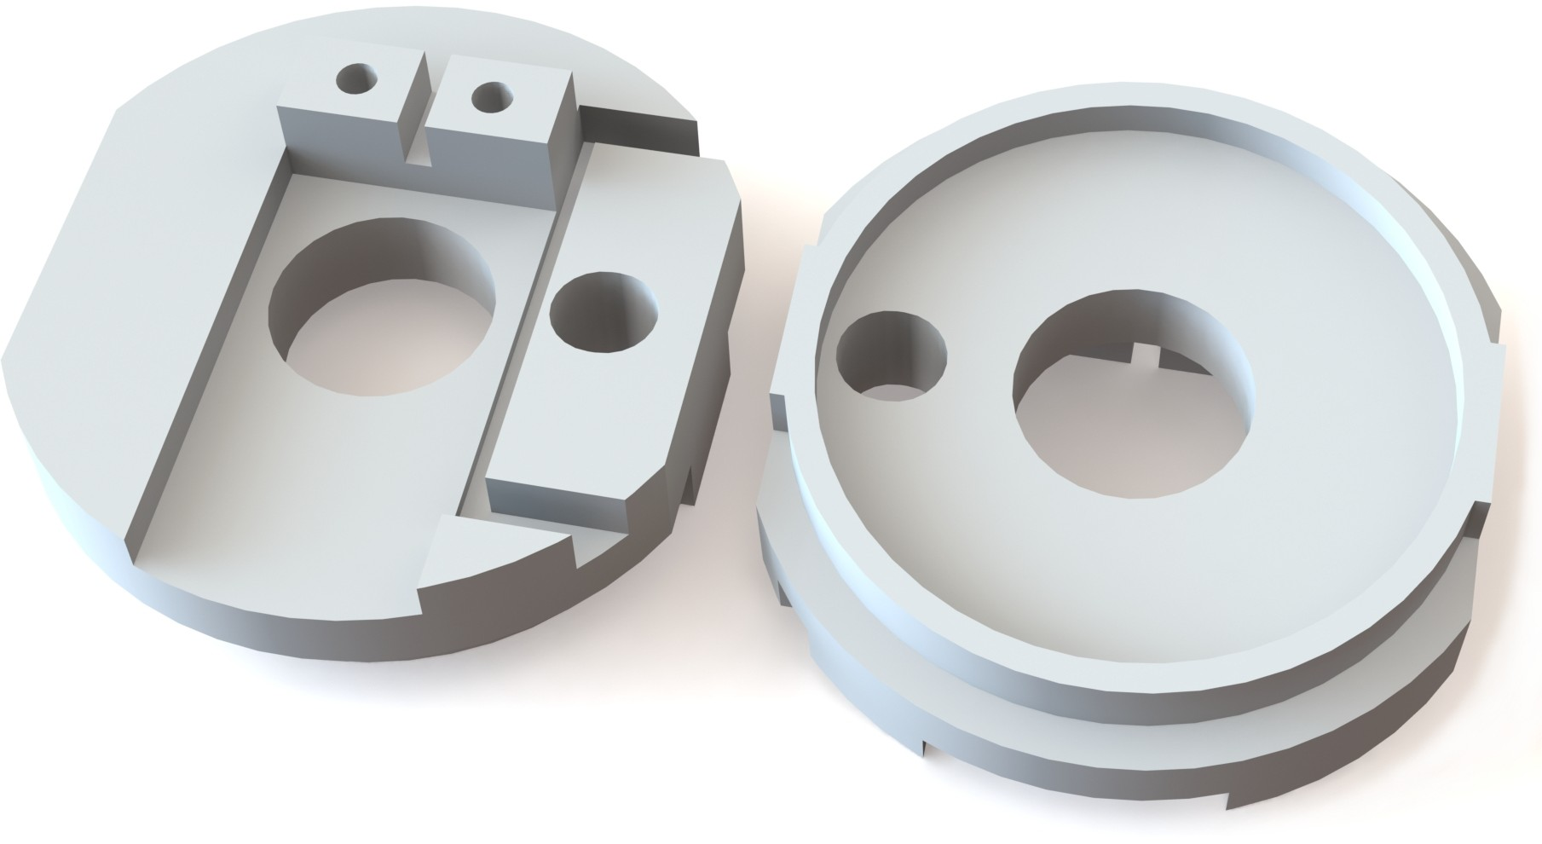

**Fig. 7**: Servo mounts for HSR-1425CR servo and 2.5mm diameter pellets

*Pellet Dispenser* 7

### Servo Motor and Horn

The source of the feeding disk’s rotation is a Hitec HSR-1425CR servo motor [6], which is a continuous-rotation servo, meaning it can rotate continuously past the standard 180° limit. A continuous rotation servo is not necessary for the operation of the dispenser, but we have found that it yields consistent results and provide a code sample specifically for continuous servos in the Code Sample section. Note, if a different servo is used, such as a Hitec FS5103R[7], the servo mount discussed previously must be modified to support it and the feeding disk may need to be adjusted to support a different diameter horn.

Servo horns (or arms) are included with servos when purchased and are the components that mesh with the teeth on the output spline of the servo. They typically vary between servo models and have very small features, so we choose to modify these included horns instead of trying to model and 3D print custom ones for every individual servo that we use. This modification only involves cutting away the outer features of a stock horn, as illustrated in Figure 8, until it is completely circular and fits into the socket of the feeding disk.

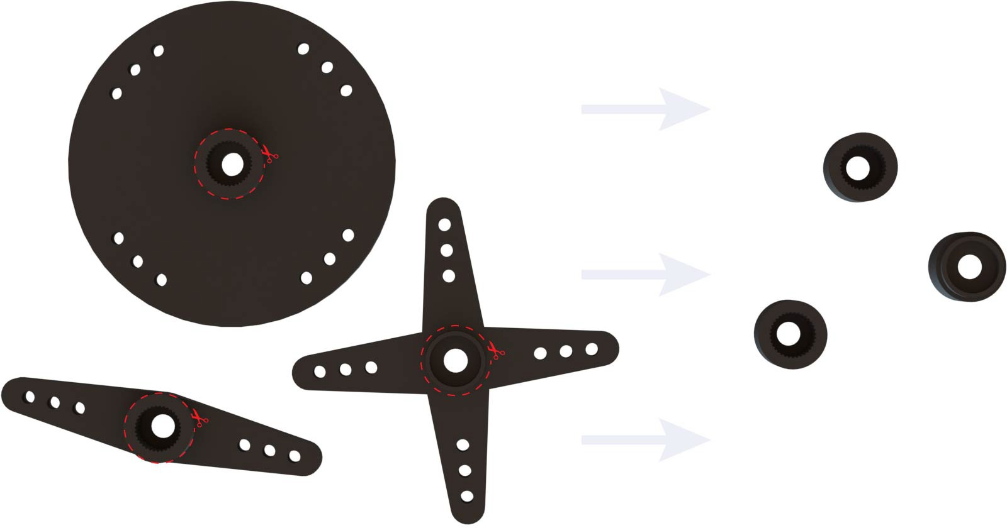

**Fig. 8**: Stock servo horns (left) with cutting guides that result in a circular servo horns (right)

Once this modification is made, we use an epoxy to adhere the modified horn to the socket on the bottom of the feeding disk. This creates an interface that doesn’t slip when rotating. We then press the servo motor into the horn, as shown by Figure 9. This assembly process is described in more detail in the Assembly section.

8 *Pellet Dispenser*

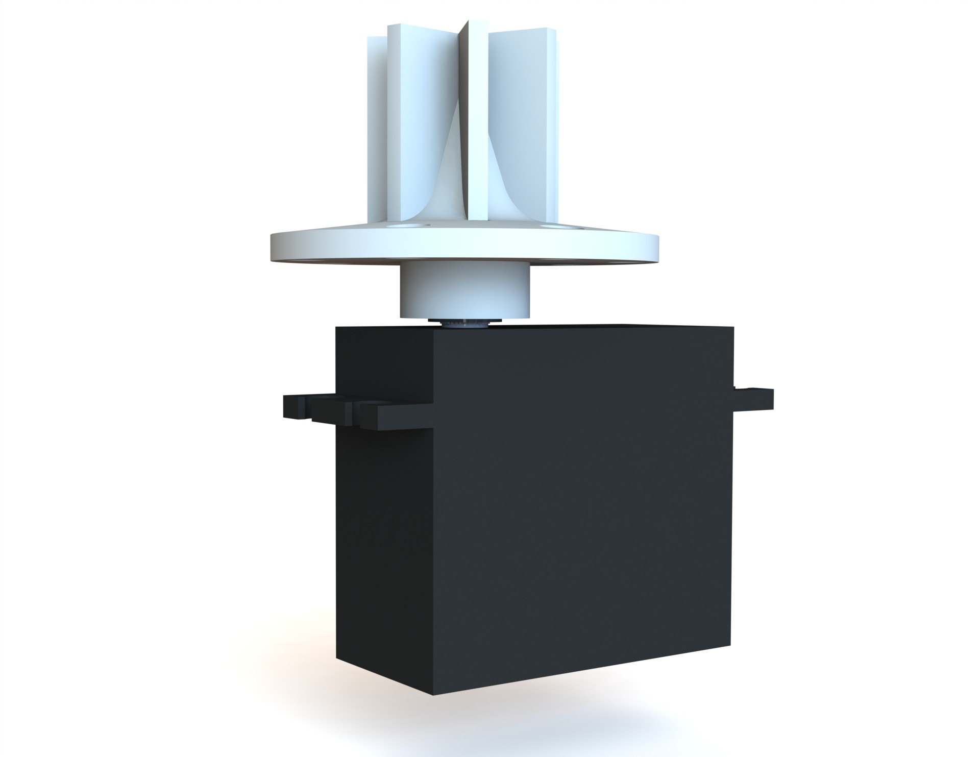

**Fig. 9**: HSR-1425CR servo and servo horn interfaces with feeding disk

## Trough Subassembly

The trough subassembly consists of every component involved with catching a dispensed pellet, including the trough, mounting plate, IR sensor, two IR shields, and the top, side, and front trough shields. This is shown in Figure 4, followed by a description of each component.

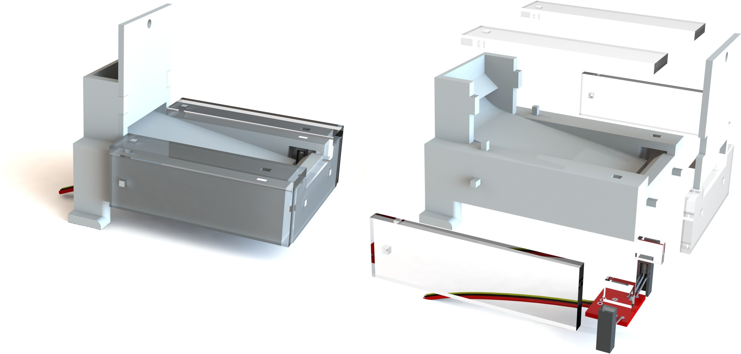

**Fig. 10**: Trough subassembly

### Trough

The trough is the primary component within this subassembly and is where the animal retrieves the dispensed pellet. For easier fabrication on a 3D printer, it was designed in two parts, the trough and the mounting plate, which press together to form internal obstacles that reduce a pellet’s bounce. These features can be seen in the section view in Figure 3. The width is 50mm, but can be

easily adjusted as long as the resistor in the IR sensor is adjusted accordingly, as described in the IR Sensor section. To prevent the pellets from bouncing out of the trough while ensuring that they reach the IR sensor, the slope of the ramp is determined by the total length of the trough, which in this case are 8.8° and 78mm, respectively. We have used different sized troughs, for example a 45mm-long trough with a 15° ramp, but the 78mm-long one shown in Figure 11 is the longest trough and least steep, designed to allow easier accessibility for head-mounted animals. If the length is adjusted, the ramp angle will also adjust inherently, since the position of the ramp’s end relates to the IR slot dimensions. It should, however, never be less than 8.8°.

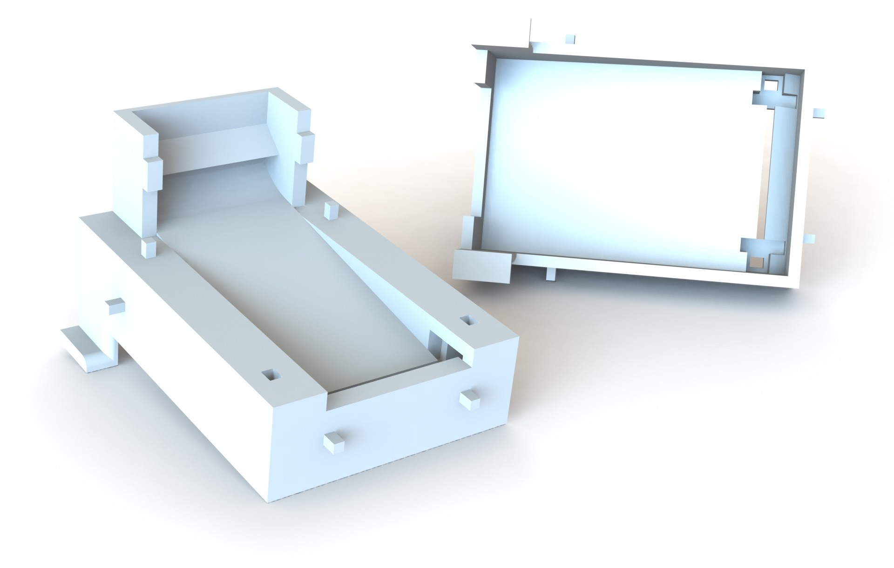

**Fig. 11**: Trough subassembly

There is a small cutout on the front of the trough to give the voles easier access to the dispensed pellet, while still preventing it from bouncing out with a 3.75mm-tall lip. The legs on either side of the trough are guides that slide into a track so the user can expose as little or as much of it as they want. When used with voles, the trough must also be protected from exces- sive chewing, since the trough houses an electronic component and the 3D printed material is soft. We protect the exposed sections with acrylic shields that press onto the body of the trough, but this can be replaced with other durable and easily cleaned materials, such as aluminum.

The IR sensor, discussed later, is pressed into slots in the bottom of the trough and is protected from debris by acrylic IR shields, also pressed into slots in the bottom of the trough. These slots stop the top of the IR receiver and emitter 4.5mm above the end of the ramp, positioning the beam 2mm above the end of the ramp to detect even 2mm diameter pellets while avoiding detection of small debris. To avoid further unwanted obstruction, the trough has a slot across the ramp, which allows debris to fall through and clear of the IR beam.

If necessary, the IR sensor can be removed by pressing through the two holes on the top of the trough. The dimensions for the IR sensor and the trough are provided in the drawings in Appendix A.

### Mounting Plate

As stated in the previous section, the mounting plate fits together with the trough and forms internal obstacles for the pellet to reduce how much it bounces. It also acts as an extra mounting point for the hopper subassem- bly, where the trough subassembly can be fastened with an M3x6 bolt incase more securement is necessary. This component is shown in Figure 12 and the drawing can be found in Appendix A.

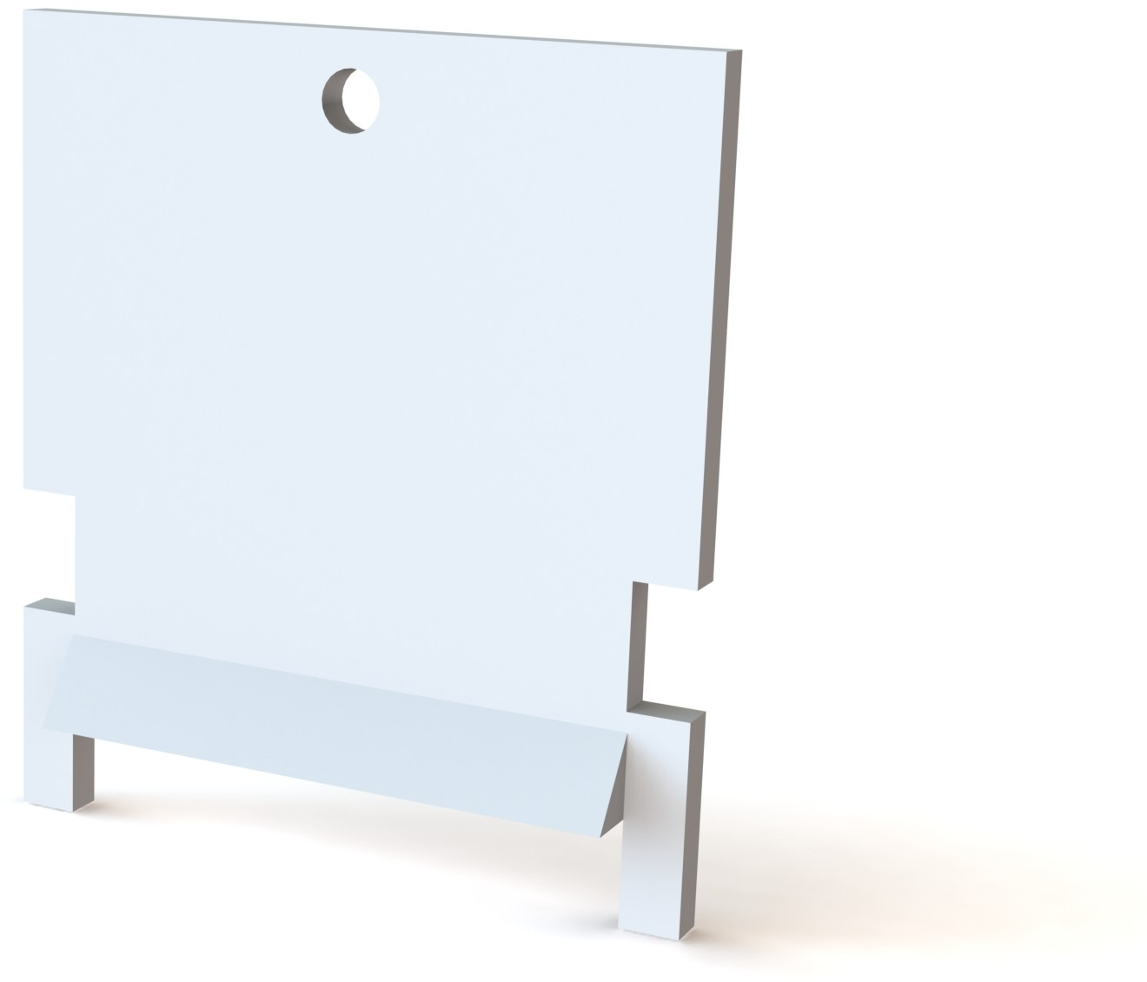

**Fig. 12**: Trough mounting plate

### Trough Shields

The trough shields are used to prevent the voles from chewing through the 3D printed trough. We use a lasercutter to create these shields out of acrylic and secure them to exposed corners on the trough, since corners are the most prone to being destroyed. This includes one front, two top, and two side shields, as shown in Figure 10. The dimensions for each shield are given in Appendix A.

### IR Shields

The IR shields are also acrylic pieces created on a laser cutter and are used to protect the IR transmitter and receiver from damage and debris. These are pressed into slots on the bottom of the trough along with the IR sensor, as shown in more detail in the Assembly. For a tighter fit, these are designed with a very slight draft angle, as shown in Appendix A.

### IR Sensor

The IR sensor is used to identify the times at which a pellet is dispensed and retrieved, which helps to quantify the progress of an animal’s learning. The sensor that we use is a modified version of a Photo Interrupter from Sparkfun

[8], where we separate the IR transmitter and receiver to extend the sensor’s range, as shown in the diagram in Figure 13.

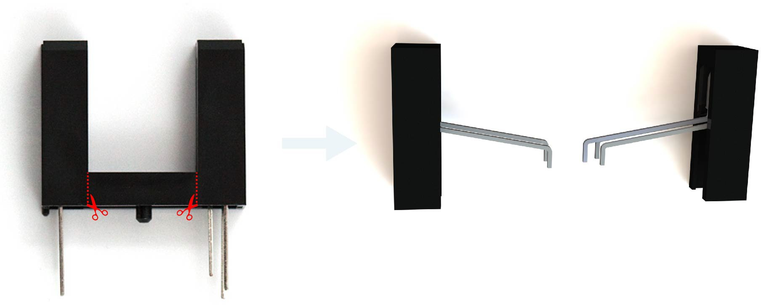

**Fig. 13**: Cut lines for modified Sparkfun Photo Interrupter

Once separated, the IR transmitter and receiver are soldered to a Photo Inter- rupter Breakout Board [9] along with a 1kΩ resistor. This resistance was determined through testing to be necessary for proper sensitivity with the 50mm trough width, but it must be adjusted if the width is changed. To con- nect to a Raspberry Pi or other external controller, power, ground, and signal wires must also be connected to the breakout board, as shown in Figure 14. A more detailed assembly procedure is provided in a later section and the dimensions of the Photo Interrupter are given in Appendix A.

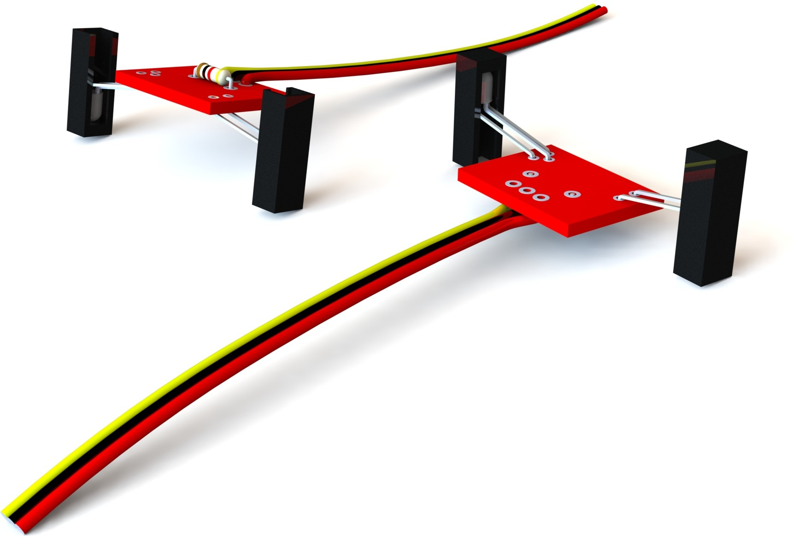

**Fig. 14**: IR sensors modified to fit 50mm-wide trough with 1kΩ resistor

Alternative IR sensors can be used in place of the Sparkfun Photo Interrupter, such as Adafruit’s 3mm IR Break Beam Sensors[10], which remove the need to make any cuts and modifications, since the emitter and receiver are already separated. If an alternative is used, however, the IR slots in the trough, as detailed in the Trough section, must be modified, potentially requiring addi- tional changes to the trough’s outer dimensions. Other IR sensors may also still require a breakout board and resistor in order to tune the sensitivity.

12 *Pellet Dispenser*

# Assembly

This section describes the recommended procedure for assembling a dispenser in the most efficient way. Each component, along with its method of procure- ment, is listed in the bill of materials (BOM) below, followed by the assembly steps. An assembly drawing is also provided in Appendix A.

**Table 1**: Bill of Materials

Item No. Part No. Description Quantity

1. dispenser feedingDisk 3D printed Z-ULTRAT (ABS) 1
2. dispenser servoMount 3D printed Z-ULTRAT (ABS) 1
3. dispenser funnel 3D printed Z-ULTRAT (ABS) 1
4. servo HSR1425CR OTS[6] 1
5. servoHorn HSR1425CR Included w/ servo and modified 1
6. socketButtonCapScrew M3x6 OTS 3
7. dispenser trough 3D printed Z-ULTRAT (ABS) 1
8. dispenser mountingPlate 3D printed Z-ULTRAT (ABS) 1
9. dispenser troughShield Top laser cut acrylic 2
10. dispenser troughShield Side laser cut acrylic 2
11. dispenser troughShield Front laser cut acrylic 1
12. dispenser irShield laser cut acrylic 2
13. photoInterrupter OTS[8] 1
14. photoInterrupter breakout OTS[9] 1
15. resistor 1k OTS 1
16. wire OTS 3

Notes:

* An epoxy is needed to adhere the dispenser servoHorn hsr1425CR and dis- penser feedingDisk.
* OTS represents off-the-shelf parts.

## Assembly Procedure

Files for each component can be pulled from GitHub at [https://github.](https://github.com/donaldsonlab/Operant-Cage) [com/donaldsonlab/Operant-Cage](https://github.com/donaldsonlab/Operant-Cage), including SolidWorks parts and assemblies, engineering drawings, and .STL files used to fabricate all of the custom components. This directory also contains a text file, named preferenceEqua- tions.txt, that defines the acrylic thickness for all the Solidworks part files. Every acrylic part, aside from the bottom of the Operant Cage, has a thick- ness of *wallThickness*, which is 1 ” by default. The STL files are saved in the optimal orientation for 3D printing on an FDM printer, but printer settings will differ slightly between printers and materials. Some of the off-the-shelf files are stored in the Global directory here: [https://github.com/donaldsonlab/](https://github.com/donaldsonlab/Operant-Cage/tree/main/GLOBAL) [Operant-Cage/tree/main/GLOBAL](https://github.com/donaldsonlab/Operant-Cage/tree/main/GLOBAL).

8

*Pellet Dispenser* 13

### Assemble Hopper Subassembly

#### *Cut Servo Horn*

Cut the servo horn to fit into the feeding disk socket, as shown by the guides to the right. This may require light sanding or filing.

#### *Insert Servo Horn into Feeding Disk*

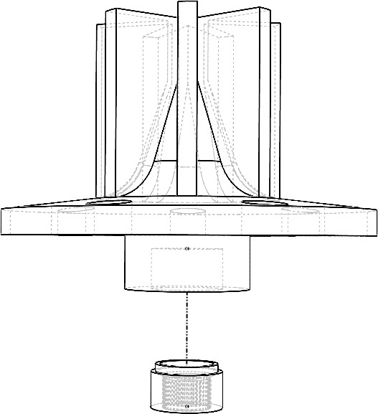Place thin layer of epoxy or other adhesive in the socket on the bottom of the feeding disk. Then, insert the servo horn into the feeding disk, ensuring that no adhesive gets on the horn’s internal teeth. Wipe away any residual adhesive.

#### *Attach Servo Motor to Feeding Disk and Servo Mount*

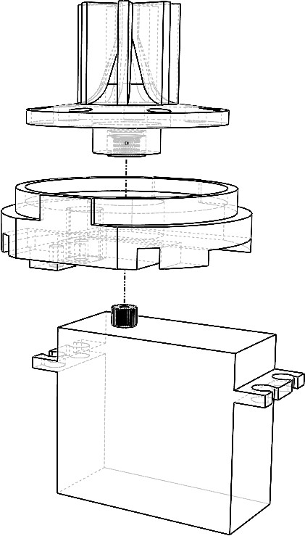While the servo horn adhesive is still wet, place the servo mount on top of the servo motor, so that the servo spline fits into the center hole. Then, press the feeding disk (with servo horn inserted) onto the spline as far as it will allow. Try to avoid separating the servo and feeding disk during the next step.

14 *Pellet Dispenser*

#### *Attach Funnel to Servo Mount*

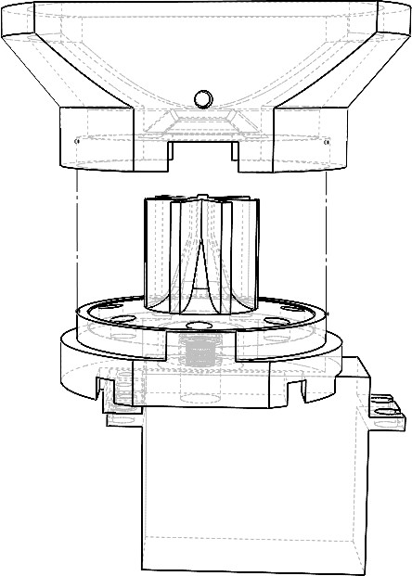Press the funnel onto the servo mount as far as it will allow. Once all of these components are pressed together, let this subassembly sit until the adhesive dries to ensure that the servo-disk interface is flat.

### Assemble IR Sensor

#### *Cut Photo Interrupter*

Cut the photo interrupter along the guides given in figure to the right to separate the transmitter from the receiver. Bend the pins as shown.

This may require widening the slots up to each bulb so that the pins can bend without touching one another. To ensure that enough of the pins are exposed, it may be helpful to slide them into the trough and check that they can be connected to the breakout board. This requires a minimum exposed pin length of 12mm for the 50mm-wide trough.

*Pellet Dispenser* 15

#### *Solder Photo Interrupter to Breakout Board*

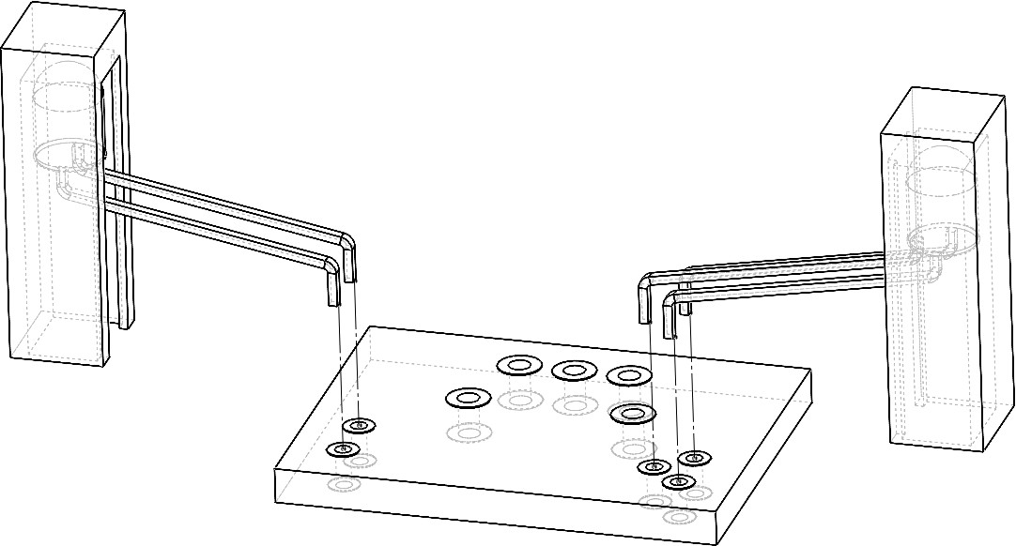Once the pins are exposed enough, insert them into their corresponding holes so that they barely come through the other side and solder them to the terminals. It may be helpful to mount the transmitter and receiver into the trough prior to soldering to ensure that they are positioned correctly.

#### *Connect Resistor and External Wires to Breakout Board*

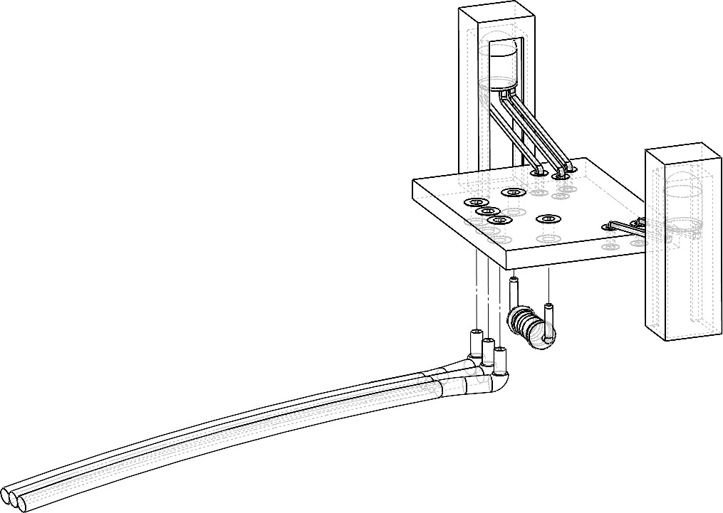A 1kΩ resistor is needed for the 50mm-wide trough, so solder it to the corresponding holes. Then, solder a power (red), ground (black), and signal (yellow) wire to the corresponding terminals with lengths dependent on the application.

### Assemble Trough Subassembly

#### *Insert IR Shields Into Trough*

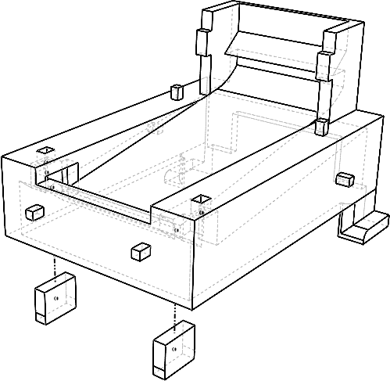Press the two IR shields into the slots on the bottom of the trough. These have a draft angle and are easier to insert with the narrower end first. Ensure they are clean prior to insertion.

16 *Pellet Dispenser*

#### *Insert IR Sensor Into Trough*

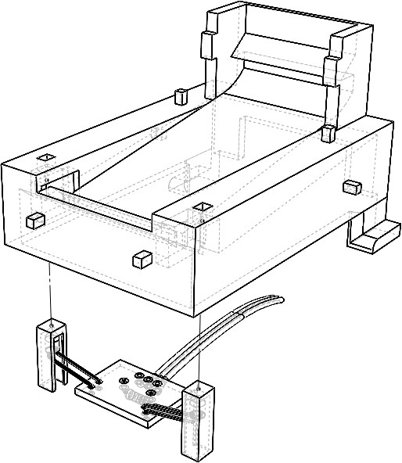Press the IR sensor into the slots on the bottom of the trough so that the wires are directed towards the back of the trough. Inspect that the transmitter and receiver are pressed in as far as possible.

#### *Attach Mounting Plate to Trough*

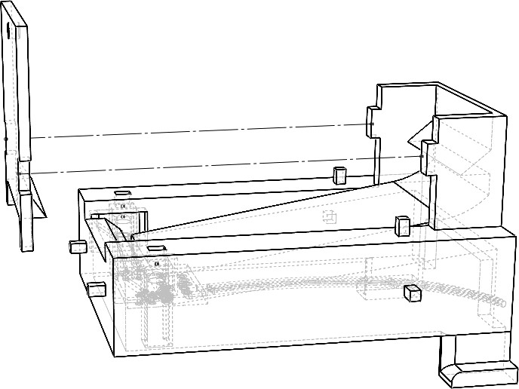Attach the mounting plate to the trough so that the exposed surface is the flat side of the plate.

#### *Attach Trough Shields to Body*

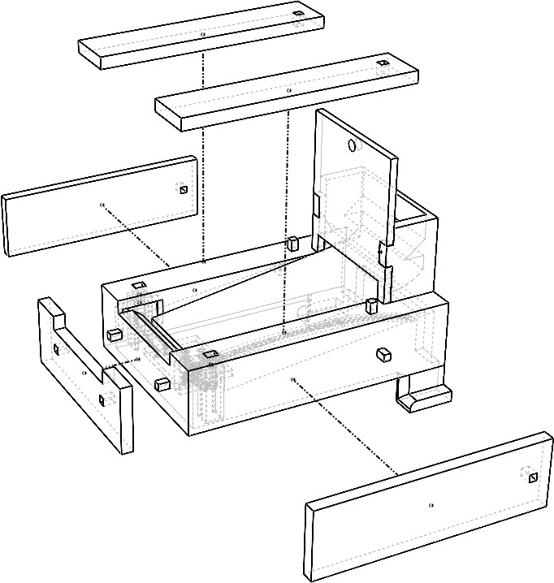Attach the top, side, and front trough shields to the body of the trough. The side and front shields are symmetrical and can be placed on either face. The top shields, however, are directional and should be placed so that there is no acrylic overhanging the trough’s ramp. In other words, the outside edges should be flush with the outside faces of the side shields.

*Pellet Dispenser* 17

### Connect the Hopper and Trough Subassemblies

#### *Screw Servo to Servo Mount*

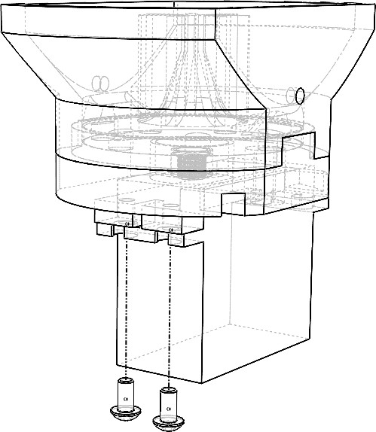Once the adhesive between the servo horn and feeding disk is dry, screw the servo to the servo mount.

#### *Connect the Trough Subassembly to Servo Mount*

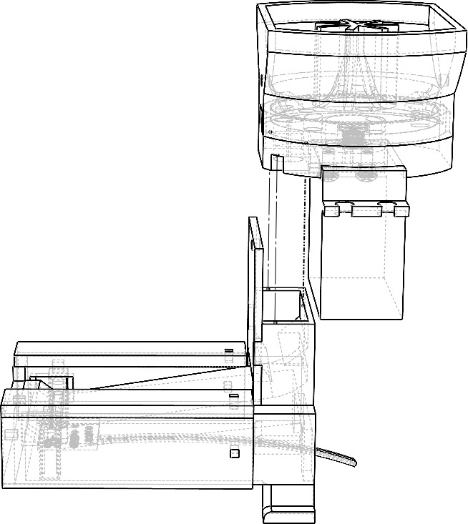Press the top edges of the trough into the slots on the bottom of the servo mount. This will be seated correctly when the screw hole of the funnel and mounting plate are aligned.

18 *Pellet Dispenser*

#### *Screw Mounting Plate to Funnel (Optional)*

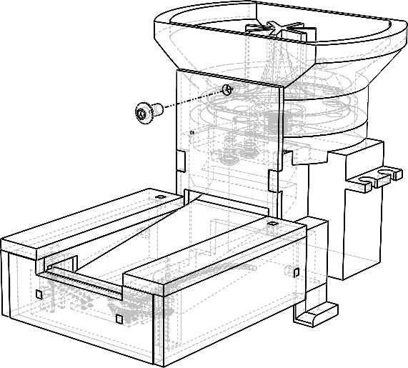Depending on the capabilities of the 3D printer that are used for this, the tolerances may be slightly different and further securement may be necessary. If so, simply screw the mounting plate to the funnel.

# Code Sample

Two of the components within this assembly, the IR Sensor and servo motor, must be controlled by an external computer or microcontroller to operate the dispenser. A sample of Python code is given below for operating the dispenser using a Raspberry Pi. This code will rotate a continuous servo motor until a pellet is dispensed, which will be recognized by the obstruction of the IR sensor, and it will output the times at which this dispensing takes place and when the pellet is retrieved.

#External Module Imports import RPI.GPIO as GPIO import time

from adafruit_servokit import ServoKit kit = ServoKit(channels=16)

#Pin Setup

ir = 1 #Plug IR signal wire into GPIO pin 1

GPIO.setup(ir, GPIO.IN, pull_up_down=GPIO.PUD_UP) #ir pin set as input w/ pull-up dispenserServo = kit.continous_servo[0] #Plug servo into pins 0 on hat

#Start Test

dispenserServo.throttle = .5 #rotate servo forward at half speed while True:

if not GPIO.input(ir): #if the IR sensor is blocked print("The pellet was dispensed at ", time.time()) dispenserServo.throttle = 0 #stop servo

if GPIO.input(ir): #if the IR sensor is not blocked print("The pellet was retrieved at ", time.time()) dispenserServo.throttle = .5 #start dispensing again

As mentioned previously and discussed further in the Electronic Hardware documentation, we use an Adafruit Servo Hat to control the servos, which requires and external power supply of 5-6V and the installation of the Circuit- Python ServoKit library. A tutorial for powering the hat and installing this library for use with Python is given on the Adafruit website [11].

REV. A

DESCRIPTION INITIAL RELEASE

DATE 12/23/21

APPROVED GABRIEL CHAPEL

17.500

41.50

A

4.500 THRU X7

20.9

R5.5

20.00

2.77

6.00

2.0 X7

DETAIL A SCALE 2 : 1

R7.00

8.000

4.500

NOTES:

- REFER TO

dispenser_feedingDisk_withAgitator.sldprt FOR ANY UNSPECIFIED DIMENSIONS

TOLERANCES UNLESS NOTED:

UNITS: MM

MATERIAL

X.X 1

X.XX 0.5

X.XXX 0.1

X.X 2

DESCRIPTION

UNIVERSITY OF COLORADO BOULDER DONALDSON LAB

ZORTRAX ULTRAT FEEDING DISK WITH AGITATOR

FINISH

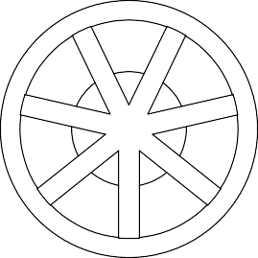

**Appendix A**

REMOVE SUPPORT AND DEBUR

PN

dispenser_feedingDisk

REV

A

SHEET

1 of 1

REV. A

DESCRIPTION INITIAL RELEASE

DATE 12/22/21

APPROVED GABRIEL CHAPEL

10.000

2.00

3.000 4.30 X2

3.300

8.05

4.00

7.000 X 7.500

THRU

52.00

14.000

10.500

29.700

23.3

11.749

46.005

42.01

2.000

19.80

11.350

7.300

5.100

3.00

1.00

16.00 THRU

NOTES:

- REFER TO

preferenceV2_dispenser_servoMount.sldprt

TOLERANCES UNLESS NOTED:

UNITS: MM

MATERIAL

X.X 1

X.XX 0.5

X.XXX 0.05

X.X 2

DESCRIPTION

UNIVERSITY OF COLORADO BOULDER DONALDSON LAB

FOR ANY UNSPECIFIED DIMENSIONS



ZORTRAX ULTRAT

FINISH

REMOVE SUPPORT AND DEBUR

SERVO MOUNT

PN

dispenser_servoMount

REV

A

SHEET

1 of 1

63.8

47.6

42.0

REV. A

DESCRIPTION INITIAL RELEASE

NOTES:

DATE 12/23/21

APPROVED GABRIEL CHAPEL

- REFER TO preferenceV2_dispenser_funnel FOR ANY UNSPECIFIED DIMENSIONS

2.0

5.0

4.6

A

28.00

10.59

2.90 THRU

A

14.0

9.23

6.83° SECTION A-A

5.100

42.00

R23.053

TOLERANCES UNLESS NOTED:

UNITS: MM

MATERIAL

X.X 1

X.XX 0.5

X.XXX 0.05

X.X 2

DESCRIPTION

UNIVERSITY OF COLORADO BOULDER DONALDSON LAB

ZORTRAX ULTRAT DISPENSER FUNNEL

11.780



FINISH PN REV

REMOVE SUPPORT AND DEBUR dispenser_funnel A

SHEET

1 of 1

4.00

74.59

12.7

7.06

REVISIONS

REV. DESCRIPTION DATE APPROVED

A INITIAL RELEASE 12/22/21 GABRIEL CHAPEL

36.00

A

A 1.500

7.00

5.7

2.00

3.05

21.10

* 1. X6 13.100

3.18 X6

6.00

10.50

2.4

3.1 THRU X2

4.6

2.5

8.82°

1.800

SECTION A-A SCALE 1 : 1

2.80

4.669

2.5

18.400

NOTES:

5.715

3.0

* REFER TO

preferenceV2_dispenser_trough.sldprt FOR UNSPECIFIED DIMENSIONS

* THE RAMP ANGLE DEPENDS ON THE LENGTH OF THE TROUGH AND MUST BE CHANGED IF

THE LENGTH IS ADJUSTED

TOLERANCES UNLESS NOTED:

UNITS: MM

MATERIAL

ZORTRAX ULTRAT

FINISH

X.X 1

X.XX 0.5

X.XXX 0.05

X.X 2

DESCRIPTION

TROUGH

PN

UNIVERSITY OF COLORADO BOULDER DONALDSON LAB

REV

SHEET

REMOVE SUPPORT AND DEBUR



dispenser_trough A

1 of 2

|  |  |  |  |  |  |  |  |
| --- | --- | --- | --- | --- | --- | --- | --- |
| 10.00  1.63 5.200  5.050  3.18  C  11.00  30.0  1.625 6.06  DETAIL C SCALE 5 : 2 | | | | | | | |
|  | TOLERANCES X.X 1  UNLESS X.XX 0.5  NOTED: X.XXX 0.05  UNITS: MM X.X 2 | UNIVERSITY OF COLORADO BOULDER DONALDSON LAB | | | | | |
| MATERIAL  ZORTRAX ULTRAT | DESCRIPTION  TOP TROUGH SHIELD | | | | | |
| FINISH  REMOVE SUPPORT AND DEBUR | PN  dispenser_troughShield_Top | REV  A |  |  |  | SHEET  2 of 2 |
|  |  |

**SOLIDWORKS Educational Product. For Instructional Use Only.**

|  |  |  |  |  |  |  |  |  |  |  |  |  |  |
| --- | --- | --- | --- | --- | --- | --- | --- | --- | --- | --- | --- | --- | --- |
|  | | | REVISIONS | | | | | | | | | | |
| REV. | DESCRIPTION | | | | DATE | | APPROVED | | | |
| A | INITIAL RELEASE | | | | 12/22/21 | | GABRIEL CHAPEL | | | |
|  |  |  |  | |  | |  | | 2.00 | |  |  |  |
| 3.25 |  |  |  | |  | |  | |  | |  |  |  |
|  |  |  |  | | 40.35 | |  | |  | |  |  |  |
| 6.15 |  |  |  | | 3.10 | |  | |  | |  |  |  |
|  |  |  |  | |  | | 5.15 | |  | |  |  |  |
| 10.43 |  |  |  | |  | |  | |  | |  |  |  |
|  | 5.28 |  |  | |  | |  | |  | |  |  |  |
|  |  | 30.00 |  | | 3.00 | | 2.81 | |  | |  |  |  |
| NOTES:  - REFER TO | | | TOLERANCES UNLESS NOTED:  UNITS: MM | | X.X 1  X.XX 0.5  X.XXX 0.05  X.X 2 | UNIVERSITY OF COLORADO BOULDER DONALDSON LAB | | | | | | | |
| dispenser_trough_mountingPlate.sldprt | | |  | | | | | | | |
| FOR UNSPECIFIED DIMENSIONS | | |
| MATERIAL  ZORTRAX ULTRAT | | | DESCRIPTION  TROUGH MOUNT PLATE | | | | | | | |
|  | | | FINISH  REMOVE SUPPORT AND DEBUR | | | PN  dispenser_trough_mountingPlate | | | REV  A |  |  |  | SHEET  1 of 1 |
|  |  |





REV. A

DESCRIPTION INITIAL RELEASE

DATE 12/22/21

APPROVED GABRIEL CHAPEL

62.00

2.050

3.975

A 13.18

2.050

3.531

3.18

NOTES:

* THIS DESIGN IS FOR 1/8" SHIELD THICKNESS
* A THIS DIMENSION INTERFACES WITH

preferenceV2_dispenser_troughShield_Sides

AND SHOULD BE CHANGED IF A DIFFERENT

TOLERANCES UNLESS NOTED:

UNITS: MM

MATERIAL

X.X 1

X.XX 0.5

X.XXX 0.05

X.X 2

DESCRIPTION

UNIVERSITY OF COLORADO BOULDER DONALDSON LAB

SHIELD THICKNESS IS USED



1/8" ACRYLIC

FINISH

NONE

TOP TROUGH SHIELD

PN

dispenser_troughShield_Top

REV

A

SHEET

1 of 1

REV.

A

DESCRIPTION

INITIAL RELEASE

DATE

12/22/21

APPROVED

GABRIEL CHAPEL

3.18

3.96

29.90

2.050 THRU

18.40

8.175

9.975

50.00

TOLERANCES UNLESS NOTED:

UNITS: MM

MATERIAL

X.X 1

X.XX 0.5

X.XXX 0.05

X.X 2

DESCRIPTION

UNIVERSITY OF COLORADO BOULDER DONALDSON LAB

1/8" ACRYLIC



FINISH

NONE

FRONT TROUGH SHIELD

PN

dispenser_troughShield_Front

REV

A

SHEET

1 of 1

REV. A

DESCRIPTION INITIAL RELEASE

DATE 12/22/21

APPROVED GABRIEL CHAPEL

A 62.00

2.050 THRU

18.40

3.531

3.18

NOTES:

* + - THIS DESIGN IS FOR 1/8" SHIELD THICKNESS
    - A THIS DIMENSION INTERFACES WITH

preferenceV2_dispenser_troughShield_Front

TOLERANCES UNLESS NOTED:

UNITS: MM

MATERIAL

X.X 1

X.XX 0.5

X.XXX 0.05

X.X 2

DESCRIPTION

UNIVERSITY OF COLORADO BOULDER DONALDSON LAB

AND SHOULD BE CHANGED IF A DIFFERENT SHIELD THICKNESS IS USED



1/8" ACRYLIC

FINISH

NONE

SIDE TROUGH SHIELD

PN

dispenser_troughShield_Side

REV

A

SHEET

1 of 1

REV.

A

DESCRIPTION

INITIAL RELEASE

DATE

12/22/21

APPROVED

GABRIEL CHAPEL

9.800 3.18

8.000

9.900

TOLERANCES UNLESS NOTED:

UNITS: MM

MATERIAL

X.X 1

X.XX 0.5

X.XXX 0.05

X.X 2

DESCRIPTION

UNIVERSITY OF COLORADO BOULDER DONALDSON LAB

1/8" ACRYLIC SHEET



FINISH

NONE

IR SHIELD

PN

dispenser_IRShield

REV

A

SHEET

1 of 1

* **Internal Connection Diagram**

**GP1A57HRJ00F**

Top view

Voltage regulator Amp.



3

2

4

5

1

(15k)

Anode Cathode VCC

VO GND



1

2

3

4

5

0.7

1.5

* **Outline Dimensions** (Unit : mm)



Slit width

(Detector side)

18.6

10

1.80.1

C1

50.4

C0.3

(1.5)

Date

code

50.45

 0.7

(2.54)

(15.2)

8.95

5

1

3 4 2

* Tolerance : 0.2mm
* ( ) : Reference dimensions

Product mass : approx. 0.7g

GP1A57HR

Detector center (2.5)

5

3

15.2

4MIN.

Dip soldering material : Sn3Ag0.5Cu

2

Sheet No.: D3-A03901EN

2

|  |  |  |  |  |  |  |  |  |  |  |  |  |  |  |  |  |  |  |  |  |  |
| --- | --- | --- | --- | --- | --- | --- | --- | --- | --- | --- | --- | --- | --- | --- | --- | --- | --- | --- | --- | --- | --- |
| ITEM | PART NUMBER | | | | | QTY. | | 2 | 5 |  |  |  | 3  1 | 6 |  |  | | 9 | |  |  |
| NO. |
| 1 | preferenceV2_dispenser_feedingDisk_withAgitator | | | | | 1 | |
| 2 | preferenceV2_dispenser_servoMount | | | | | 1 | |
| 3 | preferenceV2_dispenser_funnel | | | | | 1 | |
| 4 | servo_HSR1425CR | | | | | 1 | |
| 5 | servoHorn_HSR1425CR | | | | | 1 | |
| 6 | socketButtonCapScrew_M3x6 | | | | | 3 | |
| 7 | preferenceV2_dispenser_trough | | | | | 1 | |
| 8 | preferenceV2_dispenser_mountingPlate | | | | | 1 | |
| 9 | preferenceV2_dispenser_troughShield_Top | | | | | 2 | |
| 10 | preferenceV2_dispenser_troughShield_Side | | | | | 2 | |
| 11 | preferenceV2_dispenser_troughShield_Front | | | | | 1 | |
| 12 | preferenceV2_dispenser_irShield | | | | | 2 | |
| 13-16 | irAssembly | | | | | 1 | |
|  |  |  |  |  |  |  |  | | 4 |  |  |  | 7 |  |  | 10 | |  | |  | 8 |
|  |  |  |  |  |  |  |  | | 6 |  |  |  |  |  |  |  | |  | |  | 11 |
|  |  |  |  |  |  |  |  | | 10 |  |  |  |  |  |  |  | | 12 | |  |  |
|  |  |  |  |  |  |  |  | |  |  |  | 13-16 |  |  |  |  | |  | |  |  |
|  | | | | | | | TOLERANCES UNLESS NOTED: | |  | X.X X.XX X.XXX | 1  0.5  0.05 | UNIVERSITY OF COLORADO BOULDER | | | | | | | | | |
| DONALDSON LAB | | | | | | | | | |
| UNITS: MM | | X.X | 2 |  | | | | | | | | | |
| A | | INITIAL RELEASE | 12/22/21 | GABRIEL CHAPEL |  | | MATERIAL  VARIOUS | | | | | DESCRIPTION  DISPENSER ASSEMBLY | | | | | | | | | |
| REV. | | DESCRIPTION | DATE | APPROVED |
| FINISH  VARIOUS | | | | | PN  dispenserAssembly | | REV  A | | |  | |  |  | SHEET  1 of 1 |
| REVISIONS | | | | |  |  |

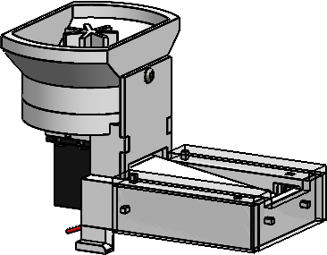

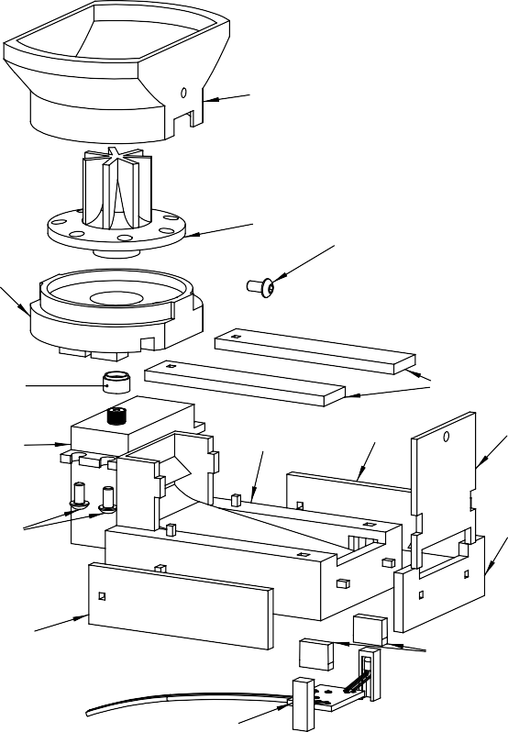

|  |  |  |  |  |  |  |  |  |  |  |  |  |  |  |  |  |  |
| --- | --- | --- | --- | --- | --- | --- | --- | --- | --- | --- | --- | --- | --- | --- | --- | --- | --- |
| ITEM NO. | PART NUMBER | QTY. |  | REVISIONS | | | | | | | | | | | | | |
| REV. | DESCRIPTION | | | | | DATE | | | | APPROVED | | | |
| 13 | sparkfunPhotointerrupter | 1 | A | INITIAL | | | RELEASE | | 12/22/21 | | | | GABRIEL CHAPEL | | | |
| 14 | sparkfunPhotointerrupter_breakout | 1 | 13 | | | | | | | | | | | | | | |
| 15 | resistor_1k | 1 |
| 16 | wire | 1 |
|  |  |  | 14  16 | | |  |  |  | 15 | |  |  |  | |  |  |  |
|  | | | TOLERANCES UNLESS NOTED:  UNITS: MM | | | X.X X.XX X.XXX X.X | 1  0.5  0.05  2 | | UNIVERSITY OF COLORADO BOULDER | | | | | | | | |
|  | | | DONALDSON LAB | | | | | | | | |
| NOTES: | | |  | | | | | | | | |
| - THE sparkfunPhotointerrupter IS CUT INTO TWO SEPARATE PARTS, THE TRANSMITTER AND RECEIVER, PRIOR TO ASSEMBLY | | |
| MATERIAL  VARIOUS | | | | | | DESCRIPTION  IR ASSEMBLY | | | | | | | | |
| FINISH  VARIOUS | | | | | |  | |  | |  | |  |  |  |
| REV  A | | SHEET  1 of 1 |
| PN  dispenser_irAssembly | |
|  |  |

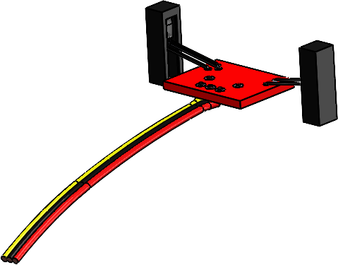

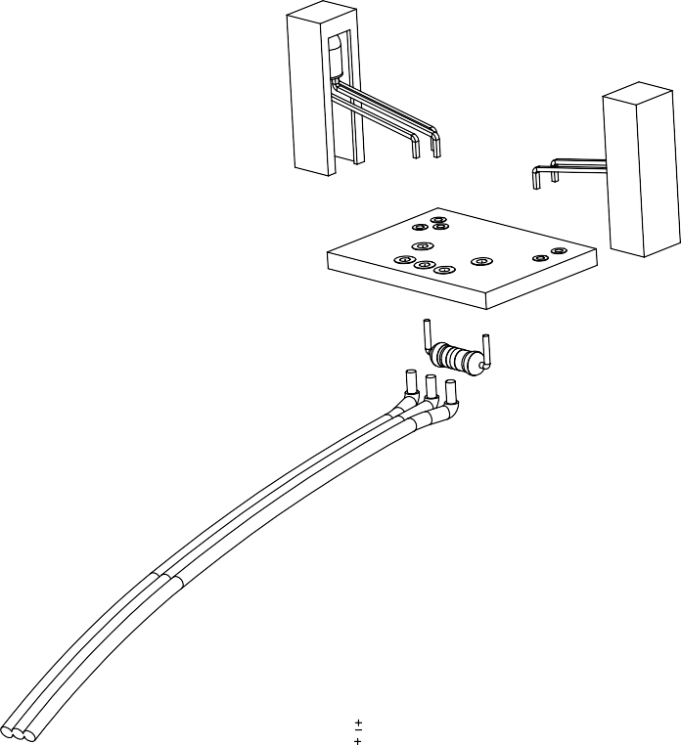

Springer Nature 2021 LATEX template

32 *Pellet Dispenser*

# References

1. Raspberry Pi 3 Model B+. [https://www.raspberrypi.org/products/](https://www.raspberrypi.org/products/raspberry-pi-3-model-b-plus/) [raspberry-pi-3-model-b-plus/](https://www.raspberrypi.org/products/raspberry-pi-3-model-b-plus/)
2. Adafruit 16-Channel PWM / Servo HAT for Raspberry Pi. [https://www.](https://www.adafruit.com/product/2327) [adafruit.com/product/2327](https://www.adafruit.com/product/2327)
3. Z-ULTRAT 3D printer Filament. [https://zortrax.com/filaments/](https://zortrax.com/filaments/z-ultrat/) [z-ultrat/](https://zortrax.com/filaments/z-ultrat/)
4. Zortrax M200 Plus FDM Printer. [https://zortrax.com/3d-printers/](https://zortrax.com/3d-printers/m200-plus/) [m200-plus/](https://zortrax.com/3d-printers/m200-plus/)
5. Dustless Precision Pellets® Rodent Grain-Based Diet, Bio-Serv. [https://us.vwr.com/store/product/15984153/](https://us.vwr.com/store/product/15984153/dustless-precision-pellets-rodent-grain-based-diet-bio-serv) [dustless-precision-pellets-rodent-grain-based-diet-bio-serv](https://us.vwr.com/store/product/15984153/dustless-precision-pellets-rodent-grain-based-diet-bio-serv)
6. HSR-1425CR Continuous Rotation Robot Servo. [https://hitecrcd.com/](https://hitecrcd.com/products/servos/robotic-servos/hsr1425/product) [products/servos/robotic-servos/hsr1425/product](https://hitecrcd.com/products/servos/robotic-servos/hsr1425/product)
7. Continuous Rotation Servo - FeeTech FS5103R. [https://www.adafruit.](https://www.adafruit.com/product/154) [com/product/154](https://www.adafruit.com/product/154)
8. Photo Interrupter - GP1A57HRJ00F. [https://www.sparkfun.com/](https://www.sparkfun.com/products/9299) [products/9299](https://www.sparkfun.com/products/9299)
9. SparkFun Photo Interrupter Breakout Board - GP1A57HRJ00F. [https:](https://www.sparkfun.com/products/9322)

[//www.sparkfun.com/products/9322](https://www.sparkfun.com/products/9322)

1. IR Break Beam Sensors with Premium Wire Header Ends - 3mm LEDs. <https://www.adafruit.com/product/2167>
2. Adafruit Servo Hat Tutorial. [https://learn.adafruit.com/](https://learn.adafruit.com/adafruit-16-channel-pwm-servo-hat-for-raspberry-pi/overview) [adafruit-16-channel-pwm-servo-hat-for-raspberry-pi/overview](https://learn.adafruit.com/adafruit-16-channel-pwm-servo-hat-for-raspberry-pi/overview)