SolidWorks

Stress Plot for load 1:

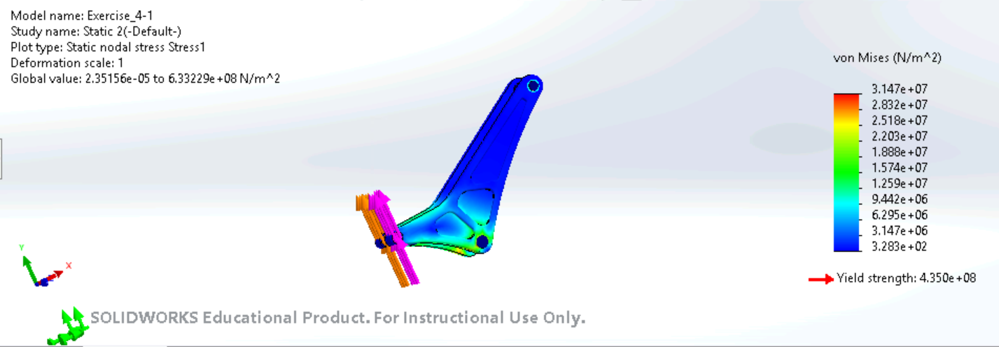

Stress Plot for load 2:

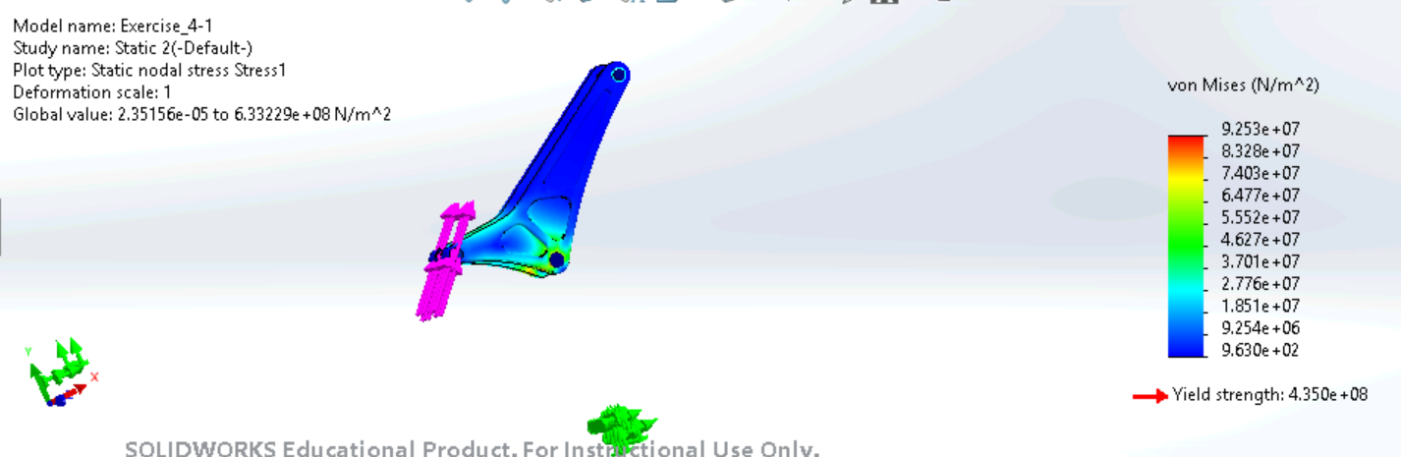

Inspire

Stress Plot load 1:

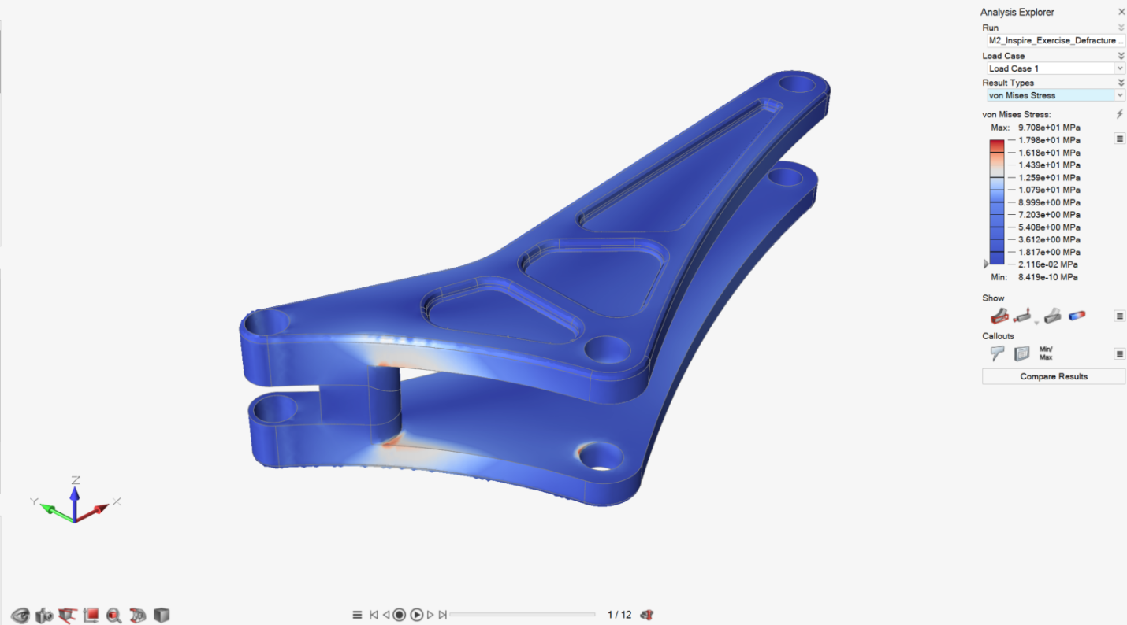

Stress Plot for load 2:

