Use Cases and Logical Architecture

X00099816

Dónal McManus

Project Odyssey

## Section 1: Use Cases

|  |  |
| --- | --- |
| Title (goal) | becomeMentor – have an employee become a mentor |
| Primary Actor | Employee |
| Story | The employee will select the Mentoring option from the sidebar, once clicked it will bring them to the Mentoring dashboard where they will see all current and previous Mentoring experiences they have been involved in. On the top there will be a button ‘Become Mentor’ once clicked it will bring them to a form to fill out with what topic and subtopic they would like to mentor along with how many hours a week or month they have available and on what days. Once the form is filled out correctly and all validations pass, they can click on the submit button. This employee is now a mentor and will be able to be requested to another Employee seeking mentorship |

|  |  |
| --- | --- |
| Title (goal) | becomeMentee – have an employee become a mentee |
| Primary Actor | Employee |
| Story | The employee will select the Mentee option from the sidebar, once clicked it will bring them to the Mentee dashboard where they will see all current and previous Mentee experiences they have been involved in. On the top there will be a button ‘Become Mentee’. When clicked a form will appear identical to the mentor form, after filling this out and submitting it they will be brought to a page with a listing of mentors that match your inputs regarding topic, subtopic and availability. When the employee selects a mentor and confirms the option they become a mentee. |

|  |  |
| --- | --- |
| Title (goal) | viewTeam – managers ability to view his team members |
| Primary Actor | Employee (Manager) |
| Story | A Manager can view the employees in his team by selecting the manager option in the sidebar (only visible by managers). When clicked the manager will be brought to their manager dashboard which will display the employees in their team in a table format. The rows of employees will show a quick overview of the employee and their activity. |

|  |  |
| --- | --- |
| Title (goal) | createEmployee – the ability of an administrator to add an employee |
| Primary Actor | Employee (Admin) |
| Story | The admin can select the administration option on the sidebar (only visible by admins), when clicked they will be brought to the administration dashboard from which they can click a button at the top of the page ‘Create Employee’. Once clicked a form will appear for the admin to fill out all the nesacery information to create a user which will be validated. The on click of the button ‘submit’ a new employee will be added to the list of employees. |

|  |  |
| --- | --- |
| Title (goal) | viewEmployee – view details of an employee |
| Primary Actor | Employee (Admin & Manager) |
| Story | In both the Manger and the Administration dashboard will display a list of employees with the option to view an employee by clicking on a view icon. When clicked the list of employees will be pushed down by the display of the employee you clicked on, the view will display all details and activities of the employee. |

|  |  |
| --- | --- |
| Title (goal) | createOdyssey – finalise the details of an odyssey |
| Primary Actor | Employee (Mentor & Mentee) |
| Story | Once a mentee has selected a mentor, the mentor will be notified and asked to enter a suggested time to have their meetings. This will then be sent to the mentee to accept or propose a different time or day. Once both agree on a schedule the times will update both employees’ availability and their schedules will be updated. |

|  |  |
| --- | --- |
| Title (goal) | reviewOdyssey – have a post odyssey review |
| Primary Actor | Employee (Mentor & Mentee) |
| Story | At the end of the odyssey both the mentor and mentee will be asked to fill out a review of how the odyssey went giving feedback on both the experience and the other member. There will be a form to fill out with options and text boxes, finally an option to rate the other employee out of five. |

|  |  |
| --- | --- |
| Title (goal) | editProfile – lets employees edit their profile details |
| Primary Actor | Employee |
| Story | A profile icon will be on the title bar, when selected you will be brought to your profile page where all your information is displayed to you. On this screen there are several boxes showing your personal information, your skills, previous and current odysseys with figures for them. Each of these sections with have an edit icon when clicked you change create, update and delete anything in that section, with the option to then save changes or cancel. |

## Section 2: Prototype Schedule, Winter Semester 2017

|  |  |
| --- | --- |
| Iteration #1, Complete 25/10/2017 | becomeMentor, becomeMentee |
| Iteration #2 Complete 15/11/2017 | reviewOdyssey, createOdyssey, createEmployee |
| Iteration #3 Complete 13/12/2017 | editProfile, viewTeam, viewEmployee |

## 

## 

## Section 3: Logical Architecture

This will be a web-based application, it will be hosted on AWS. The connection will be over HTTPS. The database will be a AWS database with security restrictions around it. Java will be used for the core functionality with a RESTful API and it will persist to the database using Hibernate. There will be a Python application for data processing with a stretch goal of machine learning this will also have a RESTful API which could directly communicate with the Java API. The frontend would use the React library. User data would be encrypted. The use of a container is still in discussion, if this goes ahead Docker will be the choice.

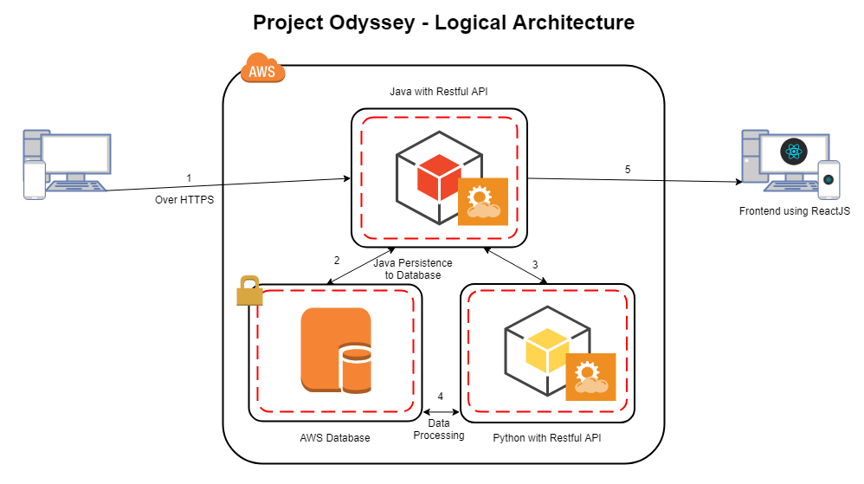

## Logical Architecture Discussion

[1] The tool will be able to be accessed through the web from both mobile and desktop. It will be accessed over HTTPS for more security. It will be hosted on AWS, once the user has signed in [2] most actions the user does will be handled by the java backend. [3] Data will be persisted to the database from Java using Hibernate. [3][4] If the user requires some data processing the Java API will call upon the Python API which will run its processing on the database and then feed its findings back to the Java API. [5] This will then be outputted to the user with the help of the React library with HTML and SCSS.