**SOFTWARE DESIGN SPECIFICATION**

**AccessScienceS**

**Revision History**

|  |  |  |  |  |  |  |
| --- | --- | --- | --- | --- | --- | --- |
| **Ver. #** | **Description of change** | **Sections Affected** | **Created/ Modified By** | **Reviewed By** | **Approved By** | **Date of issue** |
| 1 | Initial Draft | Whole sections |  |  |  |  |

**Table of contents**

# **1 Scope**

*<Mention the project scope in brief>*

# **2 Design Alternate Solutions**

*<Mention alternative solutions evaluated and provide links to documents containing the same if any>*

# **3 System Architecture**

*<System architecture represents the structure of the software. This includes the structural arrangements of software components, and various static and dynamic interrelationships between these components. Present the architecture diagram and describe the different layers / Components in the project.>*

*<Also represent the deployment architecture as a diagram which actually shows the interrelationships of various components involved in the application deployment>*

# **4 Solution Summary**

*<This section briefs the special designs/security/exceptions and error handling to be implemented in the application.>*

## **4.1 System Security**

*<This section should describe about various security methods going to be followed in the application. Also Describe about Authentication/Authorization/Role rights related designs.>*

## **4.2 Exception and Error Handling**

*<This section should brief about how the exception will be handled in the application design and if any errors are occurred, what will be the communication mechanism.>*

## **4.3 Special Designs**

*<Please brief about any special designs followed in the project>*

*The following are some samples.*

*Configurable Records per page for Data Grid*

*Application Configuration Settings*

*Database connection parameters such as User id, Password and Server name.*

*Error log path or any special settings to be followed in the application.*

## **4.4 Directory Structure**

*<This should brief about physical solution structure which is going to be followed in the application design. This should address what are the projects solution is going to contain, and each project level what will be the folder structure.>*

## **4.5 Software Requirement**

|  |  |  |  |
| --- | --- | --- | --- |
| **System** | **Development** | **Test/UAT** | **Production** |
| Web Server |  |  |  |
| Application Server |  |  |  |
| Database |  |  |  |
| Browser |  |  |  |
| Client side scripting |  |  |  |
| Server side Languages |  |  |  |
| Reporting |  |  |  |
| Development IDE |  |  |  |
| Other Frameworks |  |  |  |
| Frameworks |  |  |  |
| Tools |  |  |  |
| Configuration Management |  |  |  |
| Design Tool |  |  |  |

## **4.6 Hardware Requirement**

|  |  |  |  |
| --- | --- | --- | --- |
| System | **Development** | **Test/UAT** | **Production** |
| Machine configuration |  |  |  |
| Network details |  |  |  |
| Firewall details |  |  |  |
|  |  |  |  |
|  |  |  |  |
|  |  |  |  |
|  |  |  |  |

## **4.7 Re-useable components**

*<List all the reusable components to be used in the application. Mention any new reusable components being developed and describe how the same would be updated >*

**5 User Interface Design**

#### **5.1 Create Document**

|  |  |
| --- | --- |
| **Requirement ID** | **Description** |
| FRD-DM-001 | Create a document in QDMS |

##### **5.1.1 Screen Layout**

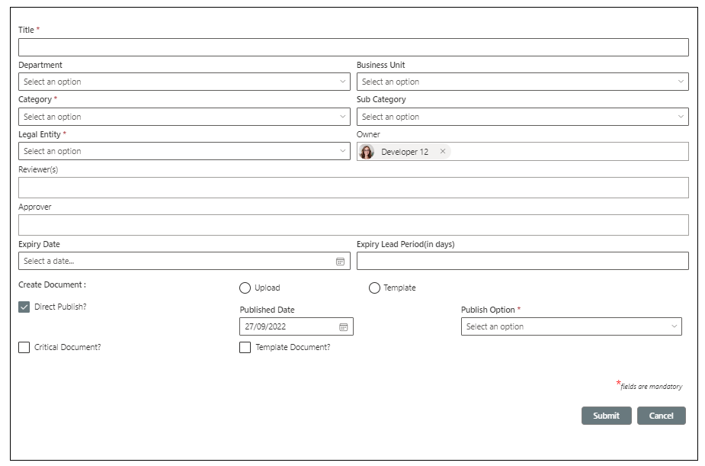

##### **5.1.2 Functional description**

* SPFX webpart will be developed for implementing the functionality for creating a document in QDMS.
* Create document webpart will have the provision to choose a standard document template which is published as Template in published library to create a document from the scratch.
* Externally prepared documents can be attached for creating a document in the system.
* Webpart will generate a unique *Document Id* for documents and this D*ocument Id* and *Title* will be appended to generate the document name.
* Document Index custom list will keep the metadata of the document and actual document will be kept in Source Documents.
* Document will be published to Published Documents library with a new revision number after review/ approval process.
* Metadata of *Source Documents* and *Published Documents* libraries will be in sync with *Document* *Index* list.
* *Reviewer (s)* and *Approver* can be set from the webpart, and it can be modified later from send workflow form.
* Webpart will have a *Direct Publish* option for publishing the document without sending it for review approval process.
* The *Direct Publish* option will be restricted for specific roles based on *Permission Matrix Settings*.

|  |  |  |  |
| --- | --- | --- | --- |
| **Property Name** | **Property Type** | **Display Name** | **Description** |
| DocumentIndexList | String | Document Index list name | Internal name of Document Index list and it will be same for QDMS and Projects |
| SourceDocumentLibrary | String | Source Documents library name | Internal name of Source Documents library and it will be same for QDMS and Projects |
| PublishedDocumentLibrary | String | Published Documents library name | Internal name of Published Documents library and it will be same for QDMS and Projects |
| UserMessageSettings | String | List name for end user messages | Internal name of User Message Settings list and it will be same for QDMS and Projects. |
| EmailNotificationSettings | String | List name for email messages | Internal name of Email Notification Settings list and it will be same for QDMS and Projects. |
| NotificationPreferenceSettings | String | List name for user email preference | Internal name Notification Preference Settings list and it will be same for QDMS and Projects. |
| PermissionMatrixSettings | String | List name for Permission Matrix Settings | Internal name of Permission Matrix Settings list and it will be same for QDMS and Projects. |
| Send Workflow page name | String | Page name of send workflow webpart | Eg. SendWorkflow.aspx |
| Revision History page name | String | Page name of revision history webpart | Eg. RevisionHistory.aspx |

##### **5.1.3 Page load**

Page load should load data, Webpart will function in following two modes

1. Legal Document
2. QDMS Document
3. Bind the following field values on page load.

Place the controls in the tab **Legal Document**

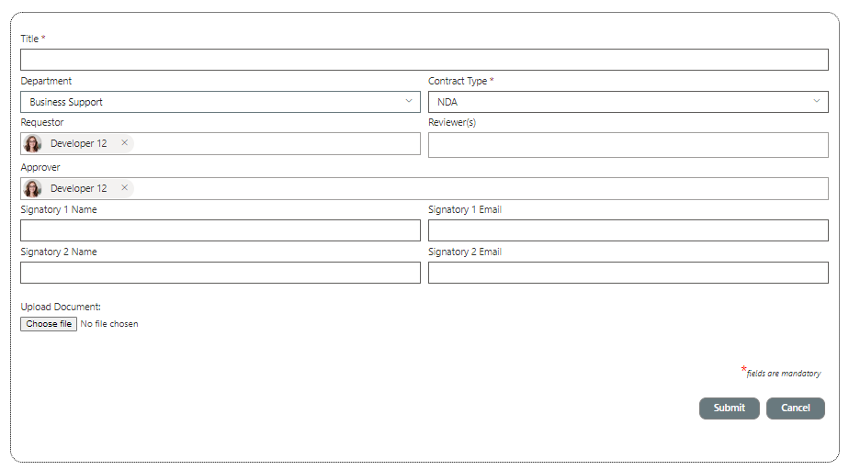

**Form controls**

|  |  |  |
| --- | --- | --- |
| **Field** | **Control** | **Description** |
| Title | Text Box | * Mandatory * Maximum 255 chars * Special characters including */\!@#$%^&*().+= are not allowed |
| Department | Drop Down | Lookup values from *Department* list’s Title field |
| Contract Type | Drop Down | *Contract-Type* list’s Title field and filter condition for QDMS |
| Owner | People Picker | With default value current user. |
| Reviewer(s) | Multi select people picker control | For entering Reviewers and it is optional |
| Approver | Single selection people picker control | For entering Approver and it is mandatory |
| Signatory1 Name | SLT | Capture the name of external signatory |
| Signatory1 Email | SLT | Capture the email of external signatory |
| Signatory2 Name | SLT | Capture the name of external signatory |
| Signatory2 Email | SLT | Capture the email of external signatory |

* Show the **Submit** and **Close** buttons

Place the controls in the tab **QDMS Document**



**Form controls**

|  |  |  |
| --- | --- | --- |
| **Field** | **Control** | **Description** |
| Title | Text Box | * Mandatory * Maximum 255 chars * Special characters including */\!@#$%^&*().+= are not allowed |
| Department | Drop Down | Lookup values from *Department* list’s Title field |
| Category | Drop Down | *Category* list’s Title field and filter condition for QDMS / Project |
| Owner | People Picker | With default value current user. |
| Reviewer(s) | Multi select people picker control | For entering Reviewers and it is optional |
| Approver | Single selection people picker control | For entering Approver and it is mandatory |
| Create Document | Radio | Upload Document & Select a Template |
| Select a Template | Drop Down | Filtered view of template documents from QDMS Published library. (*Template* = yes) |
| Upload Document | File Upload control | To choose an external file to create a document with it |
| Direct Publish | Check box | Default unselected |
| Approved Date | Date Picker | Default current date. Will be visible on selecting *Direct Publish* |
| Publish Option | Drop down | PDF / Native. Will be visible on selecting *Direct Publish* |
| Set Expiry | Checkbox | Initially check and uncheck based on value in Expiry Date |
| Expiry Date | Date picker | Should be a future date if a date is selected |
| Expiry Lead Period (in days) | Text Box | Number field. Will be visible in entering *Expiry Date* |
| Critical Document | Check box | Default unselected |
| Template | Check box | Default unselected, decides whether a document should be published as a template. |

* Show the **Submit** and **Close** buttons

##### **5.1.4 On Submit button click**

* Check validation of given field values and display messages to end user as per table.

|  |  |  |
| --- | --- | --- |
| **Field** | **Validation** | **Message** |
| Title | Mandatory | Title cannot be blank. |
| Title | Special characters including /\!@#$%^&*().+= are not allowed | Special characters /\!@#$%^&*().+= are not supported for document name. |
| Title | Maximum 200 char in length | Name cannot exceed 200 letters. |
| Department | Mandatory only if *Business Unit* is not selected | Choose either *Business Unit* or *Department*. |
| Category | Mandatory | Choose a Category value. |
| Owner | Mandatory | Owner field cannot be blank. |
| Approver | Mandatory | Mandatory |

* Meta data from the form will be saved to the Document Index list as below.

|  |  |  |
| --- | --- | --- |
| **Metadata from form** | **List Field (Internal name)** | **Description** |
| Document Id | DocumentID | Auto generated in the format AS_1010_00001 here  AS - Fixed text from Document ID Settings list  1010 – BU code or Department code  00001 - Sequence number |
| Title | Title | Text box in form |
| Department | Department | Dropdown values with data from Department master |
| Category | Category | Dropdown values with data from Category master |
| Sub Category | SubCategory | Dropdown values with data from Sub-Category master. Can be editable in edit form |
| Owner | Owner | People picker control with current user as default user. |
| Reviewer(s) | Reviewers | Multi selectable People picker control. |
| Approver | Approver | Single user People picker control. |
| Expiry Date | ExpiryDate | Datetime picker field |
| Expiry Lead Period | ExpiryLeadPeriod | Text box with optional value |
| Select a Template | DocumentTemplate | Dropdown with names of template documents from Published Documents library |
| Attachment | Attachment | File upload control |
| Create Document | CreateDocument | Check box |
| Direct Publish | DirectPublish | Checkbox |
| Publish Option | PublishOption | Dropdown with values “Native” or “PDF” |
| Approved Date | Approved Date | Date picker field and mandatory for *Direct Publish* |
| Critical Document | CriticalDocument | Checkbox , value will be using for notification preference checking. |
| Template | Template | Yes/ No – check box control |
| Type | Dropdown | Legal or QDMS |

* Create an entry in Document Revision History list if the document is upload or select as a template with Document name, created on, created by.

###### **5.1.5 Document ID generation**

* Check whether Business Unit or Department field value is selected. Get the code value of BU or Department based on the selection.
* If Business Unit is selected, read the code of selected Business Unit, else read Department code.
* Read the *Prefix , SequenceDigit, Separator* values from *DocumentIDSettings* list

E.g., AS , “_” and 5

*DocumentIDSettings*

|  |  |  |
| --- | --- | --- |
| **Prefix** | **Separator** | **SequenceDigit** |
| AS | **_** | **5** |

* Concatenate this with the code value of BU or Department i.e. EMEC_1010
* Get the Sequence value from *DocumentIDSequenceSettings* list for this combination

DocumentIDSequenceSettings

|  |  |
| --- | --- |
| **Code** | **Sequence** |
| AS _1010 | 1 |
| AS _1040 | 5 |

* Append zeros based on current *Sequence* value and *Sequence Digit* value, i.e., if the *Sequence* value is a one-digit number, pre append 4 zeros as *00001*
* Combine all these values with separator (underscore) and get the *Document ID* in a format as AS *_1010_00001*
* Increment the *Sequence* value and update the *QDMS DocumentIDSequenceSettings* list for the current combination, i.e., *Sequence* field value of AS*_1010* would be 2 after update.

##### **5.1.6 Create Document**

###### **Copy attachment document to Source Documents library**

* Read the attachment from *Document Index* item.
* Copy this file to a OneDrive location of current user and rename it with Document Name from Document Index item.
* Copy this document to *Source Documents* library with the same name.
* Update the metadata of this Source Document same as Document Index item fields.
* Update the *Document Link* field of *Document Index* list with this source document link.
* Remove the attachment from *Document Index* List

###### **Copy template document to Source Documents library**

* Read the selected template document from *Published Documents* library.
* Copy this file to a OneDrive location of current user and rename it with Document Name from Document Index item.
* Copy this document to *Source Documents* library with the same name.
* Update the metadata of this Source Document same as *Document Index* item fields.
* Update the *Document Link* field of *Document Index* list with this source document link.

###### **Direct Publish**

* Check whether *Direct Publish* check box is selected and *Publish Option*, *Approver* and *Approved Date* field values are entered
* Copy the document to *Published Documents* library if the selected *Published Option* is *Native*.
* Covert the OneDrive document to PDF if the selected *Published Option* is *PDF* and copy the PDF document to *Published Documents* library.
* Update the metadata of the published document same as Document Index item.
* Approve the source document to major version.
* Check whether there is any access groups defined for Category metadata in Category master list.
* If set, restrict the permission of published document for these access groups with read only access.
* Update the *Workflow Status* field value as *Published* in *Document Index, Source Documents* and *Published Documents.*

###### **Additional metadata field update**

* Update the hyperlink field *Edit Document* with the Site Page URL of Edit document webpart with a query string value of *Document Index* item id.
* Update the hyperlink field *Revision History* with the Site Page URL of *Revision History* webpart with a query string value of *Document Index* item id.
* Update the hyperlink field *Document version* with the Site Page URL of *Document Version* webpart with a query string value of Document Index item id.
* Update the hyperlink field *Send for workflow* with the Site Page URL of *Send Request* webpart with a query string value of Document Index item id.
* Update the hyperlink field *Revoke Expiry* with the Site Page URL of Edit *Document webpart* with a query string value of Document Index item id and mode=expiry.
* Update the hyperlink field *Void Document* with the Site Page URL od Void Send flow *webpart* with a query string value of Document Index item id.

#### **5.2 Edit Document**

|  |  |
| --- | --- |
| **Requirement ID** | **Description** |
| FRD-DM-002 | Edit a document in QDMS |

##### **5.2.1 Screen Layout**

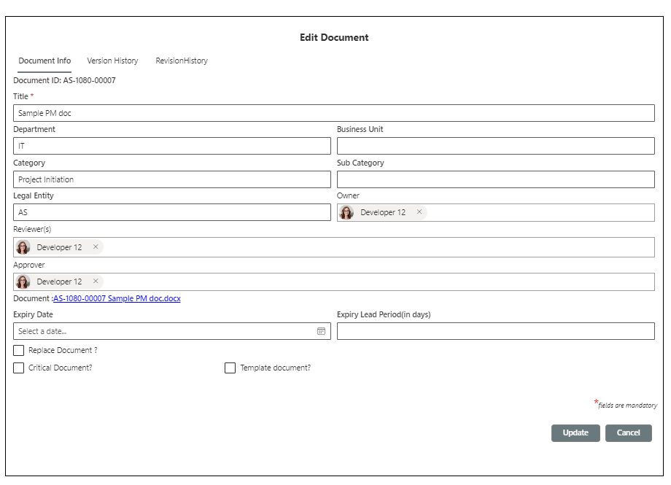

##### **5.2.2 Functional description**

* SPFX webpart will be developed for implementing the functionality for creating a document in QDMS.
* On clicking the Icon in Document Index List a new page will open with a query string as “did”in the URL

**1. Document Info**

* Get the item details with the “did” value and bind the controls as below.
* Place the controls in the tab **Document Info** and show Version History , Revision History tabs.
* Version History should load the current Source Document’s version history.
* Revision History should load current Document’s revision history.

**Form controls**

|  |  |  |
| --- | --- | --- |
| **Field** | **Control** | **Description** |
| Document ID | Label | Show the auto generated document Id as first field |
| Title | Text Box | Enable title only if current user has access to rename a document as per *PermissionMatrixSettings* list. |
| Department | Drop Down | Drop Down with current Department value as read only. |
| Category | Drop Down | Drop Down with current *Category* value as read only. |
| Owner | People Picker | Owner value from current item. |
| Reviewer(s) | Multi select people picker control | Reviewer value from current item. |
| Approver | Single selection people picker control | Approver value from current item. |
| Create Document | Radio button | Select a Template & Upload Document |
| Select a Template | Drop Down | Filtered view of template documents from QDMS Published library. (*Template* = yes). Show this field only if Source Document is yet to be created. Set the default value from current item. |
| Upload Document | File Upload control | To choose an external file to create a document with it |
| Direct Publish | Check box | Default unselected and hide if Source document is already created. |
| Approved Date | Date Picker | Default current date. Will be visible on selecting *Direct Publish* |
| Publish Option | Drop down | PDF / Native. Will be visible on selecting *Direct Publish* |
| Set Expiry | Checkbox | Initially check and uncheck based on value in Expiry Date |
| Expiry Date | Date picker | Should be a future date if a date is selected |
| Expiry Lead Period (in days) | Text Box | Number field. Will be visible in entering *Expiry Date* |
| Critical Document | Check box | Default unselected |
| Template | Check box | Default unselected, decides whether a document should be published as a template. |

* Show the **Submit** and **Close** buttons

###### **2.Version History**

SPFX webpart will be developed for implementing the functionality for viewing a document’s version history in QDMS.

**2.1 Screen Layout**

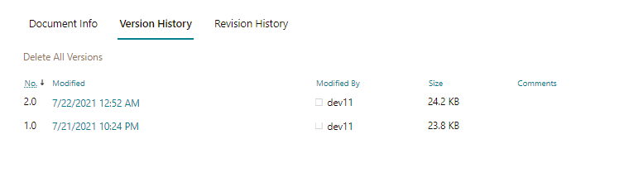

###### **3.Revision History**

SPFX webpart will be developed for implementing the functionality for viewing a document’s revision history in QDMS.

**3.1 Screen Layout**

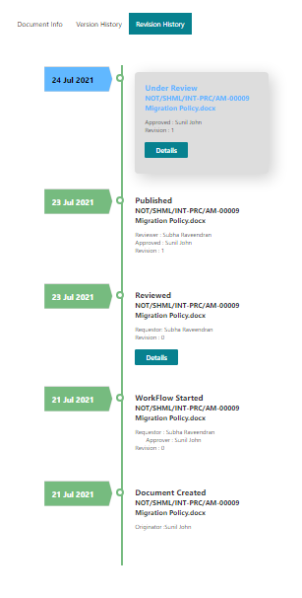

**3.2 On Click**

* On the basis of workflow status the revision history is loaded
* Get the item of Document Index list
* Get the items of details list with the edited Document Index list ID.
* Bind the data

#### **5.3 Send Workflow form**

|  |  |
| --- | --- |
| **Requirement ID** | **Description** |
| FRD-DM-003 | Send the QDMS document for review / approval. |

##### **5.3.1 Screen Layout**

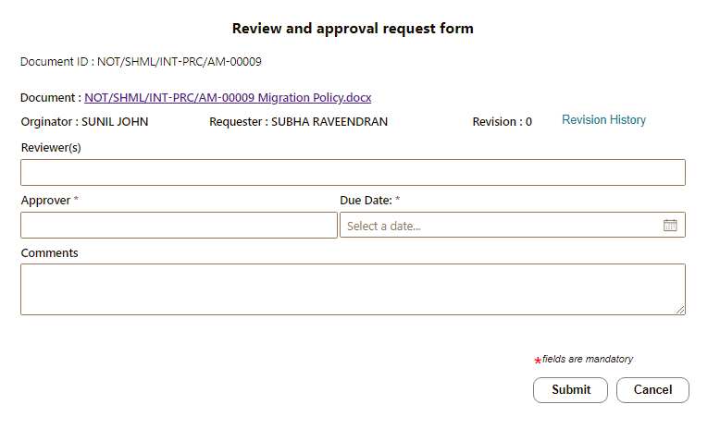

##### **5.3.2 Functional Description**

SPFX webpart will be developed for sending a document to review / approval process in QDMS .

Webpart properties

|  |  |  |  |
| --- | --- | --- | --- |
| **Property Name** | **Property Type** | **Display Name** | **Description** |
| WorkflowHeaderList | String | Workflow Header list name | Internal name of workflow header list and it will be same for QDMS and Projects |
| WorkflowDetailList | String | Workflow Detail list name | Internal name of workflow detail list and it will be same for QDMS and Projects |
| WorkflowTasksList | String | Workflow Tasks list name | Internal name of workflow tasks list and it will be same for QDMS and Projects |
| DocumentIndexList | String | Document Index list name | Internal name of Document Index list and it will be same for QDMS and Projects |
| SourceDocumentLibrary | String | Source Documents library name | Internal name of Source Documents library and it will be same for QDMS and Projects |
| PublishedDocumentLibrary | String | Published Documents library name | Internal name of Published Documents library and it will be same for QDMS and Projects |
| UserMessageSettings | String | List name for end user messages | Internal name of User Message Settings list and it will be same for QDMS and Projects. |
| EmailNotificationSettings | String | List name for email messages | Internal name of Email Notification Settings list and it will be same for QDMS and Projects. |
| NotificationPreferenceSettings | String | List name for user email preference | Internal name Notification Preference Settings list and it will be same for QDMS and Projects. |
| Review page name | String | Page name of review webpart | Eg. Review.aspx |
| Approval page name | String | Page name of approval webpart | Eg. Approval.aspx |

##### **5.3.3 On Page Load**

* Check the *Workflow Status* of the current document and if it is “*Under Review*” or “*Under Approval*” display the message “*There is already an ongoing workflow associated with this document.*” by querying *User Message settings*.
* Show the message for 5 seconds and redirect the user to Document Index list.
* For a valid user and valid document .
* Display the basic details of the document from *Document Index* list as shown in the screenshot.

**Form controls**

|  |  |  |
| --- | --- | --- |
| **Field** | **Control** | **Description** |
| Document ID | Label | Read only text to display document id. |
| Document name | Hyperlink | With Source document name as caption and Source document URL as URL |
| Revision History | Hyperlink | Link to Revision history. |
| Revision | Label | Read only text with Revision from Workflow Header list |
| Requestor | Label | Read only text with Requester username from Workflow Header list |
| Owner | Label | Owner of the document |
| Due Date | Textbox | Date picker to enter Due date. current date + default days set in webpart property |
| Requester Comments | Multiline text box | For Requester comment and it is optional. |
| Reviewer(s) | Multi select people picker control | For entering Reviewers and it is optional |
| Approver | Single selection people picker control | For entering Approver and it is mandatory |

##### **5.3.4 On Submit**

* Check the validation of field values

|  |  |
| --- | --- |
| **Display Name** | **Validation** |
| Approver | Mandatory |
| Due Date | Mandatory and should be a future date |

* Create an item in *Workflow Header* list in the QDMS site.

|  |  |
| --- | --- |
| **Form field** | **Form data** |
| Document Name | Document Name |
| Document ID | Document ID from form |
| Workflow Status | Under Review / Under Approval based on reviewers / approval selection. (Reviewers is an optional field) |
| Revision | Current revision |
| Requested Date | Current date |
| Source Document ID | ID of *Source Documents* |
| Document Index ID | ID of *Document Index* |
| Document Index | Lookup of *Document Index* list |
| Reviewers | Selected users in Reviewer people picker control. |
| Approver | Selected user in pprover people picker control. |
| Due Date | Due Date selected in date picker field. |
| Requester | Current user |
| Requester Comment | Comments entered in multiline text box. |
| Previous Review Header | Header id of previous review process. |
| Workflow | Review/ Approval based on reviewers / approval selection. (Reviewers is an optional field) |
| Owner | Owner of the document |

* Create individual items for all the reviewers in *Workflow Tasks list* only if Reviewers field is not blank.

|  |  |
| --- | --- |
| **List Field** | **Form data** |
| Title | Review [DocumentName] |
| Description | Review request for [DocumentName] by [Requester] on [RequestedDate]. |
| Priority | *Critical* if the current document is a critical document else leave it. |
| StartDate | Current date |
| DueDate | Due date from *Workflow Header* list |
| AssignedTo | Selected *Reviewer* from form |
| Link | URL to review page with hid and dtld id. Link to review / Approval page in the following format URL/Sitepages/Review.aspx?hid={0}&dtlid={1}  Or URL/Sitepages/Approve.aspx?hid{0}&dtlid={1}  Ge the page name from webpart properties |
| Source | QDMS / Project |
| Workflow | Review / Approval, based on *Reviewers* / *Approver* selection. (*Reviewers* is an optional field) |

* Create individual items for all the reviewers in *Workflow Details list* only if Reviewers field is not blank.

|  |  |
| --- | --- |
| **Form field** | **Form data** |
| Title | Document ID |
| Responsible | Selected *Reviewer* user in form |
| Response Status | Under Review |
| Header ID | Lookup to header list |
| Link | Link used in Task list |
| Task ID | Task ID generated for individual reviewers. |
| DueDate | DueDate from form |

* Update the *Workflow Status* as “*Under Review”* in *Document Index* and *Source Documents* for the current item if *Reviewers* field is not blank.
* Update the *Workflow Status* as “*Under Approval”* in *Document Index* and *Source Documents* for the current item if *Reviewers* field is blank.
* Check the Notification Preference Settings list for individual Reviewers
* Also check the *Critical* metadata of the selected document.
* Get the email subject and email body from *Notification Settings* list for the codes set for review process according to the status selected.
* Send review request notification to *reviewers* if the Notification Preference is set to Yes and the document is a critical document.
* If Reviewers field is blank and Approver is selected
* Create a task for approver user in *Workflow Tasks* list with details as below

|  |  |
| --- | --- |
| **List Field** | **Form data** |
| Title | Approve [DocumentName] |
| Description | Approval request for [DocumentName] by [Requester] on [RequestedDate]. |
| Priority | *Critical* if the current document is a critical document else leave it. |
| StartDate | Current date |
| DueDate | Due date from *Workflow Header* list |
| AssignedTo | Approver from *Workflow Header* list. |
| Link | URL to approve page with hid and dtld id. |
| Source | QDMS / Project |
| Workflow | Approve |

* Create an entry in *Workflow Details* list for the approver user with details as below

|  |  |
| --- | --- |
| **List Field** | **Form data** |
| Title | Approve [DocumentName] |
| Responsible | Approver from *Workflow Header* list or *Delegated To* user if the tsk has to be delegated on behalf of current *Approver*. |
| Response Status | Under approval |
| Workflow | Approve |
| Header ID | ID from *Workflow Header* list. |
| Task ID | Task id from *Workflow Tasks* |

* Check the *Notification Preference Settings* list for *Approver*. Also check the *Critical* metadata of the selected document. Send the notification to *Approver* if the Notification Preference is set to Yes and the document is a critical document. By default, system should send notification for all the critical documents even if there is no preference set for the user.
* Get the email subject and email body from *Notification Settings* list for the codes set for approve process. Build the email subject and email body with dynamic content and send the email to approver with requester’s email as from address.
* Display the message to current user based on the action performed and whether the operation is success or not. Read message content from *User Message Settings* list with corresponding codes set for Review process.
* Show the success/ error message for 5 seconds and redirect the user back to *Dashboard (page name can be set in webpart property)*.

##### **5.3.5 On Cancel**

* Redirect the user back to *Dashboard (page name can be set in webpart property)* by asking a confirmation message “Are you sure you want to redirect from this page?”

#### **5.4 Document Review process**

|  |  |
| --- | --- |
| **Requirement ID** | **Description** |
| FRD-DM-004 | Workflow – QDMS Document Review process |

##### **5.4.1 Screen Layout**

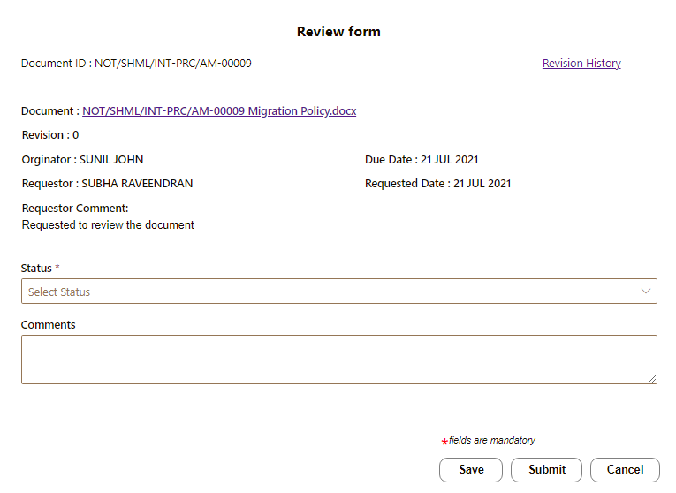

##### **5.4.2 Functional description**

SPFX webpart will be developed for handling review process in QDMS

**Webpart properties**

|  |  |  |  |
| --- | --- | --- | --- |
| **Property Name** | **Property Type** | **Display Name** | **Description** |
| WorkflowHeaderList | String | Workflow Header list name | Internal name of workflow header list and it will be same for QDMS and Projects |
| WorkflowDetailList | String | Workflow Detail list name | Internal name of workflow detail list and it will be same for QDMS and Projects |
| WorkflowTasksList | String | Workflow Tasks list name | Internal name of workflow tasks list and it will be same for QDMS and Projects |
| DocumentIndexList | String | Document Index list name | Internal name of Document Index list and it will be same for QDMS and Projects |
| SourceDocumentLibrary | String | Source Documents library name | Internal name of Source Documents library and it will be same for QDMS and Projects |
| DocumentRevisionLog | String | Document Revision Log list name | Internal name of DocumentRevisionLog list. |
| UserMessageSettings | String | List name for end user messages | Internal name of User Message Settings list and it will be same for QDMS and Projects. |
| EmailNotificationSettings | String | List name for email messages | Internal name of Email Notification Settings list and it will be same for QDMS and Projects. |
| NotificationPreferenceSettings | String | List name for user email preference | Internal name Notification Preference Settings list and it will be same for QDMS and Projects. |

##### **5.4.3 On Page Load**

* Get the *Header ID* and *Detail ID* from URL query string and check whether it is null.

e.g., hid=1&dtlid=12

* If the values are null, show the message “*Invalid review link. Required parameters are missing for the review process*” by querying *User Message settings*.
* Show the message for 5 seconds and redirect the user to dashboard page.
* Check whether current user is permitted to perform the current review request by checking the Details item with query string value of *dtlid*.
* If the detail item does not match for the current user,
* show the message “*You are not permitted to perform this operation*” by querying *User Message settings*.
* Show the message for 5 seconds and redirect the user to dashboard page.
* If the detail item matches for the current user, Display the basic details of the document from *Workflow Header* list as shown in the screenshot.
* Display the last review process details in a table if the last review process was with status “*Returned with comments*”. For that check the current header item whether there is a value set in *PreviousReviewHeader*. If there is a value, query the *Workflow Details* list with this Id and show the details as below.

|  |  |  |
| --- | --- | --- |
| **Reviewer** | **Reviewed Date** | **Comments** |
| Reviewer1 | - | - |
| ---- | -- | -- |

* Display the saved comment from *Workflow Details* list if the review request is draft saved.
* Display the Status and Comment from Details list if the user already completed his review request. Also disable the Save and Submit buttons for submitted requests.

**Form controls**

|  |  |  |
| --- | --- | --- |
| **Field** | **Control** | **Description** |
| Document ID | Label | Id of the current document. |
| Document name | Hyperlink | With Source document name as caption and Source document URL as URL |
| Revision History | Hyperlink | Link to Revision history. |
| Revision | Label | Read only text with Revision from Workflow Header list |
| Requestor | Label | Read only text with Requester username from Workflow Header list |
| Owner | Label | Owner of the document |
| Due Date | Label | Read only text with Due date from Workflow Header list |
| Requester Comments | Label | Read only text with Requester comments from Workflow Header list |
| Requested Date | Label | Read only text with Requested date from Workflow Header list |
| Status | Dropdown | Dropdown with values *Reviewed* and *Returned with comments*. |
| Comments | Multiline text box | Mandatory and editable multiline text box to enter approver’s comment. |

##### **5.4.4 On Save as draft**

* Update the Workflow *Details* item using the detail id.

|  |  |
| --- | --- |
| **Form field** | **Form data** |
| Responsible Comment | Comment from form |

* Display a message to current user based on the action performed and whether the operation is success or not. Read message content from *User Message Settings* list with corresponding codes set for Review process.

##### **5.4.5 On Submit**

* Check the validation of field values

|  |  |
| --- | --- |
| **Display Name** | **Validation** |
| Comments | Mandatory |
| Status | Mandatory |

* Delete the task associated with this review request in *Workflow Tasks* using the *Task ID* field value of current detail item.
* Update the Workflow *Details* item using the detail id.

|  |  |
| --- | --- |
| **Form field** | **Form data** |
| Response Date | Current date |
| Responsible Comment | Comment from form |
| Response Status | Status from form |

* If current user is the last reviewer, check the Response status of all the reviewers for the same header id and check any one of the status values is “*Returned with comments”.*

– Update the *Workflow Status* as “*Returned with comments”* in *Document Index* and *Source Documents* for the current item.

* Update the entry in *WorkflowHeader* list using the header id.

|  |  |
| --- | --- |
| **Form field** | **Form data** |
| Workflow Status | *Returned with comments* |
| Reviewed Date | Current date (for the completed review process) |

* Check the Notification Preference Settings list for *Owner* and *Requester*. Also check the *Critical* metadata of the selected document. Send the notification to *Owner* and *Requester* if the Notification Preference is set to Yes and the document is a critical document.
* Get the email subject and email body from *Notification Settings* list for the codes set for review process according to the status selected.
* If the current user is the last reviewer, check the Response status of all the reviewers for the same header id and check whether all the status values are “*Reviewed”.* Then
* Update the *Workflow Status* as “*Under Approval”* in *Document Index* and *Source Documents* for the current item.
* Update the in *WorkflowHeader* item using the header id.

|  |  |
| --- | --- |
| **List field** | **Form data** |
| Workflow Status | *Under Approval* |
| Approver | *Delegated To* user if the tsk has to be delegated on behalf of current *Approver*. |
| Reviewed Date | Current date (for the completed review process) |

* Create a task for approver user in *Workflow Tasks* list with details as below

|  |  |
| --- | --- |
| **List Field** | **Form data** |
| Title | Approve [DocumentName] |
| Description | Approval request for [DocumentName] by [Requester] on [RequestedDate]. |
| Priority | *Critical* if the current document is a critical document else leave it. |
| StartDate | Current date |
| DueDate | Due date from *Workflow Header* list |
| AssignedTo | Approver from *Workflow Header* list. |
| Link | URL to approve page with hid and dtld id. |
| Source | QDMS / Project |
| Workflow | Approve |

* Create an entry in *Workflow Details* list for the approver user with details as below

|  |  |
| --- | --- |
| **List Field** | **Form data** |
| Title | Approve [DocumentName] |
| Responsible | Approver from *Workflow Header* list or *Delegated To* user if the tsk has to be delegated on behalf of current *Approver*. |
| Response Status | Under approval |
| Workflow | Approve |
| Header ID | ID from *Workflow Header* list. |
| Task ID | Task id from *Workflow Tasks* |

* Check the *Notification Preference Settings* list for *Approver*. Also check the *Critical* metadata of the selected document. Send the notification to *Approver* if the Notification Preference is set to Yes and the document is a critical document. By default, system should send notification for all the critical documents even if there is no preference set for the user.
* Get the email subject and email body from *Notification Settings* list for the codes set for approve process. Build the email subject and email body with dynamic content and send the email to approver with requester’s email as from address.
* Display the message to current user based on the action performed and whether the operation is success or not. Read message content from *User Message Settings* list with corresponding codes set for Review process.
* Show the success/ error message for 5 seconds and redirect the user back to *Dashboard (page name can be set in webpart property)*.

##### **5.4.6 On Cancel**

* Redirect the user back to *Dashboard (page name can be set in webpart property)* by asking a confirmation message “Are you sure you want to redirect from this page?”

#### **5.5 QDMS Document Approval**

|  |  |
| --- | --- |
| **Requirement ID** | **Description** |
| FRD-DM-005 | Approval process of a QDMS document by approver. |

##### **5.5.1 Screen Layout**

##### 

##### **5.5.2 Functional description**

SPFX webpart will be developed for handling approval process in QDMS.

**Webpart properties**

|  |  |  |  |
| --- | --- | --- | --- |
| **Property Name** | **Property Type** | **Display Name** | **Description** |
| WorkflowHeaderList | String | Workflow Header list name | Internal name of workflow header list and it will be same for QDMS and Projects |
| WorkflowDetailsList | String | Workflow Details list name | Internal name of workflow details list and it will be same for QDMS and Projects |
| WorkflowTasksList | String | Workflow Tasks list name | Internal name of workflow tasks list and it will be same for QDMS and Projects |
| DocumentIndexList | String | Document Index list name | Internal name of Document Index list and it will be same for QDMS and Projects |
| SourceDocumentLibrary | String | Source Documents library name | Internal name of Source Documents library and it will be same for QDMS and Projects |
| PublishedDocumentLibrary | String | Published Documents library name | Internal name of Published Documents library and it will be same for QDMS and Projects |
| UserMessageSettings | String | List name for end user messages | Internal name of User Message Settings list and it will be same for QDMS and Projects. |
| EmailNotificationSettings | String | List name for email messages | Internal name of Email Notification Settings list and it will be same for QDMS and Projects. |
| NotificationPreferenceSettings | String | List name for user email preference | Internal name Notification Preference Settings list and it will be same for QDMS and Projects. |
| Redirect URL | String | URL to redirect | Eg. emechub/home.aspx |
| PermissionMatrixSettings | String | List name for Permission Matrix Settings | PermissionMatrixSettings |
| DocumentRevisionLog | String | List name for Document Revision Log | DocumentRevisionLog |

##### **5.5.3 Page Load**

* Get the *Header ID* and *Detail ID* from URL query string and check whether it is null.

e.g., hid=1&dtlid=12

If the values are null, show the message “*Invalid approval link. Required parameters are missing for the approval process*” by querying *User Message settings*.

* Show the message for 5 seconds and redirect the user to dashboard page.
* Check whether current user is permitted to perform the current approval request by checking the Details item with query string value of *dtlid*.
* If the detail item does not match for the current user,
* show the message “*You are not permitted to perform this operation*” by querying *User Message settings*.
* Show the message for 5 seconds and redirect the user to dashboard page.
* If the detail item matches for the current user,
* Display the basic details of the document from *Workflow Header* list as shown in the screenshot.
* Display the review process details in a table by querying the *Workflow Details* list with header Id and show the details as below.

|  |  |  |
| --- | --- | --- |
| **Reviewer** | **Reviewed Date** | **Comments** |
| Reviewer1 | - | - |
| ---- | -- | -- |

* Display the saved comment from *Workflow Details* list if the approval request is draft saved.
* Display the *Status* and *Comment* from Details list if the user already completed his approval request. Also disable the Save and Submit buttons for submitted requests.

**Form controls**

|  |  |  |
| --- | --- | --- |
| **Field** | **Control** | **Description** |
| Document ID | **Label** | Read only text with Document id. |
| Document | Hyperlink | With Source document name as caption and Source document URL as URL |
| Revision History | Hyperlink | Link to Revision history. |
| Revision | Label | Read only text with Revision from Workflow Header list |
|  |  |  |
| Requestor | Label | Read only text with Requester username from Workflow Header list |
| Owner | Label | Owner of the document |
| Due Date | Label | Read only text with Due date from Workflow Header list |
| Requester Comments | Label | Read only text with Requester comments from Workflow Header list |
| Requested Date | Label | Read only text with Requested date from Workflow Header list |
| Status | Dropdown | Dropdown with values Approved , *Returned with comments and Rejected* |
| Publish Option | Dropdown | Native or PDF. Enable the field for first time publishing else preselect and disable the field with current Publish Option value from Document Index. |
| Comments | Multiline text box | Mandatory and editable multiline text box to enter approver’s comment. |

##### **5.5.4 On Save as draft**

* Update the Workflow *Details* item using the detail id.

|  |  |
| --- | --- |
| **Form field** | **Form data** |
| Responsible Comment | Comment from form |

* Display a message to current user based on the action performed and whether the operation is success or not. Read message content from *User Message Settings* list with corresponding codes set for Approval process.

##### **5.5.5 On Submit**

* Check the validation of field values

|  |  |
| --- | --- |
| **Display Name** | **Validation** |
| Comments | Mandatory |
| Status | Mandatory |
| Publish Option | Mandatory if status selected is “Approved” |

* If the selected status is *Approved*,
* Update the *Workflow* Status as *Published”* and *Publish Option* in *Document Index* and *Source Documents* for the current item.
* Increment the document revision by one in the case of QDMS documents and update the revision field.
* Update the in *WorkflowHeader* item using the header id.

|  |  |
| --- | --- |
| **List field** | **Form data** |
| Workflow Status | *Published* |
| Approval Completion Date | Current date |
| Publish Option | Selected publish option |

* Call the logic app flow for publishing the document
* Check if the Type in *Document Index* list is QDMS or Legal
* If the Type is QDMS Publish the document in selected publish option and add the published document in *Published Documents* library.
* If the Type is Legal Publish the document in selected publish option and add the published document in *Published Staging Documents* library.
* *DocumentID*, Revision and all other metadata of this *Published Document* should be same as *Source Document.*
* Publish the *Source Document* to next major version.

If the response status from logic app flow is “OK” then

* Delete the task associated with this approval request in *Workflow Tasks* using the *Task ID* field value of current detail item.
* Update the Workflow *Details* item using the detail id.

|  |  |
| --- | --- |
| **Form field** | **Form data** |
| Response Date | Current date |
| Responsible Comment | Comment from form |
| Response Status | Status from form |

* If the status selected is “*Returned with comments” or “Rejected”.*

– Update the *Workflow Status* as “*Returned with comments” or “Rejected”* in *Document Index* and *Source Documents* for the current item.

* Update the entry in *WorkflowHeader* list using the header id.

|  |  |
| --- | --- |
| **Form field** | **Form data** |
| Workflow Status | *Returned with comments or “Rejected”* based on the selection |
| Approval Completion Date | Current date |

* For “Rejected” status
* Check the Notification Preference Settings list for *Owner* and *Requester*.
* Also check the *Critical* metadata of the selected document.
* Send the notification to *Owner* and *Requester* if the Notification Preference is set to *Yes* and the document is a critical document.
* For “*Returned with comments*” status
* Check the Notification Preference Settings list for *Owner* and *Requester*.
* Also check the *Critical* metadata of the selected document.
* Send the notification to *Owner* and *Requester* if the Notification Preference is set to *Yes* and the document is a critical document.
* Get the email subject and email body from *Notification Settings* list for the codes set for review process according to the status selected.
* Check the *Notification Preference Settings* list for *Requester* and *Owner.* Also check the *Critical* metadata of the selected document. Send the notification to *Requester* if the Notification Preference is set to Yes and the document is a critical document. By default, system should send notification for all the critical documents even if there is no preference set for the user.
* Get the email subject and email body from *Notification Settings* list for the codes set for approve process. Build the email subject and email body with dynamic content and send the email to approver with requester’s email as from address.
* Display the message to current user based on the action performed and whether the operation is success or not. Read message content from *User Message Settings* list with corresponding codes set for Review process.
* Show the success/ error message for 5 seconds and redirect the user back to *Dashboard (page name can be set in webpart property)*.

##### **5.5.6 On Cancel**

* Redirect the user back to *Dashboard (page name can be set in webpart property)* by asking a confirmation message “Are you sure you want to redirect from this page?”

#### **5.6 Document Expiry Process**

|  |  |
| --- | --- |
| Requirement ID | Description |
| FRD-DM-006 | Document Expiry Process |

###### **5.6.2 Functional description**

* Automate flow will be developed for implementing the functionality for setting QDMS
* There is no interface for this.
* In this workflow process first capture expiry date of QDMS Published Documents and uncontrolled documents from projects.
* System shall have a settings list to capture expiry lead period where user can define lead period in days.
* Send notification to the originator user after expiry of a document.
* System shall capture Lead period of individual documents from new form and edit form of Document Index. This expiry date will be set in Published Documents only after publishing. Expiry date from Published library will be considered for expiry process.
* Originator shall be notified before expiry date based on lead period settings.
* E.g., If lead period is 20 days, reminder notification shall be sent to Originator 20 days before expiry date
* If there is no lead period in document then it should take from common list.
* System shall have provision to set expiry date for QDMS documents from create doc of Document Index
* System shall have provision to capture expiry date for other uncontrolled documents within QDMS site and set it as expired.
* System shall have a settings list to capture expiry lead period where user can define lead period in days.
* System shall capture Lead period of individual documents from new form and edit form of Document Index. This expiry date will be set in Published Documents only after publishing. Expiry date from Published library will be considered for expiry process.
* Originator shall be notified before expiry date based on lead period settings.
* E.g., If lead period is 20 days, reminder notification shall be sent to Originator 20 days before expiry date.
* Notification content shall contain document name as a link to actual document and E*xpiry Date* details.
* System shall run this workflow every day to check E*xpiry Date* of all the documents once in a day.
* System shall set the document status as *Expired* for Published Documents having Expiry *Date* matching with current date.
* System shall update the expiry date to Published Documents only after approval process.
* Expired documents shall be kept in a separate view and shall not be available in normal views.
* Permission of the expired documents shall be set to certain groups and restricted from normal users based on settings.
* Owners (having permission to edit expired documents) can revoke the expiry from Document Index list. Originator of the document shall be notified, and permission shall be reset.
* Expired documents shall not be available in search results for normal users.

**5.7 Revoke Expiry Documents**

|  |  |
| --- | --- |
| **Requirement ID** | **Description** |
| FRD-DM-007 | Revoke a document in QDMS |

##### **5.7.1 Screen Layout**

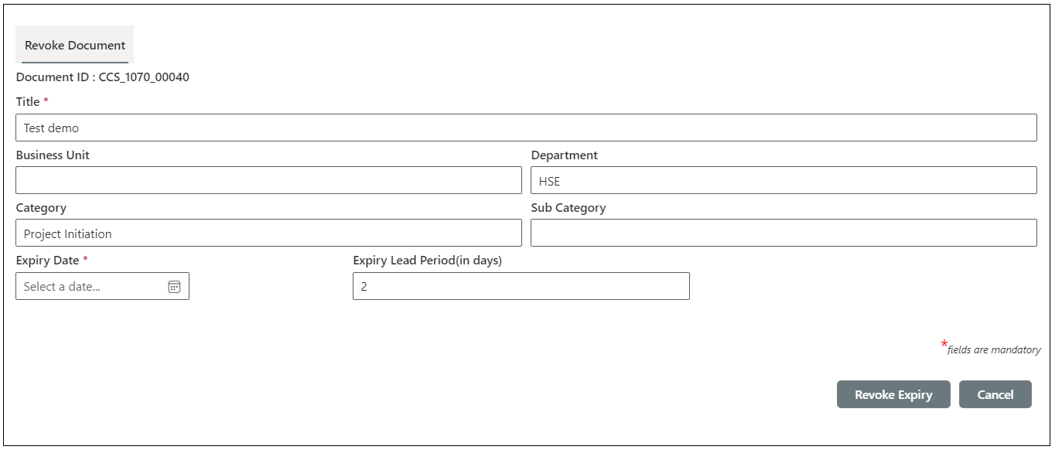

##### **5.7.2 Functional description**

* SPFX webpart will be developed for implementing the functionality for revoking a document in QDMS.
* On clicking the Icon in Document Index List a new page will open with a query string as “did” and “mode” in the URL
* Get the item details with the “did” value and bind the controls as below.
* Check whether current document’s *DocumentStatus* field value is “*Expired*”.
* If the above condition satisfied, show the basic metadata of the document as below

|  |  |  |
| --- | --- | --- |
| **Field** | **Control** | **Description** |
| Document ID | Label | Show the auto generated document Id as first field |
| Title | Text Box | Read only |
| Department | Drop Down | Drop Down with current *Department* value as read only. |
| Category | Drop Down | Drop Down with current *Category* value as read only. |

* Also show the Document Expiry details

|  |  |  |
| --- | --- | --- |
| **Field** | **Control** | **Description** |
| Set Expiry | Checkbox | Initially check and uncheck based on value in Expiry Date |
| Expiry Date | Date picker | Should be a future date if a date is selected |
| Expiry Lead Period (in days) | Text Box | Number field. Will be visible in entering *Expiry Date* |

* Show the **Revoke**  and **Close** buttons

**5.7.3 On Revoke Button Click**

* Update the document status as “Active” for Document Index, Source Document and Published Document.
* Reset the permission of Document Index, Source Document and Published Documents as initial permission.
* Send an email notification to Owner with the details of revoke expiry process.

**5.8 Document Revision History**

|  |  |
| --- | --- |
| **Requirement ID** | **Description** |
| FRD-DM-008 | Document Revision History |

##### **5.8.1 Functional description**

* SPFX webpart will be developed for implementing the functionality to track the stages of all the QDMS documents.
* It display document creation details such as Created by and created date as first entry in the revision history.
* Details of each workflow shall be displayed in revision history page.
* Able to send reminder to reviewers and approvers for pending tasks.

###### **5.8.1 Page Load**

* On the basis of workflow status, the revision history is loaded
  1. Item is created

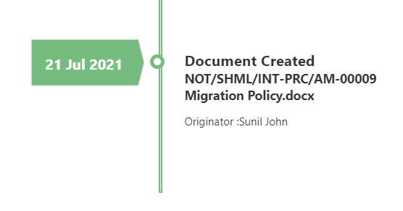

*Document Index (Document Index)*

|  |  |
| --- | --- |
| **Form field** | **List field** |
| Title | “Document Created” |
| Document Name | Document Name |
| Originator | Created By |
| Created On | Created |

* 1. Document starts Workflow

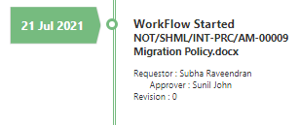

*WF Header List(WFHeaderList)*

|  |  |
| --- | --- |
| **Form field** | **List field** |
| Title | “Workflow Started” |
| Document Name | Document Name |
| Requestor | Requestor |
| Requested Date | Requested Date |
| Approver | Approver |
| Revision | Revision |

Document status is Under Review

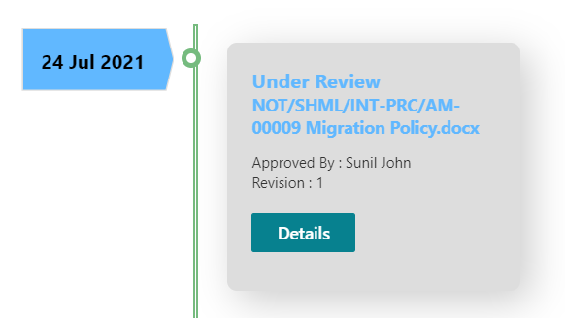

*WF Header List(WFHeaderList)*

|  |  |
| --- | --- |
| **Form field** | **List field** |
| Title | “Under Review” |
| Document Name | Document Name |
| Requestor | Requestor |
| Requested Date | Requested Date |
| Approver | Approver |
| Revision | Revision |

There is a button **“Details”**

On click

A modal is loaded. It contains the list of reviewers and the status.

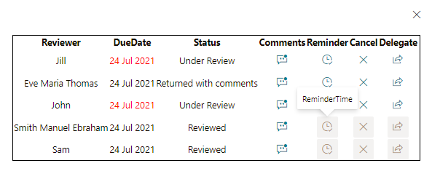

Get current user

Get Detail list where action is REW

*Detail List(DetailList)*

|  |  |
| --- | --- |
| **Form field** | **List field** |
| Responsible | Responsible |
| Status | Responsible Status |
| ExpiryDate | Expiry Date |
| Comment | Responsible Comment |

If the current user is the document originator or requestor the buttons are visible

Reminder

On click an email notification is send to the reviewer

Cancel

On click the status in Detail List is changed to cancelled

Delegate

On click a new field is visible to add a delegate user

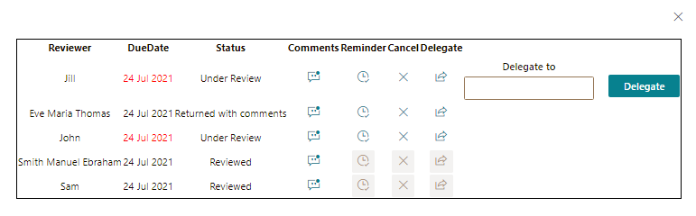

Document status is Reviewed

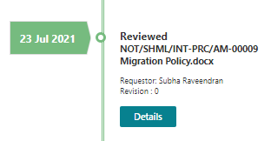

*WF Header List(WFHeaderList)*

|  |  |
| --- | --- |
| **Form field** | **List field** |
| Title | “Reviewed” |
| Document Name | Document Name |
| Requestor | Requestor |
| Orginator | Orginator |
| ExpiryDate | ExpiryDate |
| Revision | Revision |

There is a button **“Details”**

On click

A modal is loaded. It contains the list of reviewers and the status.

*Detail List(DetailList)*

|  |  |
| --- | --- |
| **Form field** | **List field** |
| Responsible | Responsible |
| Status | Responsible Status |
| ExpiryDate | Expiry Date |
| Comment | Responsible Comment |

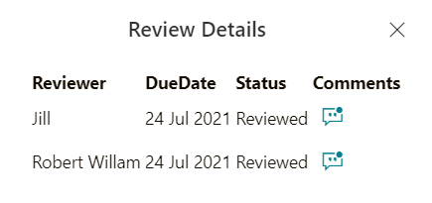

Document status is Published

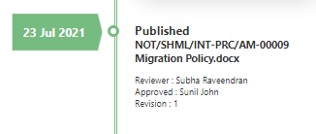

*WF Header List(WFHeaderList)*

|  |  |
| --- | --- |
| **Form field** | **List field** |
| Title | “Reviewed” |
| Document Name | Document Name |
| Requestor | Requestor |
| Orginator | Orginator |
| ExpiryDate | ExpiryDate |
| Revision | Revision |
| Approver | Approver |

There is a button **“Details”**

On click

A modal is loaded. It contains the list of reviewers.

*Detail List(DetailList)*

|  |  |
| --- | --- |
| **Form field** | **List field** |
| Responsible | Responsible |
| Status | Responsible Status |
| ExpiryDate | Expiry Date |
| Comment | Responsible Comment |



**5.9 Document Signature**

|  |  |
| --- | --- |
| **Requirement ID** | **Description** |
| FRD-DM-008 | Document Signature |

##### **5.9.1 Functional description**

* Automate flow will be developed for implementing the functionality for recieving signature in the document
* There is no interface for this.
* When an item is added to the *Published Staging Library* the automated flow is triggered
* Within that item details we can have Signatories Detail
* There we created an envelope for sending to recieve signatories as below

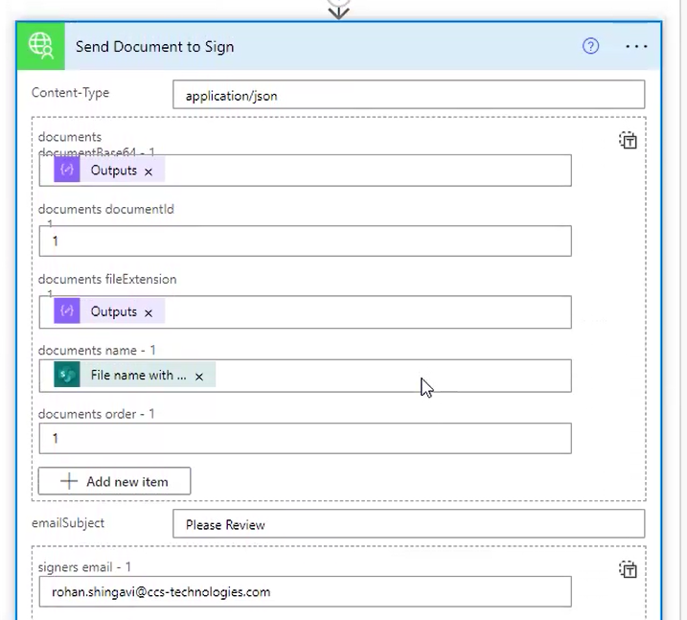

If we have multiple signatories

* After all signatories sign the document another Logic App will triggered whenever the Envelope status is completed
* Then create new item to the *Published Document Library*
* Update document status in Document Index, Source Document as Published

#### **5.10 Workflow - Void process**

|  |  |
| --- | --- |
| **Requirement ID** | **Description** |
| FRD-DM-010 | **Workflow - Void process** |

##### **5.10.1 Screen layout**

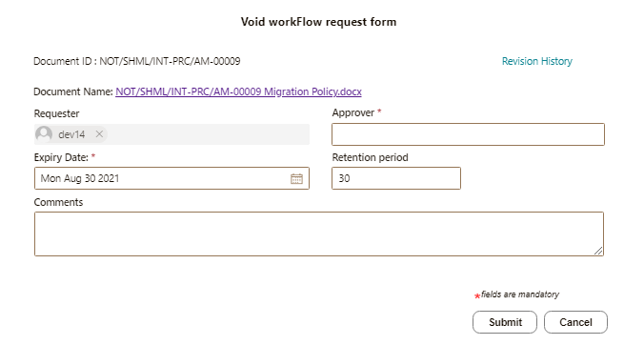

**5.10.2 Send Void Workflow Functional description**

* SPFX webpart will be developed for implementing void workflow for QDMS

**Webpart properties**

|  |  |  |  |
| --- | --- | --- | --- |
| **Property Name** | **Property Type** | **Display Name** | **Description** |
| WorkflowHeaderList | String | Workflow Header list name | Internal name of workflow header list and it will be same for QDMS and Projects |
| WorkflowDetailList | String | Workflow Detail list name | Internal name of workflow detail list and it will be same for QDMS and Projects |
| WorkflowTasksList | String | Workflow Tasks list name | Internal name of workflow tasks list and it will be same for QDMS and Projects |
| DocumentIndexList | String | Document Index list name | Internal name of Document Index list and it will be same for QDMS and Projects |
| SourceDocumentLibrary | String | Source Documents library name | Internal name of Source Documents library and it will be same for QDMS and Projects |
| PublishedDocumentLibrary | String | Published Documents library name | Internal name of Published Documents library and it will be same for QDMS and Projects |
| UserMessageSettings | String | List name for end user messages | Internal name of User Message Settings list and it will be same for QDMS and Projects. |
| EmailSettings | String | List name for email messages | Internal name of Email Notification Settings list and it will be same for QDMS and Projects. |
| NotificationPreferenceSettings | String | List name for user email preference | Internal name Notification Preference Settings list and it will be same for QDMS and Projects. |
| ApprovalPageName | String | Page name of void approval page. | VoidApproApprove  Eg.URL/Sitepages/VoidApprove.aspx?hid={0}&dtlid={1} |

**5.10.3 On Page Load**

* Check whether current user is permitted to send a void workflow.
* If invalid user, show the message “*You are not permitted to perform this operation*” by querying *User Message settings*.
* For a valid user
* Populate the document metadata as per the screenshot.
* Display the project number and project name for transmittal (project) documents.

**Form controls**

|  |  |  |
| --- | --- | --- |
| **Field** | **Control** | **Description** |
| Document name | Hyperlink | With Source document name as caption and Source document URL as URL |
| Requestor | Label with default value current user | Read only with current user as requester |
| Due Date | Datetime picker | Default current date + number of days from webpart property |
| Approver | People picker value | Any user from system |
| Owner | Label | Owner of the Document |
| Comments | Multiline text box | Optional multiline value |
| Retention period | Text box with number field validation | Number of days a document should be kept in the document library after void process. |

###### **5.10.4 On Submit**

* Check the validation of field values

|  |  |  |  |
| --- | --- | --- | --- |
| **Display Name** | **List Field** | **Type** | **Validation** |
| Due Date | DueDate | Date and Time | Mandatory and should be a future date |
| Approver | Approver | People picker | Mandatory |

* Add an item in *WorkflowHeader* item using the header id.

|  |  |
| --- | --- |
| **Form field** | **Form data** |
| Title | [Document Name] |
| Document ID | Document ID |
| Workflow Status | Ongoing |
| Revision | Current document revision |
| Requestor | Current user |
| Requested Date | Current date |
| Requestor Comment | Comments from form |
| Source Document ID | Source document id |
| Document Index ID | Document Index id |
| Document Index | Document Index lookup |
| Approver | Approver |
| Due Date | Due Date |
| Action | Void |

* Create an entry in *WorkflowDetails* list.

|  |  |
| --- | --- |
| **Form field** | **Form data** |
| Title | [Document Name] |
| Workflow Status | Ongoing |
| Responsible | Current document revision |
| Response Date | Current user |
| Responsible Comment | Current date |
| Response Status | Comments from form |
| Action | Void |
| HeaderID | Lookup |

* Create a task for approver user in *Workflow Tasks* list with details as below

|  |  |
| --- | --- |
| **List Field** | **Form data** |
| Title | Approve void request of [DocumentName] |
| Description | Void approval request for [DocumentName] by [Requester] on [RequestedDate]. |
| Priority | *Critical* if the current document is a critical document else leave it. |
| StartDate | Current date |
| DueDate | Due date from form |
| AssignedTo | Approver from form |
| Link | URL to Void Approval page with hid and dtld id. |
| Source | QDMS / Project |
| Workflow | Void |

* Check the Notification Preference Settings list for Approver and the *Critical* metadata of the selected document. Send the notification to Approver if the Notification Preference is set to Yes and the document is a critical document.
* Get the email subject and email body from *Notification Settings* for email sending.

###### **5.10.5 On Cancel**

* Redirect the user back to Document Index list.

###### **5.11 Approve Void Workflow**

###### **Functional description**

* SPFX webpart will be developed for approving a void workflow approval for QDMS.

**Screen layout**



**5.11.1. On Page Load**

* Check whether current user is permitted to approve the current void workflow request and display the message as “You are not permitted to perform this action”. Also display the close button to redirect the user back to Document Index list.
* Populate the document metadata as per the screenshot.

**Form controls**

|  |  |  |
| --- | --- | --- |
| **Field** | **Control** | **Description** |
| Document name | Hyperlink | With Source document name as caption and Source document URL as URL |
| Requestor | Label | Read only text with Requester username from Workflow Header list |
| Due Date | Label | Read only text with Due date from Workflow Header list |
| Requester Comments | Label | Read only text with Requester comments from Workflow Header list |
| Retention Period | Text box with number field validation | Display the Retention period set from send form |
| Status | Dropdown | Dropdown with values *Approved* and *Cancelled*. |
| Comments | Multiline text box | Optional and editable multiline text box to enter approver’s comment. |

###### **5.11.2 On Submit**

* Check the validation of field values

|  |  |
| --- | --- |
| **Display Name** | **Validation** |
| Retention Period | Number field validation |
| Status | Mandatory |

* Delete the task associated with this void request in *Workflow Tasks* using the task id from the URL query string if the selected status is “Approved”.
* Update the entry in *WorkflowHeader* list using the header id.

|  |  |
| --- | --- |
| **Form field** | **Form data** |
| Workflow Status | Status from form |
| Response Date | Current date |
| Action | Void |
| Retention Period | Retention Period from form |

* Create an entry in *WorkflowDetails* list using the detail id.

|  |  |
| --- | --- |
| **Form field** | **Form data** |
| Responsible | Current document revision |
| Response Date | Current date |
| Responsible Comment | Comment from form |
| Response Status | Status from form |
| Action | Void |

* Update the revision to X in *Document Index, Source Documents* and *Published Documents* if the selected status is “Approved”.
* Update the *Document Status* to “*Archived*” in *Document Index, Source Documents* and *Published Documents* if the selected status is “Approved”.
* Update the *Workflow Status* to “*Cancelled*” in *Document Index, Source Documents* and *Published Documents* if the selected status is “Cancelled”.
* Set the permission of the Source Document and Published Document as per *Permission Matrix Settings* list if the selected status is “Approved”.
* Check the Notification Preference Settings list for *Owner* and *Requester*. Also check the *Critical* metadata of the selected document. Send the notification to *Owner* and *Requester* if the Notification Preference is set to Yes and the document is a critical document.
* Get the email subject and email body from Notification Settings for email sending for the code “VoidApproved” or “VoidCancelled” according to the status selected.
* Display the message to end user based on the action performed and whether the operation is success or not. Read message content from *User Message Settings* list with corresponding codes “VoidApproveSuccess” or VoidCancelSuccess” or “VoidApproveError” or VoidCancelError”.

###### **5.11.3 On Cancel**

* Redirect the user back to *Document Index (page name can be set in webpart property)* by asking a confirmation message “Are you sure you want to redirect from this page?”

#### **6 Lists and Libraries**

|  |  |  |  |
| --- | --- | --- | --- |
|  | **Internal Name** | **Display Name** | **Description** |
| 1 | BusinessUnit | Business Unit | Add list of units |
| 2 | Department | Department | Add list of department |
| 3 | Category | Category | Add list of Categories |
| 4 | SubCategory | Sub-Category | Add list of subcategories |
| 5 | DocumentIndex | Document Index | Repository to add document metadata |
| 6 | SourceDocuments | Source Documents | Library to store documents |
| 7 | DocumentIDSettings | DocumentID Settings list | List to store ID combination |
| 8 | DocumentIDSequenceSettings | DocumentID Sequence Settings | List to store count of id |
| 9 | PublishedDocuments | Published Documents | Documents saved after published documents |
| 10 | WorkflowHeader | Workflow Header | Workflow Header List |
| 11 | WorkflowDetails | Workflow Details | List to store details |
| 12 | NotificationPreferenceSettings | Notification Preference Settings | List to save notification preference of the users |
| 13 | DocumentRevisionLog | Document Revision Log | To hold the status of the document revision |
| 14 | EmailSettings | Email Settings | Email content and subjects |
| 15 | PermissionMatrixSettings | Permission Matrix Settings |  |
| 16 | UserMessageSettings | User Message Settings | To keep the messages of actions |
| 17 | Tasks | Tasks | To save tasks with easy access Links |
| 18 | PublishedStagingDocuments | PublishedStaging Documents | To save the published documents before receiving External Signature |

##### **6.1 Business Unit(BusinessUnit)**

|  |  |  |  |  |
| --- | --- | --- | --- | --- |
| **Internal Name** | **Display Name** | **Type** | **Validation** | **Notes** |
| Title | Code | SLT | mandatory |  |
| BusinessUnitName | Unit Name | SLT | mandatory |  |

##### **6.2 Department (Department)**

|  |  |  |  |  |
| --- | --- | --- | --- | --- |
| **Internal Name** | **Display Name** | **Type** | **Validation** | **Notes** |
| Title | Code | SLT | mandatory |  |
| Department | Department | SLT | mandatory |  |

##### **6.3 Category (Category)**

|  |  |  |  |  |
| --- | --- | --- | --- | --- |
| **Internal Name** | **Display Name** | **Type** | **Validation** | **Notes** |
| Title | Code | SLT | mandatory |  |
| Category | Category | SLT | mandatory |  |

##### **6.4 Sub Category(SubCategory)**

|  |  |  |  |
| --- | --- | --- | --- |
| **Internal Name** | **Display Name** | **Type** | **Notes** |
| Title | Code | SLT |  |
| Subcategory | Sub-category | SLT |  |
| Category | Category | Lookup | From category list |

##### **6.5 Document Index(DocumentIndex)**

|  |  |  |  |  |
| --- | --- | --- | --- | --- |
| **Internal Name** | **Display Name** | **Type** | **Validation** | **Notes** |
| DocumentID | Document ID | SLT | *Mandatory  *Auto generated  *Unique  *Cannot be blank | Cannot be manually modified once generated |
| Title | Title | SLT | *Mandatory  *Special Characters including */\!@#$%^&*().+= are not allowed  Max length – 200 chars |  |
| DocumentName | Document Name | SLT |  | Combination of (DocumentID+ “ “+ Title) |
| BusinessUnitID | Business Unit ID | Number |  | ID of Business Unit item |
| BusinessUnit | Business Unit | SLT |  | Name of Business Unit item |
| CategoryID | Category ID | Number |  | ID from Category list |
| Category | Category | SLT |  | Name of Category item |
| SubCategoryID | Sub-Category ID | Number |  | ID from SubCategory list |
| SubCategory | Sub-Category | SLT |  | Name of SubCategory item |
| Originator | Originator | Person or Group |  | Default bind as current user |
| Reviewers | Reviewer(s) | Person or Group | *Not mandatory | Can have multiple values and limit to 50 persons |
| Approver | Approver | Person or Group | *Mandatory | Single selection |
| ExpiryDate | Expiry Date | Date and Time | optional | Date only |
| ExpiryLeadPeriod | Expiry Lead Period | Number | Optional |  |
| Revision | Revision | SLT | *Default 0 | Incremented after approval / publishing |
| WorkflowStatus | Workflow Status | Choice | *Default Draft  *System shall update the status value on each Workflow (WF) step. | Draft  Under Review  Returned with Comments  Under Approval  Published  Rejected  Cancelled |
| DocumentStatus | Document Status | Choice |  | Active  Expired  Archived |
| RevisionHistory | Revision History | Hyperlink |  | Link to Revision history page with query string Document Index item id. |
| LinktoDocument | Link to Document | Hyperlink |  | Link to Source Document |
| CreateDocument | Create Document | Yes/No |  | **Yes,** option shall create the document in the Source Documents library. |
| DirectPublish | Direct Publish | Yes/No |  | Yes, option publish the document in published library without sending it for review / approval. |
| PublishFormat | Publish Format | Choice | *Default Native | Values:  *Native  *PDF |
| ApprovedDate | Approved Date | DateTime | Date only | Mandatory for Direct Publish |
| CriticalDocument | Critical Document | Yes/No |  | Yes option to decide whether the document is a critical document. |
| Attachments | Attachments | Attachments |  | Allow to attach externally prepared drawings and other read only formatted documents for creating a new document. |
| SelectTemplate | Select Template | Lookup |  | Document Name from Published Documents list |

##### **6.6 Source Documents(SourceDocuments)**

|  |  |  |
| --- | --- | --- |
| **Internal Name** | **Display Name** | **Type** |
| Name | File Name | Hyperlink(Default) |
| DocumentID | Document ID | SLT |
| DocumentName | Document Name | SLT |
| DocumentIndex | Document Index | Lookup to Document Index with cascade delete enabled |
| BusinessUnit | Business Unit | SLT |
| Category | Category | SLT |
| SubCategory | Sub-Category | SLT |
| Originator | Originator | Person or Group |
| Reviewers | Reviewer(s) | Person or Group |
| Approver | Approver | Person or Group |
| Revision | Revision | SLT |
| WorkflowStatus | Workflow Status | Choice |
| DocumentStatus | Document Status | Choice |
| RevisionHistory | Revision History | Hyperlink |
| PublishFormat | Publish Format | Choice |

##### **6.7 Document ID Settings (DocumentIDSettings)**

|  |  |  |
| --- | --- | --- |
| **Internal Name** | **Display Name** | **Type** |
| Prefix | Prefix | SLT |
| Separator | Separator | SLT |
| SequenceDigit | Sequence Digit | SLT |

##### **6.8 Document IDSequenceSettings (DocumentID Sequence Settings)**

|  |  |  |
| --- | --- | --- |
| **Internal Name** | **Display Name** | **Type** |
| Code | Code | SLT |
| Sequence | Sequence | Number |

##### **6.9 Published Documents(PublishedDocuments)**

|  |  |  |
| --- | --- | --- |
| **Internal Name** | **Display Name** | **Type** |
| Name | File Name | Hyperlink (Default) |
| DocumentID | Document ID | SLT |
| DocumentName | Document Name | SLT |
| DocumentIndex | Document Index | Lookup to Document Index with cascade delete enabled |
| PublishedDate | Published Date | Date and Time |
| BusinessUnit | Business Unit | SLT |
| Category | Category | SLT |
| SubCategory | Sub-Category | SLT |
| Owner | Owner | Person or Group |
| Reviewers | Reviewer(s) | Person or Group |
| Approver | Approver | Person or Group |
| Revision | Revision | SLT |
| WorkflowStatus | Workflow Status | Choice |
| DocumentStatus | Document Status | Choice |
| RevisionHistory | Revision History | Hyperlink |
| PublishFormat | Publish Format | Choice |

##### **6.10 Workflow Header (WorkflowHeader)**

|  |  |  |
| --- | --- | --- |
| **Internal name** | **Display Name** | **Field type** |
| ID | Workflow ID | Number |
| DocumentID | Document ID | SLT |
| Title | Title | SLT |
| WorkflowStatus | Workflow Status | Choice |
| Revision | Revision | SLT |
| Requestor | Requestor | Person or Group |
| RequestedDate | Requested Date | Date and Time |
| RequestorComment | Requestor Comment | MLT |
| SourceDocumentID | Source Document ID | Number |
| DocumentIndexID | Document Index ID | Number |
| DocumentIndex | Lookup | Lookup to Document Index with cascade delete enabled |
| Reviewers | Reviewer(s) | Multi selection enabled Person or Group field |
| Approver | Approver | Person or Group |
| DueDate | Due Date | Date and Time |

##### **6.11 WorkflowDetails (Workflow Details)**

|  |  |  |
| --- | --- | --- |
| **Internal name** | **Display Name** | **Field type** |
| DocumentID | Document ID | SLT |
| Title | Title | SLT |
| WorkflowStatus | Work flow Status | Choice |
| Responsible | Responsible | Person or Group |
| ResponseDate | Response Date | Date and Time |
| ResponsibleComment | Responsible Comment | MLT |
| ResponseStatus | Response Status | Choice |
| SourceDocumentID | Source Document ID | SLT |
| DocumentIndex | Document Index ID | Lookup |
| HeaderListID | HeaderList ID | lookup |
| Action | Action | Choice  IFR - Review  IFA - Approval |
| Link | Approve/Verify | Hyperlink |

##### **6.12 NotificationPreferenceSettings (Notification Preference Settings)**

|  |  |  |
| --- | --- | --- |
| **Internal name** | **Display Name** | **Field type** |
| EmailUser | Email User | Person or Group |
| Preference | Preference | Choice – No Email  Send mail for critical documents (Default)  Send all emails |

##### **6.13 DocumentRevisionLog (Document Revision Log)**

|  |  |  |
| --- | --- | --- |
| **Internal name** | **Display Name** | **Field type** |
| DocumentIndex | Document Index | Lookup |
| Title | Title | SLT |
| Status | Status | SLT |
| LogDate | Log Date | Date Time |
| Description | Description | MLT |
| WorkflowID | Workflow ID | number |
| Action | Action | IFA  IFR |

##### **6.14 EmailNotificationSettings (Email Notification Settings)**

|  |  |  |
| --- | --- | --- |
| **Internal name** | **Display Name** | **Field type** |
| Title | Code | SLT |
| Description | Purpose | MLT |
| Subject | Subject | SLT |
| Body | Body | MLT |

##### **6.15 PermissionMatrixSettings (Permission Matrix Settings )**

|  |  |  |
| --- | --- | --- |
| **Internal name** | **Display Name** | **Field type** |
| Title | Code | SLT |
| AccessGroups | Access Groups | MLT |

**6.16 UserMessageSettings (User Message Settings)**

|  |  |  |
| --- | --- | --- |
| **Internal name** | **Display Name** | **Field type** |
| Title | Title | SLT |
| Message | Message | MLT |

##### **6.17 Tasks (Tasks)**

|  |  |  |
| --- | --- | --- |
| **Internal name** | **Display Name** | **Field type** |
| Title | Title | SLT |
| Date | Date | Date Time |
| Status | Status | Choice |
| AssignedTo | Assigned To | Person or Group |

**6.18 PublishedStagingDocuments(Published Staging Documents)**

|  |  |  |
| --- | --- | --- |
| **Internal Name** | **Display Name** | **Type** |
| Name | File Name | Hyperlink (Default) |
| DocumentID | Document ID | SLT |
| DocumentName | Document Name | SLT |
| DocumentIndex | Document Index | Lookup to Document Index with cascade delete enabled |
| PublishedDate | Published Date | Date and Time |
| BusinessUnit | Business Unit | SLT |
| Category | Category | SLT |
| SubCategory | Sub-Category | SLT |
| Owner | Owner | Person or Group |
| Reviewers | Reviewer(s) | Person or Group |
| Approver | Approver | Person or Group |
| Revision | Revision | SLT |
| WorkflowStatus | Workflow Status | Choice |
| DocumentStatus | Document Status | Choice |
| RevisionHistory | Revision History | Hyperlink |
| PublishFormat | Publish Format | Choice |