User Manual

For

PAPL Sales Officer App

(Sales Officer Module)

**Login**

Site Url - <https://mrbutlers.sharepoint.com/sites/SalesOfficerApplication/>

Enter your O365 credentials, to login SalesOfficer Application

Click on sales user from Home page.

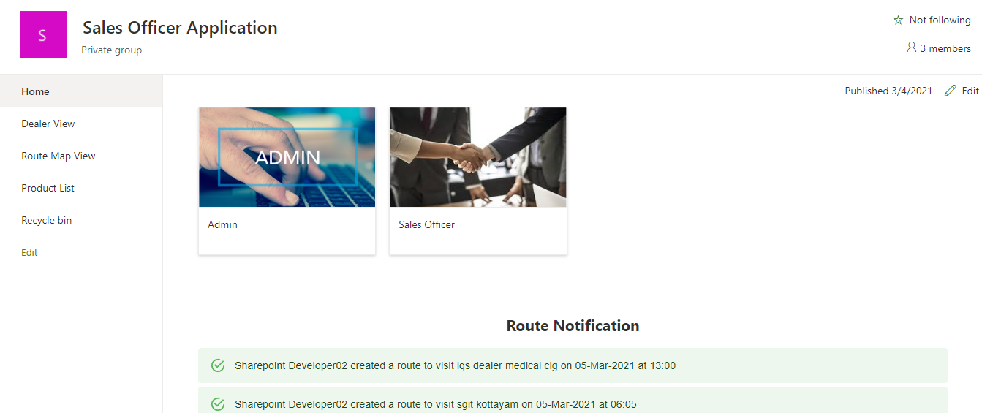

The page redirected to sales officer landing page

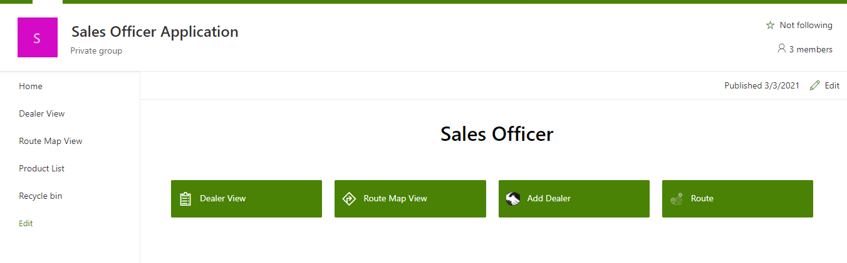

**Create Route**

Click on ‘Route’ from sales officer landing page.

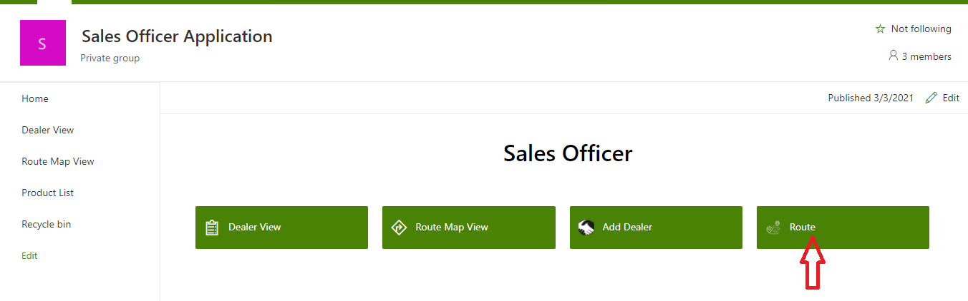

The page navigated to route list. Here all assigned routes are displayed for the current user.

For create new route click add button from top

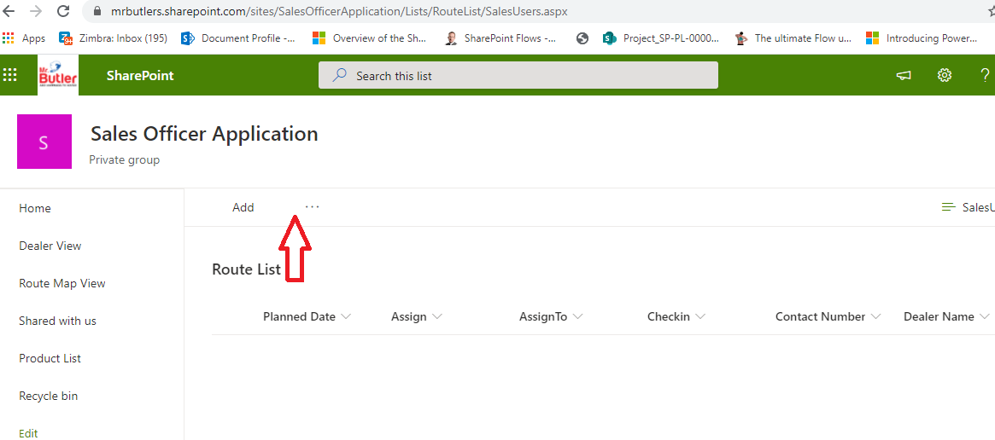

New form displayed for route creation

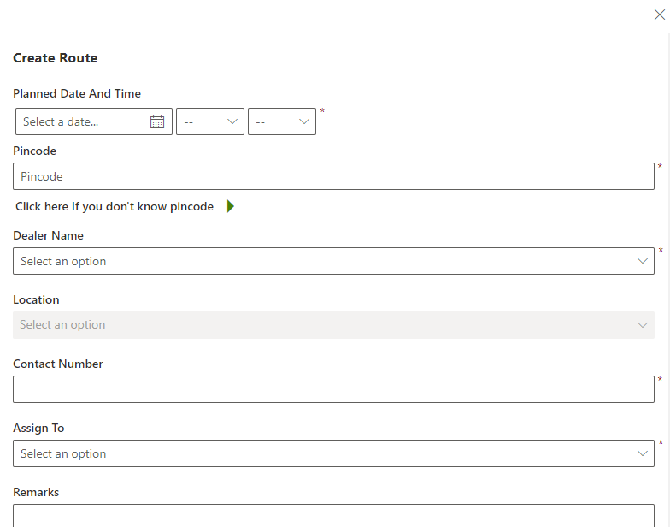

Enter planned date time and pin code for the dealer. Then dealer name will bind in dropdown. Nearby dealer name also bind in the dropdown.

If you want dealer based on district, click the arrow button with text “Click here if you don’t know pin code”. It will possible to select State/district and the dealer dropdown binding based on the selected district. The route is assigned to the current user. The contact number will be filled from dealer details. After clicking add button the created route will displayed in a table. User will be able to edit/delete the route by clicking edit/delete buttons.

Multiple dealer visit can be add using this form. Date picker is disabled and user can change the time.

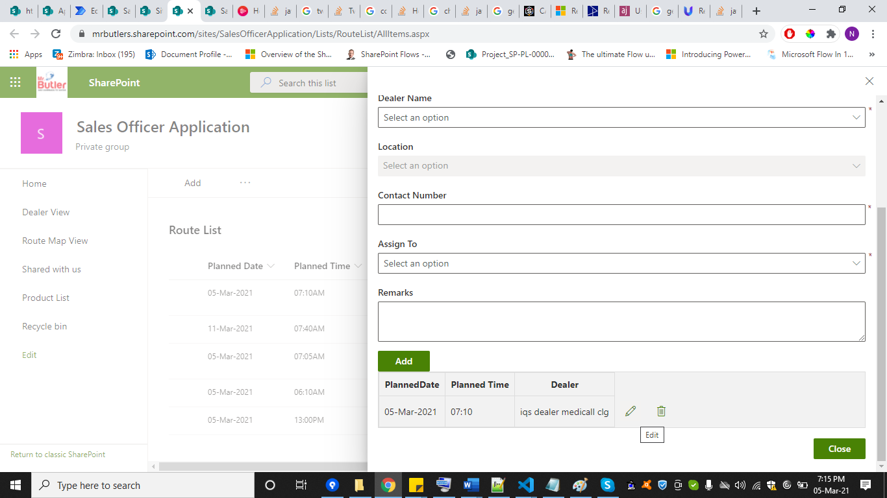

On clicking close button the form will be closed.

**Change Route**

If you want to edit a specific route , it will be possible by clicking change button.

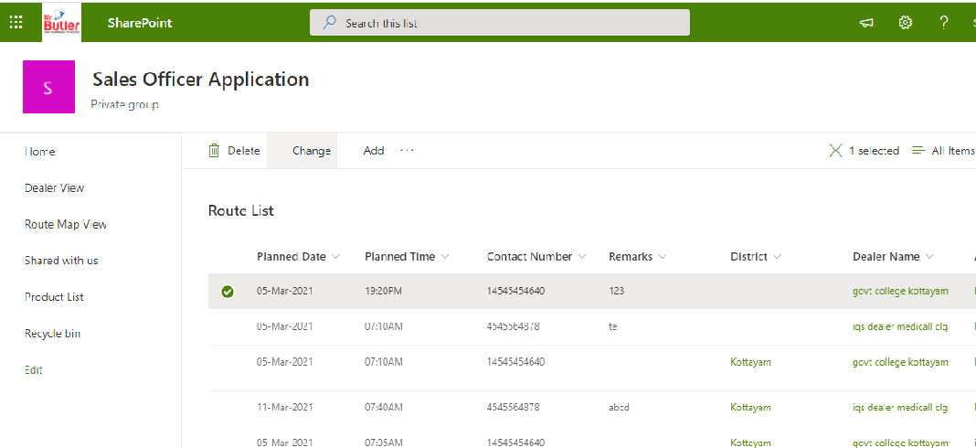

If a route created by admin user and a sales officer modified to specific route a mail notification will sent to corresponding admin user.

If a sales officer created , a notification displayed in home page.

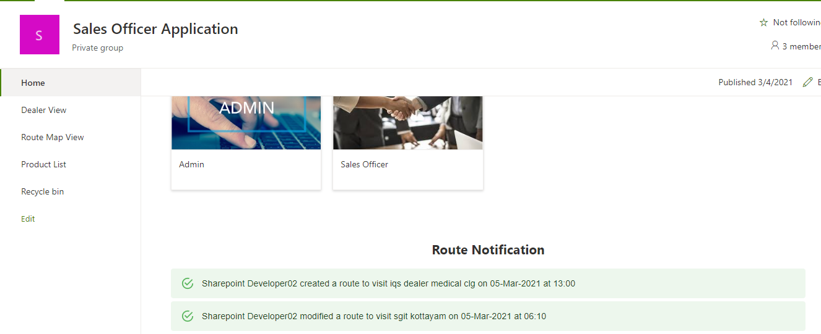

**RouteMap View**

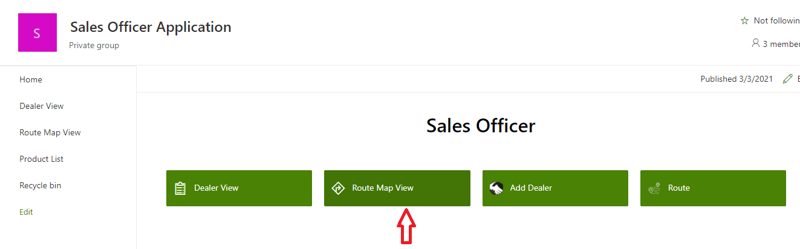

Click on route map view from sales officer landing page/side navigation Routemap page will be displayed.

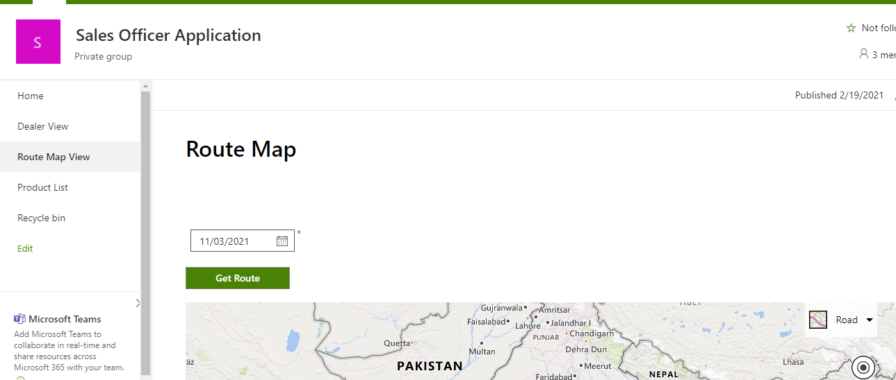

Here sales officer can select the date able to view the route in a map.

**Dealer Creation**

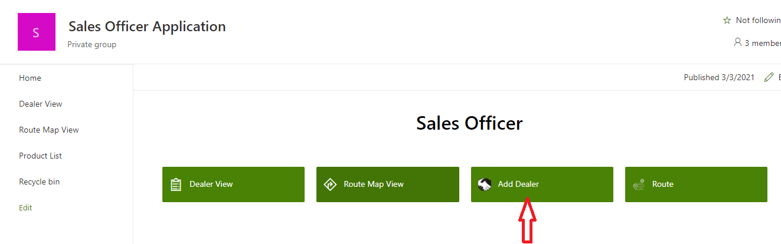

Click on dealer from admin landing page

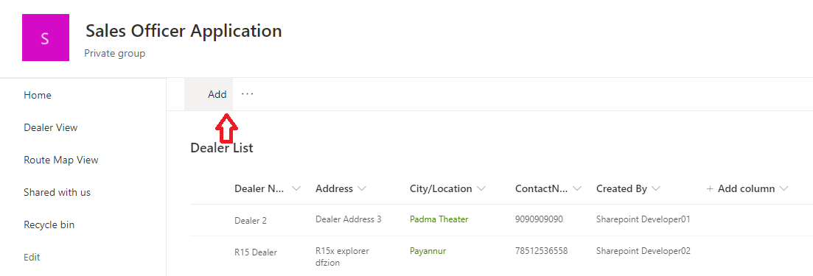

Fill all data about the dealer and click on save button, a confirmation alert displayed. After clicking ok the dealer is saved

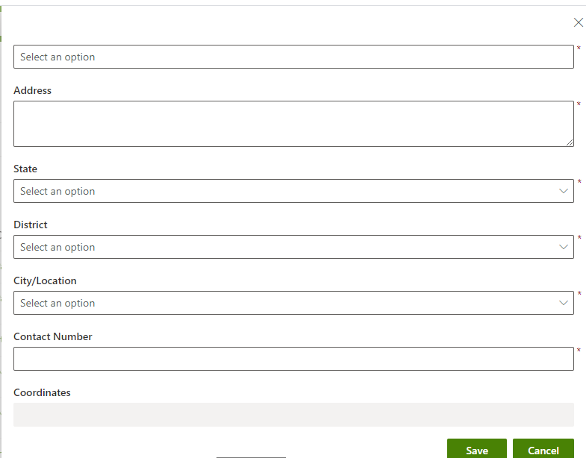

For editing the dealer data click on change button, Here the edit form is displayed and change the data and click on save button

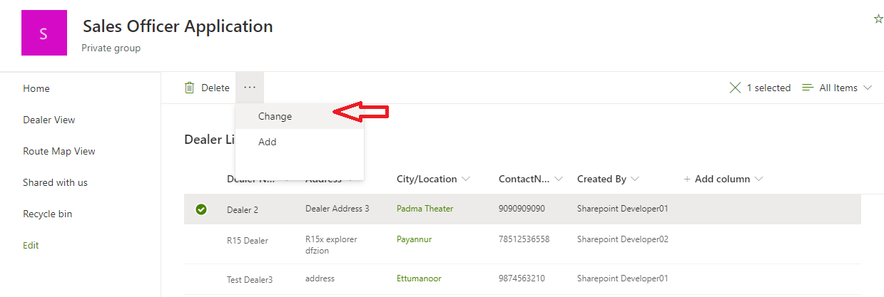

**Dealer View**

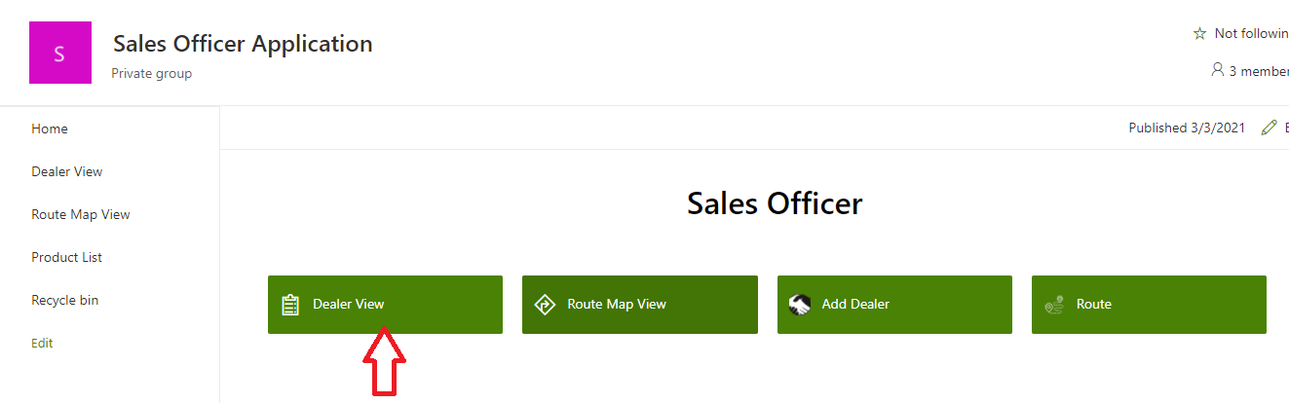

Click on dealer view from sales officer landing page and the same option will be available from left navigation bar

On clicking this Dealer view page will be displayed.

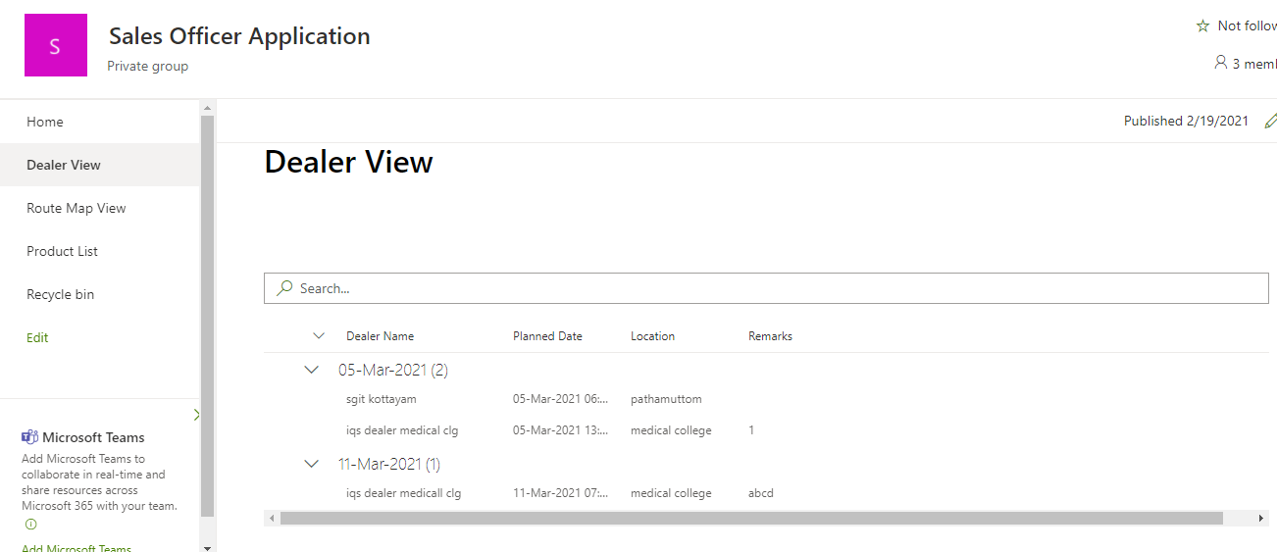

Select dealer from current date, Then an alert message will display for navigating check-in page. For Check-in the dealer click ok otherwise click cancel.

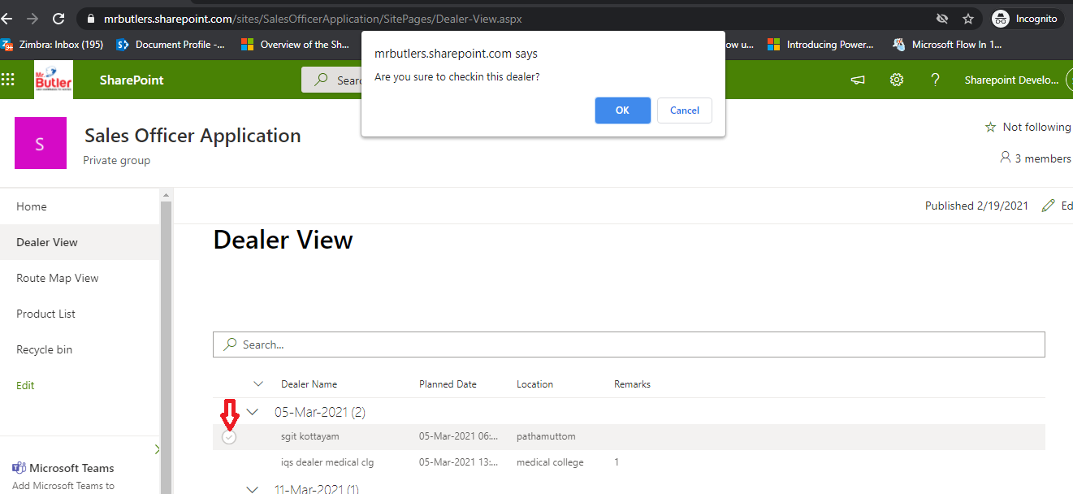

Here we have two option one is check-in the dealer and the other one -If no process executed, there should be a provision to mark as “**Nil” by clicking** No process button**.**

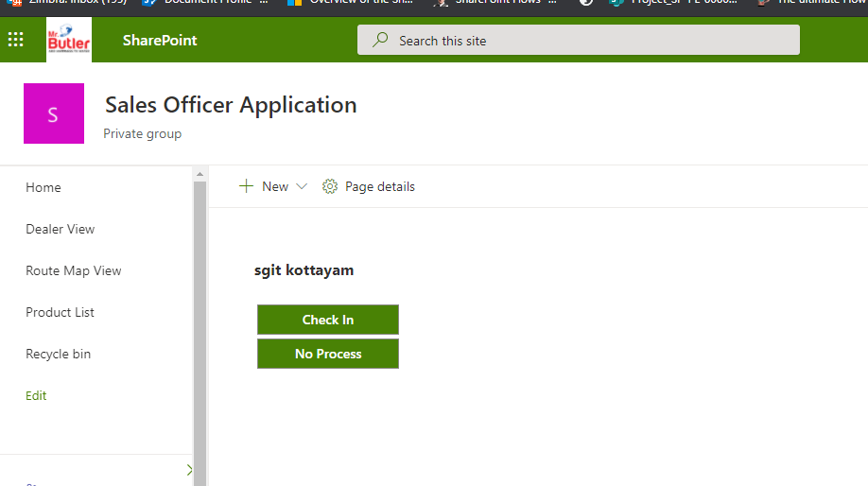

Checkin

On clicking check in button an alert will displayed for available for dealer meet

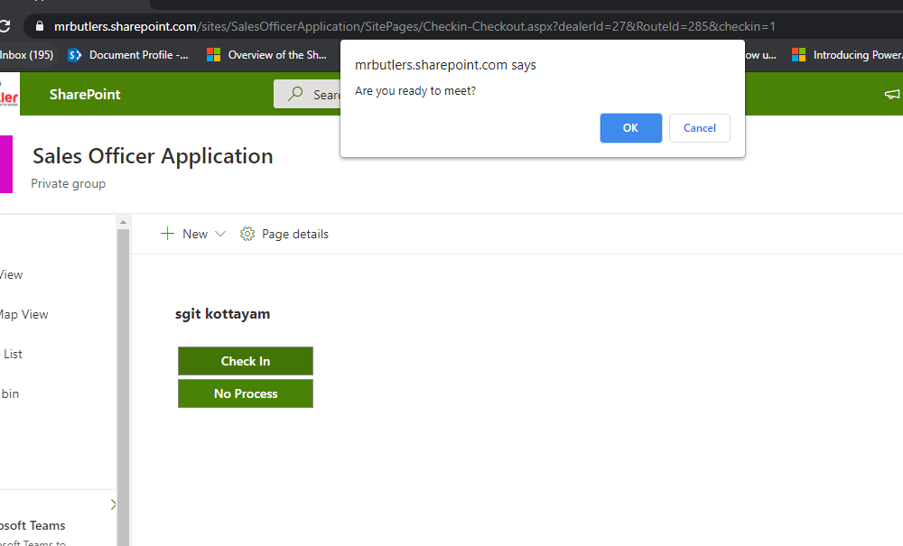

Click OK to start dealer meet

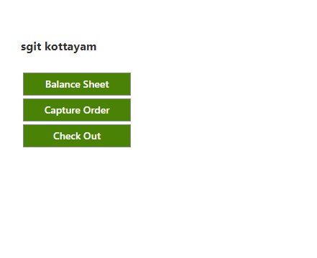

Here Sales officer will available 3 options

1.Balance Sheet

On clicking this page navigated to balance stock update

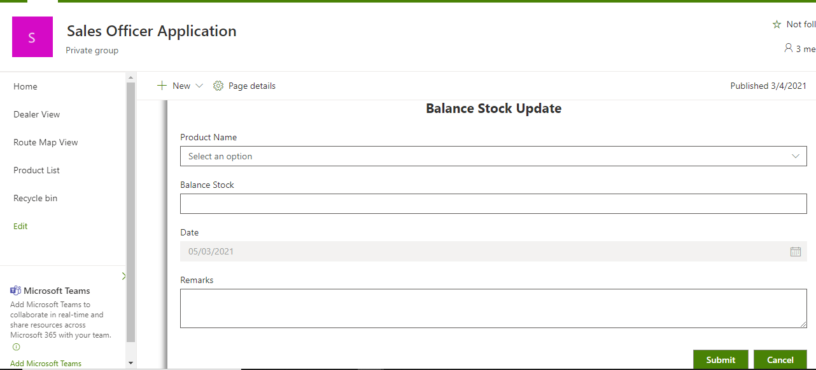

While selecting product name the current balance stock is displayed in the text.

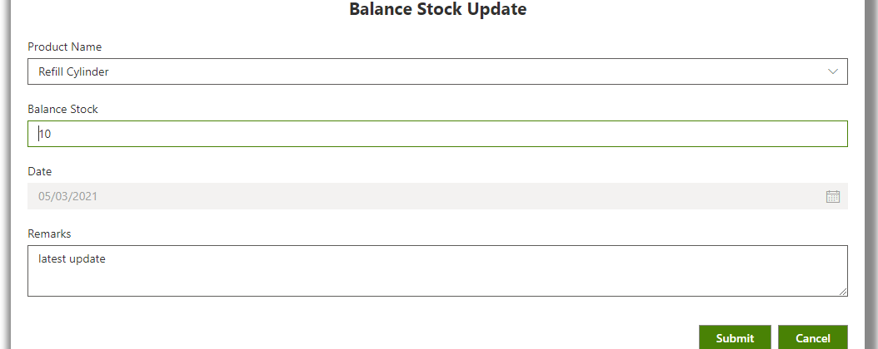

Fill all data and click on submit button the saved data displayed in a list. Here user can edit/delete the order and it is possible to add more product by clicking Submit button.

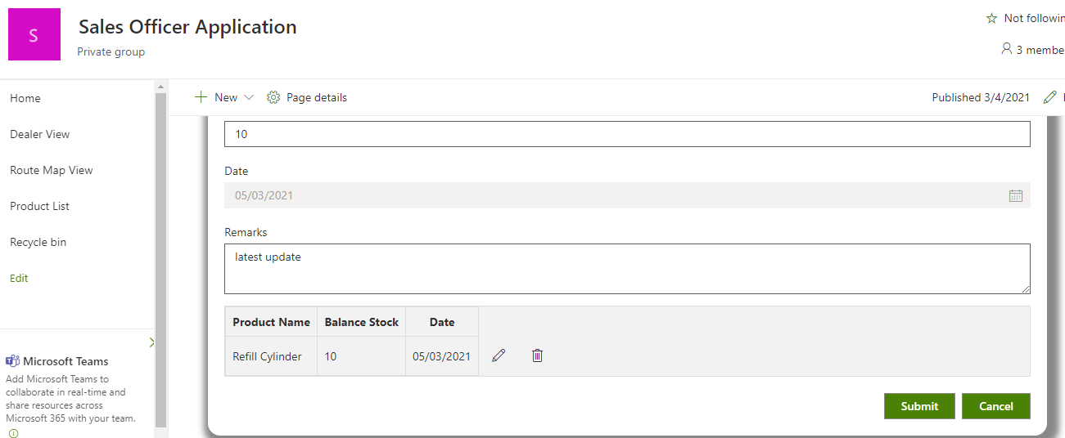

Click cancel for checkout/ Capture Order update

2.Capture Order

On clicking this the page navigated to add order details

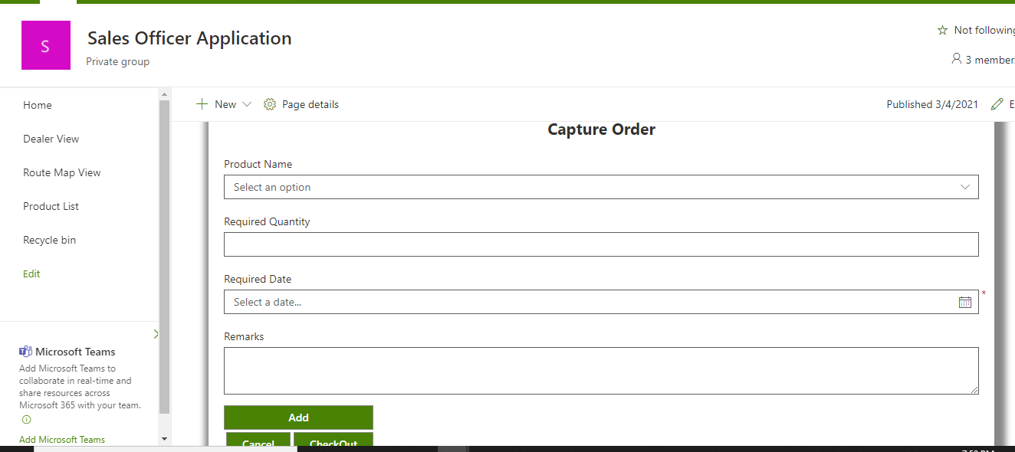

Here sales officer can track the order details

After entering the information click on add button. The captured data will displayed in a list. Here user can edit/delete the order and it is possible to add more product by clicking add button

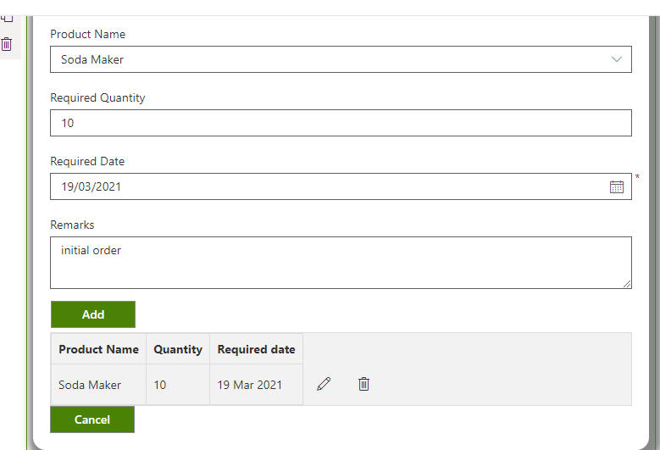

At the time of order is created/modified, An email notification will be sent to [sales@mrbutller.com](mailto:sales@mrbutller.com) .

Click cancel for checkout/balance stock update

3.CheckOut

Click on checkout button for checking out from the current dealer point. Then an alert message will display for confirmation . click ok for check out and cancel for further updation

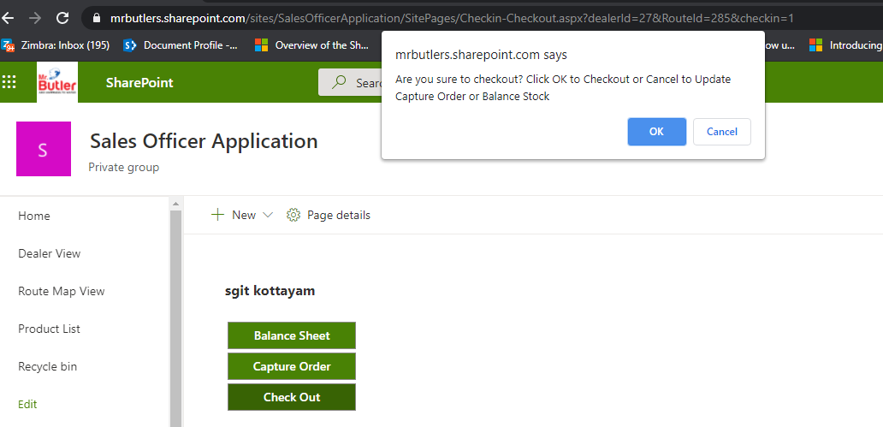

After the confirmation alert remark option displayed. Here sales officer can mark remark about checkin/checkout.

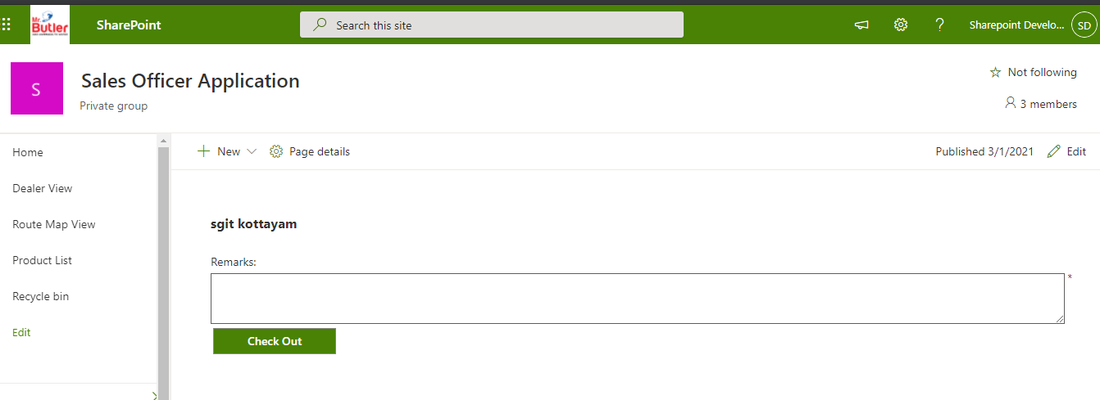

After adding the remark and click on check out button ,At this time, an email to be sent to [sales@mrbutlers.com](mailto:sales@mrbutlers.com) stating the check-out information from a dealer point.