**ASSIGNMENT-8**

1.When to use (Rapid Application Development) RAD model When not to use (Rapid Application Development) RAD model

Ans:

Areas where RAD model is used:

* RAD should be used only when a system can be modularized to be delivered in incremental manner.
* It should be used if there is high availability of expert persons for modelling is available.
* It should be used only if the budget permits use of automated code generating tools.
* Dependency on technically strong team members for identifying business requirements are available.
* RAD model should be chosen only if domain experts are available with relevant business knowledge.
* Used in the systems that are component based and scalable.
* Should be used where the requirements change during the course of the project and working prototypes are to be presented to customer in small iterations of 2-3 months.
* Suitable for project requiring shorter development times.
* Used when the user involvement is present throughout the life cycle.

Areas where RAD model is not used:

* Not used in the situations such as when experienced professionals are required to rethink the way they worked.
* Not used when Dependency on technically strong team members for identifying business requirements are not available.
* Only system that can be modularized can be built using RAD.So it is difficult to use.
* Can’t used due to the unavailability of highly skilled developers/designers.
* Inapplicable to cheaper projects as cost of modelling and automated code generation is very high.
* Management complexity is more so it is difficult to use.
* Suitable only for systems that are component based and scalable.
* Requires user involvement throughout the life cycle. So it is difficult to use.
* Not suitable for project requiring higher development times.

2.Define an ER diagram of a software Organization with all the relationship model that was discussed in the classroom?

Ans:

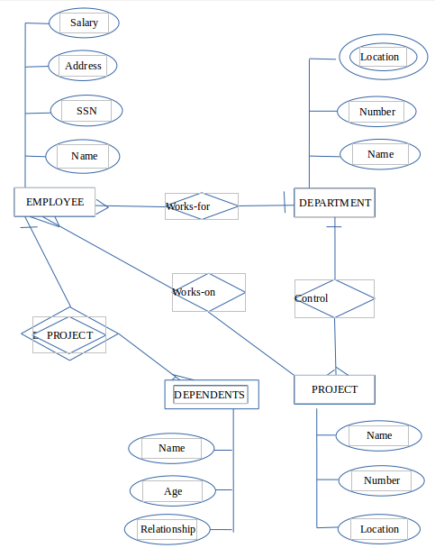

Screenshort of ER diagram

3.Describe the Entity Relationships for the following diagram.

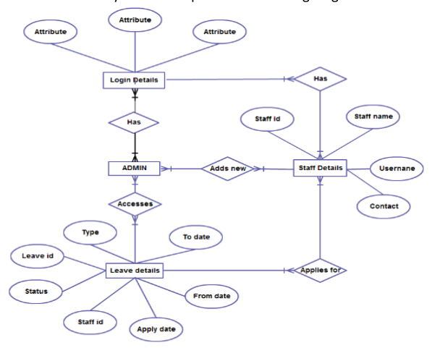Ans:

**ENTITIES**

1.Login details

2.Admin

3.Leave details

4.Staff details

|  |  |
| --- | --- |
| **Entities** | **Attributes** |
| Login details | Attribute,Attribute,Attribute |
| Admin | No attributes. |
| Leave details | To date,From date,Type,Leave id,Status,Staff id,Apply date |
| Staff details | Staff id,staff name,username,contact |

**RELATIONSHIPS**

1.has-one or more admin has one or more login details(many to many relation).

2.has- One or more staff has one or more login details(many to many relation).

3.Accesses-one or more admin accesses one or more leave details(many to many relation).

4.Add new-one or more admin can add new staff details(many to many relation).

5.Applies for-one or more staff applies for one or more leave(many to many relation).