ASSIGNMENT-8
1.When to use (Rapid Application Development) RAD model When not to use (Rapid Application Development) RAD model
Ans:
Areas where RAD model is used:
- RAD should be used only when a system can be modularized to be delivered in incremental manner.
- It should be used if there is high availability of expert persons for modelling is available.
- It should be used only if the budget permits use of automated code generating tools.
- Dependency on technically strong team members for identifying business requirements are available.
- RAD model should be chosen only if domain experts are available with relevant business knowledge.
- Used in the systems that are component based and scalable.
- Should be used where the requirements change during the course of the project and working prototypes are to be presented to customer in small iterations of 2-3 months.
- Suitable for project requiring shorter development times.
- Used when the user involvement is present throughout the life cycle.
Areas where RAD model is not used:

- Not used in the situations such as when experienced professionals are required to rethink the way they worked.
- Not used when Dependency on technically strong team members for identifying business requirements are not available.
- Only system that can be modularized can be built using RAD.So it is difficult to use.
- Can’t used due to the unavailability of highly skilled developers/designers.
- Inapplicable to cheaper projects as cost of modelling and automated code generation is very high.
- Management complexity is more so it is difficult to use.
- Suitable only for systems that are component based and scalable.
- Requires user involvement throughout the life cycle. So it is difficult to use.
- Not suitable for project requiring higher development times.
2.Define an ER diagram of a software Organization with all the relationship model that was discussed in the classroom?
Ans:
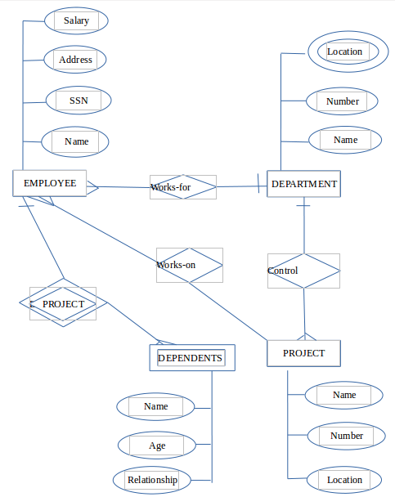

Screenshort of ER diagram

3.Describe the Entity Relationships for the following diagram.
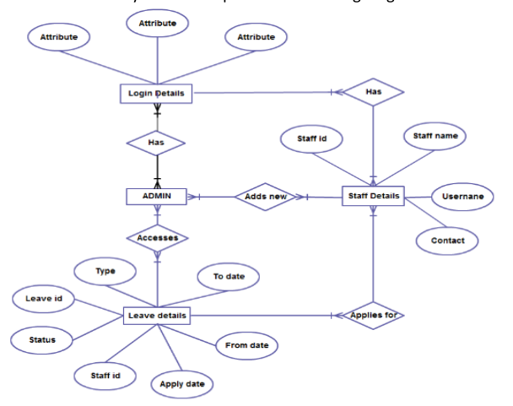
Ans:
ENTITIES
1.Login details
2.Admin
3.Leave details
4.Staff details
Entities | Attributes
Login details | Attribute,Attribute,Attribute
Admin | No attributes.
Leave details | To date,From date,Type,Leave id,Status,Staff id,Apply date
Staff details | Staff id,staff name,username,contact

RELATIONSHIPS
1.has-one or more admin has one or more login details(many to many relation).
2.has- One or more staff has one or more login details(many to many relation).
3.Accesses-one or more admin accesses one or more leave details(many to many relation).
4.Add new-one or more admin can add new staff details(many to many relation).
5.Applies for-one or more staff applies for one or more leave(many to many relation).

