**ASSIGNMENT-9**

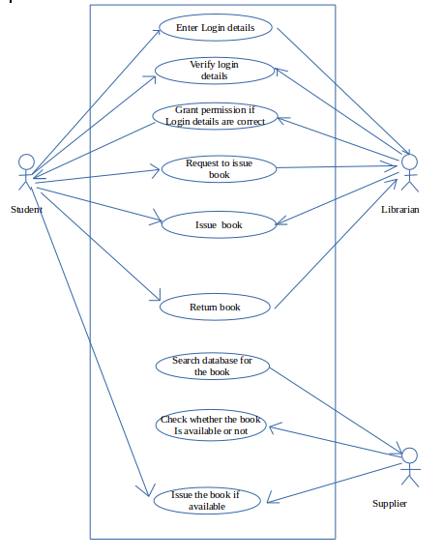**1.Draw a Use Case Diagram for an online Library Management System.**

Ans:

**2.List down the best practices from Agile/Scrum methodology**

Ans:

The best practices from agile/scrum methodology are:

* **Daily meetings**:Daily meetings must not be longer than 15 minutes.Standup meeting style is usually adopted.This is not a problem solving session.The problems are made into notice and solutions will be found later
* **Burndown charts**:work to be done is specified on a chart. When certain tasks are completed,they are removed or marked off from this chart., which is called a burndown chart. It aslo helps to determine the project progress.

Also, there are certain other measures that can be used to determine the performance of a project

* **Collaboration**:Collaboration ensures the involvement of customer at various levels so that they can correctly evaluate the progress of the project
* **Planning poker**:An iterative approach to estimating .This is used to determine the relative toughness of the project
* **Time-boxed sprints**:Produces potentially shippable output
* **Sprint retrospective**:Learning from previous sprint.At regular intervals, the team reflects on how to become more effective, then tunes and adjusts its behavior accordingly
* **Acceptance test**:They are often done and score is published based on this
* **Product backlog**:The product owner defines the product backlog.Here all possible system features are captured in a ordered list.New features can be added to the backlog at any time.
* **Iterative development**
* **Test driven development**:All sessions begin by writing programming adaptive tests that are preceded by unit tests. Only later write code specific to the user stories. This approach is updated daily at scrum meetings
* **Release planning:**It is the process of managing, planning, scheduling and controlling a software construct through different stages and environments including testing and deploying software release.

**3.Collaboration**

**a.How does collaboration help agile development?**

**b.What if the team is distributed and can you achieve the same productivity?**

**c.What would you do to achieve the productivity for a distributed team?**

Ans:

Collaboration simply means to work jointly rather than independently to accomplish a task.

Two of the four values in the agile manifesto highlight the emphasis Agile methodologies place on strong collaboration. "Individuals and interactions over processes and tools" reminds us of the importance of strong and respectful communication. "Customer collaboration over contract negotiation“reminds us that it's more important for a development team to allow for some flexibility to please a customer, seeking a collaborative solution to issues that might arise during product development, rather than to stick to a rigid contract.

a.)Through collaboration,customer satisfaction can be ensured as they evaluate the product at each level.Modifications can be incorporated at each level.

Collaboration has the following advantages:

* Satisfy the customer through early and continuous delivery
* Welcome changing requirements
* Business people and developers work together daily
* The best way to convey information is face-to-face
* The team regularly tunes and adjust its behavior

b.)Achieving the best results with agile requires a well-connected team. If the team is distributed the productivity tends to decrease

The issues in distributed development are:

* Strategic: Difficult leveraging available resources, best practices are often deemed proprietary, are time consuming and difficult to maintain.
* Project and process management:Difficulty synchronizing work between distributed sites.
* Communication:Lack of effective communication mechanisms.
* Cultural: Conflicting behaviors, processes,and technologies.
* Technical: Incompatible data formats,schemas, and standards.
* Security: Ensuring electronic transmissionconfidentiality and privacy.

c.)Following are the methods to achieve productivity in a distributed agile team:

* **Optimize Team Size and Team Mix**:Finding the right mix of talent at every location is critical when the team is distributed.Effective distributed Agile development is about minimizing the impact of distribution.
* **Distribute Work Evenly**:Make sure all team members understand their role and have fairly equal workloads. In a distributed team, if the workload is uneven, you may risk the overall project delivery schedule if you ignore the imbalance. Uneven workloads can also cause bottlenecks
* **Set Up Pair Programming**:Pair programming, where two team members sit side by side and work on the same code, is a challenge for distributed teams
* **Enforce and Re-enforce Agile Practices**:Agile approaches rely on a set of mutually supporting practices. When one practice doesn’t make sense for one team, the practice should be either abandoned or replaced. With distributed teams, enforcing and reinforcing a practice takes time and effort
* **Use Online Tools for Agile Artifacts:**take advantage of Agile process artifacts (white boards, sticky notes, and so on) by moving them from their physical environment to an online tool**.**
* **Understand Time Differences**
* **Understand Cultural Differences**
* **Adapt Communication for Remote Teams**
* Arrange Face-to-Face Interactions
* Plan Frequent Demos and Retrospectives

**4.What is Sprint Zero in Agile?Describe the activities that are done in Sprint Zero.**

Ans:

Sprint Zero is same as initial sprint.It is also named as Iteration Zero.It should be used to create the basic skeleton for the project so that future sprints can be truly add incremental value in an efficient way. Its main goals are:

1. Get some quality items on the Product Backlog,
2. Provide a minimal environment that enables the writing of quality code, and
3. Write a piece of **real code**, no matter how small.

During sprint zero the scrum team might be assembled and technical issues like hardware, software and colocation issues sorted out.It is as short as possible and can be short as one week.

Sprint zero might also be used in some organisations to train and coach a team that is entirely new to Scrum so that they’re familiar with the basic concepts, can experience the new working rhythm etc. It might also be used to populate the product backlog with a few high-level items in preparation for the first sprint planning meeting.