Donark Patel, CSC161-60, Lab – 2

Date – 1/31/2018

Lab2a

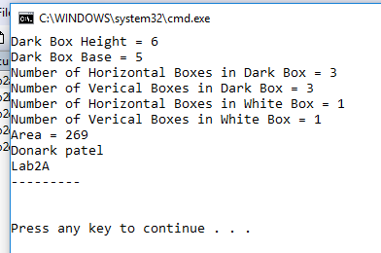

Lab2b

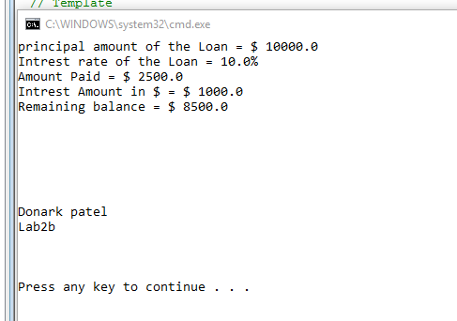

Lab2c

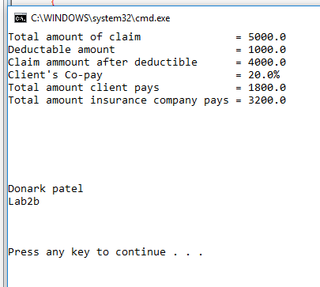

Lab2d

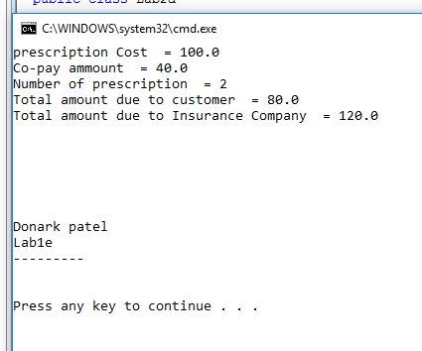

Lab2e

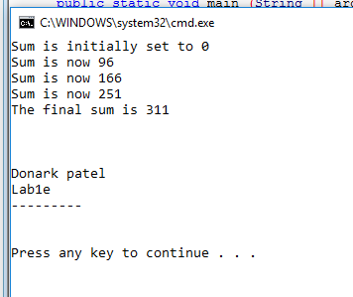

Donark Patel, CSC161-60, Lab – 2

Date – 1/31/2018