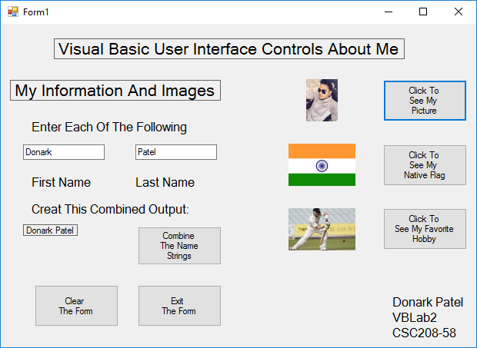

Donark Patel, VBLab2, CSC208-58.

|  |  |  |  |  |
| --- | --- | --- | --- | --- |
| **Donark Patel - CSC208-58 - Visual Basic Labs Version 6 – Lab #2 Test Cases –**  **Visual Basic User Interface Controls** | | | | |
| **Test Case Number** | **Input**  **Data** | **Calculation / Function / Event** | **Anticipated Output** | **Test Case**  **Successfully**  **Completed** |
| 1 | Launch icon | Run the form | VB Form Loads | Yes |
| 2 | Input of your first and last name in each of the textboxes | Command button click | A label containing your combined name should display. | Yes |
| 3 | 3 separate pictures | Command button click | 3 new pictures are placed in the picture boxes | Yes |
| 4 | None | Full form Clear button clicked | All selected items and text and picture data and messages are cleared from the form | Yes |
| 5 | None | Exit button clicked | Active form is exited | Yes |

Donark Patel, VBLab2, CSC208-58.