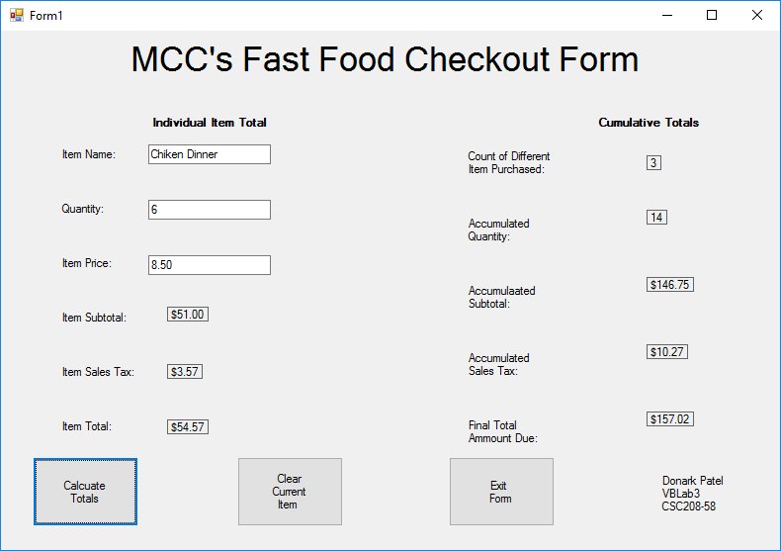

Donark Patel CSC 208-58 Lab 3