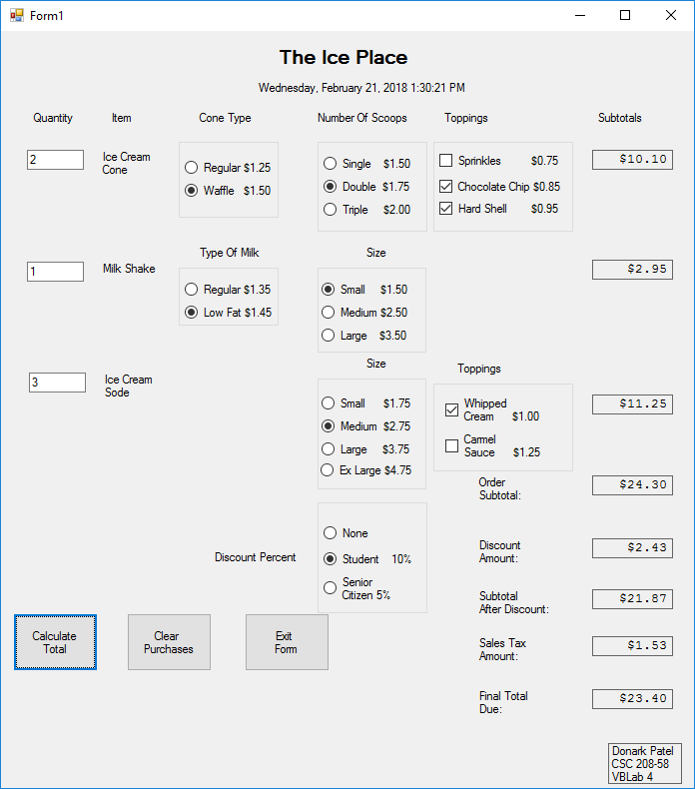

Donark Patel

CSC-208-58

VB Lab 4