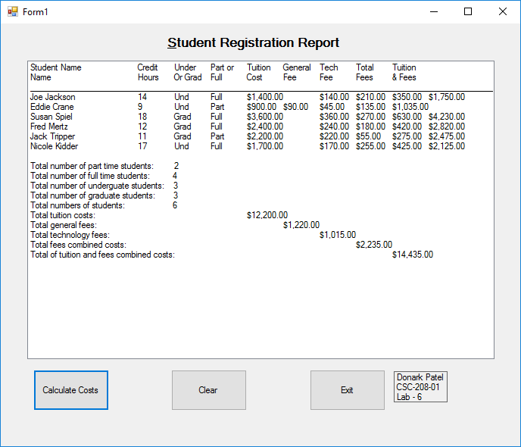

Donark Patel

CSC 208-01

Lab – 6

Date – 3/6/2018