Donark Patel

CSC – 208-58

Date – 4/3/2018

VB Lab 7

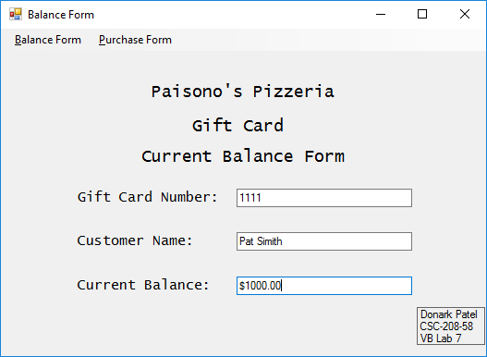

Donark Patel

CSC – 208-58

Date – 4/3/2018

VB Lab 7

