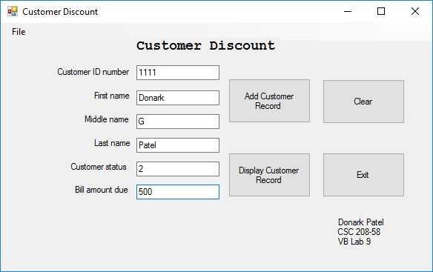

Donark Patel

CSC 208-58

Lab 9

Date – 4/16/2018