Snake Game Based on Q-Learning
Youtube: https://youtu.be/OkzuvAuusFI
Github: donascimentohannah49-crypto/snake.git

1 Introduction
This project aims to apply the reinforcement learning algorithm Q-learning to the classic Snake game, designing an autonomous learning agent. The game environment consists of a 7×7 grid where the snake grows by moving and eating while avoiding collisions with walls or itself. Q-learning is a value-based, model-free reinforcement learning algorithm that updates its Q-table through interactions with the environment to ultimately learn an optimal strategy. Due to the extremely large state space of Snake (explosive combinations of snake body positions), feature engineering is employed to compress the original states into 256 discrete states, making tabular Q-learning feasible. The project utilizes the following technology stack: Python serves as the primary programming language. Pygame functions as the game development library, providing graphics, sound effects, and input processing capabilities. This library implements game controls, dynamic updates, event detection, and interface rendering.

2 Game Design

2.1 Rules of the Game
In this game, players manually place food with the goal of minimizing the score of the AI-controlled snake. When the snake's head consumes food, its body length increases by 1 and its score increases by 1. The game ends when the snake's head collides with a wall or its own body.
The game state space contains key information such as the snake's position, food locations, and direction. This state data will be used to train the learning model, guiding the snake's decision-making behavior. The snake's action space includes three operations: moving straight, turning left, and turning right. The agent will assess the real-time state based on the coordinate difference between the snake's head and the food and execute the corresponding action.

2.2 Class Design of the Game
Game class responsible for managing the overall flow and state of the game. It initializes the game window and game objects, loads the AI ​​model, and updates the game state and handles collision detection during the game.
Trainer class used to train the AI ​​model. It generates random bullets, calculates rewards, trains the model, and saves the trained model.
Enemy class represents the enemy tank controlled by AI. It is responsible for the behavior and state update of the enemy tank, including getting the current state and selecting actions.
Player class represents the tank controlled by the player. It handles the player's input and controls the movement and shooting of the tank.
Tank class as the base class of Enemy and Player classes, it provides the basic functions and properties of the tank, such as movement, shooting, and collision detection.
Bullet class represents the bullet in the game. It handles the movement and collision detection of the bullet.

2.3 UI Design
The overall user interface adopts a minimalist style. The top of the game screen displays the game title and gameplay description. The top-left corner shows the current score and game mode. Utilizing Pygame's UI rendering capabilities, the game features a bright green snake head and a dark green snake body. Food items are represented as red squares with a yellow dot at their center. The game interface is shown below. Pressing the R key resets the game, returning the snake to its initial state.

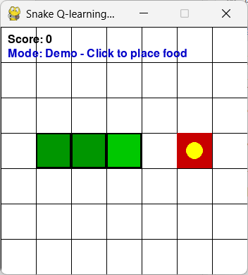
Fig 2.1 Snake UI-1
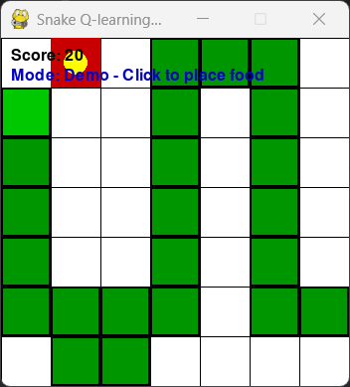
Fig 2.2 Preying

3 Implement of Q-learning Algorithm
Q-Learning is a value-based reinforcement learning algorithm that selects the best action by learning a Q-value table. In the project, I use numpy to create a zero matrix with 256 rows and 3 columns, where row indices correspond to state IDs and column indices correspond to actions (0: left turn, 1: straight, 2: right turn).
The ε-greedy policy balances exploration and exploitation by randomly selecting a valid action with probability ε and choosing the action with the highest Q-value in the current state with probability 1-ε. Initially set ε to 0.2. As training iterations increase, ε decays exponentially (ε = max(MIN_EPSILON, ε * EPSILON_DECAY)), eventually stabilizing at 0.01. This encourages the agent to progressively favor exploiting acquired knowledge.
After executing each action, update the current Q-value based on the actual reward and the maximum Q-value of the next state:
Q(s, a) ← Q(s, a) + α [ r + γ max_{a'} Q(s', a') - Q(s, a) ]
Here, α = 0.1 is the learning rate, and γ = 0.9 is the discount factor. If the next state is a terminal state, i.e., the game ends, then max_{a'} Q(s', a') is set to 0.
Training consists of 3000 episodes, which is adjustable. Each episode proceeds as follows: First, reset the game and obtain the initial state. Loop until the game ends or the number of steps exceeds 200: Select an action based on the current state and ε. Then execute the action, obtaining a new state, reward, and whether the game ends. If not ended, compute the maximum Q-value for the next state; otherwise, set it to 0. Update the Q-values according to the formula. Accumulate total reward and transition to the new state. Record the episode's total reward to monitor learning progress.
Then, with the exploration rate decaying, proceed to the next episode. Every 200 episodes, print the average reward of the most recent 200 episodes to observe convergence.

3 Challenges and Solutions
First, the original state of the snake game—including the coordinates of each body segment and food locations—comprises an extremely large number of combinations that cannot be stored in a table. I opted to use feature engineering to extract the three features most relevant to decision-making: the snake's head direction, the relative direction of food, and whether the three forward cells contain obstacles. This compresses the state into 256 discrete cases. This design is based on the prior knowledge that “the snake's core decisions depend on food orientation and forward obstacles,” making the learning problem solvable.
During the early stages of training, the snake's random movements made it difficult to consume food, resulting in sparse reward signals and slow learning. To address this, I designed a negative reward (-0.1) for each step, encouraging the agent to move quickly and avoid circling in place. Simultaneously, the positive reward (+10) for consuming food and the severe penalty (-100) for death provided strong learning signals. This reward shaping helped accelerate convergence.
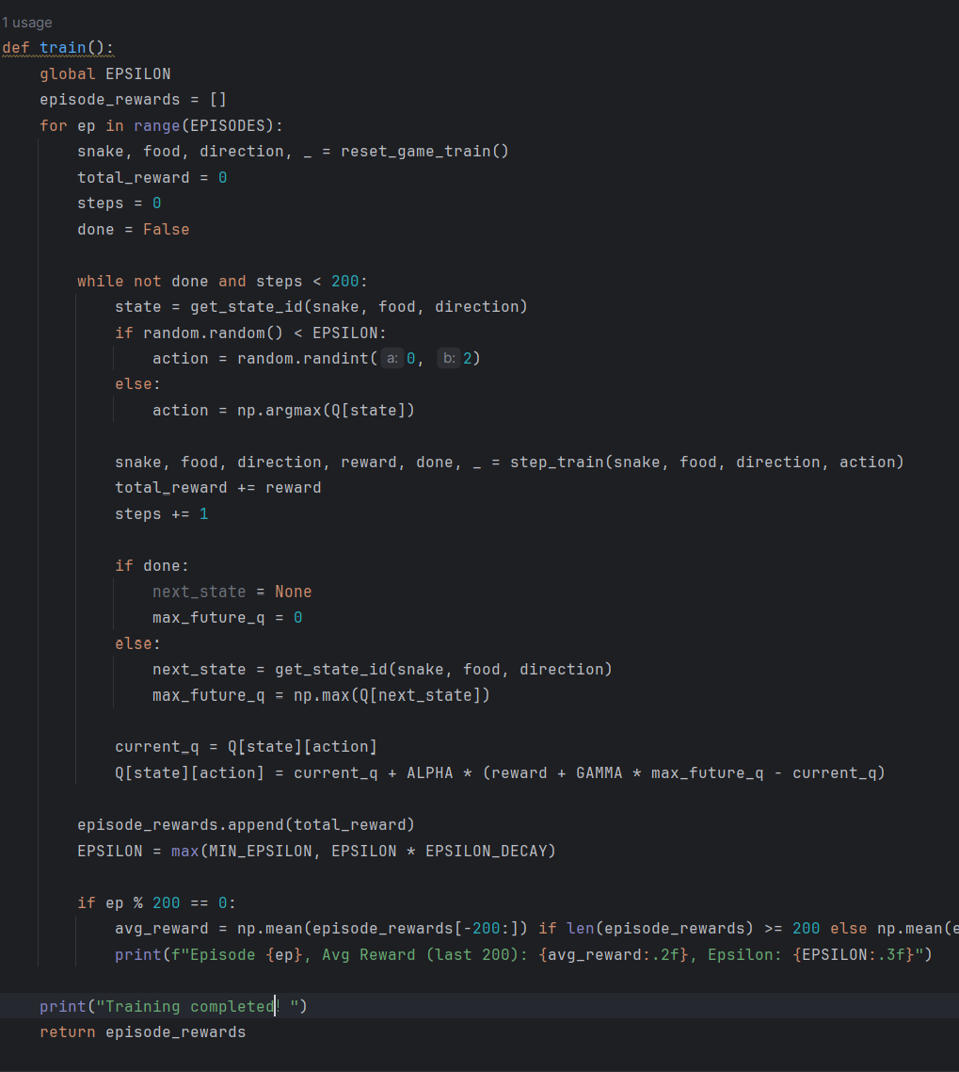
Fig 3.1 Training function
Due to feature simplification, the agent may get stuck in local optima, such as merely circling within safe zones. I employed exploration rate decay and a sufficiently large number of training episodes (3000) to enable the agent to stabilize its execution by leveraging acquired knowledge in later stages. Additionally, each game is capped at 200 steps to prevent infinite loops from wasting training time.
Finally, I discovered that Snake does not permit immediate reversals, so the action space is restricted to left turns, straight movement, and right turns—rather than selecting any of the four directions directly. This approach adheres to the game's rules while reducing invalid actions and improving learning efficiency.
4 Conclusion
This project successfully applied Q-learning to the Snake game. Through ingenious feature engineering, the high-dimensional state space was compressed into a tabular format suitable for processing, enabling the agent to learn autonomously. The trained agent can avoid obstacles to some extent and move toward food. In demonstration mode, pressing the spacebar allows observation of its decision-making process. Experiments show that feature selection and reward design are crucial for reinforcement learning performance.
While tabular Q-learning performs well on small grids, expanding the grid or snake length causes a dramatic increase in states, necessitating function approximation methods like Deep Q-Network (DQN). Future work could explore using neural networks to directly process raw board images or incorporate richer features (e.g., snake length, spatial connectivity) to enhance agent performance.
The project's complete code and interface demonstration provide an intuitive example for understanding reinforcement learning while laying the groundwork for further exploration of complex game environments.

5 Reference
[1] Emmanuel Byrd. (2023). QLearning: Teaching AI to play Snake. 8th Light Insights.
https://8thlight.com/insights/qlearning-teaching-ai-to-play-snake
[2] Nomination-NRB. (2023). RL-snack [Computer software]. GitHub.
https://github.com/Nomination-NRB/RL-snack
[3] Chrisson543. (2025). Deep Q-learning snake game [Computer software]. GitHub.
https://github.com/Chrisson543/deep-qlearning-snake-game

