INST 327
Section: 0304
Final Deliverable
5/15/2025
Team 8
Donasyl Aho, Crystal Mbah, Kristi Sunwar and Natalie Weger

Introduction:
As the world shifts toward more sustainable transportation, electric vehicles (EVs) are becoming an increasingly popular choice for consumers. With advancements in technology and growing government incentives, the EV market is expanding rapidly. Washington State, known for its commitment to clean energy and environmental sustainability, has seen a significant rise in EV adoption. Our team is focused on creating a database that compiles all relevant and available information on electric vehicles (EVs) in Olympia, WA. We aim to provide an accessible and intuitive tool that helps consumers, local government agencies, and dealerships make informed decisions about EV adoption. Our ultimate objective is to centralize and refine key data points related to EV capabilities and common EV vehicles.
Our goal is to create a well-organized and user-friendly tool that provides insights into EV affordability, adoption trends, and sustainability benefits. By making this information accessible, we aim to support local government agencies, manufacturers, dealerships, and consumers in better understanding EV trends and facilitating the expansion of EV infrastructure. Ultimately, our project will promote a greener future by encouraging more informed decision-making about electric vehicles.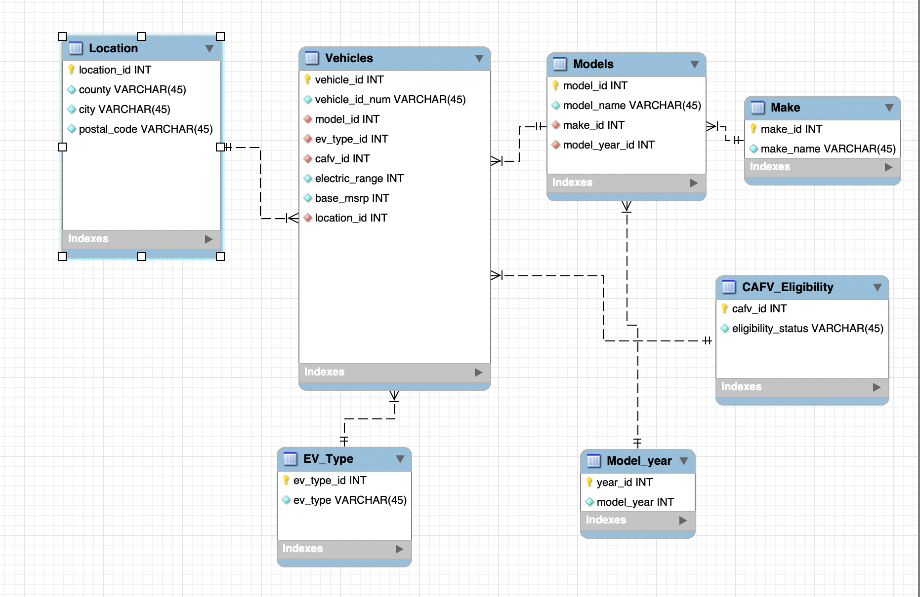
Database Description - Logical Design:
Our final database only captured information that we felt could be used to help find information on the electric vehicles of Olympia. We included 7 tables, with our main table being a vehicles table. The vehicles table was linked to 4 tables with a many-to-one relationship: location, EV_type, Models, and CAFV_eligibility all had a one-to-many relationship with Vehicles. The other two tables had a one-to-many relationship with one of the Model tables: Model_year had a one-to-many relationship with the Models, and Make also had a one-to-many relationship with the Models. Formatting our data this way made it easy to access information about the vehicles, as information was linked to the vehicles.
Database Description - Physical Database:
We approached our database design intending to organize essential information about electric vehicles EVs registered in Olympia, Washington, in a clear and accessible way. We aimed to support stakeholders interested in understanding patterns within the electric vehicle population in Olympia. To do this, we focused on key attributes such as vehicle make and model, electric range, MSRP, location, and eligibility for clean alternative fuel programs.
Our first step was figuring out what we wanted to capture about each vehicle. This included both individual-level data, such as vehicle ID, location ID, and model ID, and manufacturing details such as make ID and make name. We then structured this information into separate but interconnected tables: “Vehicles”, “Models”, “Make”, “Model_Year”, “EV_Type”, “CAFV_Eligibility”, and “Location”. Each table is linked primarily through foreign keys stemming from the “Vehicles” table, for example, “model_id” connects to “Models”, “EV_type_id” links to “EV_Type”, and so on.
Our design is meant to be both clear and extensible, with information that isn’t too compromising on the privacy of the EV owners in our dataset. Each vehicle is associated with a single model, while each model can correspond to multiple vehicles, allowing for flexible grouping and in-depth analysis. This relational structure not only maintains data integrity but also supports future expansion and integration with new sources of EV-related information.
Database Description: Sample Data:

Sample Models Table:
model_id | model_name | make_id | model_year_id
1 | WRANGLER | 1 | 1
2 | WRANGLER | 2 | 1
3 | WRANGLER | 3 | 1

Sample Vehicles Table:
vehicle_id | vehicle_id_num | model_id | ev_type_id | cafv_id | electric_range | base_msrp | location_id
1 | 196059356 | 1 | 1 | 1 | 25 | 0 | 1
2 | 157549416 | 2 | 2 | 2 | 25 | 0 | 2
3 | 157633122 | 3 | 3 | 3 | 25 | 0 | 3

Sample Location Table:
location_id | county | city | postal_code
1 | Thurston | Olympia | 98506
2 | Thurston | Olympia | 98502
3 | Thurston | Olympia | 98513

Sample CAFV_Eligibility Table:
cafv_id | elgibility_status
1 | Not eligible due to low battery range
2 | Not eligible due to low battery range
3 | Not eligible due to low battery range
Sample Make Table:
make_id | make_name
1 | JEEP
2 | JEEP
3 | JEEP

Sample EV_Type Table:
ev_type_id | ev_type
1 | Plug-in Hybrid Electric Vehicle (PHEV)
2 | Plug-in Hybrid Electric Vehicle (PHEV)
3 | Plug-in Hybrid Electric Vehicle (PHEV)

Sample Model_year Table:
year_id | model_year
1 | 2021
2 | 2021
3 | 2021

Database Description: Views/Queries:

- Create a view that ranks the most popular EV models currently registered in Olympia, WA.
- Create a view that shows the vehicles with the top 10 highest electric ranges.
- Create a view that shows the number of registered electric vehicles by ZIP code in Olympia, WA.
- Create a view that shows the average range of electric vehicles by manufacturer and type.
- Create a view showing electric vehicles with a range above the average range of all vehicles.

Changes from Original Design:
In our project proposal, we have made several changes from our original design due to various reasons, such as ethical concerns and a focus on more specialized information. Most of our changes came in the form of deleting columns from tables in our new database with information we felt like we did not need, while keeping the general shape of our ERD intact. Some of the first changes we made were getting rid of the column names: “legislative district” and “2020 census tract”. We chose to get rid of the “legislative district” column because we felt that it was not very relevant to the information we generally wanted to display. There is only one legislative district in Olympia; therefore, because we already have the county and city names, we don’t need more of the same location information, as that would become too redundant. We removed the “2020 census tract” for the same reason as the legislative district; our area was too small to have much variation, so we cut it for redundancy in location data.
Since our given dataset was too large to take consistent samples from, we chose to filter our data to include only the electric vehicle population of Olympia, Washington, instead of utilizing broader geographic data. This cut down our original state and county columns we put in our location table. This will be helpful for a more comprehensive analysis, and it will make the data more manageable. Additionally, it will allow us to answer more specific questions about a certain place in Washington and make the scope of the data narrower. Our last big change to our original design was not to include location coordinates. This change was mostly due to an ethical concern, as we wanted to ensure our data could not be used to track individual EV owners or make assumptions about these EV owners from their exact location. Therefore, our location table will only have the postal codes, county, and city. This location information is much safer to give out as it does not target specific EV owners and their immediate circles, but just general locations of where certain EVs would be located in the city of Olympia.
Database Ethics Considerations:
Within our database, we want to try and combat any complications with accessibility and accurately describe our population. Since we focused on electric vehicle usage in Olympia, we want to account for factors such as different zip codes having certain per capita income. Without accounting for information such as per capita income in cities, we have the potential of making incorrect conclusions about electric vehicle popularity in certain zip codes, with reasons such as a higher city per capita income having more electric vehicles.
Additionally, some things to account for when creating our database are how our database can be used to create harm, even if unintentionally done. Our data is sourced primarily from the Washington government’s official website, where its data was sourced primarily through the Washington State Department of Licensing. To ensure the privacy of Washington State residents is upheld, we will ensure not to use information that may provide too specific information on vehicle owners, such as street addresses. Therefore, though our database will provide more honed information on electric vehicle usage and growth within cities in Washington State, it will not be able to provide thorough information on the number of cars owned per household or the address of ownership.

Lessons Learned:
This project has taught our group many lessons about working as a team, creating an ERD, organizing sample data, uploading data to SQL, drafting queries, and finally presenting our findings in an organized manner. This process began with us brainstorming ideas, creating a proposal, picking tables and attributes, and preparing the data to be used. While completing each step, we realized that early planning was crucial to ensure we had time for corrections if something went wrong.
First, we learned how to work together effectively as a team to finish this project. We often formulated questions together to ask TAs and figured out ways to divide different aspects of this project. We shared the work based on what we felt we could handle. For example, creating the sample data, building the tables in SQL, making the ERD diagram, and composing queries. Clear communication was essential for completing this project.
Something our group got stuck on was figuring out the scope of our data, and if we wanted to focus on Washington broadly, Thurston County, or just Olympia. However, we decided that it would be easier to focus on Olympia so that users of our database could have a narrower and more detailed scope on the EV population. This decision allowed us to streamline our data and align more closely with our goal of helping local governments, car dealers, and buyers understand electric vehicle trends in the county. It also made our queries more comprehensive and helped us identify patterns in price and range. Analyzing our data became easier as well due to the removal of missing prices.
Potential Future Work:
Although our database provides a comprehensive view of the EV population in Olympia, there are still ways that we can improve our data and the way that it is presented. First, it would be interesting if we made a broader database on the EV population outside of Olympia to offer a broader perception of the EV in Washington.
Since all current MSRPs are listed as zero within our database, it would be interesting to incorporate accurate MSRP values so that we can have a more in-depth analysis of the costs of electric vehicles. Adding an actual price to our analysis would allow us to see how much electric range a consumer gets per dollar and further provide us with insights into the EV market. Additionally, it would allow us to see how the MSRP of vehicles in Olympia compares to those outside this specific region.
Lastly, it would be beneficial to add when certain electric vehicles are registered. Right now, our database only reflects which EVs are registered. But adding specific registration data would allow us to have a time-based analysis. This would be helpful if users of our database would like to explore trends regarding the growth of electric vehicles.
Works Cited
“District Maps & Handouts.” District Maps & Handouts, www.redistricting.wa.gov/district-maps-handouts.html . Accessed 15 May 2025.
Licensing, Washington State Department of. “Electric Vehicle Population Data: Data.WA: State of Washington.” Data.Wa.Gov, 15 May 2025, data.wa.gov/Transportation/Electric-Vehicle-Population-Data/f6w7-q2d2/about_data.

