**QAP 3 – Self-Assessment & Reflection**

**Ivan Zymalov** **Course:** Advanced Programming (Java)  
 **Submission Date:** [e.g., July 11, 2025]  
 **GitHub Repository Link:** https://github.com/yourusername/qap3-java-sd13

### **1. How many hours did it take you to complete this assessment?**

* **Problem 1:** 2 hours
* **Problem 2:** 5 hours
* **Problem 3:** 3 hours
* **Problem 4:** 4 hours
* **Total:** 14 hours  
  but git push was done later in time, I forgot about it. but I pushed in the original order in which I did the work.

**2. What online resources did you use?**None

**3. Did you get help from any classmates?**

* No

**4. Did you ask for help from an instructor?**

* No

**5. Rate the difficulty of each problem and your confidence in solving similar problems in the future.**

| **Problem** | **Difficulty (1-5)** | **Confidence (1-5)** |
| --- | --- | --- |
| 1 | 3 | 4 |
| 2 | 4 | 3 |
| 3 | 4 | 4 |
| 4 | 4 | 4 |

### **📸 2. Screenshots of Code Output (Console)**

Take screenshots of your terminal/IDE showing the output of each Demo.java file.

#### **Problem 1 – Demo.java Output:**

**

#### **Problem 2 – Demo.java Output:**

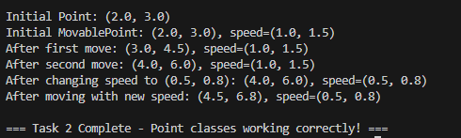

#### **Problem 3 – Demo.java Output:**

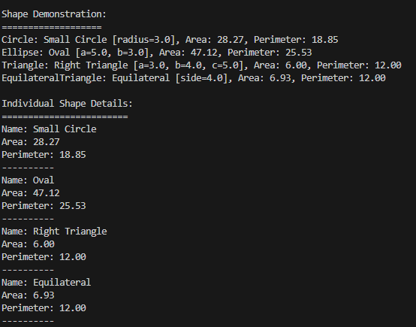

#### **Problem 4 – Demo.java Output Before & After Scaling:**

