**AUTOMATIC IRRIGATION SYSTEM**

# **Introduction**

In crop farming watering is the best way of maintaining crops’ wellness as well as maintaining best production. Some crops require continues monitoring of water level for irrigation. But locally it is performed with the help of humans; This continuous monitoring by humans is not possible for all the time. Hence automatic irrigation system is a suitable one which helps to irrigate the crops without the help of human intervention. This system will have continuous monitoring that helps better production.

# **Components needed**

* Soil moisture sensor
* Arduino board
* Dc pump
* Relay
* Breadboard
* Jumper wires
* Power supply

# **DRAWING:**

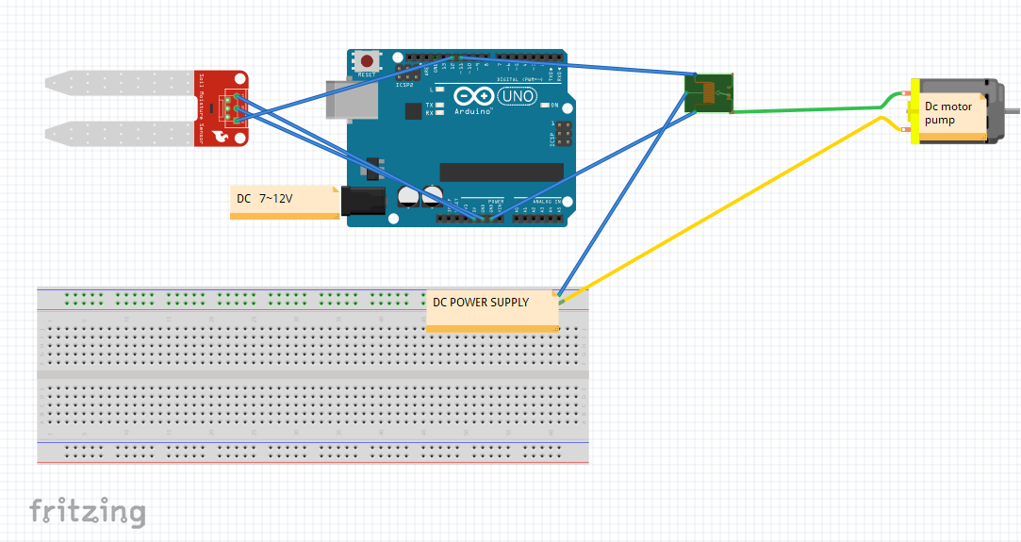

# **CODES:**

*#define soil_moisture 12*

*#define pump 11*

*void setup() {*

*pinMode(pump, OUTPUT);*

*pinMode(soil_moisture, INPUT);*

*Serial.begin(9600);*

*}*

*void loop() {*

*int val = digitalRead(soil_moisture);*

*Serial.println(val);*

*if(val == 1)*

*{*

*digitalWrite(pump, HIGH);*

*}*

*else*

*{*

*digitalWrite(pump, LOW);*

*}*

*}*