**Summary**

**Observation #1 –** Male players are the majority

From the data extrapolated, we can observe a Total of 576 players, with a gender mix of Male, Female, and Other/Non-Disclosed. When the data was categorized by gender demographics, we noticed most players were Male with the highest percentage of 84.03%, followed by the Female 14.06%, and Other/Non-Disclosed group with 1.91%. **(see Figure 1 – Population by Gender)**

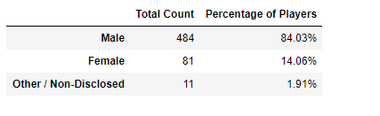

**Figure 1 – Depicts the population by gender**

## Observation #2 - Purchasing Analysis (Gender)

In analyzing the Purchase by gender, we noticed the Male population was greater than both Female and Other/Non-Disclosed; however, the female and other /Non-Disclosed group average purchase price was greater than the Male population.

Similarly, for the Average Total Purchase per person. But it did not boost the Total Purchase Value for both Female and Other/Non-Disclosed group, the Male population Total Purchase Value was greater than both Female and Other/Non-Disclosed.

In conclusion the Avg Purchase Price and Average Total Purchase per Person, although greater for both Female and Other/Non-Disclosed population did not make a difference in their total Purchase Value. The total Purchase Value is an indicator of the volume of the population. Hence the reason why the Male population Total Purchase Value is higher. **(See Figure 2 – Purchase Analysis by Gender)**

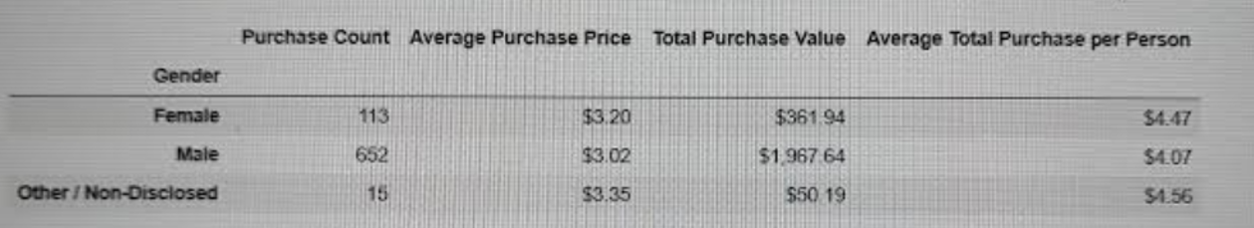

**Figure 2 – Depicts the Purchase Analysis by Gender**

## Observation #3 - Purchasing Analysis (Age)

## In inference, we can confidently state that players from the age group of 15-19 and 20-24 were mostly male. the base on the previous data collected. (See Figure 3 – Purchase Analysis by Age)

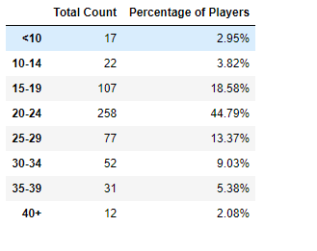

**Figure 3 – Depicts the Purchase Analysis by Age**

1. The trendingofAverage Purchase Price **and** the Average Total Purchase supports the observation made earlier. An inference can be made stating most of the players belong to the 15-19 & 20-24 age group ranges.

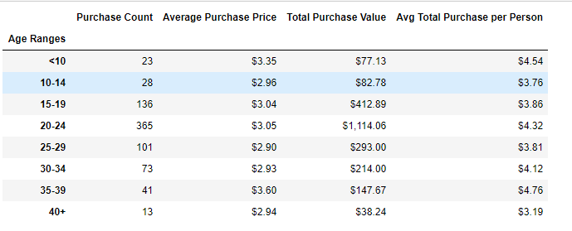

**Figure 3 – Depicts the Purchase Analysis by Age**

Trending with a lower average and total price, can inference most Male Players population are in the 15-19 & 20-24 age group