Exceptions

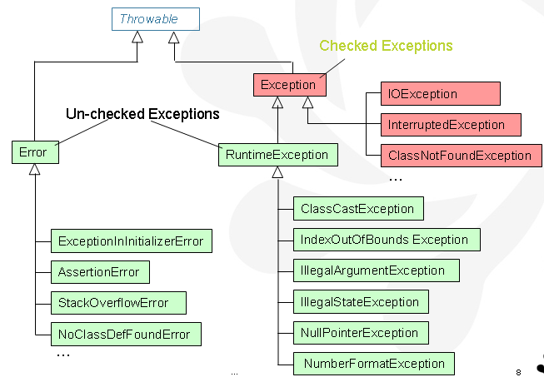

Exception | RuntimeException
„checked“ | „unchecked“
must  handle (try/catch)  or must  declare (throws) | can  handle (try/catch)  or can  declare (throws)  or may not do anything

When any exception is thrown in a static block, it is wrapped into ExceptionInInitializerError and then that ExceptionInInitializerError is thrown. Remember that a static initializer can only throw a RuntimeException.
If you try to throw a checked exception from a static block to the outside, the code will not compile.
An instance block is allowed to throw a checked exception but only if that exception is declared in the throws clause of all the constructors of the class.

