DSRIP Documentation Notebook

October 08, 2019

Table of Contents

# PPS identifying information

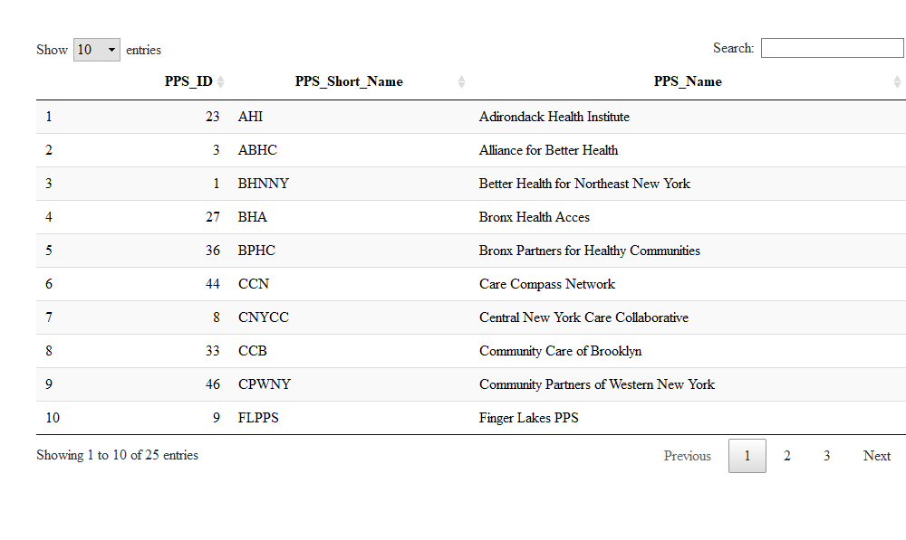

# Measures

