Surprising html, pdf, and docx rendering behavior with R gt table objects

Table of contents

## 1 Environment

* Windows 10 x64 (build 22598)
* R version 4.1.3 (2022-03-10)
* RStudio-2022.06.0-daily-310.exe
* quarto-0.9.282-win.msi
* gt * 0.4.0 2022-02-15 [1] CRAN (R 4.1.2)

## 2 SHOW gt object but do not save

* as html, text and table render
* as pdf, text and table render
* as docx, text renders but table does NOT render(!)

tab <- df %>%   
 mutate(type="SHOW gt object but do NOT save") %>%  
 gt() %>%   
 cols_label(rank="Rank", money="Amount")  
  
tab

## 3 SAVE gt object but do NOT show

* as html, text renders, and table object renders (!), differently, as if retrieved from file
* as pdf, same as html
* as docx, same as html

tab <- df %>%   
 mutate(type="SAVE gt object but do NOT show") %>%  
 gt() %>%   
 cols_label(rank="Rank", money="Amount")  
  
gtsave(tab, "tab.png")

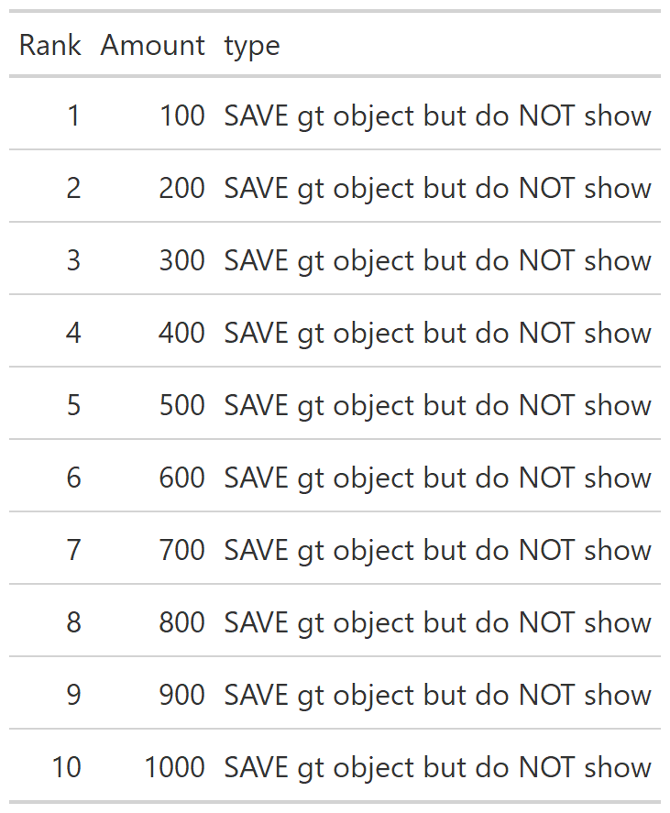

## 4 Retrieve and SHOW previously saved gt object

* as html, table object renders, but differently than when created and shown
* as pdf, same as html
* as docx, same as html



## 5 Sessioninfo

sessionInfo()

R version 4.1.3 (2022-03-10)  
Platform: x86_64-w64-mingw32/x64 (64-bit)  
Running under: Windows 10 x64 (build 22598)  
  
Matrix products: default  
  
locale:  
[1] LC_COLLATE=English_United States.1252   
[2] LC_CTYPE=English_United States.1252   
[3] LC_MONETARY=English_United States.1252  
[4] LC_NUMERIC=C   
[5] LC_TIME=English_United States.1252   
  
attached base packages:  
[1] stats graphics grDevices utils datasets methods base   
  
other attached packages:  
 [1] gt_0.4.0 forcats_0.5.1 stringr_1.4.0 dplyr_1.0.8   
 [5] purrr_0.3.4 readr_2.1.2 tidyr_1.2.0 tibble_3.1.6   
 [9] ggplot2_3.3.5 tidyverse_1.3.1  
  
loaded via a namespace (and not attached):  
 [1] tidyselect_1.1.2 xfun_0.30 haven_2.5.0 colorspace_2.0-3  
 [5] vctrs_0.4.1 generics_0.1.2 htmltools_0.5.2 yaml_2.3.5   
 [9] utf8_1.2.2 rlang_1.0.2 pillar_1.7.0 glue_1.6.2   
[13] withr_2.5.0 DBI_1.1.2 dbplyr_2.1.1 modelr_0.1.8   
[17] readxl_1.4.0 lifecycle_1.0.1 munsell_0.5.0 gtable_0.3.0   
[21] cellranger_1.1.0 rvest_1.0.2 evaluate_0.15 knitr_1.38.3   
[25] callr_3.7.0 tzdb_0.3.0 fastmap_1.1.0 ps_1.6.0   
[29] fansi_1.0.3 broom_0.8.0 checkmate_2.0.0 backports_1.4.1   
[33] scales_1.2.0 webshot_0.5.3 jsonlite_1.8.0 fs_1.5.2   
[37] hms_1.1.1 digest_0.6.29 stringi_1.7.6 processx_3.5.3   
[41] grid_4.1.3 cli_3.2.0 tools_4.1.3 sass_0.4.1   
[45] magrittr_2.0.3 crayon_1.5.1 pkgconfig_2.0.3 ellipsis_0.3.2   
[49] xml2_1.3.3 reprex_2.0.1 lubridate_1.8.0 assertthat_0.2.1  
[53] rmarkdown_2.13 httr_1.4.2 rstudioapi_0.13 R6_2.5.1   
[57] compiler_4.1.3