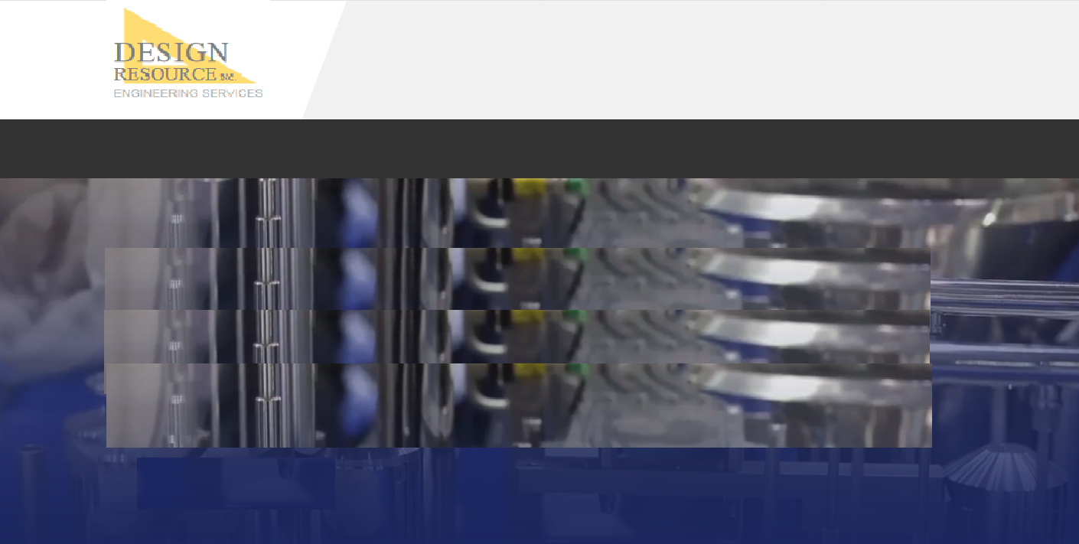

Links to job description docs

**Mechanical CAD designer**

**Manufacturing Engineer**

***We are always seeking talented, enthusiastic individuals to join our team or find a home with one of our customers.***

**HOME | ENGINEERING | STAFFING | COMPANY | CONTACT**

**© 2019 DESIGN RESOURCE, INC.**

**Career Opportunities**

**HOME ENGINEERING STAFFING COMPANY CONTACT**