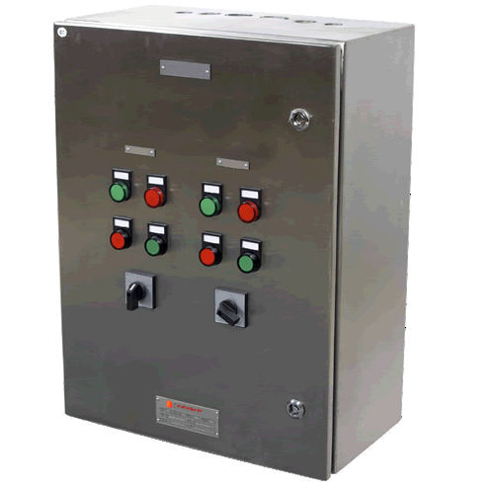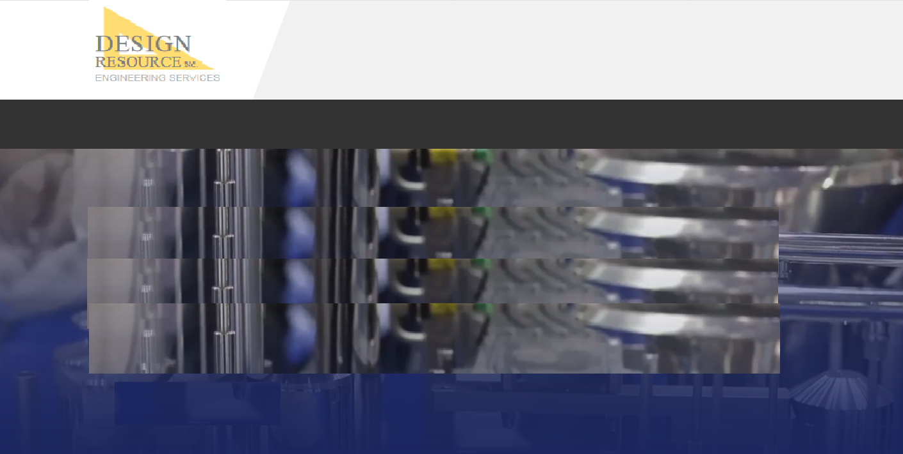 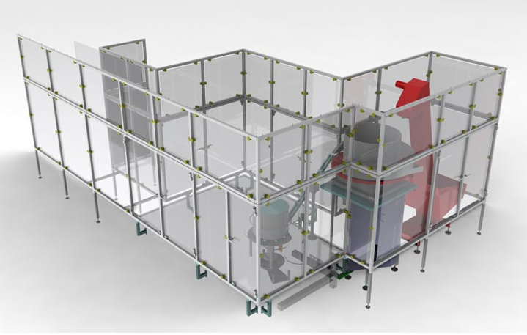

**Safety Barriers**

* Enclosures
* RABs
* Light curtains

**Controls design**

* Automation controls
* PLC programming
* HMIs

***Complete design and build of controls and safety barriers for manufacturing and automation.***

**HOME | ENGINEERING | STAFFING | COMPANY | CONTACT**

**© 2019 DESIGN RESOURCE, INC.**

**Controls and Safety**

**HOME ENGINEERING STAFFING COMPANY CONTACT**