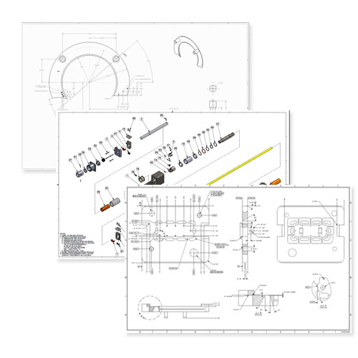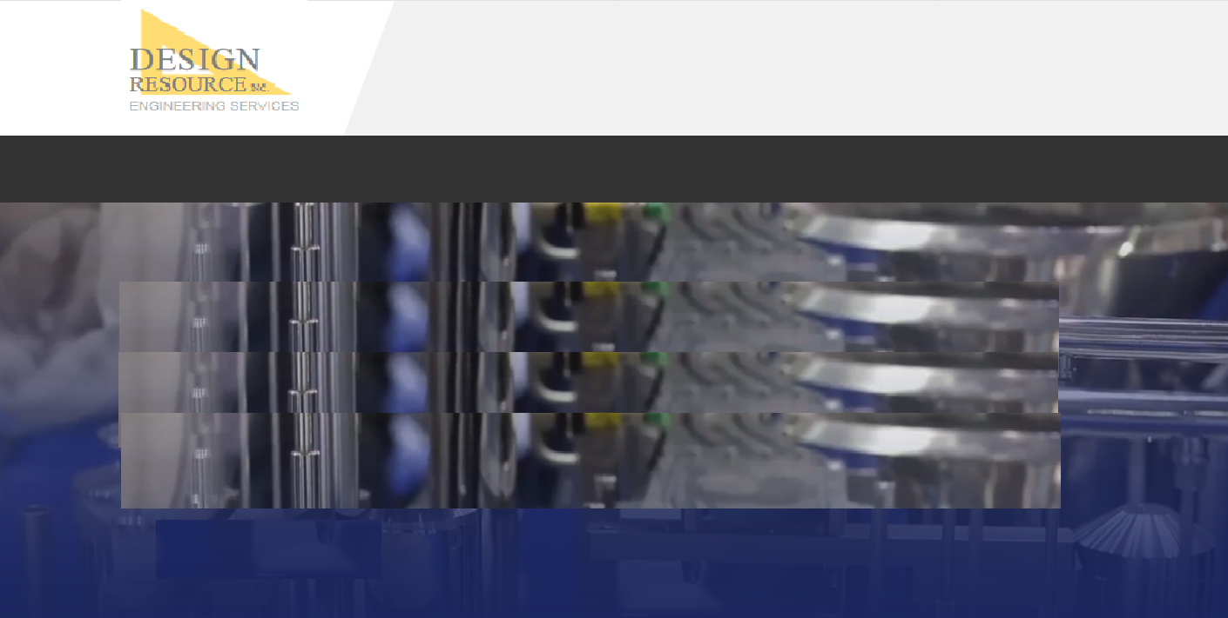

**Drafting**

* Complete documentation to current industry standards or your own company standards.
* ANSI, ISO, ASME
* Application of GD&T
* Intelligent application of tolerances to ensure form, fit, and function at manufacture.
* Full BOMs

**Reverse Engineering**

* Measure and model existing parts or assemblies with application of original design intent.
* Develop robust CAD models and drawings from 2D prints or non native CAD data

**Drawing Conversion**

* Conversion from any format
* Native CAD Remodeling of older data, STEP, or IGES.

***Full drafting and documentation services to ensure your designs comply with current industry standards and manufacturing methodologies.***

**HOME | ENGINEERING | STAFFING | COMPANY | CONTACT**

**© 2019 DESIGN RESOURCE, INC.**

**DRAFTING AND DOCUMENTATION DRAFTING**

**HOME ENGINEERING STAFFING COMPANY CONTACT**