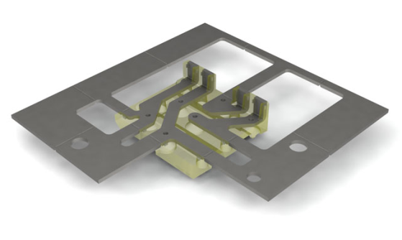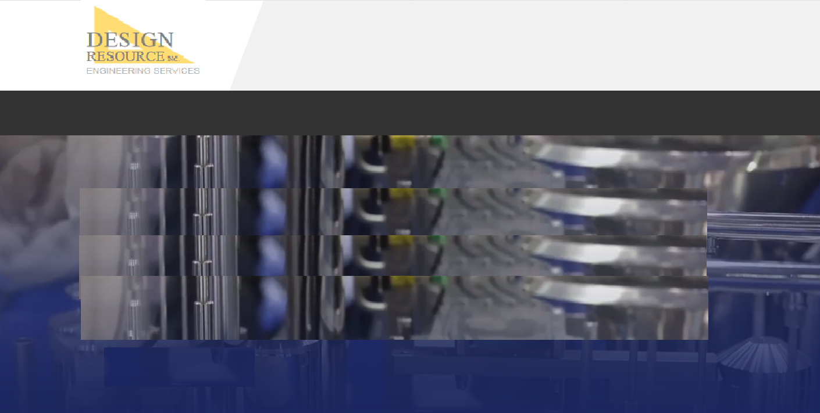

**Electrical**

* Board level design and build
* Full ECAD documentation

***Electrical design/build***

**HOME | ENGINEERING | STAFFING | COMPANY | CONTACT**

**© 2019 DESIGN RESOURCE, INC.**

**Electrical**

**HOME ENGINEERING STAFFING COMPANY CONTACT**