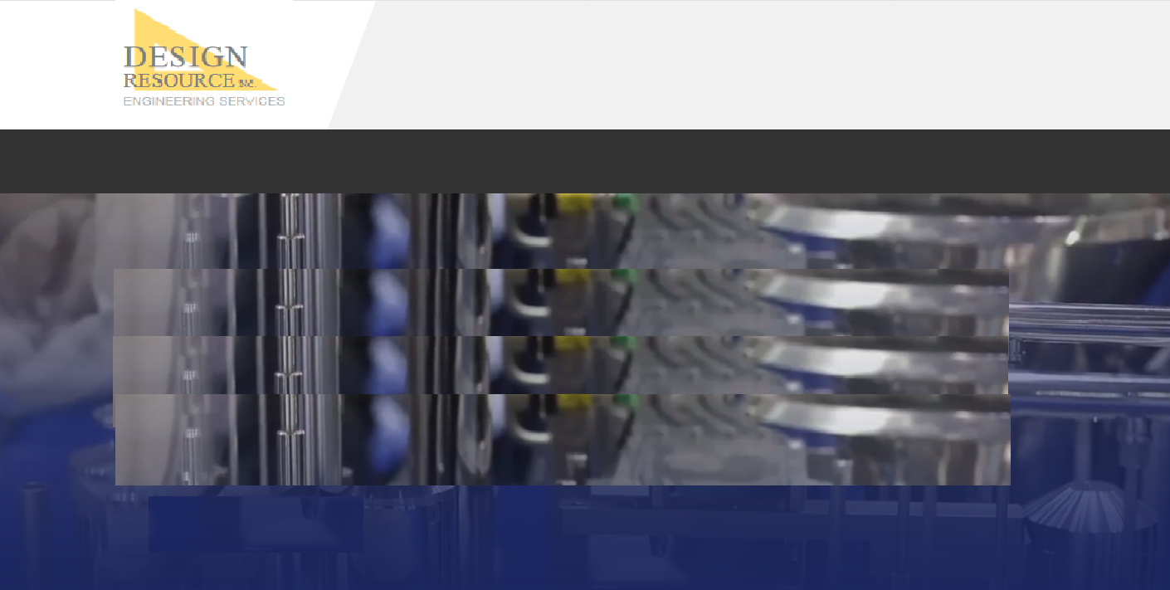

**Outsourcing**

* Work with our staff remotely through VPN, FTP, or cloud exchange.
* Available as need.

***Our staff available to complete and deliver your projects when you need them.***

**HOME | ENGINEERING | STAFFING | COMPANY | CONTACT**

**© 2019 DESIGN RESOURCE, INC.**

**Outsourcing**

**HOME ENGINEERING STAFFING COMPANY CONTACT**