**HUMAN RESOURCES INFORMATION SYSTEM**

**FOR PSA ENTERPRISES**

A Project Proposal in

System Administration and Design

Presented to the

Faculty of Computer Engineering Department

Polytechnic University of the Philippines

Sta. Mesa, Manila

In Partial Fulfillment

Of the Requirements for the Degree

**BACHELOR OF SCIENCE IN COMPUTER ENGINEERING**

By

Dulay, Angela Louise G.

Gutierrez, Jeria G

Hernaez, Sheila Marie A.

Mercado, Julianne K.

Mergilla, Zildjian L.

Otawa, Marc Oliver P.

Patricio, Kristine Gaile M.

October 2018

**ACKNOWLEDGEMENT**

**DEDICATION**

**TABLE OF CONTENTS**

**Chapter 1 COMPANY BACKGROUND**

History of the Company 1

Vision and Mission 1

Organizational Structure 3

Definition of Terms 5

**Chapter 2 SYSTEM ANALYSIS**

Business Processes 6

Problem Definition 9

Proposed Solution 9

Significance of the Study 10

Scope and Limitation 11

**Chapter 3 SYSTEM DESIGN**

Business Processes 12

Data Flow Diagram 19

Entity-Relationship Diagram 21

**Chapter 3 SYSTEM FEASIBILITY**

Proposed Solution 24

Alternative Solution 24

**REFERENCES** 38

**APPENDICES**

Appendix A

Appendix B

**GANTT CHART**

**Curriculum Vitae**

**RATIONALE**

**CHAPTER I**

**COMPANY BACKGROUND**

**HISTORY OF THE COMPANY**

PSA Enterprises was born out of the entrepreneurial drive of Pinky Santiago-Alqueros. Starting her career working for one of the leading manpower agencies in the Philippines, she saw and seized the opportunity to build her own business and founded PSA Enterprises. In less than 10 years, PSA has grown into a major player in the manpower business, offering manpower solutions and services to a variety of industries (FMCG, Retail, Technology).

**MISSION**

We Strive to be a profitable, progressive and dynamic manpower services provider in the Philippines by being a stable and reliable partner of businesses while striving to provide a fair and lawful employment opportunities for Filipinos.

**CORE VALUES**

**PROFESSIONALISM -** PSA staff performs their duties with a high degree of integrity and professionalism. They are aware that this is the trait that wins the confidence of our clients and applicants.

**ACHIEVEMENT -** We are committed to attain the highest possible goals and recognize that success is the outcome of hard work and dedication. PSA ENTERPRISES faces all challenges with a positive attitude, constantly striving to improve and celebrate our success.

**COMMITMENT -** From the first meeting with a potential employee or client to the successful deployment, PSA staff is committed to provide our applicants and clients the highest level of service and dedication.

**EXCELLENCE -** The emphasis is always attention to detail and we believe that the strongest foundation of a successful business is to deliver our services with quality and integrity. PSA ENTERPRISES is determined to offer the highest level of service and dedication.

**TEAMWORK -** Success comes from people who care about each other, our clients and our company. We support listening, talking openly and sharing our knowledge freely. Finding the best solution by embracing our strengths and differences bring out the best in PSA ENTERPRISES staff.

**SUPPORT** - PSA ENTERPRISES offers fast, reliable, professional result to our clients together with dedication and guidance to our applicants. Our applicants are our greatest resource and are treated with the respect and courtesy they deserve.

**INNOVATION** - PSA ENTERPRISES is not complacent and continually looks to identify and implement solutions, improve our business processes and services. Our staff is empowered to use their imagination and to innovate while handling assignments.

**OBLIGATIONS** - We abide by all the rules and regulations as stipulated by the Department of Labor and Employment (DOLE) and PSA Enterprises will not violate our obligations or principles with objectionable business practices. Since 2007, we have not had any violation.

**ORGANIZATIONAL STRUCTURE**

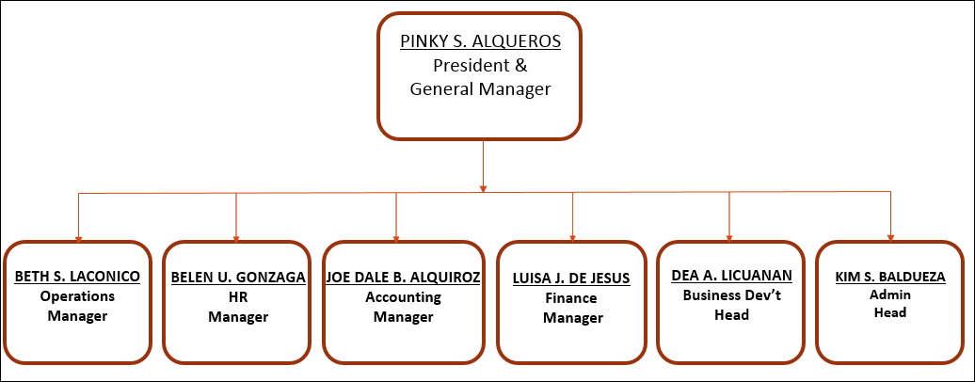

**DEFINITION OF TERMS**

|  |  |
| --- | --- |
| **Terms** | **Definition** |
| **Admin** | Higher level of access to the system than the user. |
| **Bootstrap** | Bootstrap is a free and open-source front-end framework for designing websites and web applications. It contains HTML- and CSS-based design templates for typography, forms, buttons, navigation and other interface components, as well as optional JavaScript extensions. |
| **CSS** | Cascading Style Sheets is a style sheet language used for describing the presentation of a document written in a markup language like HTML. CSS is a cornerstone technology of the World Wide Web, alongside HTML and JavaScript. |
| **Dashboard** | An information management tool that visually tracks, analyzes and displays key performance indicators (KPI), metrics and key data points to monitor the health of a business, department or specific process. |
| **Database** | A structured set of data held in a computer, especially one that is accessible in various ways. |
| **GUI** | Graphic User Interface. A type of user interface that allows users to interact with electronic devices through graphical icons and visual indicators such as secondary notation, instead of text-based user interfaces, typed command labels or text navigation. |
| **HRIS** | Human Resource Information System. Intersection of human resources and information technology through HR software. This allows HR activities and processes to occur electronically. |
| **HTML** | Hypertext Markup Language is the standard markup language for creating web pages and web applications. With Cascading Style Sheets and JavaScript, it forms a triad of cornerstone technologies for the World Wide Web. |
| **Local deployment** | Access to the system is only possible if the computer is connected through LAN. |
| **Master list** | List of records and information necessary from the employees for verification by the staff. |
| **Module** | Function or part of a system. |
| **Spreadsheet** | It is an electronic document in which data is arranged in the rows and columns of a grid and can be manipulated and used in calculations. |
| **SQL** | Structured Query Language. SQL lets you access and manipulate databases. |
| **User** | Most basic level of access to the system. |
| **Web application** | An application program that is stored on a remote server and delivered over the Internet through a browser interface. |

**CHAPTER II**

**SYSTEM ANALYSIS**

**CURRENT BUSINESS PROCESS**

The company has a master list in the form of an Excel Spreadsheet. This list is updated through and through over time. Different departments refer to this and rely on the information it conveys—agency, account and employee information. They retrieve the data necessary for their work by browsing and navigating through this master list.

On a weekly basis, a report, containing the information and status of employees, is generated and submitted to their specific coordinator, they retrieve the necessary data from the master list by searching through rows in the Excel Spreadsheet. These are then compiled into another spreadsheet and then sent to the relevant people-in-charge.

The person-in-charge inputs the time in time out of the employees per day on the excel spreadsheet and calculates the days tardy and absences of each. Depending on the value, there is a corresponding sanction to be imposed.

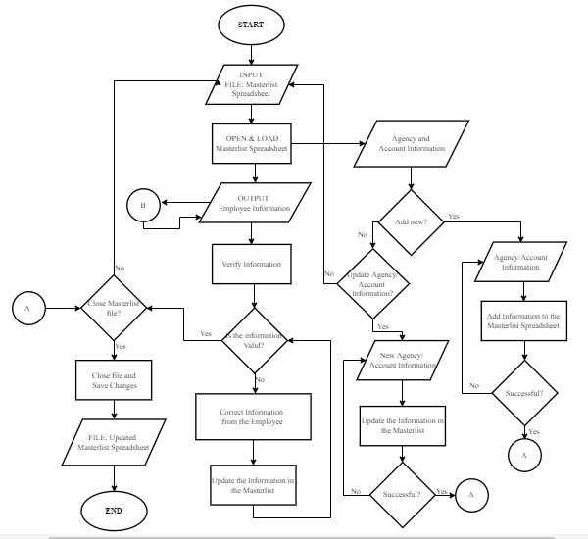**FLOWCHART**

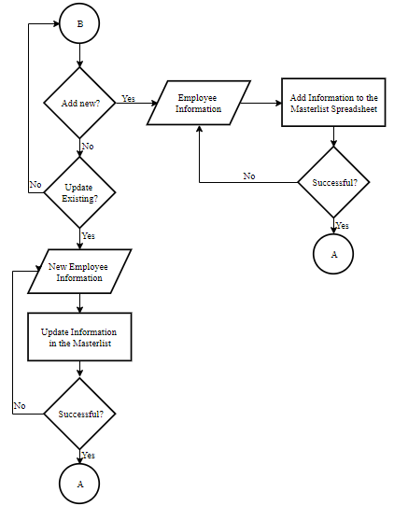

**PROBLEM DEFINITION**

The main problem which aims to be addressed in this project is the lack of automation in the company’s business process. Currently, they have their master list, and records are stored in large excel files that need to be updated and sent weekly. Due to the growth of the file in size over time, the documents take lengthy time to load and make the software lag while navigating through it. Due to the limitations of the software (Microsoft Excel), finding specific records is not easy, and so is generating the reports weekly. This results to lack of conviction to work due to the amount of time and energy that is wasted in the process. Which then leads to lack of assurance that the records are well-maintained and no procedure is being/going to be overlooked.

**PROPOSED SOLUTION**

The proponents decided that developing a computerized system for the company is a good solution for the problems they encounter. The Human Resources Information System for PSA Enterprises aim to:

* Improve the company’s HRIS from simple excel files to locally-deployed web application.
* Provide a better storage for the HRIS records, from excel files to SQL-based database.
* Develop a user-friendly interface for the HRIS.
* Lessen the time consumed in accessing and fetching the necessary records from the database.

**SIGNIFICANCE OF THE STUDY**

The result of this study will be beneficial to the following:

* **PSA Enterprises –** Having an automated system will help maintain the accuracy of the company’s records in terms of their employees’ information.
* **PSA Enterprises Human Resources Department**. – Having an automated system will help ease out the process that the staff undergo whenever they access their master list spreadsheet. Fetching the necessary records will be easier and faster, adding new and updating existing information will also be simpler with an organized database and user-friendly interface.
* **Proponents** – Developing an HRIS for PSA Enterprise will help hone the proponents’ software engineering skills and expand their knowledge and experience in handling projects and business processes.

**SCOPE AND LIMITATION**

The PSA Enterprises HRIS will:

* Cover the development of a web application for the PSA Enterprises’ HRIS, but will not be deployed online.
* Include an Agency management module with addition, viewing and updating as its modules.
* Include an Accounts management module with addition, viewing and updating as its modules.
* Include an Employee management module with addition, viewing and updating as its modules.
* Include 4 Dashboards for different departments with different columns which will depend on its relevance to their work.
* Include a User management module with addition of users and updating of access as its modules.
* Include a time-tracking with entering time-in and time-out and viewing as its modules.
* Include a logs interface for the tracking of changes in the system.

**CHAPTER III**

**SYSTEM DESIGN**

**BUSINESS PROCESSES**

The HRIS for PSA Enterprises as a whole has the following integrated modules:

* **User Management –** This lets the ‘Super Admin’ or head of the system add users who can access the HRIS. It also lets them edit the level of access of each user.
* **Agency Management –** This lets the head of the system add new agencies that they have an outstanding contract with. It can also update some agency information, like their status and disengagement date with PSA Enterprises.
* **Accounts Management –** This lets an admin add new accounts that they have an outstanding contract with, under an agency that has a contract with that particular account. You can also add managers or persons-in-charge under these accounts. It can also update some information, like the client information, service agreement end date, cut-off date, pay date, persons-in-charge information, etc.
* **Employee Management –** This lets an admin add new employees their hired. It can also update some information, like end date, status of mandatories and the information for their mandatories, per se. It also records the employment history of the employees under PSA Enterprises.
* **Time Tracking for Employees –** This lets an admin record the time-in and time-out of the employees per day. It is capable of recording absences and day-offs.
* **Dashboard –** This lets the different users from different departments retrieve the necessary information for their work, e.g. checking the status of the employees’ mandatories and/or verifying the existence and trueness of the mandatories, per se.
* **Logs –** This records all transactions done in the system by the different users. It provides the username, date and transaction record and displays it with GUI to help track the changes in the database.

**FLOWCHART**

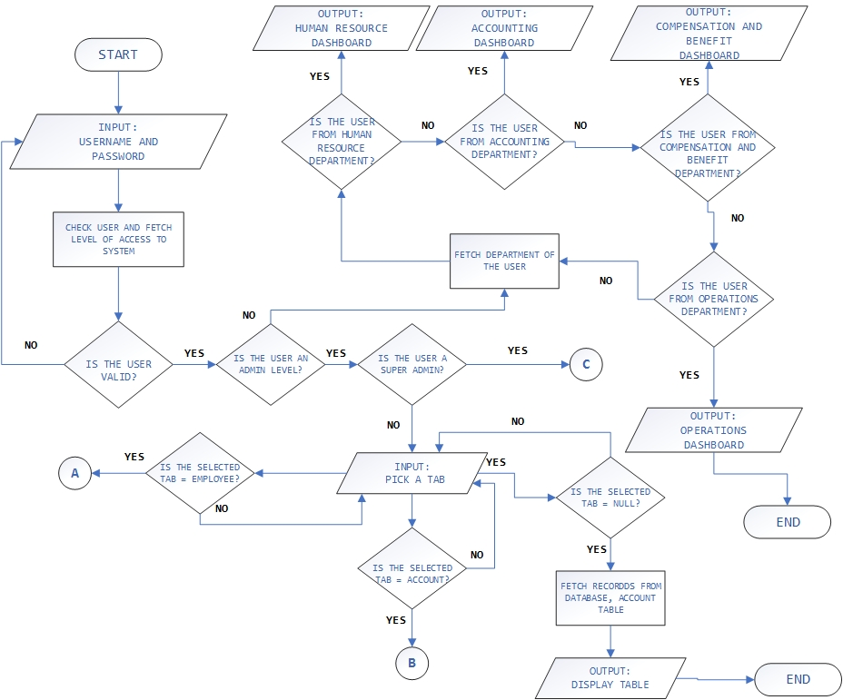

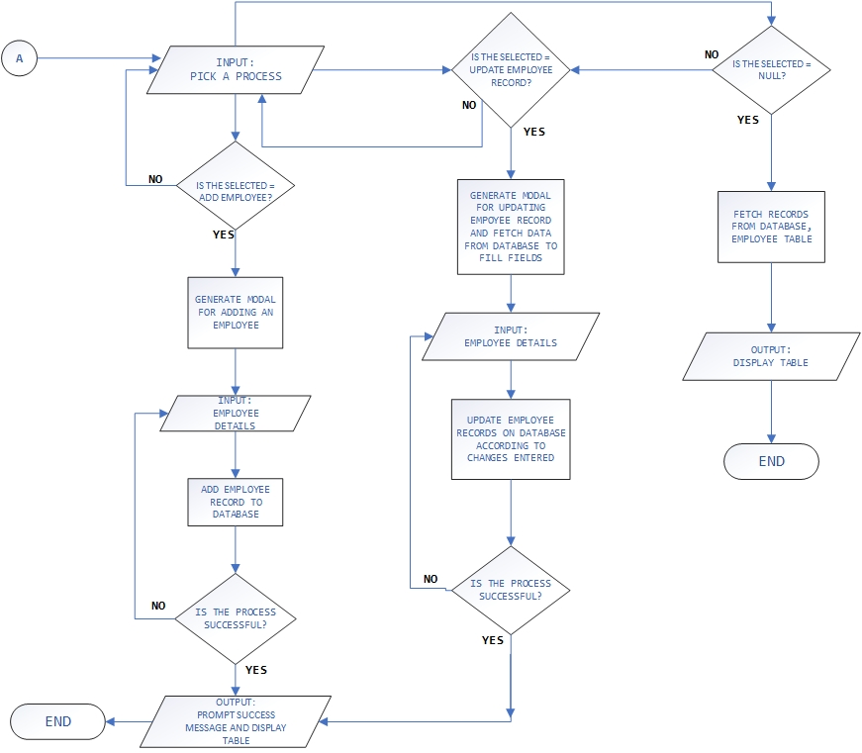

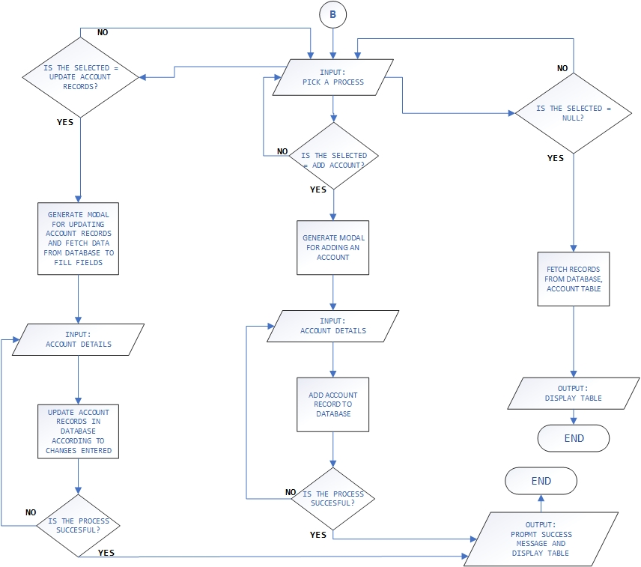

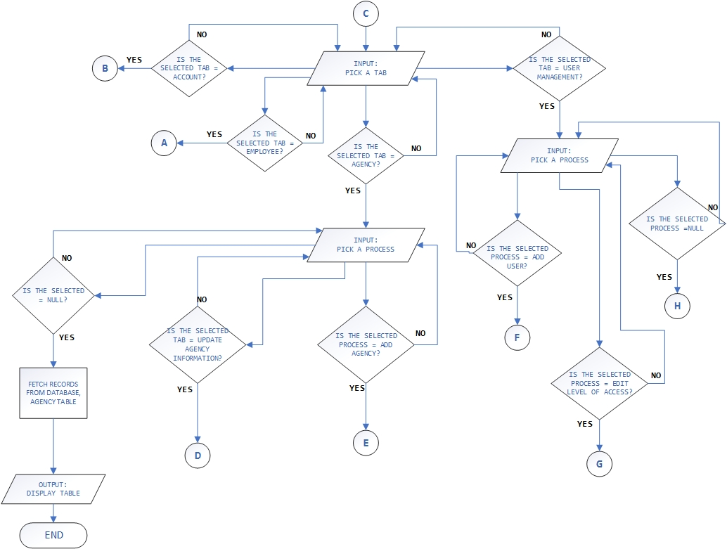

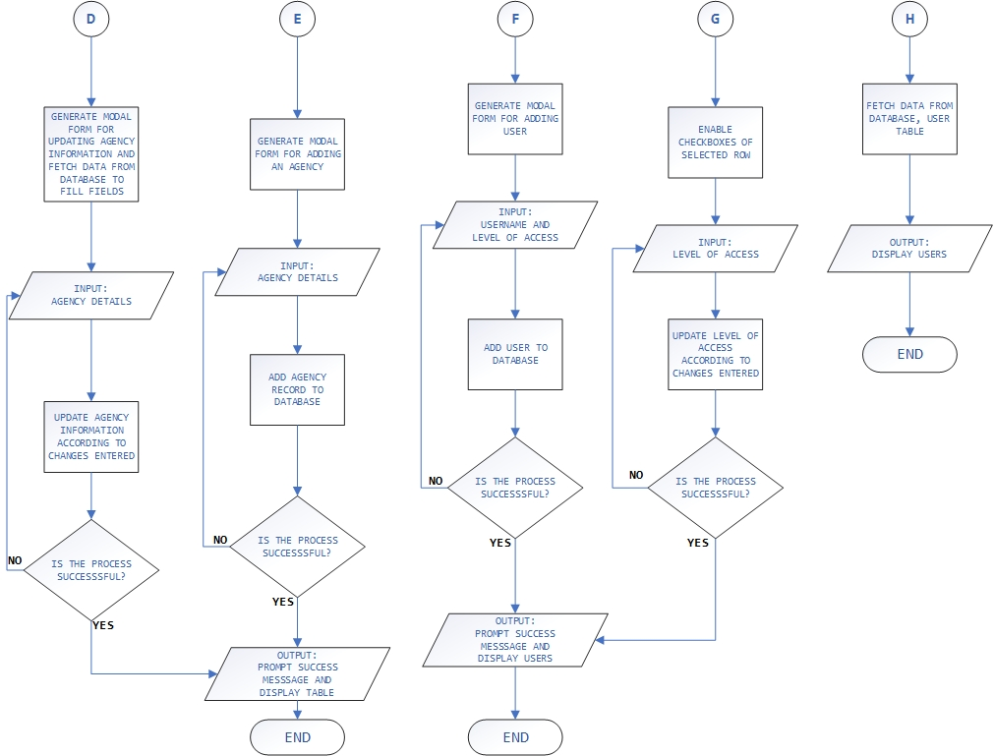

**DATA FLOW DIAGRAM**

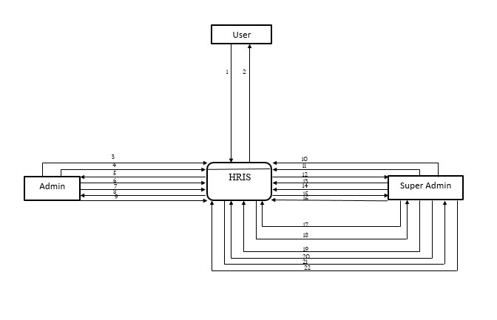**CONTEXT LEVEL DIAGRAM**

LEGEND:

1 – Log in and access dashboard

2 – Retrieve employee records

3 – Log in and access HRIS

4 – Add employee information

5 – Retrieve employee records

6 – Update employee records

7 – Add account information

8 – Retrieve account records

9 – Update account records

10 – Log in and access HRIS

11 – add user and grant access to HRIS

12 – Retrieve list of user with level of access

13 – Edit level of access of user

14 – Add agency information

15 – Retrieve agency records

16 – Update agency record

**TOP LEVEL DIAGRAM**

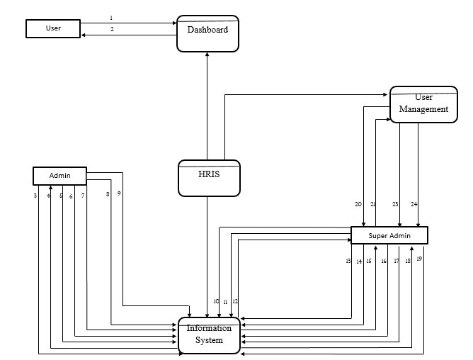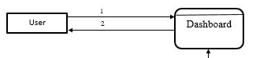

LEGEND:

1 – Log in and access dashboard

2 – Retrieve employee records

3 – Update account records

4 – Retrieve account records

5 – Add account information

6 – Update employee records

7 – Retrieve information records

8 – Add employee information

9 – Log in and access HRIS – IMS

10 – Log in and access HRIS – IMS

11 – Add agency information

12 - Retrieve agency access

13 – Update agency records

14 – Add account information

15 – Retrieve account information

16 – Update account records

17 – Add employee information

18 – Retrieve employee records

19 – Update employee record

20 – Login and access HRIS – IMS

21 – Retrieve list of users and level of access

22 – Add user and grant access to HRIS

23 – Edit level of access of use

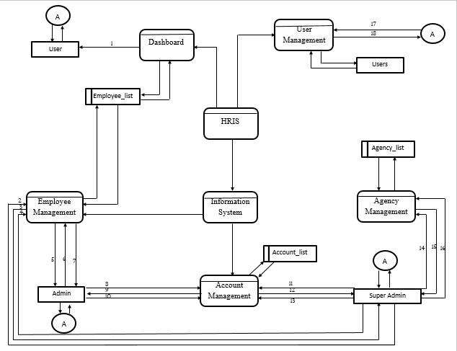**CHILD DIAGRAM**

LEGEND:

1 – Retrieve employee records

2 – Update employee records

3 – Retrieve employee records

4 – Add employee information

5 – Add employee information

6 – Retrieve employee records

7 – Update employee records

8 – Add account information

9 – Retrieve account records

10 – Update account records

11 – Update account records

12 – Retrieve account records

13 – Add account information

14 – Add agency information

15 – Retrieve agency information

16 – Update agency records

17 – Login

18 – Fetch level of access

**ENTITY-RELATIONSHIP DIAGRAM**

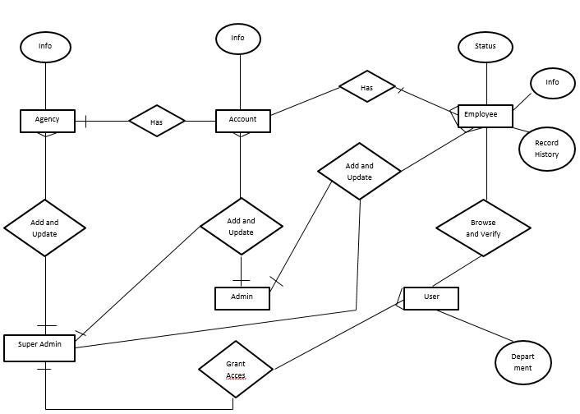**THE DIAGRAM**

**DATABASE SCHEMA**

account_list

account_id (PK) int(11)

agency_id(FK) int(11)

account_principal varchar(30)

account_client_Name varchar(65)

account_serAge_sDate date

account_serAge_eDate date

account_add_province varchar(20)

account_qdd_town varchar(20)

account_add_net varchar(35)

account_CO_date1 date

account_CO_date2 date

account_pay_date1 date

account_pay_date2 date

account_status varchar(10)

account_DE_date date

agency_list

agency_id(PK) int(11)

agency_name(FK) varchar(30)

agency_gm_lname varchar(30)

agency_gm_fname varchar(30)

agency_gm_mname varchar(30)

agency_gm_email varchar(35)

agency_gm_conNum varchar(20)

agency_sss_regdate date

agency_philhealth_regdate date

agency_pagibig_regdate date

agency_status varchar(10)

employee_list

emp_man_PAGIBIG varchar(20)

emp_man_NBI_expDate date

emp_man_NBI_ORNum varchar(20)

emp_man_polClear tinyint(1)

emp_man_brgyClear tinyint(1)

Account_persons

accPer_id (PK) int(11)

account_id(FK) int(11)

accPer_pos varchar(20)

accPer_Name varchar(65)

accPer_conNum varchar(20)

accPer_email VARCHAR(35)

accPer_bday date

pp

users

id (PK) int(11)

username(FK) varchar(20)

password varchar(128)

access tinyint(4)

employee_list

emp_id(PK) int(11)

account_id(FK) int(11)

emp_lname varchar(35)

emp_fname varchar(35)

emp_mname varchar(35)

emp_status varchar(10)

emp_bday date

emp_sex varchar(10)

emp_email varchar(35)

emp_conNum varchar(20)

emp_pos varchar(20)

emp_type varchar(20)

emp_dateHired date

emp_endDate date

emp_add_province varchar(20)

emp_add_town varchrar(20)

emp_add_det varchar(35)

emp_emergency_conPer varchar(65)

emp_emergency_conNum varchar(15)

emp_civilStatus varchar(15)

emp_noOfChildren smallint(3)

emp_man_status varchar(20)

emp_man_SSS varchar(20)

emp_man_PhilHealth varchar(20)

pp

Employment_history

empmHisto_id(PK) int(11)

empHisto_lname varchar(35)

empHisto_fname varchar(35)

empHisto_mname varchar(35)

empmHisto_agency varchar(30)

empmHisto_account varchar(30)

empmHisto_sDate date

empmHisto_eDate date

empmHisto_RFL varchar(200)

**CHAPTER IV**

**SYSTEM FEASIBILITY**

**PROPOSED SOLUTION: ECONOMIC FEASIBILITY**

**COST AND BENEFIT ANALYSIS**

|  |  |  |  |  |
| --- | --- | --- | --- | --- |
| **Personel** | **Position** | **Cost/Hour** | **Total Number of Labor Hours** | **Total Cost** |
| Mergilla, Zildjian | Head Programmer | ₱ 400.00 | 1040 | ₱ 416,000.00 |
| Mercado, Julianne | System Analyst | ₱ 500.00 | 1000 | ₱ 500,000.00 |
| Otawa, Marc Oliver | Operations Manager / Assistant Programmer | ₱ 350.00 | 1080 | ₱ 378,000.00 |
| Dulay, Angela | Assistant Programmer | ₱ 300.00 | 1040 | ₱ 312,000.00 |
| Gutierrez, Jeria | AssistantProgrammer | ₱ 300.00 | 1040 | ₱ 312,000.00 |
| Patricio, Kristine | UI Developer/Tester | ₱ 300.00 | 1040 | ₱ 312,000.00 |
| Hernaez, Sheila | UI Developer/Tester | ₱ 300.00 | 1040 | ₱ 312,000.00 |
| **TOTAL DEVELOPMENT COST:** | | | | **₱ 2,542,000.00** |

**Development Costing**

**Operational Cost**

|  |  |  |  |
| --- | --- | --- | --- |
|  | **Cost per Day  (Team Value)** | **Labor Days (per Month)** | **Total Cost  (6 months Value)** |
| Internet Subscription | 100.00 | 20 | 12,000.00 |
| Power Consumption | 45.00 | 20 | 5,400.00 |
| Transportation | 120.00 | 20 | 10,800.00 |
| Miscellaneous | 250.00 | 20 | 30,000.00 |
| **TOTAL OPERATIONAL COST:** | | | **₱ 58,200.00** |

**New Hardware and Software**

|  |  |  |  |  |
| --- | --- | --- | --- | --- |
| **Item** | **Quantity** | **Cost** | **Total Cost** | **Item Description** |
| Employee Laptop | 1 | ₱ 21,000.00 | ₱ 21,000.00 | i3 7100u , 4gb DDR4 2133mhz , 72000rpm 1TB HDD, 15in Display ,Windows 10 Home |
| Web Hosting | 12 months | ₱ 517.90 | ₱ 6,214.8 | Swift Package from a2 Hosting ( unlimited sites and resources) |
| **TOTAL COST:** | | | | **₱ 27,214.8** |

**PROPOSED SOLUTION: OPERATIONAL FEASIBILITY**

The employees of PSA Enterprises are computer-literate, as they use computers (e.g., desktops, laptops, etc.) for their everyday work. They can navigate through their desktop with confidence. They were exposed to Excel Spreadsheets for their database and information-retrieval.

The HRIS for PSA Enterprises is a locally-deployed web application. It has a user-friendly interface and organized database. With these, the staff will have a better experience at work without difficulty.

**PROPOSED SOLUTION: TECHNICAL FEASIBILITY**

The HRIS for PSA Enterprises uses various tools and resources that are widely available. There are Integrated Development Environments that are free to be used. The team is knowledgeable with regards to networks and servers, making the deployment possible and setting the level of confidence in the system high.

**ALTERNATIVE SOLUTION: ECONOMIC FEASIBILITY**

Excel Spreadsheets can be a tool for storing information for the company’s employees, accounts, agencies, etc. It can also contain formulas for data relationships. You can also use a few tools available there to make the spreadsheet a little eye-pleasing. There are different tools for spreadsheets available for free and/or for a price. Though it has a lot of disadvantages, using excel spreadsheets will accumulate less expenses.

**PROPOSED SOLUTION: OPERATIONAL FEASIBILITY**

Even though excel spreadsheets are known for being low-cost, it is also known to have its disadvantages. Excel files grow in size over time as you encode data continuously. Upon opening, it loads all of its resources which makes it load longer than the desired amount of time. Also, a result of this, navigating through the file takes up significant amount of time which can be used for important tasks instead. Lastly, keeping multiple copies on different storage drives does not eliminate the risk of data loss, but rather exposes the threat of data-leakage, security and/or breach of confidentiality.

**PROPOSED SOLUTION: TECHNICAL FEASIBILITY**

Though a lot of tools for viewing, editing, etc. of excel spreadsheets are widely available, it cannot eliminate the risk of technical limitations. The software tool might be free, but hardware components are expensive. To be able to use excel spreadsheets for record-storage (or basically the system for your department), the computer that runs it must be of medium to high quality. Since the tool itself uses a lot of memory, adding up to this is the large file size for the spreadsheet, the computer can cause lags and can be slow depending on its specifications.

**APPENDICES**

**COMMUNICATION LETTERS**

**Project Charter**

**PERTINENT DOCUMENTS**

**EXISTING FORMS FROM THE COMPANY**

**PSA INFORMATION SHEET**

**QUESTIONNAIRE**

1. What is the nature of work of the company?
2. What are the business processes of these departments?
3. What are the different departments existing in the company?
4. In what department would you say needs help regarding its business processes?
5. What is the problem and its root cause?
6. Would developing a computerized system application help in solving this problem and improve the business processes of the said department?
7. What problems do you want to be addressed by the system? How?
8. Ow many main entities would be concerned in this system>
9. How would you want the system to be available?
10. What are the resources available in the company that can be useful in the system’s environment setting?

**Gantt Chart**

**PERT**

**CURRICULUM VITAE**