1. Introduction (20%)

這次實驗是要去分析因糖尿病而導致的視網膜病變，這次的資料輸入會是眼球的圖片，然後通過圖片來預測該圖片的人是否患有視網膜病變。

1. 首先，我們要設計一個Data Loader來將圖片轉換成可運算的Tensor
2. 利用Resnet18、50來辨識該圖片的人是否患有視網膜病變，並比較Resnet在有無Pre-train 的分別。
3. 利用預測和實際的值來製作Confusion matrix以評估模型在區分不同階段病患的準確度。
4. Experiment setups (30%)
   1. The details of your model (ResNet)

模型是直接使用Library中的ResNet，再通過更改最後的Fully Connection（FC） Layer的輸出來使用。我們要把病情階段分為5個，所以輸出為5。

以下是ResNet18的結構:

總共有conv1(1 layer) + 4大層x 4 (每層有2個Basic Block，每個Basic Block有2層convolution layer，共16層) + 1 FC layer = 18

Resnet18: ---------------------------------------------------------------------------------------------

ResNet(

(conv1): Conv2d(3, 64, kernel_size=(7, 7), stride=(2, 2), padding=(3, 3), bias=False)

(bn1): BatchNorm2d(64, eps=1e-05, momentum=0.1, affine=True, track_running_stats=True)

(relu): ReLU(inplace=True)

(maxpool): MaxPool2d(kernel_size=3, stride=2, padding=1, dilation=1, ceil_mode=False)

(layer1): Sequential(

(0): BasicBlock(

(conv1): Conv2d(64, 64, kernel_size=(3, 3), stride=(1, 1), padding=(1, 1), bias=False)

(bn1): BatchNorm2d(64, eps=1e-05, momentum=0.1, affine=True, track_running_stats=True)

(relu): ReLU(inplace=True)

(conv2): Conv2d(64, 64, kernel_size=(3, 3), stride=(1, 1), padding=(1, 1), bias=False)

(bn2): BatchNorm2d(64, eps=1e-05, momentum=0.1, affine=True, track_running_stats=True)

)

(1): BasicBlock(

(conv1): Conv2d(64, 64, kernel_size=(3, 3), stride=(1, 1), padding=(1, 1), bias=False)

(bn1): BatchNorm2d(64, eps=1e-05, momentum=0.1, affine=True, track_running_stats=True)

(relu): ReLU(inplace=True)

(conv2): Conv2d(64, 64, kernel_size=(3, 3), stride=(1, 1), padding=(1, 1), bias=False)

(bn2): BatchNorm2d(64, eps=1e-05, momentum=0.1, affine=True, track_running_stats=True)

)

)

(layer2): Sequential(

(0): BasicBlock(

(conv1): Conv2d(64, 128, kernel_size=(3, 3), stride=(2, 2), padding=(1, 1), bias=False)

(bn1): BatchNorm2d(128, eps=1e-05, momentum=0.1, affine=True, track_running_stats=True)

(relu): ReLU(inplace=True)

(conv2): Conv2d(128, 128, kernel_size=(3, 3), stride=(1, 1), padding=(1, 1), bias=False)

(bn2): BatchNorm2d(128, eps=1e-05, momentum=0.1, affine=True, track_running_stats=True)

(downsample): Sequential(

(0): Conv2d(64, 128, kernel_size=(1, 1), stride=(2, 2), bias=False)

(1): BatchNorm2d(128, eps=1e-05, momentum=0.1, affine=True, track_running_stats=True)

)

)

(1): BasicBlock(

(conv1): Conv2d(128, 128, kernel_size=(3, 3), stride=(1, 1), padding=(1, 1), bias=False)

(bn1): BatchNorm2d(128, eps=1e-05, momentum=0.1, affine=True, track_running_stats=True)

(relu): ReLU(inplace=True)

(conv2): Conv2d(128, 128, kernel_size=(3, 3), stride=(1, 1), padding=(1, 1), bias=False)

(bn2): BatchNorm2d(128, eps=1e-05, momentum=0.1, affine=True, track_running_stats=True)

)

)

(layer3): Sequential(

(0): BasicBlock(

(conv1): Conv2d(128, 256, kernel_size=(3, 3), stride=(2, 2), padding=(1, 1), bias=False)

(bn1): BatchNorm2d(256, eps=1e-05, momentum=0.1, affine=True, track_running_stats=True)

(relu): ReLU(inplace=True)

(conv2): Conv2d(256, 256, kernel_size=(3, 3), stride=(1, 1), padding=(1, 1), bias=False)

(bn2): BatchNorm2d(256, eps=1e-05, momentum=0.1, affine=True, track_running_stats=True)

(downsample): Sequential(

(0): Conv2d(128, 256, kernel_size=(1, 1), stride=(2, 2), bias=False)

(1): BatchNorm2d(256, eps=1e-05, momentum=0.1, affine=True, track_running_stats=True)

)

)

(1): BasicBlock(

(conv1): Conv2d(256, 256, kernel_size=(3, 3), stride=(1, 1), padding=(1, 1), bias=False)

(bn1): BatchNorm2d(256, eps=1e-05, momentum=0.1, affine=True, track_running_stats=True)

(relu): ReLU(inplace=True)

(conv2): Conv2d(256, 256, kernel_size=(3, 3), stride=(1, 1), padding=(1, 1), bias=False)

(bn2): BatchNorm2d(256, eps=1e-05, momentum=0.1, affine=True, track_running_stats=True)

)

)

(layer4): Sequential(

(0): BasicBlock(

(conv1): Conv2d(256, 512, kernel_size=(3, 3), stride=(2, 2), padding=(1, 1), bias=False)

(bn1): BatchNorm2d(512, eps=1e-05, momentum=0.1, affine=True, track_running_stats=True)

(relu): ReLU(inplace=True)

(conv2): Conv2d(512, 512, kernel_size=(3, 3), stride=(1, 1), padding=(1, 1), bias=False)

(bn2): BatchNorm2d(512, eps=1e-05, momentum=0.1, affine=True, track_running_stats=True)

(downsample): Sequential(

(0): Conv2d(256, 512, kernel_size=(1, 1), stride=(2, 2), bias=False)

(1): BatchNorm2d(512, eps=1e-05, momentum=0.1, affine=True, track_running_stats=True)

)

)

(1): BasicBlock(

(conv1): Conv2d(512, 512, kernel_size=(3, 3), stride=(1, 1), padding=(1, 1), bias=False)

(bn1): BatchNorm2d(512, eps=1e-05, momentum=0.1, affine=True, track_running_stats=True)

(relu): ReLU(inplace=True)

(conv2): Conv2d(512, 512, kernel_size=(3, 3), stride=(1, 1), padding=(1, 1), bias=False)

(bn2): BatchNorm2d(512, eps=1e-05, momentum=0.1, affine=True, track_running_stats=True)

)

)

(avgpool): AdaptiveAvgPool2d(output_size=(1, 1))

(fc): Linear(in_features=512, out_features=5, bias=True)

)

以下是ResNet50的結構:

Resnet50: ---------------------------------------------------------------------------------------------

ResNet(

(conv1): Conv2d(3, 64, kernel_size=(7, 7), stride=(2, 2), padding=(3, 3), bias=False)

(bn1): BatchNorm2d(64, eps=1e-05, momentum=0.1, affine=True, track_running_stats=True)

(relu): ReLU(inplace=True)

(maxpool): MaxPool2d(kernel_size=3, stride=2, padding=1, dilation=1, ceil_mode=False)

(layer1): Sequential(

(0): Bottleneck(

(conv1): Conv2d(64, 64, kernel_size=(1, 1), stride=(1, 1), bias=False)

(bn1): BatchNorm2d(64, eps=1e-05, momentum=0.1, affine=True, track_running_stats=True)

(conv2): Conv2d(64, 64, kernel_size=(3, 3), stride=(1, 1), padding=(1, 1), bias=False)

(bn2): BatchNorm2d(64, eps=1e-05, momentum=0.1, affine=True, track_running_stats=True)

(conv3): Conv2d(64, 256, kernel_size=(1, 1), stride=(1, 1), bias=False)

(bn3): BatchNorm2d(256, eps=1e-05, momentum=0.1, affine=True, track_running_stats=True)

(relu): ReLU(inplace=True)

(downsample): Sequential(

(0): Conv2d(64, 256, kernel_size=(1, 1), stride=(1, 1), bias=False)

(1): BatchNorm2d(256, eps=1e-05, momentum=0.1, affine=True, track_running_stats=True)

)

)

(1): Bottleneck(

(conv1): Conv2d(256, 64, kernel_size=(1, 1), stride=(1, 1), bias=False)

(bn1): BatchNorm2d(64, eps=1e-05, momentum=0.1, affine=True, track_running_stats=True)

(conv2): Conv2d(64, 64, kernel_size=(3, 3), stride=(1, 1), padding=(1, 1), bias=False)

(bn2): BatchNorm2d(64, eps=1e-05, momentum=0.1, affine=True, track_running_stats=True)

(conv3): Conv2d(64, 256, kernel_size=(1, 1), stride=(1, 1), bias=False)

(bn3): BatchNorm2d(256, eps=1e-05, momentum=0.1, affine=True, track_running_stats=True)

(relu): ReLU(inplace=True)

)

(2): Bottleneck(

(conv1): Conv2d(256, 64, kernel_size=(1, 1), stride=(1, 1), bias=False)

(bn1): BatchNorm2d(64, eps=1e-05, momentum=0.1, affine=True, track_running_stats=True)

(conv2): Conv2d(64, 64, kernel_size=(3, 3), stride=(1, 1), padding=(1, 1), bias=False)

(bn2): BatchNorm2d(64, eps=1e-05, momentum=0.1, affine=True, track_running_stats=True)

(conv3): Conv2d(64, 256, kernel_size=(1, 1), stride=(1, 1), bias=False)

(bn3): BatchNorm2d(256, eps=1e-05, momentum=0.1, affine=True, track_running_stats=True)

(relu): ReLU(inplace=True)

)

)

(layer2): Sequential(

(0): Bottleneck(

(conv1): Conv2d(256, 128, kernel_size=(1, 1), stride=(1, 1), bias=False)

(bn1): BatchNorm2d(128, eps=1e-05, momentum=0.1, affine=True, track_running_stats=True)

(conv2): Conv2d(128, 128, kernel_size=(3, 3), stride=(2, 2), padding=(1, 1), bias=False)

(bn2): BatchNorm2d(128, eps=1e-05, momentum=0.1, affine=True, track_running_stats=True)

(conv3): Conv2d(128, 512, kernel_size=(1, 1), stride=(1, 1), bias=False)

(bn3): BatchNorm2d(512, eps=1e-05, momentum=0.1, affine=True, track_running_stats=True)

(relu): ReLU(inplace=True)

(downsample): Sequential(

(0): Conv2d(256, 512, kernel_size=(1, 1), stride=(2, 2), bias=False)

(1): BatchNorm2d(512, eps=1e-05, momentum=0.1, affine=True, track_running_stats=True)

)

)

(1): Bottleneck(

(conv1): Conv2d(512, 128, kernel_size=(1, 1), stride=(1, 1), bias=False)

(bn1): BatchNorm2d(128, eps=1e-05, momentum=0.1, affine=True, track_running_stats=True)

(conv2): Conv2d(128, 128, kernel_size=(3, 3), stride=(1, 1), padding=(1, 1), bias=False)

(bn2): BatchNorm2d(128, eps=1e-05, momentum=0.1, affine=True, track_running_stats=True)

(conv3): Conv2d(128, 512, kernel_size=(1, 1), stride=(1, 1), bias=False)

(bn3): BatchNorm2d(512, eps=1e-05, momentum=0.1, affine=True, track_running_stats=True)

(relu): ReLU(inplace=True)

)

(2): Bottleneck(

(conv1): Conv2d(512, 128, kernel_size=(1, 1), stride=(1, 1), bias=False)

(bn1): BatchNorm2d(128, eps=1e-05, momentum=0.1, affine=True, track_running_stats=True)

(conv2): Conv2d(128, 128, kernel_size=(3, 3), stride=(1, 1), padding=(1, 1), bias=False)

(bn2): BatchNorm2d(128, eps=1e-05, momentum=0.1, affine=True, track_running_stats=True)

(conv3): Conv2d(128, 512, kernel_size=(1, 1), stride=(1, 1), bias=False)

(bn3): BatchNorm2d(512, eps=1e-05, momentum=0.1, affine=True, track_running_stats=True)

(relu): ReLU(inplace=True)

)

(3): Bottleneck(

(conv1): Conv2d(512, 128, kernel_size=(1, 1), stride=(1, 1), bias=False)

(bn1): BatchNorm2d(128, eps=1e-05, momentum=0.1, affine=True, track_running_stats=True)

(conv2): Conv2d(128, 128, kernel_size=(3, 3), stride=(1, 1), padding=(1, 1), bias=False)

(bn2): BatchNorm2d(128, eps=1e-05, momentum=0.1, affine=True, track_running_stats=True)

(conv3): Conv2d(128, 512, kernel_size=(1, 1), stride=(1, 1), bias=False)

(bn3): BatchNorm2d(512, eps=1e-05, momentum=0.1, affine=True, track_running_stats=True)

(relu): ReLU(inplace=True)

)

)

(layer3): Sequential(

(0): Bottleneck(

(conv1): Conv2d(512, 256, kernel_size=(1, 1), stride=(1, 1), bias=False)

(bn1): BatchNorm2d(256, eps=1e-05, momentum=0.1, affine=True, track_running_stats=True)

(conv2): Conv2d(256, 256, kernel_size=(3, 3), stride=(2, 2), padding=(1, 1), bias=False)

(bn2): BatchNorm2d(256, eps=1e-05, momentum=0.1, affine=True, track_running_stats=True)

(conv3): Conv2d(256, 1024, kernel_size=(1, 1), stride=(1, 1), bias=False)

(bn3): BatchNorm2d(1024, eps=1e-05, momentum=0.1, affine=True, track_running_stats=True)

(relu): ReLU(inplace=True)

(downsample): Sequential(

(0): Conv2d(512, 1024, kernel_size=(1, 1), stride=(2, 2), bias=False)

(1): BatchNorm2d(1024, eps=1e-05, momentum=0.1, affine=True, track_running_stats=True)

)

)

(1): Bottleneck(

(conv1): Conv2d(1024, 256, kernel_size=(1, 1), stride=(1, 1), bias=False)

(bn1): BatchNorm2d(256, eps=1e-05, momentum=0.1, affine=True, track_running_stats=True)

(conv2): Conv2d(256, 256, kernel_size=(3, 3), stride=(1, 1), padding=(1, 1), bias=False)

(bn2): BatchNorm2d(256, eps=1e-05, momentum=0.1, affine=True, track_running_stats=True)

(conv3): Conv2d(256, 1024, kernel_size=(1, 1), stride=(1, 1), bias=False)

(bn3): BatchNorm2d(1024, eps=1e-05, momentum=0.1, affine=True, track_running_stats=True)

(relu): ReLU(inplace=True)

)

(2): Bottleneck(

(conv1): Conv2d(1024, 256, kernel_size=(1, 1), stride=(1, 1), bias=False)

(bn1): BatchNorm2d(256, eps=1e-05, momentum=0.1, affine=True, track_running_stats=True)

(conv2): Conv2d(256, 256, kernel_size=(3, 3), stride=(1, 1), padding=(1, 1), bias=False)

(bn2): BatchNorm2d(256, eps=1e-05, momentum=0.1, affine=True, track_running_stats=True)

(conv3): Conv2d(256, 1024, kernel_size=(1, 1), stride=(1, 1), bias=False)

(bn3): BatchNorm2d(1024, eps=1e-05, momentum=0.1, affine=True, track_running_stats=True)

(relu): ReLU(inplace=True)

)

(3): Bottleneck(

(conv1): Conv2d(1024, 256, kernel_size=(1, 1), stride=(1, 1), bias=False)

(bn1): BatchNorm2d(256, eps=1e-05, momentum=0.1, affine=True, track_running_stats=True)

(conv2): Conv2d(256, 256, kernel_size=(3, 3), stride=(1, 1), padding=(1, 1), bias=False)

(bn2): BatchNorm2d(256, eps=1e-05, momentum=0.1, affine=True, track_running_stats=True)

(conv3): Conv2d(256, 1024, kernel_size=(1, 1), stride=(1, 1), bias=False)

(bn3): BatchNorm2d(1024, eps=1e-05, momentum=0.1, affine=True, track_running_stats=True)

(relu): ReLU(inplace=True)

)

(4): Bottleneck(

(conv1): Conv2d(1024, 256, kernel_size=(1, 1), stride=(1, 1), bias=False)

(bn1): BatchNorm2d(256, eps=1e-05, momentum=0.1, affine=True, track_running_stats=True)

(conv2): Conv2d(256, 256, kernel_size=(3, 3), stride=(1, 1), padding=(1, 1), bias=False)

(bn2): BatchNorm2d(256, eps=1e-05, momentum=0.1, affine=True, track_running_stats=True)

(conv3): Conv2d(256, 1024, kernel_size=(1, 1), stride=(1, 1), bias=False)

(bn3): BatchNorm2d(1024, eps=1e-05, momentum=0.1, affine=True, track_running_stats=True)

(relu): ReLU(inplace=True)

)

(5): Bottleneck(

(conv1): Conv2d(1024, 256, kernel_size=(1, 1), stride=(1, 1), bias=False)

(bn1): BatchNorm2d(256, eps=1e-05, momentum=0.1, affine=True, track_running_stats=True)

(conv2): Conv2d(256, 256, kernel_size=(3, 3), stride=(1, 1), padding=(1, 1), bias=False)

(bn2): BatchNorm2d(256, eps=1e-05, momentum=0.1, affine=True, track_running_stats=True)

(conv3): Conv2d(256, 1024, kernel_size=(1, 1), stride=(1, 1), bias=False)

(bn3): BatchNorm2d(1024, eps=1e-05, momentum=0.1, affine=True, track_running_stats=True)

(relu): ReLU(inplace=True)

)

)

(layer4): Sequential(

(0): Bottleneck(

(conv1): Conv2d(1024, 512, kernel_size=(1, 1), stride=(1, 1), bias=False)

(bn1): BatchNorm2d(512, eps=1e-05, momentum=0.1, affine=True, track_running_stats=True)

(conv2): Conv2d(512, 512, kernel_size=(3, 3), stride=(2, 2), padding=(1, 1), bias=False)

(bn2): BatchNorm2d(512, eps=1e-05, momentum=0.1, affine=True, track_running_stats=True)

(conv3): Conv2d(512, 2048, kernel_size=(1, 1), stride=(1, 1), bias=False)

(bn3): BatchNorm2d(2048, eps=1e-05, momentum=0.1, affine=True, track_running_stats=True)

(relu): ReLU(inplace=True)

(downsample): Sequential(

(0): Conv2d(1024, 2048, kernel_size=(1, 1), stride=(2, 2), bias=False)

(1): BatchNorm2d(2048, eps=1e-05, momentum=0.1, affine=True, track_running_stats=True)

)

)

(1): Bottleneck(

(conv1): Conv2d(2048, 512, kernel_size=(1, 1), stride=(1, 1), bias=False)

(bn1): BatchNorm2d(512, eps=1e-05, momentum=0.1, affine=True, track_running_stats=True)

(conv2): Conv2d(512, 512, kernel_size=(3, 3), stride=(1, 1), padding=(1, 1), bias=False)

(bn2): BatchNorm2d(512, eps=1e-05, momentum=0.1, affine=True, track_running_stats=True)

(conv3): Conv2d(512, 2048, kernel_size=(1, 1), stride=(1, 1), bias=False)

(bn3): BatchNorm2d(2048, eps=1e-05, momentum=0.1, affine=True, track_running_stats=True)

(relu): ReLU(inplace=True)

)

(2): Bottleneck(

(conv1): Conv2d(2048, 512, kernel_size=(1, 1), stride=(1, 1), bias=False)

(bn1): BatchNorm2d(512, eps=1e-05, momentum=0.1, affine=True, track_running_stats=True)

(conv2): Conv2d(512, 512, kernel_size=(3, 3), stride=(1, 1), padding=(1, 1), bias=False)

(bn2): BatchNorm2d(512, eps=1e-05, momentum=0.1, affine=True, track_running_stats=True)

(conv3): Conv2d(512, 2048, kernel_size=(1, 1), stride=(1, 1), bias=False)

(bn3): BatchNorm2d(2048, eps=1e-05, momentum=0.1, affine=True, track_running_stats=True)

(relu): ReLU(inplace=True)

)

)

(avgpool): AdaptiveAvgPool2d(output_size=(1, 1))

(fc): Linear(in_features=2048, out_features=5, bias=True)

)

至於pre-train model其結構也是一樣的，只是參數不同。

* 1. The details of your Dataloader

以輸入的root作為讀取的路徑，再通過助教提供的getData function 來取得Dataset中的所有圖片名稱，並一個個打開讀取，最後為了提高準確度，使用了RandomFlip來將圖片翻轉，以達到data augmentation的目的。

import pandas as pd  
import torch  
from torch.utils import data  
from torchvision import transforms  
import numpy as np

def getData(mode):  
 if mode == 'train':  
 img = pd.read_csv('train_img.csv')  
 label = pd.read_csv('train_label.csv')  
 return np.squeeze(img.values), np.squeeze(label.values)  
 else:  
 img = pd.read_csv('test_img.csv')  
 label = pd.read_csv('test_label.csv')  
 return np.squeeze(img.values), np.squeeze(label.values)

class RetinopathyLoader(data.Dataset):  
 def __init__(self, root, mode):  
self.root = root  
 self.img_name, self.label = getData(mode)  
 self.mode = mode  
 print("> Found %d images..." % (len(self.img_name)))  
  
 def __len__(self):  
 *"""'return the size of dataset"""* return len(self.img_name)

def __getitem__(self, index):  
 path_img = self.root + self.img_name[index] + '.jpeg'  
 img = Image.open(path_img)  
 label = self.label[index]  
 if self.mode == 'train':  
 img = transforms.RandomRotation(90)(img)  
 img = transforms.RandomHorizontalFlip()(img)  
 img = transforms.RandomVerticalFlip()(img)  
 img = transforms.ToTensor()(img).to(torch.device("cuda"))  
 # print(path_img)  
 return img, label

* 1. Describing your evaluation through the confusion matrix

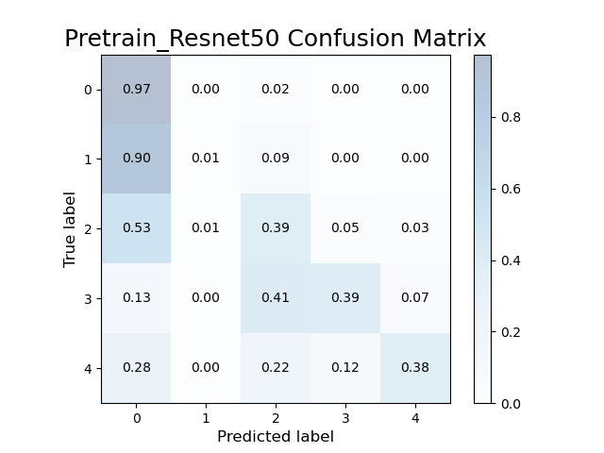

Without flip on dataset, lr=1e-3

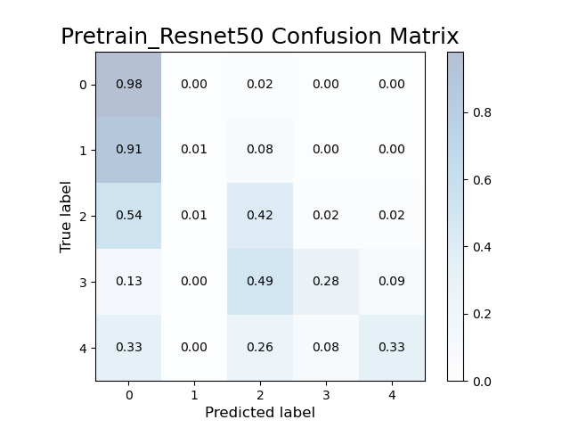

With flip on dataset, lr=1e-3

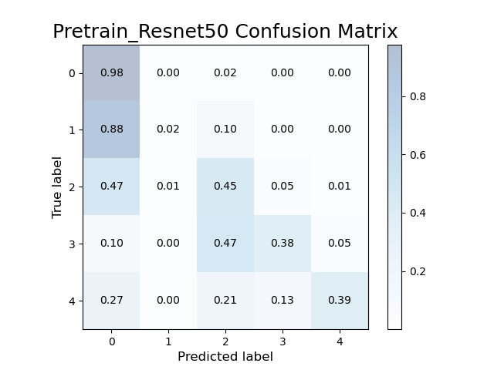

With flip on dataset, lr=25e-5

Pretrain_Resnet50 max train accuracy: 84.32% max test accuracy: 80.58% // without flip on dataset

Pretrain_Resnet50 max train accuracy: 81.93%, max test accuracy: 81.17% // with flip on dataset

在對資料統計分析後，發現分類0、1、2、3、4分別佔整體資料的73%、7%、15%、2%、2%，很明顯的，因為分類0和2有相對多的資料，所以學習上會更加準確，特別是分類0準確率有98%。在加入翻轉後，產生出的Data會使模型多了資料學習，避免過度擬合，在結果上看到分類0、2的預測上都有了提升，整體約提升了0.6%。在最後調整lr後分類3、4的Confusion Matrix亦有所提升。

1. Experimental results (30%)
   1. The highest testing accuracy
      1. Screenshot

在以下parameter時的最高accuracy︰

Learning rate =25e-5, Batch size = 4, Shuffle=True, With flip on dataset

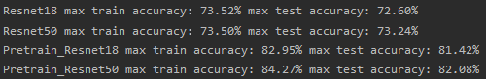

從結果看得出Pretrain過的ResNet50擁有著更高的Accuracy︰82.08%，也證實了ResNet更多層的Layer會有更高的Accuracy。

* + 1. Anything you want to present

在實驗時，我先根據助教提供的parameter來作為基礎，然後再flip dataset裡的圖片發現準確率有所提升，然後再提升和降低learning rate 來比較準確率(如下圖)。

Pretrain_Resnet18 max train accuracy: 85.52% max test accuracy: 80.74% // Original

Pretrain_Resnet18 max train accuracy: 81.94%, max test accuracy: 81.68% // with flip

Pretrain_Resnet18 max train accuracy: 80.34% max test accuracy: 80.53% // lr = 2e-3

Pretrain_Resnet18 max train accuracy: 79.09% max test accuracy: 80.14% // lr = 3e-3

Pretrain_Resnet18 max train accuracy: 82.79% max test accuracy: 81.98% // lr = 5e-4

Pretrain_Resnet50 max train accuracy: 83.28% max test accuracy: 81.84% // lr = 5e-4

Pretrain_Resnet18 max train accuracy: 82.95% max test accuracy: 81.42% // lr = 25e-5

Pretrain_Resnet50 max train accuracy 84.27% max test accuracy 82.08% // lr = 25e-5

* 1. Comparison figures
     1. Plotting the comparison figures (RseNet18/50, with/without pretraining)

Without Pre-train:

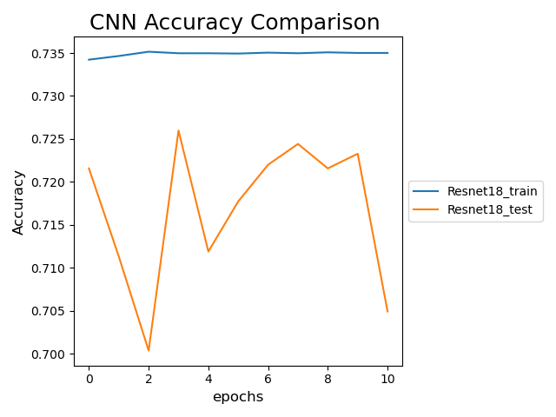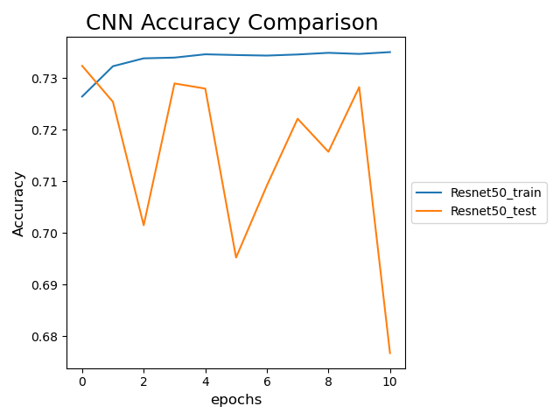

With Pre-train:

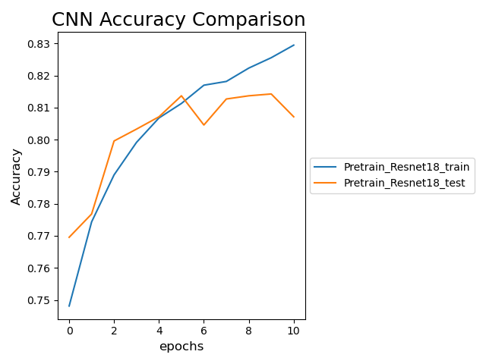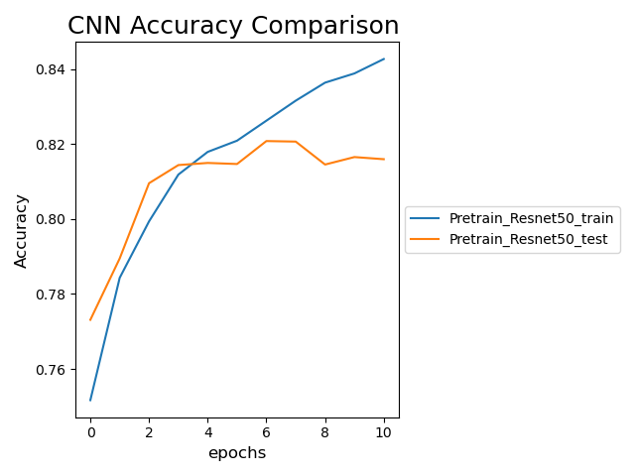

我們可以看到沒有Pre-Train過的模型訓練較慢，甚至沒有看到顯著的提升，準確度亦不如Pre-Train過的。

在Pre-Train過的模型上的準確度更高，該模型在訓練上更為快速，有一定的基礎，亦明顯看出每次訓練都有顯著的提升。

4. Discussion (20%)

Anything you want to share

分享了一下學習率的參數調整︰

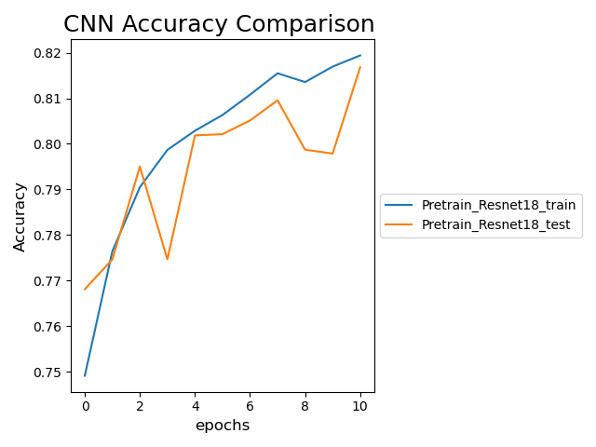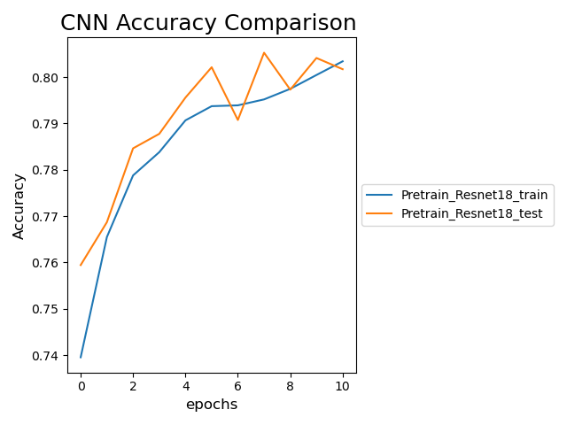

lr=1e-3

lr=2e-3

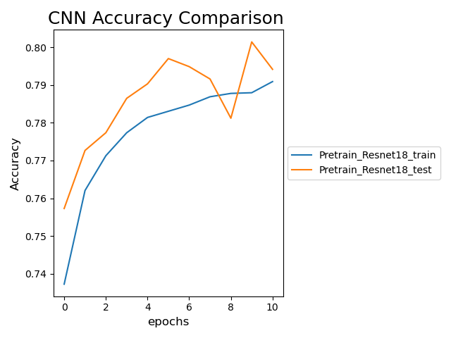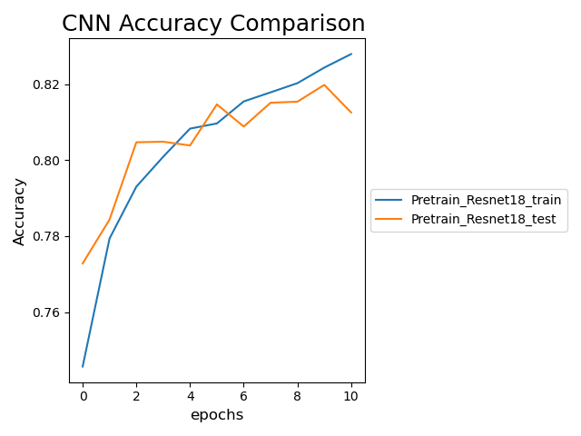

lr=3e-3

lr=5e-4



lr=25e-5

因為我們是採用SGD來去更新我們的參數，所以lr是需要調整的參數，我們可以觀察出來lr變大時學習的曲線學不起來，可能是因為lr太大導致模型一直沒有收斂，後來把lr調小後，明顥的看到lr的學習變得正常很多沒有大幅度的升降，所以調小可以幫助模型學習，慢慢收斂。

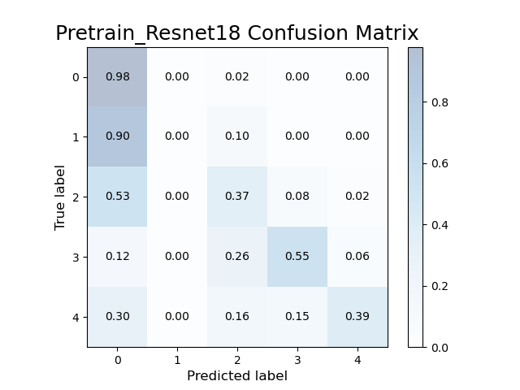



Pretrain_Resnet18 max train accuracy: 82.95% max test accuracy: 81.42% // lr = 25e-5

Pretrain_Resnet50 max train accuracy 84.27% max test accuracy 82.08% // lr = 25e-5

另外一個現象是在Confusion Matrix中，pretrain_ResNet18在3是有很顯著的提升的，但相對2的判斷就沒有那麼準確，然而，因為大部份資料分佈主要在分類0和2，所以就算在分類3上有17%的提升，亦不如在分類2上的8%提升。

這次實驗主要是在學習Dataset處理和模型的Pre-Train上，對模型準確度的影響。在較小的資料集中，Data Augmentation 是增加訓練資料的手段，同時亦可作為避免模型過擬合。

另外，Pre-train在小的資料集的應用是有幫助的，有如這次的資料集，在少次數的訓練中，pre-train可以在較為好的起始點開始的訓練，能夠較為快速的訓練好我們所需要的模型，但對於大的資料集中，Pre-Train則幫助有限，甚至可能和沒有Pre-Train的模型相近。