**Report (80%)**

**A tensorboard plot shows episode rewards of at least 800 training episodes in LunarLander-v2 (5%)**

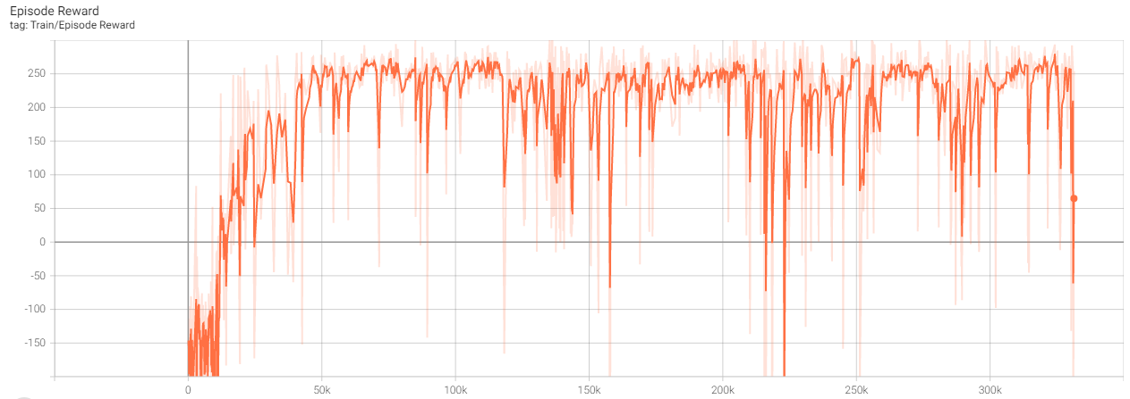

**A tensorboard plot shows episode rewards of at least 800 training episodes in LunarLanderContinuous-v2 (5%)**

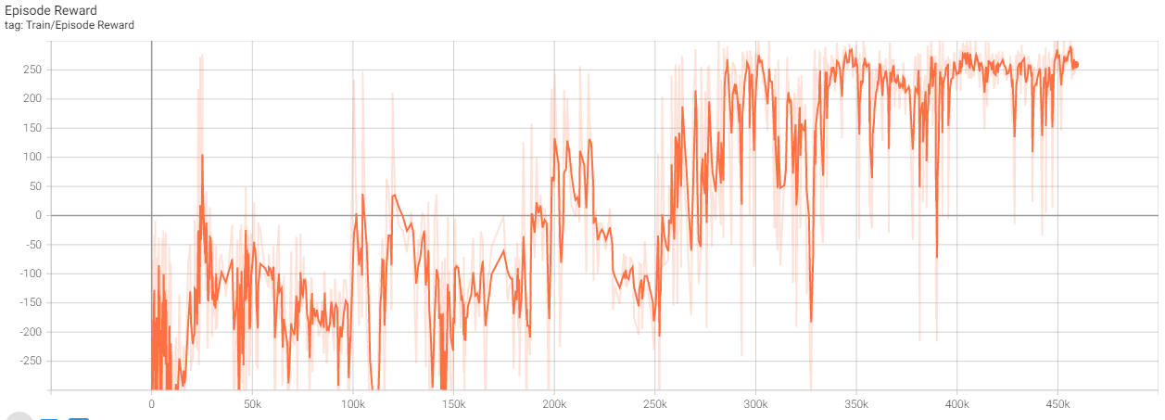

**Describe your major implementation of both algorithms in detail. (20%)**

**DQN:**

首先我們根據specification 來定義我們的網絡，輸入是8個state，輸出是4個action。

class Net(nn.Module):  
 def __init__(self, state_dim=8, action_dim=4, hidden_dim=32):  
 super().__init__()  
 ## *TODO ##* self.fc1 = nn.Linear(state_dim, hidden_dim)  
 self.fc2 = nn.Linear(hidden_dim, hidden_dim)  
 self.fc3 = nn.Linear(hidden_dim, action_dim)  
 self.relu = nn.ReLU()  
  
 def forward(self, x):  
 ## *TODO ##* x = self.fc1(x)  
 x = self.relu(x)  
 x = self.fc2(x)  
 x = self.relu(x)  
 x = self.fc3(x)  
 return x

在DQN裡選用optimizer為Adam，因為Adam是比較常用和相對快收斂的loss function

class DQN:  
 def __init__(self, args):  
 ## *TODO ##* self._optimizer = torch.optim.Adam(self._behavior_net.parameters(), lr=args.lr)

我們選用了一個慢慢減少的epsilon，一開始先隨機的行動，然後得到reward，一段時間後慢慢把epsilon降低，讓action根據Q-value來決定下一個動作。

def select_action(self, state, epsilon, action_space):  
 *'''epsilon-greedy based on behavior network'''* ## *TODO ##* if random.random() < epsilon:  
 action = action_space.sample()  
 else:  
 action = torch.argmax(self._behavior_net(torch.tensor(state).to(self.device))).item() # get propability of output and take the largest one as action  
 return action

更新網絡行為網絡的參數，先從memory 抽樣出環境參數，然後根據當前state在behavior_network的輸出作為q_value，然後如下公式︰用rewrad加上gamma 乘以下一個state的最大Q_value來作為Q_target，用以和原來state的q_value作比較，從而得出loss並更新網絡參數。

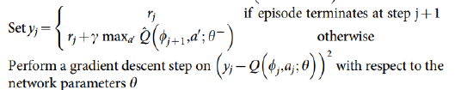

def _update_behavior_network(self, gamma):  
 # sample a minibatch of transitions  
 state, action, reward, next_state, done = self._memory.sample(  
 self.batch_size, self.device)  
  
 ## *TODO ##* q_value = self._behavior_net(state).gather(1, action.long()) # gather Q_value(ppb) from NET according to selected action, transfer to long(int) for .gather  
 with torch.no_grad():  
 q_next = torch.max(self._target_net(next_state), dim=1)[0].view(-1, 1) # get target Q_max(dim=1) value[0] from next state and convert to (-1,1) dimension  
 q_target = reward + gamma * q_next * (1 - done) # if done(end game) q_target = 0  
 criterion = nn.MSELoss()  
 loss = criterion(q_value, q_target)  
  
 # optimize  
 self._optimizer.zero_grad()  
 loss.backward()  
 nn.utils.clip_grad_norm_(self._behavior_net.parameters(), 5)  
 self._optimizer.step()

更新target_network就只是簡單的把behavior_network的參數抄去把target_network更新，我們可以根據參數來調節更新的頻率。

def _update_target_network(self):  
 *'''update target network by copying from behavior network'''* ## *TODO ##* self._target_net.load_state_dict(self._behavior_net.state_dict())

這邊基本上和train network時要做的事差不多，把模型選擇的action作為實際的行動，並根據環境的feedback來記錄reward的分數。

def test(args, env, agent, writer):  
 print('Start Testing')  
 action_space = env.action_space  
 epsilon = args.test_epsilon  
 seeds = (args.seed + i for i in range(10))  
 rewards = []  
 for n_episode, seed in enumerate(seeds):  
 total_reward = 0  
 env.seed(seed)  
 state = env.reset()  
 ## *TODO ##* for t in itertools.count(start=1):  
 # select action  
 action = agent.select_action(state, epsilon, action_space)  
 # execute action  
 next_state, reward, done, _ = env.step(action) # done - end game  
 # store transition  
 agent.append(state, action, reward, next_state, done)  
  
 state = next_state  
 total_reward += reward  
  
 if done:  
 writer.add_scalar('Test/Episode Reward', total_reward, n_episode)  
 print('Episode: {}\tLength: {:3d}\tTotal reward: {:.2f}\tEpsilon: {:.3f}'.format(n_episode, t, total_reward, epsilon))  
 rewards.append(total_reward)  
 break

**DDPG:**

Replay memory就是記錄之前的環境參數，裡面的sample是方便我們從中抽取一個作為環境參數，根據輸入的batch size來決定要抽出多少個sample然後解壓成我們需要的樣式。

class ReplayMemory:  
 __slots__ = ['buffer']  
  
 def __init__(self, capacity):  
 self.buffer = deque(maxlen=capacity)  
  
 def __len__(self):  
 return len(self.buffer)  
  
 def append(self, *transition):  
 # (state, action, reward, next_state, done)  
 self.buffer.append(tuple(map(tuple, transition)))  
  
 def sample(self, batch_size, device):  
 *'''sample a batch of transition tensors'''* ## *TODO ##* transitions = random.sample(self.buffer, batch_size) # sample: (state(8), action(2), reward(1), next_state(8), done(1)) * batch_size  
 # unzip transitions to state_vector, action_vector, reward_vector, next_state_vector, done_vector  
 return (torch.tensor(out, dtype=torch.float, device=device) for out in zip(*transitions)) # transfer from double to torch.float  
 # raise NotImplementedError

ActorNet是LunarLanderContinuous-v2中用的網絡，大體上和dqn差不多，輸入為8，輸出為2都在範圍-1到1的中，所以最後把輸出接上Tanh方便直接使用。

CriticNet則是根據state和action來輸出Q_value作為評分的網絡，這也是和DQN單純一個Net不一樣的地方。

class ActorNet(nn.Module):  
 def __init__(self, state_dim=8, action_dim=2, hidden_dim=(400, 300)):  
 super().__init__()  
 ## *TODO ##* h1, h2 = hidden_dim  
 self.actor = nn.Sequential(  
 nn.Linear(state_dim, h1),  
 nn.ReLU(),  
 nn.Linear(h1, h2),  
 nn.ReLU(),  
 nn.Linear(h2, action_dim),  
 nn.Tanh(),  
 )  
  
 # raise NotImplementedError  
  
 def forward(self, x):  
 ## *TODO ##* return self.actor(x)

和DQN一樣選擇Adam作為Optimizer，然後設定不一樣的learning rate。

class DDPG:  
 def __init__(self, args):  
 # behavior network  
 self._actor_net = ActorNet().to(args.device)  
 self._critic_net = CriticNet().to(args.device)  
 # target network  
 self._target_actor_net = ActorNet().to(args.device)  
 self._target_critic_net = CriticNet().to(args.device)  
 # initialize target network  
 self._target_actor_net.load_state_dict(self._actor_net.state_dict())  
 self._target_critic_net.load_state_dict(self._critic_net.state_dict())  
 ## *TODO ##* self._actor_opt = torch.optim.Adam(self._actor_net.parameters(), lr=args.lra)  
 self._critic_opt = torch.optim.Adam(self._critic_net.parameters(), lr=args.lrc)  
 # action noise  
 self._action_noise = GaussianNoise(dim=2)  
 # memory  
 self._memory = ReplayMemory(capacity=args.capacity)  
 ## config ##  
 self.device = args.device  
 self.batch_size = args.batch_size  
 self.tau = args.tau  
 self.gamma = args.gamma  
 self.test_only = args.test_only

根據公式在select action上加上noise幫助network更好的探索，讓action 不要一直只選擇最優解，有一定機率觸發到不一樣的action，但基本上類似的action應該是有差不多的q_value。



def select_action(self, state, noise=True):  
 *'''based on the behavior (actor) network and exploration noise'''* ## *TODO ##* state = torch.tensor(state).to(self.device)  
 action = self._actor_net(state)  
 if noise:  
 action += torch.tensor(self._action_noise.sample()).to(self.device)  
 return action.cpu().detach().numpy()

更新方面，如上所述會以criticNet作為q_value的評分，然後用q_target和q_value做MSE取得loss，更新critic的參數，actor則用minimize – q_value來作為loss更新參數，由於max Q_value 的功效等價於min Q_value。



def _update_behavior_network(self, gamma):  
 actor_net, critic_net, target_actor_net, target_critic_net = self._actor_net, self._critic_net, self._target_actor_net, self._target_critic_net  
 actor_opt, critic_opt = self._actor_opt, self._critic_opt  
  
 # sample a minibatch of transitions  
 state, action, reward, next_state, done = self._memory.sample(  
 self.batch_size, self.device)  
  
 ## update critic ##  
 # critic loss  
 ## *TODO ##* q_value = critic_net(state, action)  
 with torch.no_grad():  
 a_next = target_actor_net(next_state)  
 q_next = target_critic_net(next_state, a_next)  
 q_target = reward + gamma * q_next * (1 - done)  
 criterion = nn.MSELoss()  
 # print(q_value, q_target)  
 critic_loss = criterion(q_value, q_target)  
 # raise NotImplementedError  
 # optimize critic  
 actor_net.zero_grad()  
 critic_net.zero_grad()  
 critic_loss.backward()  
 critic_opt.step()  
 ## update actor ##  
 # actor loss  
 ## *TODO ##* action = actor_net(state)  
 actor_loss = -critic_net(state, action).mean() # min q_value: select max = -min  
 # optimize actor  
 actor_net.zero_grad()  
 critic_net.zero_grad()  
 actor_loss.backward()  
 actor_opt.step()

更新target_network則根據target network的公式，用average的方式更新。



def _update_target_network(target_net, net, tau):  
 *'''update target network by _soft_ copying from behavior network'''* for target, behavior in zip(target_net.parameters(), net.parameters()):  
 ## *TODO ##* target.data.copy_(tau * behavior + (1 - tau) * target)

test function基本上和DQN一樣，但要記得把noise關掉。

def test(args, env, agent, writer):  
 print('Start Testing')  
 seeds = (args.seed + i for i in range(10))  
 rewards = []  
 for n_episode, seed in enumerate(seeds):  
 total_reward = 0  
 env.seed(seed)  
 state = env.reset()  
 ## *TODO ##* for t in itertools.count(start=1):  
 # select action  
 action = agent.select_action(state, noise=False)  
 # execute action  
 next_state, reward, done, _ = env.step(action) # done - end game  
 # store transition  
 agent.append(state, action, reward, next_state, done)  
  
 state = next_state  
 total_reward += reward  
  
 if done:  
 writer.add_scalar('Test/Episode Reward', total_reward, n_episode)  
 print('Episode: {}\tLength: {:3d}\tTotal reward: {:.2f}'.format(n_episode, t, total_reward))  
 rewards.append(total_reward)  
 break

**Describe differences between your implementation and algorithms. (10%)**

主要是三個點︰

1. 模型開始時的隨機action，根據warmup的大小來先跑出環境參數並存入replay memory中。
2. 在更新target_network時，實際並不是每次都更新，可以利用freq來延遲更新。
3. Actor_loss用-min Q_value來實行max Q_value，藉此減少loss。

Describe your implementation and the gradient of actor updating. (10%)

因為我們希望令Q_value最大化，而用上最少化的-Q 其實也是同樣效果，用Q_value的值來更新的網絡。

action = actor_net(state)  
actor_loss = -critic_net(state, action).mean() # min q_value: select max = -min  
  
# optimize actor  
actor_net.zero_grad()  
critic_net.zero_grad()  
actor_loss.backward()  
actor_opt.step()

**Describe your implementation and the gradient of critic updating. (10%)**

Critic更新利用target_net預測的action來作為下一個action’s q_value的預測，以前來得出q_target和原先的q_value比較得出loss更新critic的參數。

q_value = critic_net(state, action)  
with torch.no_grad():  
 a_next = target_actor_net(next_state)  
 q_next = target_critic_net(next_state, a_next)  
 q_target = reward + gamma * q_next * (1 - done)  
criterion = nn.MSELoss()  
# print(q_value, q_target)  
critic_loss = criterion(q_value, q_target)  
# raise NotImplementedError  
# optimize critic  
actor_net.zero_grad()  
critic_net.zero_grad()  
critic_loss.backward()  
critic_opt.step()

**Explain effects of the discount factor. (5%)**

因為gamma和q_next相乘的，所以可以解釋成q_target考慮下一步q_value的比例，以此來加入預測未來分數的考量，而不單單只考慮當前action 的reward。

**Explain benefits of epsilon-greedy in comparison to greedy action selection. (5%)**

Epsilon其實就是讓模型多考量不一樣的action，不要單單只看q_value來決定action，若模型因為network一直選擇同一個action，可能會導致有更好的action但沒機會採用，多探索不一樣的路，讓模型不會止步不前。在初始化也是很有用，能夠讓模型得到一定的q_value，知道哪個action較好，在DQN上還將epsilon遞減，以此讓模型漸漸依賴q_value判定action。

**Explain the necessity of the target network. (5%)**

Target_network可以使更新時更加穩定，不會因為只有一個網絡導致更新時數值一直變動，容易有很大的變化。

**Explain the effect of replay buffer size in case of too large or too small. (5%)**

1. 太大的話training時間會變得很長，亦容易得到關聯性較低的sample，反之考慮亦是較為全面的訊息。
2. 太小的話會一直sample類同甚至一樣的環境參數，buffer就沒有那麼有效，且可能會造成overfitting。

**Report Bonus (25%)**

**Implement and experiment on Double-DQN (10%)**DQN和Double-DQN最大的差別在於計算Q_next的方法(如下所示)，DQN會先target_network裡的最大Q值作為Q_next用來計算Q_target，而DDQN則是把action裡擁有最大Q值的動作找出來作為Q_target的action。這樣可以減少最大Q值作為Q_target的差距，以貼近實際Q值。

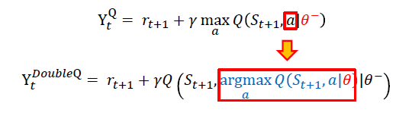

實際的coding 如下所示，先找出behavior_net裡的最大值作為action_next，然後根據此action實際的Q值作為Q_next，最後運算Q_target。

q_value = self._behavior_net(state).gather(1, action.long())   
with torch.no_grad():  
 action_next = torch.argmax(self._behavior_net(next_state), dim=1).view(-1, 1) # take max q_value action as next action index  
 q_next = self._target_net(next_state).gather(dim=1, index=action_next.long()) # take t_net q_value according to b_net's predict action  
 q_target = reward + gamma * q_next * (1 - done)

**Tensorboard plot of DDQN episode rewards:**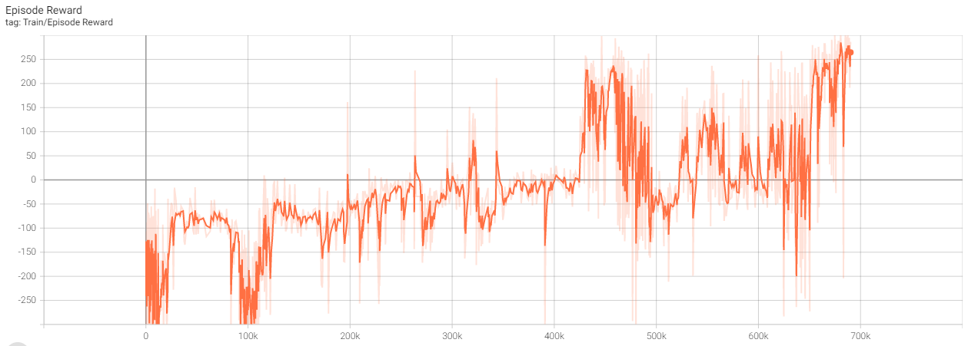

**Testing Reward of DDQN:**

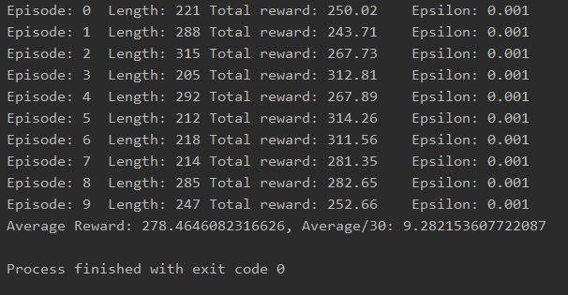

Reward比原來的DQN更好，我猜想是因為選到的動作較原來的DQN準確，導致更新的值更為直接，更容易重現以前選對的動作。

**Implement and experiment on TD3 (Twin-Delayed DDPG) (10%)**

TD3主要有3個trick︰

1. Clipped Double-Q Learning︰用2個Q-learning network(實驗裡則為2個critic_net)來取代原本只有1個network生成的Q_next，然後再取2個network中較為小的q_value作為q_next，最後計算出1個target_net的q_target



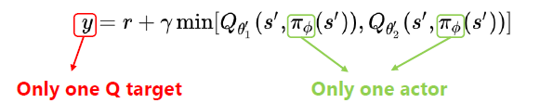

1. Delay Policy Updates︰顧名思義就是延遲更新Behavior Actor和Target Network的頻率。

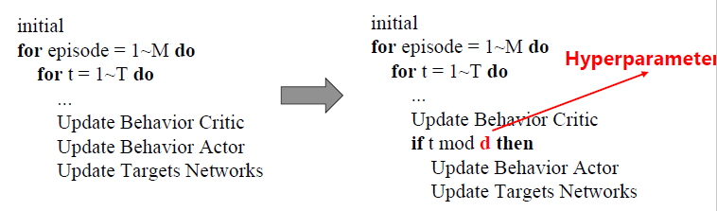

1. Target Policy Smoothing︰也是對Target policy 著手，在action加上noise，期望action不會被卡在一個點，因為類似的action會有類似的reward。

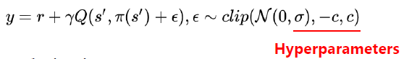

Implementation:

CriticNet改成2個network有2個輸出q_value，同時新加1個單輸出的criticNet作為target_net(如下)︰

class CriticNet(nn.Module):  
 def __init__(self, state_dim=8, action_dim=2, hidden_dim=256):  
 super(CriticNet, self).__init__()  
 self.relu = nn.ReLU()  
 # critic1  
 self.q1_fc1 = nn.Linear(state_dim + action_dim, hidden_dim)  
 self.q1_fc2 = nn.Linear(hidden_dim, hidden_dim)  
 self.q1_fc3 = nn.Linear(hidden_dim, 1)  
  
 # critic2  
 self.q2_fc1 = nn.Linear(state_dim + action_dim, hidden_dim)  
 self.q2_fc2 = nn.Linear(hidden_dim, hidden_dim)  
 self.q2_fc3 = nn.Linear(hidden_dim, 1)  
  
 def forward(self, state, action):  
 x = torch.cat([state, action], 1)  
 x1 = self.q1_fc1(x)  
 x1 = self.relu(x1)  
 x1 = self.q1_fc2(x1)  
 x1 = self.relu(x1)  
 x1 = self.q1_fc3(x1)  
  
 x2 = self.q2_fc1(x)  
 x2 = self.relu(x2)  
 x2 = self.q2_fc2(x2)  
 x2 = self.relu(x2)  
 x2 = self.q2_fc2(x2)  
 return x1, x2 # output critic1 and 2  
  
 def single_q(self, state, action):  
 x = torch.cat([state, action], 1)  
  
 x = self.relu(self.q1_fc1(x))  
 x = self.relu(self.q1_fc2(x))  
 x = self.q1_fc3(x)  
 return x # output single critic

update_behavior_net的部份，3個trick都在裡面實現了，一開始把前面提到的第3點noise加到next_action裡面，然後clip來限制noise不會導致action out of boundary。然後把next_action輸入到上面第一點提到的clip double Q-learning，取出最小的那個Q值作為q_next，用來更新q_target，最後根據現在的literation step來決定delay policy update的時機，分別更新actor、target_net。

Coding如下︰

def _update_network(self, current_step):  
 actor_net, critic_net, target_actor_net, target_critic_net = self._actor_net, self._critic_net, self._target_actor_net, self._target_critic_net  
 actor_opt, critic_opt = self._actor_opt, self._critic_opt  
  
 # sample a minibatch of transitions  
 state, action, reward, next_state, done = self._memory.sample(self.batch_size, self.device)  
 ## update critic ##  
 # critic loss  
 ## *TODO ##* with torch.no_grad():  
 noise = (torch.randn_like(action) * self.noise).clamp(-self.cp, self.cp) # 3nd: select action and clip noise  
 next_action = (target_actor_net(next_state) + noise).clamp(-self.max_action, self.max_action)  
  
 # Compute q_target value  
 q1_next, q2_next = target_critic_net(next_state, next_action)  
 q_next = torch.min(q1_next, q2_next) # 2nd: min(double critic)  
 q_target = reward + gamma * q_next * (1 - done)  
  
 q1_value, q2_value = critic_net(state, action) # get q_value from both critic  
 critic_loss = F.mse_loss(q1_value, q_target) + F.mse_loss(q2_value, q_target)  
  
 # optimize critic  
 critic_opt.zero_grad()  
 critic_loss.backward()  
 critic_opt.step()  
  
 # 2nd Delayed updates  
 if current_step % self.update_step == 0:  
 ## update actor ##  
 # actor loss  
 ## *TODO ##* actor_loss = -critic_net.single_q(state, actor_net(state)).mean()  
  
 # optimize actor  
 actor_opt.zero_grad()  
 actor_loss.backward()  
 actor_opt.step()  
  
 '''update target network by _soft_ copying from behavior network'''  
 ## *TODO ##* for param, target_param in zip(critic_net.parameters(), target_critic_net.parameters()):  
 target_param.data.copy_(self.tau * param.data + (1 - self.tau) * target_param.data)  
  
 for param, target_param in zip(actor_net.parameters(), target_actor_net.parameters()):  
 target_param.data.copy_(self.tau * param.data + (1 - self.tau) * target_param.data)

**Tensorboard plot of TD3 episode rewards:**

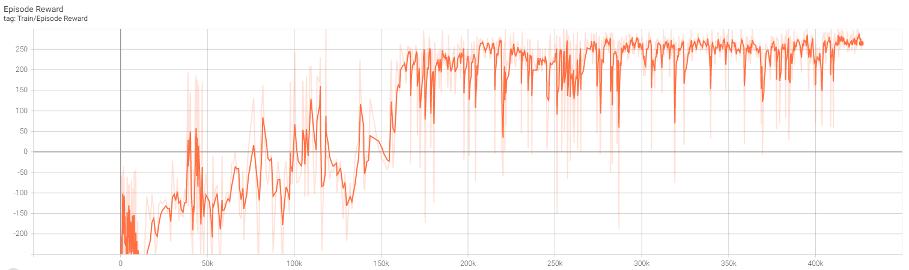

很明顯TD3有著更穩定的training reward，一直都很平穩，沒有太大起伏，也有了更多的hyper parameter可以調整。

**Testing Reward of TD3:**

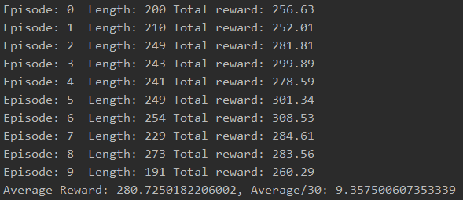

我認為TD3應該可以有更高的Reward，所以我調大了epoch，再train，得到291的reward，證明TD3是穩定而且有能力達到更高的reward。

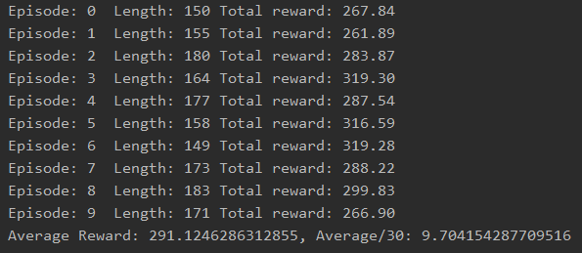

**Performance (20%)**

[LunarLander-v2] Average reward of 10 testing episodes: Average ÷ 30

**Testing Reward of DQN︰**

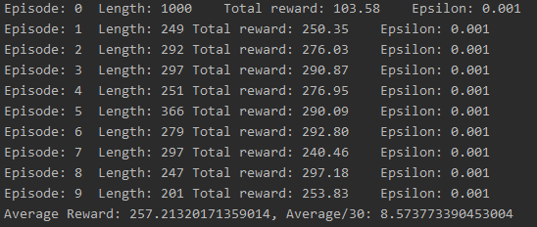

**Testing Reward of DDPG︰**

[LunarLanderContinuous-v2] Average reward of 10 testing episodes: Average ÷ 30

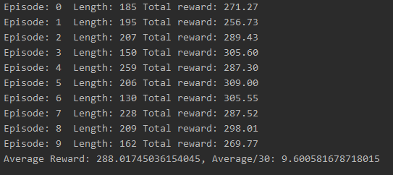

在1200 Episode訓練中，DDPG是Reward最高的，有288分，其次就是TD3，280分，然後是DDQN 278分，DQN 257分。但調大Episode到5000後，TD3仍能平穩的提升，並獲得最高的reward。整體來說還是TD3較為可控穩定，可以根據情況調整需要探索的幅度，我的例子是相對平穩，但其實也可以把參數調整成比較注重探索的TD3。DQN其實由於預測每一步都是最大的reward導致可能出現選的action不是最好，但模型卻認為這個action的reward最大的情況，所以會出現Episode越大反而不一定學好的情況。DDQN相對的改善了這部份，可以看到相對於DQN來說變得更平穩了，學習更為正確。而DDPG就提出criticNet來幫助action的評分和加入noise幫助探索，所以結果亦相對更好，但探索越多就代表越不穩定，而TD3就相對穩定而且還保有探索的部份。下面是各個模型在epochs=5000的Episode Reward的比較，同樣得出TD3相對穩定的結論。

