COVERAGE STUDY · FREE LAW PROJECT
CourtListener coverage of cited cases
Findings from a 250-citation sample
Rebecca Fordon, with Claude · May 17, 2026 · Drafted for sharing with the Free Law Project / CourtListener team
THE FINDINGS, IN BRIEF
We sampled 250 cited citations from 78 recent (2023–2026) opinions in CourtListener and tried to find each cited case in CL. After excluding 29 unmeasurable rows, 213 of 221 measurable citations (96.4%) are findable in CL — though only 170 (76.9%) are resolvable directly by the /citation-lookup/ API. The rest required a name+date+court fallback or manual investigation.
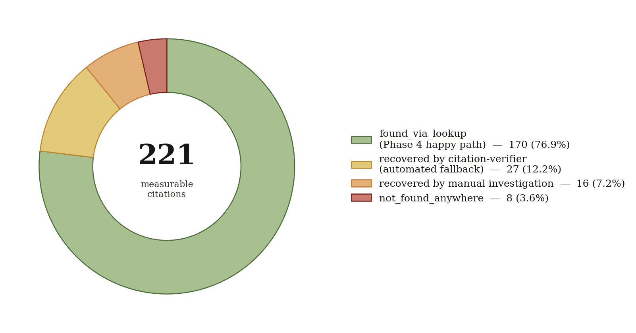
Figure 1. How we located citations.
§ § §

Coverage by court
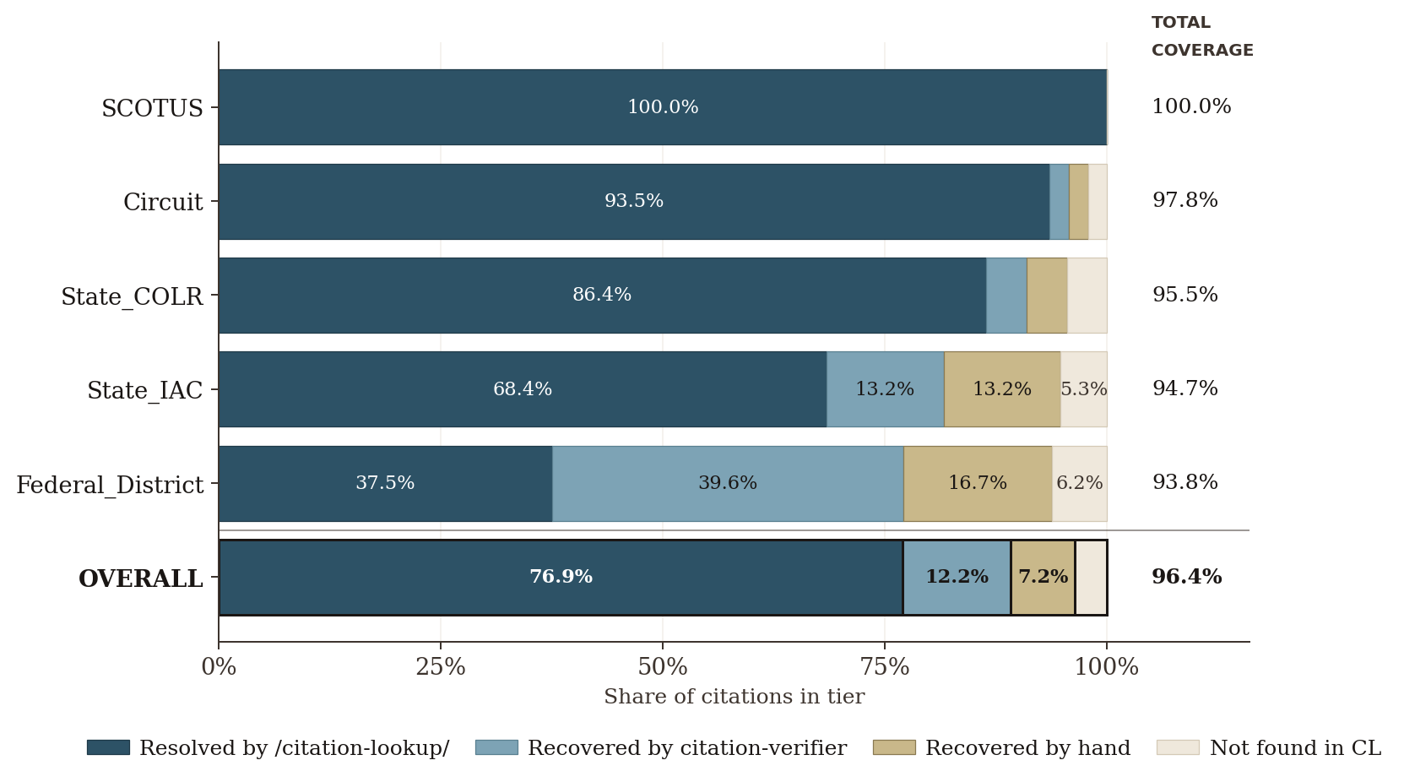
Figure 2. Coverage by court tier. Each bar represents 100% of citations in that tier, segmented by how the case was found (or not found)
The two rates diverge most for Federal District (37.5% via lookup vs. 93.8% total — a 56-point gap, representing 27 opinions), driven almost entirely by WL cites, along with a few F. Supp. 2d citations; we recovered most of these via opinions, but a few (7) through RECAP. State_IAC also shows a wide gap (68.4% vs. 94.7%, 26-point spread), driven by opinions in CourtListener without a print citation. SCOTUS shows no gap at all.
Tier | Found via lookup | + recovered by citation-verifier | + recovered manually | Lookup rate | Total coverage
SCOTUS | 45 | +0 | +0 | 45 | 45
Circuit | 43 | +1 | +1 | 45 | 46
State_COLR | 38 | +2 | +2 | 42 | 44
State_IAC | 26 | +5 | +5 | 36 | 38
Federal_District | 18 | +19 | +8 | 45 | 48
OVERALL | 170 | +27 | +16 | 213 | 221
§ § §
Westlaw cites account for 58% of the lookup misses. All are federal district — most district court opinions don't appear in print reporters, so the WL cite is often the only citable form, and citation_lookup's resolution to a cluster depends on someone having put the WL cite in citations[].

Lookup misses broken down by citation type
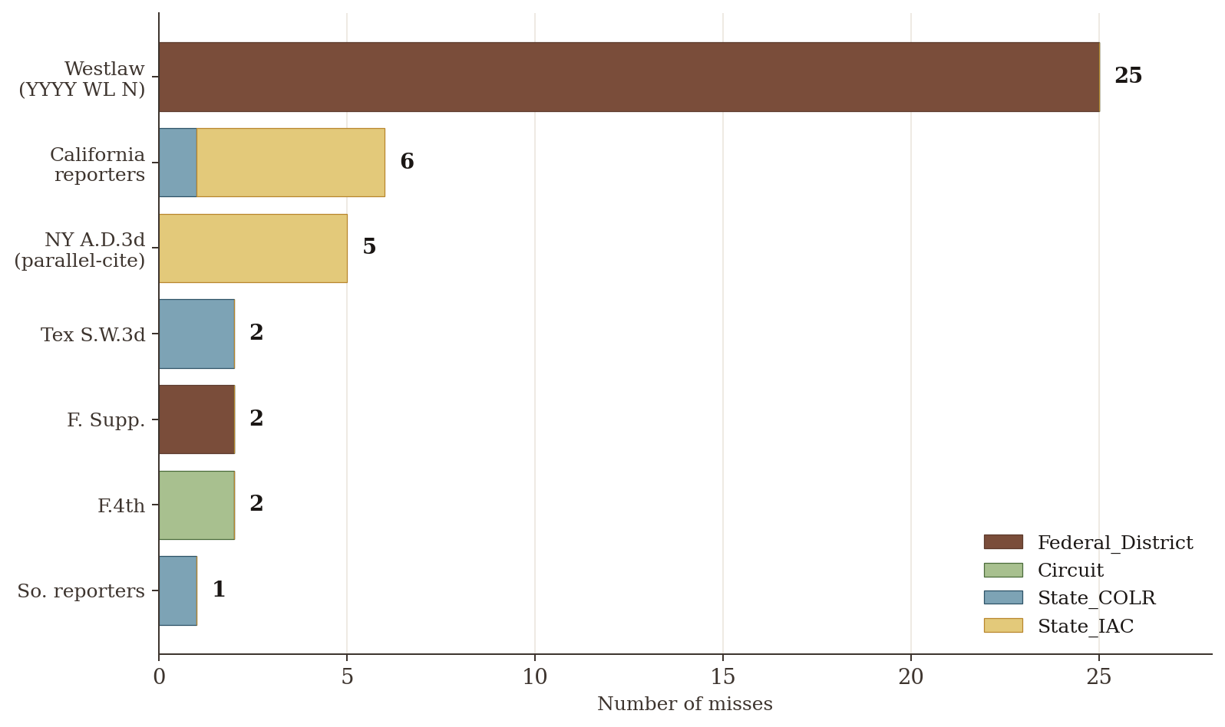
Figure 3. Reporter type within the 43 lookup misses, split by court tier. Westlaw cites account for 58% of the misses; all are federal district. NY A.D.3d and Tex S.W.3d are the next clusters.
§ § §
Eight citations could not be located in CourtListener. Four are genuine structural coverage gaps: three are Westlaw/Lexis-only district court orders that exist only as RECAP docket entries, not as searchable opinion clusters (Rose Way, Wilson, Wilmington Trust), and one reflects a Fla. 3d DCA scraper coverage gap (Iglesias). Two are one-off scraper misses on opinions that the scraper should have caught and didn't — Terry Black's (5th Cir., Jan. 5, 2022; every neighboring F.4th page from that week is in CL) and People v. Campbell (4th Dep't, Nov. 21, 2025; 70 sibling 4th Dep't opinions from the same day, same nycourts.gov URL pattern, were captured but Slip Op 06407 wasn't). Both are worth flagging for backfill. One is an Illinois App. Rule 23 unpublished order served from a non-standard URL pattern outside the scraper's reach, compounded by a docket-number typo in the cite (Thurman). And one is a N.Y. Court of Appeals motion-for-leave denial published as a row in a Decision List table rather than as a substantive opinion document (Azad) — structural but unfixable, since CourtListener's ingestion model doesn't cover tabular dispositions.

Potential mitigation of lookup misses
- The scanning project addresses the print-reporter cluster-empty cases (17 of 43). Already in motion. Will populate citations[] for the 12 cluster-empty print-reporter cases (6 Cal. state appellate, 2 Tex. Supreme Court S.W.3d, 2 F. Supp. 3d, 1 F.4th, 1 So. 3d) plus add the parallel A.D.3d cite to the 5 NY Appellate Division clusters that currently have only the slip-op cite indexed.
- Back-fill clusters from free RECAP docs (~7 of 43, plus an unknown larger backlog). A periodic sweep of recap_documents with is_free_on_pacer=true, is_available=true, opinion-typed entry description, and no associated cluster would catch both old docs uploaded after the live scrape window had completed (e.g., Mehar Holdings v. Evanston Ins. Co., docket 5474769 — a 12-page Memorandum & Order on CL since 2017-04-23 but never promoted to a cluster) and new docs where the live scraper for the relevant court is lagging. Pairs with the #7316 scraper-stall fix.
- Fix the per-court scraper stall/lag pattern surfaced in #7316. Three of the seven in_recap cases were docs created on CL in 2017 but underlying opinions filed years earlier — these wouldn't be caught by a live-scraper fix alone. Recommendation 2 above and the #7316 fix together would catch both the historical and the ongoing gap.
- Mine RECAP for WL → cluster mappings (~25 of 43, the largest single bucket). The scanning project doesn't touch Westlaw cites; CL's RECAP archive does. Millions of briefs/motions in RECAP cite cases by both their WL number and case name (often with docket and court). A one-time batch pass — essentially running citation-verifier's name+date+court logic over a large brief corpus — would seed citations[] for thousands of clusters that currently have empty arrays. Bootstraps from data CL already owns. Even cites with caption divergence (Rule 25(d), SSA pseudonyms) are seedable because briefs pair them with the WL number — Gilliard v. McWilliams, 2019 WL 3304707 is one of 5 such cases in our sample.
- Push a neutral citation system. A long-term play: adopt and advocate for a Free Law–style neutral citation format (year, court, sequence number) that doesn't depend on either Westlaw or print reporters. Even partial adoption by federal districts would reduce the WL dependency that drives most of the misses in this sample.
- "Did you mean?" on /citation-lookup/ 404s. Instead of just returning 404, the endpoint could return {status: 404, suggestions: [clusters with matching name+year+court]}. Lets API consumers (like citation-verifier or LLM agents calling CL) know "there's nothing here under this cite, but here are likely candidates." Cheap server-side change; clients still decide what to do.
- Federated cite registry with other free-law projects. vLex / Fastcase / CourtListener could share a common cite → permalink registry. Likely a longer arc but addresses the same underlying issue from a different angle.
§ § §

Methodology
Corpus. 78 citing opinions, predominantly 2023–2026, mined from CL across a mix of federal (60) and state (18) courts via the benchmark's mine_citing_opinions step.
Extraction. Per-opinion JSON via the Anthropic Haiku model (extract_citations.py). LLM extraction rather than eyecite, which does not extract case names and parentheticals from PDFs as neatly as is needed for citation-verifier. Incomplete or extraction-artifact citations (~13.5% of raw LLM output) are excluded by using citations_valid only.
Pre-filter & dedup. Drop short-form citations (Id., bare pin cites) and foreign reporters (Eng. Rep., Q.B., etc.); dedup on (citing_cluster, citation_string, parenthetical); K=5 cap per (citing_cluster, cited_tier) for opinion-level diversity.
Stratified sample. 50 cited citations per tier across SCOTUS, Circuit, State_COLR, State_IAC, and Federal_District (250 total).
Verification pipeline. Each cite runs through /citation-lookup/, then a citation-verifier name+date+court fallback for misses, then an audit on rescues, then a short-form-citation dedup pass that drops pin-cites whose fuller sibling exists in the same opinion.
Manual investigation. Two passes by hand, both recorded in manual_corrections.csv.
The pipeline is reproducible end-to-end from the scripts in benchmark/scratch/cl-coverage-offshoot/ against an unchanged CourtListener corpus.
§ § §

Caveats and limitations
Sample size. 250 rows across five tiers; per-tier sample sizes range 38–48 after Phase 6 exclusions. Confidence intervals on the individual tier coverage numbers are wide. The overall 96.4% should be read as a point estimate with ~±2 pp of slop.
Invalid citations excluded upfront. ~13.5% of the LLM's raw extracted citations were invalid (short cites or extraction artifacts) and are excluded from this sample by using citations_valid only.
NYSD skip. We initially targeted SDNY (nysd) as one of our federal district sources for citation mining. We had to drop it because the live scraper isn't currently capturing nysd free opinions — see CL #7316. This biases the sample by under-representing SDNY citations. SDNY is a heavy producer of recent unpublished WL opinions, which is the exact citation pattern most affected by cl_cluster_citations_empty. The 93.8% federal-district coverage number is therefore likely an overestimate of what a corpus that included SDNY citations would show.
Manual investigation matters a lot. Without the 16 manual corrections, measured coverage would be 197/221 = 89.1%. Manual investigation lifted that to 213/221 = 96.4% — a 7.3 point gain. Anyone re-running this measurement at scale without comparable manual follow-up should expect the lookup-only and verifier-only rates (76.9% and 89.1% respectively) rather than the 96.4% total. Using claude.ai with the CourtListener MCP helped locate many of these.

Reproducibility
All code and data live under benchmark/scratch/cl-coverage-offshoot/. Key artifacts:
File | What it is
final_200.csv | Stratified 250-row sample (post-dedup, post-cap)
coverage_per_citation.csv | Phase 4 (/citation-lookup/) results
staged_fallback_rigorous_per_row.csv | Phase 4c (name+RECAP fallback) results
audit_per_row.csv | Phase 5 audit verdicts on each rescue
recap_diagnosis.csv | Phase 18 sub-classification of the 7 in_recap cases
manual_corrections.csv | 16 user-investigated rescues (7 original + 9 from the not-found re-review)
unified_review.csv | Full audit trail (37 columns × 250 rows)
unified_review_concise.csv | Reviewer-facing view (9 columns × 250 rows)
To regenerate from the raw extractions: 12_stratify.py → 13_lookup_coverage.py → 15_staged_fallback_rigorous.py → 16_audit_rescues.py → 18_diagnose_recap_cases.py → 17_build_unified_review.py.

