**HOTEL MANAGEMENT SYSTEM**

**Shivani Sugurushetty - 002305622**

**Ashlesha Vivek Donde - 002537305  
Mohammed Sayed Hossain – 002562175**

**Meghana Thota – 002591062**

**Pranav Waghmare – 002513911**

**Dai Zhichao – 003183468**

**Github link:** [**https://github.com/dondeash2025/DMDD-Project-Group-4**](https://github.com/dondeash2025/DMDD-Project-Group-4)

**Mission:**

Hotel Management System is designed to implement a centralized, consistent and scalable solution that helps day-to-day operations of a hotel. The system will support the efficient management of reservations, staff duties, payments and bills, hotel availability, guest bookings, check-in and check-out procedures, additional services, restaurant operations, discounts, guest feedback, and maintenance requests. It reduces manual labour, minimizes errors, provides real-time information access, enhances customer satisfaction, and provides prompt and precise service.

**Objectives:**

**1. Booking Management**

* Make new bookings and cancellations in real time.
* Keep track of room availability.
* Prevent double bookings by updating room availability.
* Support multiple room assignments per booking.

**2. Guest Information Management**

* Maintain guest profiles including first name, last name, age, address, nationality, phone, etc.
* Ensure secure storage of personal data.
* Track guest history and preferences.

**3. Room and Facilities Management**

* Manage room assignments and status of rooms (available, booked, under maintenance).
* Issue alerts for out-of-service rooms.
* Track room types, capacity, and pricing.

**4. Check-in and Check-out Process**

* Log guest arrivals and departures efficiently.
* Create comprehensive invoices at checkout that include room fees, service charges, restaurant orders, applicable taxes, and applied discounts.
* Generate itemized bills with tax breakdowns.
* Process final payments and update room status.

**5. Service Management**

* Track additional services offered to guests (spa, laundry, room service, airport shuttle, etc.).
* Record service usage and charges per booking.
* Maintain a catalogue of available services with pricing and categories.
* Monitor service transaction history.

**6. Restaurant and Food Service Management**

* Process restaurant orders for both in-house guests and walk-in customers.
* Link restaurant charges to guest bookings when applicable.
* Track individual order items with pricing.
* Manage restaurant menu items and inventory.

**7. Discount and Promotion Management**

* Create and manage discount offers with validity periods.
* Apply multiple discounts to bookings.
* Track discount usage and calculate applied values.
* Support both percentage-based and fixed-amount discounts.

**8. Guest Feedback Collection**

* Collect ratings and comments from guests after their stay.
* Link feedback to specific bookings for quality tracking.
* Analyse guest satisfaction trends.
* Identify areas for service improvement.

**9. Billing and Payment Management**

* Generate detailed invoices with line-item breakdown.
* Apply multiple tax types to invoices automatically.
* Manage several payment options (online, card, and cash).
* Track payment status (Pending, Completed, Failed, Refunded).
* Maintain detailed billing and payment history.
* Support partial payments and refunds.

**10. Analytics and Reporting**

* Generate reports on occupancy rates, revenue, and guest demographics.
* Track service utilization and restaurant performance.
* Monitor discount effectiveness and promotional campaigns.
* Analyse guest feedback and satisfaction scores.
* Report on staff performance and task completion.

**11. Staff Scheduling and Allocation**

* Assign housekeeping tasks based on guest check-ins and check-outs.
* Track employee shifts and availability.
* Ensure fair and efficient workload distribution.
* Manage maintenance staff assignments.

**12. Maintenance Request Management**

* Track reported issues in rooms requiring repair or maintenance.
* Assign maintenance requests to appropriate staff members.
* Monitor request priority, status, and completion.
* Maintain maintenance history for each room.

**13. Data Security and Integrity**

* Implement user authentication and role-based access control.
* Protect sensitive information from unauthorized access or manipulation.
* Maintain data accuracy and consistency through proper constraints and relationships.

**14. Data Backup and Recovery**

* Automated backup schedules to ensure data safety.
* Recovery procedures for system failures.

**15. Scalability and Maintainability**

* Support future enhancements such as mobile integration, loyalty programs, and third-party APIs.
* Design modular architecture for easy updates and feature additions.

**ERD:**

**Updated ERD:**

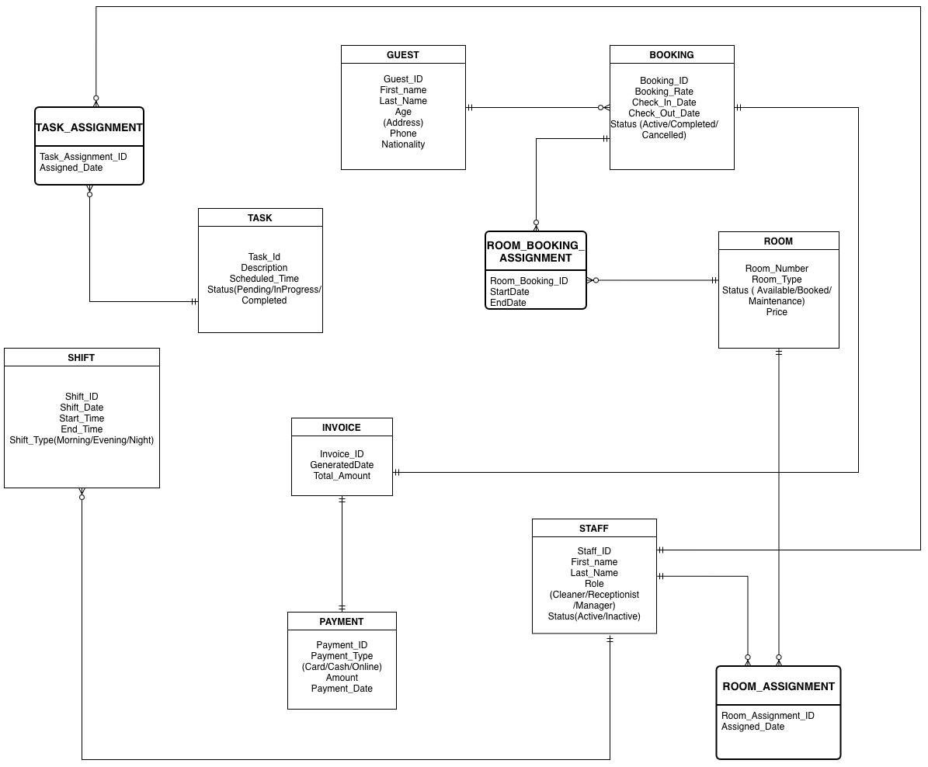

**Key Changes in ERD:**

* Introduced associative entity ROOM_BOOKING_ASSIGNMENT for ROOM – BOOKING relationship.
* Introduced associative entity TASK_ASSIGNMENT for STAFF – TASK relationship.
* Expanded ROOM_ASSIGNMENT as associative entity for STAFF – ROOM relationship.
* Added SHIFT entity linked to TASK.

**Logical ERD:**

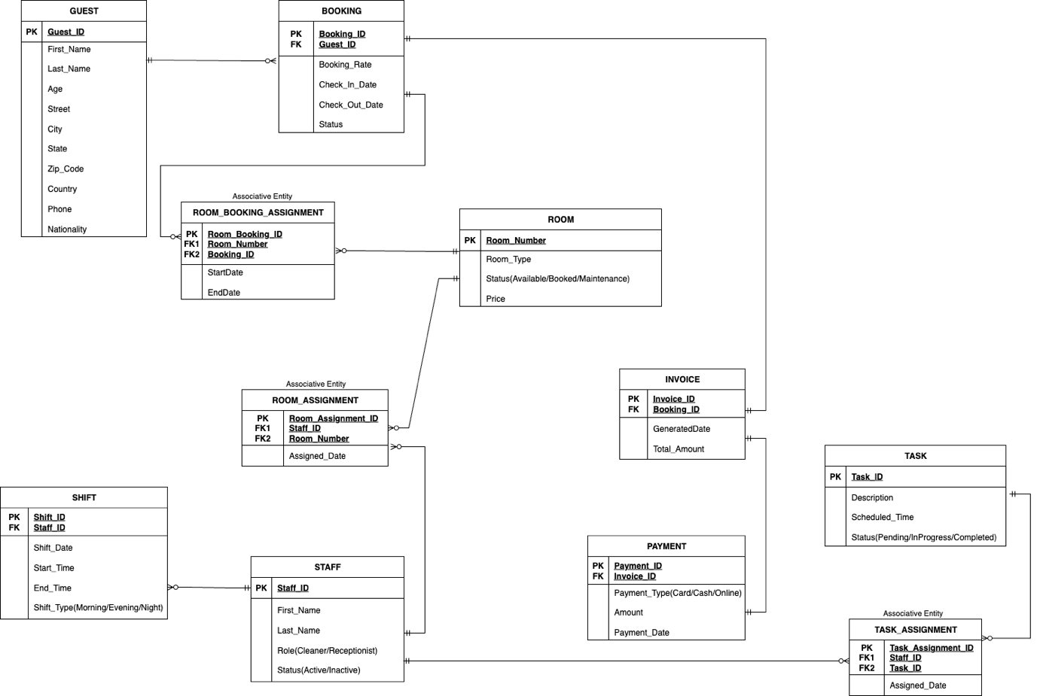

**Updated Logical ERD:**

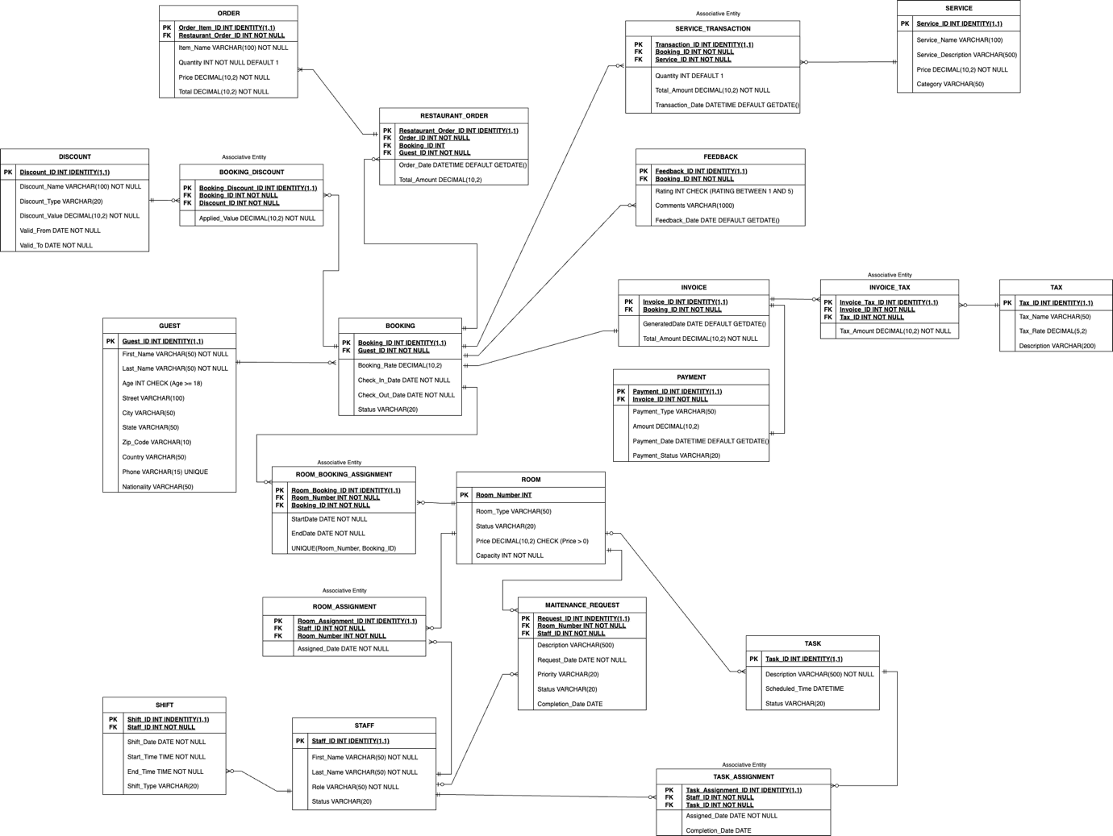

**List of entities and their relationships:**

### **GUEST -**

Represents hotel customers with personal details (name, age, address, phone, nationality). A guest can make multiple bookings and place restaurant orders. Walk-in restaurant customers are also stored as guests without booking references.

### **BOOKING -**

Represents a guest's reservation commitment. Each booking is made by one primary guest and can span multiple rooms. Includes booking rate, check-in/check-out dates, and status (Confirmed, Checked-In, Checked-Out, Cancelled). Links to services, discounts, restaurant orders, and generates one invoice.

### **ROOM -**

Physical hotel units with unique room number, type (Single, Double, Suite, Deluxe), status (Available, Occupied, Maintenance, OutOfService), price, and capacity. Rooms are assigned to bookings and staff for cleaning/maintenance.

### **ROOM_BOOKING_ASSIGNMENT -**

Associative entity linking rooms and bookings (many-to-many). Captures StartDate and EndDate for each room assignment, allowing multiple rooms per booking and tracking exact occupation periods.

### **INVOICE -**

Generated at checkout for each booking. Consolidates all charges including room fees, services, restaurant bills, taxes, and discounts. Contains generated date and total amount due.

### **PAYMENT -**

Records financial transactions for invoices (one-to-one). Includes payment type (Cash, Credit Card, Debit Card, Online, UPI), amount, payment date, and status (Pending, Completed, Failed, Refunded).

### **TAX -**

Represents tax types (state tax, city tax, VAT, service tax) with tax name, rate percentage, and description. Multiple taxes can apply to a single invoice via Invoice_Tax.

### **INVOICE_TAX -**

Associative entity linking invoices and taxes (many-to-many). Calculates and stores the specific tax amount for each tax type applied to an invoice for accurate tax reporting.

### **SERVICE -**

Additional hotel amenities (spa, laundry, room service, airport shuttle, gym) with name, description, price, and category. Services are tracked per booking through Service_Transaction.

### **SERVICE_TRANSACTION -**

Associative entity linking bookings and services (many-to-many). Tracks quantity used, total amount charged, and transaction date for each service utilized during a stay.

### **RESTAURANT_ORDER -**

Food and beverage orders placed by guests. Links to guest (always required) and optionally to booking—in-house guests have Booking_ID populated for room billing, while walk-in customers have Booking_ID as NULL. Includes order date and total amount.

### **ORDER -**

Line items within a restaurant order. Each entry represents one menu item with item name, quantity, price, and total, allowing detailed tracking of individual food/beverage items.

### **DISCOUNT -**

Promotional offers with name, type (Percentage or Fixed), discount value, and validity period (Valid_From, Valid_To). Applied to bookings through Booking_Discount associative entity.

### **BOOKING_DISCOUNT -**

Associative entity linking bookings and discounts (many-to-many). Allows multiple discounts per booking and tracks the actual applied value, which may differ from base discount value due to rules and caps.

### **FEEDBACK -**

Guest ratings and comments linked to specific bookings. Includes rating (1-5 scale), comments, and feedback date. Enables quality tracking and service improvement analysis.

### **STAFF -**

Hotel employees (housekeepers, maintenance, receptionists, managers, restaurant staff) with name, role, and status (Active, Inactive, OnLeave). Staff have multiple shifts and can be assigned to rooms and tasks.

### **SHIFT -**

Staff work schedules with shift date, start/end times, and shift type (Morning, Evening, Night). Enables proper scheduling and payroll tracking.

### **TASK -**

Operational activities (cleaning, repairs, inventory checks) with description, scheduled time, and status (Pending, InProgress, Completed). Assigned to staff through Task_Assignment.

### **TASK_ASSIGNMENT -**

Associative entity linking staff and tasks (many-to-many). Records assignment date and completion date, enabling workload distribution and accountability tracking.

### **ROOM_ASSIGNMENT -**

Associative entity linking staff and rooms (many-to-many). Tracks which staff are responsible for which rooms with assignment date, supporting housekeeping and maintenance scheduling.

### **MAINTENANCE_REQUEST -**

Tracks room repair issues with description, request date, priority (Low, Medium, High, Critical), status (Pending, InProgress, Completed), and completion date. Each request links to one room and one assigned staff member, enabling lifecycle management from reporting to resolution.

**Key database design decisions:**

### **Normalization and Data Integrity -**

* Fully normalized to Third Normal Form (3NF)—no repeating groups, partial dependencies, or transitive dependencies (except intentional GUEST address denormalization).
* Composite attributes (e.g., Address) decomposed into atomic fields (Street, City, State, Zip_Code, Country).
* All many-to-many relationships resolved using associative entities with surrogate keys.
* Foreign key constraints and CHECK constraints enforce referential and domain integrity.

### **Booking and Room Management -**

* BOOKING stores reservation commitment; ROOM_BOOKING_ASSIGNMENT tracks actual room allocations with temporal attributes (StartDate, EndDate).
* Supports multiple rooms per booking and room changes during stays.
* UNIQUE constraint on (Room_Number, Booking_ID) prevents duplicate assignments.

### **Financial Management -**

* INVOICE and PAYMENT are separate for financial integrity—INVOICE consolidates all charges; PAYMENT records transactions.
* INVOICE_TAX handles multiple tax types per invoice, storing calculated amounts for compliance and reporting.
* All financial entities linked to BOOKING for centralized billing at checkout.

### **Service and Transaction Management -**

* SERVICE_TRANSACTION resolves many-to-many between BOOKING and SERVICE, tracking quantity, amount, and date for detailed billing and analytics.

### **Restaurant Operations -**

* RESTAURANT_ORDER supports in-house guests (Booking_ID NOT NULL) and walk-ins (Booking_ID NULL). Guest_ID always required for billing and tracking.
* ORDER stores line items with Restaurant_Order_ID foreign key, enabling detailed menu item tracking.
* Relationship: RESTAURANT_ORDER (parent) → ORDER (children).

### **Discount System -**

* BOOKING_DISCOUNT enables multiple discounts per booking (e.g., early bird + loyalty).
* Applied_Value may differ from base Discount_Value due to rules, caps, and combination logic.

### **Guest Feedback -**

* Linked to BOOKING (not GUEST) to capture feedback about specific stays rather than general opinions.
* Guest information retrieved through booking relationship when needed.

### **Staff Management -**

* ROOM_ASSIGNMENT and TASK_ASSIGNMENT resolve many-to-many relationships for flexible workforce allocation.
* SHIFT tracks schedules with date, times, and shift type for payroll and coverage planning.

### **Maintenance Tracking -**

* MAINTENANCE_REQUEST is a strong entity (not associative) with rich attributes (priority, status, description, dates).
* Links to ROOM (which room) and STAFF (who's assigned) for clear responsibility and lifecycle tracking.

### **Scalability and Extensibility -**

* Modular design supports future enhancements: online booking portals, loyalty programs, third-party integrations, IoT devices, mobile apps, and advanced analytics.
* New features can be added without disrupting existing structure.

### **Data Security Considerations -**

* Separated functional areas (guest, financial, operational) support role-based access control.
* Sensitive data isolated in specific entities for targeted security measures and encryption.
* Design supports audit trails via timestamp/user tracking fields.