HOTEL MANAGEMENT SYSTEM

Shivani Sugurushetty - 002305622
Ashlesha Vivek Donde - 002537305
Mohammed Sayed Hossain – 002562175
Meghana Thota – 002591062
Pranav Waghmare – 002513911
Dai Zhichao – 003183468

Github link: https://github.com/dondeash2025/DMDD-Project-Group-4

Mission:

Hotel Management System is designed to implement a centralized, consistent and scalable solution that helps day-to-day operations of a hotel. The system will support the efficient management of reservations, staff duties, payments and bills, hotel availability, guest bookings, check-in and check-out procedures, additional services, restaurant operations, discounts, guest feedback, and maintenance requests. It reduces manual labour, minimizes errors, provides real-time information access, enhances customer satisfaction, and provides prompt and precise service.

Objectives:

1. Booking Management
- Make new bookings and cancellations in real time.
- Keep track of room availability.
- Prevent double bookings by updating room availability.
- Support multiple room assignments per booking.

2. Guest Information Management
- Maintain guest profiles including first name, last name, age, address, nationality, phone, etc.
- Ensure secure storage of personal data.
- Track guest history and preferences.

3. Room and Facilities Management
- Manage room assignments and status of rooms (available, booked, under maintenance).
- Issue alerts for out-of-service rooms.
- Track room types, capacity, and pricing.

4. Check-in and Check-out Process
- Log guest arrivals and departures efficiently.
- Create comprehensive invoices at checkout that include room fees, service charges, restaurant orders, applicable taxes, and applied discounts.
- Generate itemized bills with tax breakdowns.
- Process final payments and update room status.

5. Service Management
- Track additional services offered to guests (spa, laundry, room service, airport shuttle, etc.).
- Record service usage and charges per booking.
- Maintain a catalogue of available services with pricing and categories.
- Monitor service transaction history.

6. Restaurant and Food Service Management
- Process restaurant orders for both in-house guests and walk-in customers.
- Link restaurant charges to guest bookings when applicable.
- Track individual order items with pricing.
- Manage restaurant menu items and inventory.

7. Discount and Promotion Management
- Create and manage discount offers with validity periods.
- Apply multiple discounts to bookings.
- Track discount usage and calculate applied values.
- Support both percentage-based and fixed-amount discounts.

8. Guest Feedback Collection
- Collect ratings and comments from guests after their stay.
- Link feedback to specific bookings for quality tracking.
- Analyse guest satisfaction trends.
- Identify areas for service improvement.

9. Billing and Payment Management
- Generate detailed invoices with line-item breakdown.
- Apply multiple tax types to invoices automatically.
- Manage several payment options (online, card, and cash).
- Track payment status (Pending, Completed, Failed, Refunded).
- Maintain detailed billing and payment history.
- Support partial payments and refunds.

10. Analytics and Reporting
- Generate reports on occupancy rates, revenue, and guest demographics.
- Track service utilization and restaurant performance.
- Monitor discount effectiveness and promotional campaigns.
- Analyse guest feedback and satisfaction scores.
- Report on staff performance and task completion.

11. Staff Scheduling and Allocation
- Assign housekeeping tasks based on guest check-ins and check-outs.
- Track employee shifts and availability.
- Ensure fair and efficient workload distribution.
- Manage maintenance staff assignments.

12. Maintenance Request Management
- Track reported issues in rooms requiring repair or maintenance.
- Assign maintenance requests to appropriate staff members.
- Monitor request priority, status, and completion.
- Maintain maintenance history for each room.

13. Data Security and Integrity
- Implement user authentication and role-based access control.
- Protect sensitive information from unauthorized access or manipulation.
- Maintain data accuracy and consistency through proper constraints and relationships.

14. Data Backup and Recovery
- Automated backup schedules to ensure data safety.
- Recovery procedures for system failures.

15. Scalability and Maintainability
- Support future enhancements such as mobile integration, loyalty programs, and third-party APIs.
- Design modular architecture for easy updates and feature additions.

ERD:

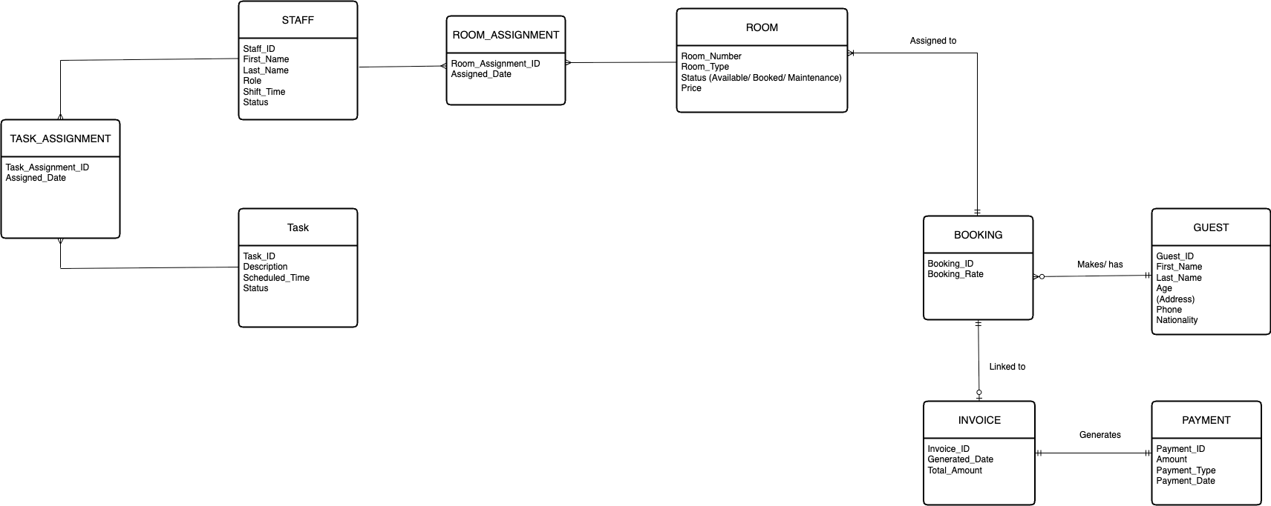

Updated ERD:

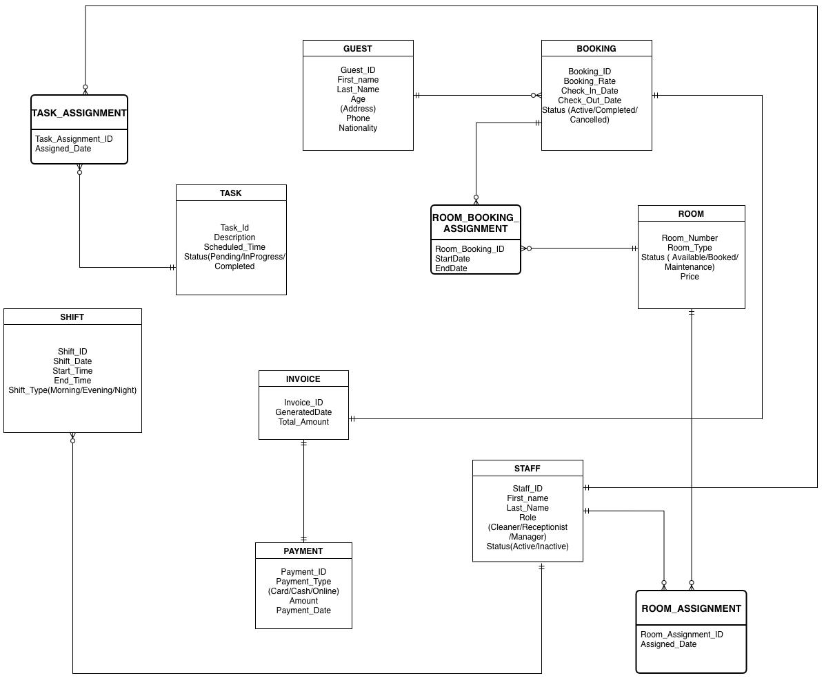

Key Changes in ERD:

- Introduced associative entity ROOM_BOOKING_ASSIGNMENT for ROOM – BOOKING relationship.
- Introduced associative entity TASK_ASSIGNMENT for STAFF – TASK relationship.
- Expanded ROOM_ASSIGNMENT as associative entity for STAFF – ROOM relationship.
- Added SHIFT entity linked to TASK.

Logical ERD:

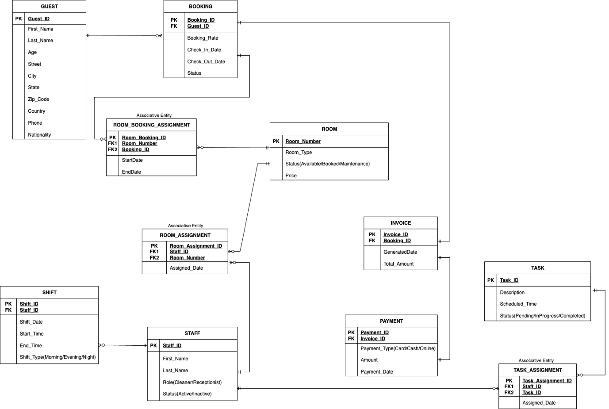

Updated Logical ERD:

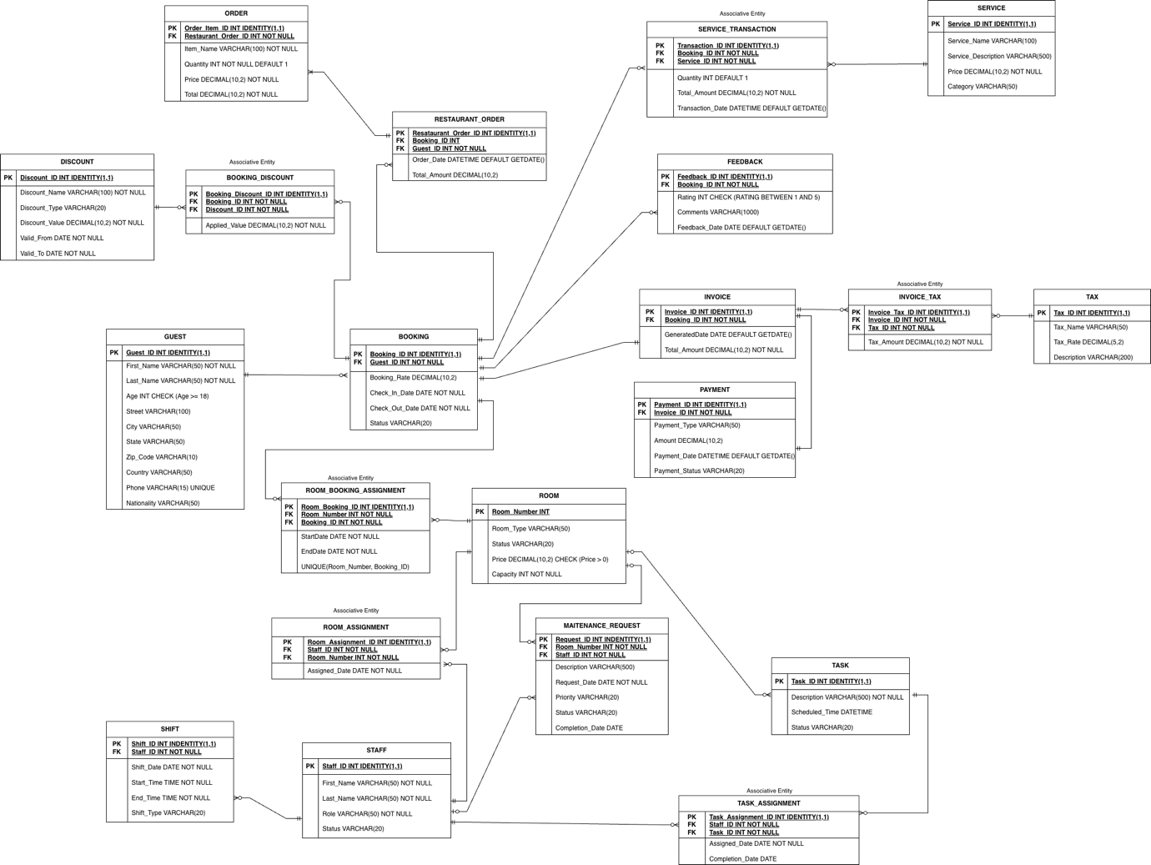

List of entities and their relationships:

GUEST -
Represents hotel customers with personal details (name, age, address, phone, nationality). A guest can make multiple bookings and place restaurant orders. Walk-in restaurant customers are also stored as guests without booking references.

BOOKING -
Represents a guest's reservation commitment. Each booking is made by one primary guest and can span multiple rooms. Includes booking rate, check-in/check-out dates, and status (Confirmed, Checked-In, Checked-Out, Cancelled). Links to services, discounts, restaurant orders, and generates one invoice.

ROOM -
Physical hotel units with unique room number, type (Single, Double, Suite, Deluxe), status (Available, Occupied, Maintenance, OutOfService), price, and capacity. Rooms are assigned to bookings and staff for cleaning/maintenance.

ROOM_BOOKING_ASSIGNMENT -
Associative entity linking rooms and bookings (many-to-many). Captures StartDate and EndDate for each room assignment, allowing multiple rooms per booking and tracking exact occupation periods.

INVOICE -
Generated at checkout for each booking. Consolidates all charges including room fees, services, restaurant bills, taxes, and discounts. Contains generated date and total amount due.

PAYMENT -
Records financial transactions for invoices (one-to-one). Includes payment type (Cash, Credit Card, Debit Card, Online, UPI), amount, payment date, and status (Pending, Completed, Failed, Refunded).

TAX -
Represents tax types (state tax, city tax, VAT, service tax) with tax name, rate percentage, and description. Multiple taxes can apply to a single invoice via Invoice_Tax.

INVOICE_TAX -
Associative entity linking invoices and taxes (many-to-many). Calculates and stores the specific tax amount for each tax type applied to an invoice for accurate tax reporting.

SERVICE -
Additional hotel amenities (spa, laundry, room service, airport shuttle, gym) with name, description, price, and category. Services are tracked per booking through Service_Transaction.

SERVICE_TRANSACTION -
Associative entity linking bookings and services (many-to-many). Tracks quantity used, total amount charged, and transaction date for each service utilized during a stay.

RESTAURANT_ORDER -
Food and beverage orders placed by guests. Links to guest (always required) and optionally to booking—in-house guests have Booking_ID populated for room billing, while walk-in customers have Booking_ID as NULL. Includes order date and total amount.

ORDER -
Line items within a restaurant order. Each entry represents one menu item with item name, quantity, price, and total, allowing detailed tracking of individual food/beverage items.

DISCOUNT -
Promotional offers with name, type (Percentage or Fixed), discount value, and validity period (Valid_From, Valid_To). Applied to bookings through Booking_Discount associative entity.

BOOKING_DISCOUNT -
Associative entity linking bookings and discounts (many-to-many). Allows multiple discounts per booking and tracks the actual applied value, which may differ from base discount value due to rules and caps.

FEEDBACK -
Guest ratings and comments linked to specific bookings. Includes rating (1-5 scale), comments, and feedback date. Enables quality tracking and service improvement analysis.

STAFF -
Hotel employees (housekeepers, maintenance, receptionists, managers, restaurant staff) with name, role, and status (Active, Inactive, OnLeave). Staff have multiple shifts and can be assigned to rooms and tasks.

SHIFT -
Staff work schedules with shift date, start/end times, and shift type (Morning, Evening, Night). Enables proper scheduling and payroll tracking.

TASK -
Operational activities (cleaning, repairs, inventory checks) with description, scheduled time, and status (Pending, InProgress, Completed). Assigned to staff through Task_Assignment.

TASK_ASSIGNMENT -
Associative entity linking staff and tasks (many-to-many). Records assignment date and completion date, enabling workload distribution and accountability tracking.

ROOM_ASSIGNMENT -
Associative entity linking staff and rooms (many-to-many). Tracks which staff are responsible for which rooms with assignment date, supporting housekeeping and maintenance scheduling.

MAINTENANCE_REQUEST -
Tracks room repair issues with description, request date, priority (Low, Medium, High, Critical), status (Pending, InProgress, Completed), and completion date. Each request links to one room and one assigned staff member, enabling lifecycle management from reporting to resolution.
Key database design decisions:

Normalization and Data Integrity -
- Fully normalized to Third Normal Form (3NF)—no repeating groups, partial dependencies, or transitive dependencies (except intentional GUEST address denormalization).
- Composite attributes (e.g., Address) decomposed into atomic fields (Street, City, State, Zip_Code, Country).
- All many-to-many relationships resolved using associative entities with surrogate keys.
- Foreign key constraints and CHECK constraints enforce referential and domain integrity.

Booking and Room Management -
- BOOKING stores reservation commitment; ROOM_BOOKING_ASSIGNMENT tracks actual room allocations with temporal attributes (StartDate, EndDate).
- Supports multiple rooms per booking and room changes during stays.
- UNIQUE constraint on (Room_Number, Booking_ID) prevents duplicate assignments.

Financial Management -
- INVOICE and PAYMENT are separate for financial integrity—INVOICE consolidates all charges; PAYMENT records transactions.
- INVOICE_TAX handles multiple tax types per invoice, storing calculated amounts for compliance and reporting.
- All financial entities linked to BOOKING for centralized billing at checkout.

Service and Transaction Management -
- SERVICE_TRANSACTION resolves many-to-many between BOOKING and SERVICE, tracking quantity, amount, and date for detailed billing and analytics.

Restaurant Operations -
- RESTAURANT_ORDER supports in-house guests (Booking_ID NOT NULL) and walk-ins (Booking_ID NULL). Guest_ID always required for billing and tracking.
- ORDER stores line items with Restaurant_Order_ID foreign key, enabling detailed menu item tracking.
- Relationship: RESTAURANT_ORDER (parent) → ORDER (children).

Discount System -
- BOOKING_DISCOUNT enables multiple discounts per booking (e.g., early bird + loyalty).
- Applied_Value may differ from base Discount_Value due to rules, caps, and combination logic.

Guest Feedback -
- Linked to BOOKING (not GUEST) to capture feedback about specific stays rather than general opinions.
- Guest information retrieved through booking relationship when needed.

Staff Management -
- ROOM_ASSIGNMENT and TASK_ASSIGNMENT resolve many-to-many relationships for flexible workforce allocation.
- SHIFT tracks schedules with date, times, and shift type for payroll and coverage planning.

Maintenance Tracking -
- MAINTENANCE_REQUEST is a strong entity (not associative) with rich attributes (priority, status, description, dates).
- Links to ROOM (which room) and STAFF (who's assigned) for clear responsibility and lifecycle tracking.

Scalability and Extensibility -
- Modular design supports future enhancements: online booking portals, loyalty programs, third-party integrations, IoT devices, mobile apps, and advanced analytics.
- New features can be added without disrupting existing structure.

Data Security Considerations -
- Separated functional areas (guest, financial, operational) support role-based access control.
- Sensitive data isolated in specific entities for targeted security measures and encryption.
- Design supports audit trails via timestamp/user tracking fields.

DDL Script:

CREATE DATABASE HotelManagementDB;
GO

USE HotelManagementDB;
GO

IF OBJECT_ID('dbo.MAINTENANCE_REQUEST', 'U') IS NOT NULL DROP TABLE dbo.MAINTENANCE_REQUEST;
IF OBJECT_ID('dbo.ROOM_ASSIGNMENT', 'U') IS NOT NULL DROP TABLE dbo.ROOM_ASSIGNMENT;
IF OBJECT_ID('dbo.TASK_ASSIGNMENT', 'U') IS NOT NULL DROP TABLE dbo.TASK_ASSIGNMENT;
IF OBJECT_ID('dbo.TASK', 'U') IS NOT NULL DROP TABLE dbo.TASK;
IF OBJECT_ID('dbo.SHIFT', 'U') IS NOT NULL DROP TABLE dbo.SHIFT;
IF OBJECT_ID('dbo.STAFF', 'U') IS NOT NULL DROP TABLE dbo.STAFF;
IF OBJECT_ID('dbo.FEEDBACK', 'U') IS NOT NULL DROP TABLE dbo.FEEDBACK;
IF OBJECT_ID('dbo.[ORDER]', 'U') IS NOT NULL DROP TABLE dbo.[ORDER];
IF OBJECT_ID('dbo.RESTAURANT_ORDER', 'U') IS NOT NULL DROP TABLE dbo.RESTAURANT_ORDER;
IF OBJECT_ID('dbo.SERVICE_TRANSACTION', 'U') IS NOT NULL DROP TABLE dbo.SERVICE_TRANSACTION;
IF OBJECT_ID('dbo.SERVICE', 'U') IS NOT NULL DROP TABLE dbo.SERVICE;
IF OBJECT_ID('dbo.PAYMENT', 'U') IS NOT NULL DROP TABLE dbo.PAYMENT;
IF OBJECT_ID('dbo.INVOICE_TAX', 'U') IS NOT NULL DROP TABLE dbo.INVOICE_TAX;
IF OBJECT_ID('dbo.TAX', 'U') IS NOT NULL DROP TABLE dbo.TAX;
IF OBJECT_ID('dbo.INVOICE', 'U') IS NOT NULL DROP TABLE dbo.INVOICE;
IF OBJECT_ID('dbo.BOOKING_DISCOUNT', 'U') IS NOT NULL DROP TABLE dbo.BOOKING_DISCOUNT;
IF OBJECT_ID('dbo.DISCOUNT', 'U') IS NOT NULL DROP TABLE dbo.DISCOUNT;
IF OBJECT_ID('dbo.ROOM_BOOKING_ASSIGNMENT', 'U') IS NOT NULL DROP TABLE dbo.ROOM_BOOKING_ASSIGNMENT;
IF OBJECT_ID('dbo.BOOKING', 'U') IS NOT NULL DROP TABLE dbo.BOOKING;
IF OBJECT_ID('dbo.ROOM', 'U') IS NOT NULL DROP TABLE dbo.ROOM;
IF OBJECT_ID('dbo.GUEST', 'U') IS NOT NULL DROP TABLE dbo.GUEST;
GO

CREATE TABLE GUEST (
Guest_ID INT IDENTITY(1,1) PRIMARY KEY,
First_Name VARCHAR(50) NOT NULL,
Last_Name VARCHAR(50) NOT NULL,
Age INT NOT NULL CHECK (Age >= 18),
Street VARCHAR(100),
City VARCHAR(50),
State VARCHAR(50),
Zip_Code VARCHAR(10),
Country VARCHAR(50),
Phone VARCHAR(20) UNIQUE,
Email VARCHAR(100),
Nationality VARCHAR(50)
);

CREATE TABLE ROOM (
Room_Number INT PRIMARY KEY,
Room_Type VARCHAR(20) NOT NULL CHECK (Room_Type IN ('Single', 'Double', 'Suite', 'Deluxe')),
Status VARCHAR(20) NOT NULL CHECK (Status IN ('Available', 'Occupied', 'Maintenance', 'OutOfService')),
Price DECIMAL(10,2) NOT NULL CHECK (Price > 0),
Capacity INT NOT NULL CHECK (Capacity > 0)
);

CREATE TABLE BOOKING (
Booking_ID INT IDENTITY(1,1) PRIMARY KEY,
Guest_ID INT NOT NULL,
Booking_Rate DECIMAL(10,2) NOT NULL CHECK (Booking_Rate > 0),
Check_In_Date DATE NOT NULL,
Check_Out_Date DATE NOT NULL,
Status VARCHAR(20) NOT NULL CHECK (Status IN ('Confirmed', 'CheckedIn', 'CheckedOut', 'Cancelled')),
FOREIGN KEY (Guest_ID) REFERENCES GUEST(Guest_ID),
CHECK (Check_Out_Date > Check_In_Date)
);

CREATE TABLE ROOM_BOOKING_ASSIGNMENT (
Room_Booking_ID INT IDENTITY(1,1) PRIMARY KEY,
Room_Number INT NOT NULL,
Booking_ID INT NOT NULL,
StartDate DATE NOT NULL,
EndDate DATE NOT NULL,
FOREIGN KEY (Room_Number) REFERENCES ROOM(Room_Number),
FOREIGN KEY (Booking_ID) REFERENCES BOOKING(Booking_ID),
UNIQUE (Room_Number, Booking_ID),
CHECK (EndDate >= StartDate)
);

CREATE TABLE DISCOUNT (
Discount_ID INT IDENTITY(1,1) PRIMARY KEY,
Discount_Name VARCHAR(100) NOT NULL,
Discount_Type VARCHAR(20) NOT NULL CHECK (Discount_Type IN ('Percentage', 'Fixed')),
Discount_Value DECIMAL(10,2) NOT NULL CHECK (Discount_Value > 0),
Valid_From DATE NOT NULL,
Valid_To DATE NOT NULL,
CHECK (Valid_To >= Valid_From)
);

CREATE TABLE BOOKING_DISCOUNT (
Booking_Discount_ID INT IDENTITY(1,1) PRIMARY KEY,
Booking_ID INT NOT NULL,
Discount_ID INT NOT NULL,
Applied_Value DECIMAL(10,2) NOT NULL CHECK (Applied_Value > 0),
FOREIGN KEY (Booking_ID) REFERENCES BOOKING(Booking_ID),
FOREIGN KEY (Discount_ID) REFERENCES DISCOUNT(Discount_ID)
);

CREATE TABLE INVOICE (
Invoice_ID INT IDENTITY(1,1) PRIMARY KEY,
Booking_ID INT NOT NULL,
Generated_Date DATE NOT NULL DEFAULT GETDATE(),
Total_Amount DECIMAL(10,2) NOT NULL CHECK (Total_Amount > 0),
FOREIGN KEY (Booking_ID) REFERENCES BOOKING(Booking_ID)
);

CREATE TABLE TAX (
Tax_ID INT IDENTITY(1,1) PRIMARY KEY,
Tax_Name VARCHAR(50) NOT NULL,
Tax_Rate DECIMAL(5,2) NOT NULL CHECK (Tax_Rate >= 0 AND Tax_Rate <= 100),
Description VARCHAR(200)
);

CREATE TABLE INVOICE_TAX (
Invoice_Tax_ID INT IDENTITY(1,1) PRIMARY KEY,
Invoice_ID INT NOT NULL,
Tax_ID INT NOT NULL,
Tax_Amount DECIMAL(10,2) NOT NULL CHECK (Tax_Amount >= 0),
FOREIGN KEY (Invoice_ID) REFERENCES INVOICE(Invoice_ID),
FOREIGN KEY (Tax_ID) REFERENCES TAX(Tax_ID)
);

CREATE TABLE PAYMENT (
Payment_ID INT IDENTITY(1,1) PRIMARY KEY,
Invoice_ID INT NOT NULL,
Payment_Type VARCHAR(20) NOT NULL CHECK (Payment_Type IN ('Cash', 'CreditCard', 'DebitCard', 'Online', 'UPI')),
Amount DECIMAL(10,2) NOT NULL CHECK (Amount > 0),
Payment_Date DATETIME NOT NULL DEFAULT GETDATE(),
Payment_Status VARCHAR(20) NOT NULL CHECK (Payment_Status IN ('Pending', 'Completed', 'Failed', 'Refunded')),
FOREIGN KEY (Invoice_ID) REFERENCES INVOICE(Invoice_ID)
);

CREATE TABLE SERVICE (
Service_ID INT IDENTITY(1,1) PRIMARY KEY,
Service_Name VARCHAR(100) NOT NULL,
Service_Description VARCHAR(200),
Price DECIMAL(10,2) NOT NULL CHECK (Price > 0),
Category VARCHAR(50)
);

CREATE TABLE SERVICE_TRANSACTION (
Transaction_ID INT IDENTITY(1,1) PRIMARY KEY,
Booking_ID INT NOT NULL,
Service_ID INT NOT NULL,
Quantity INT NOT NULL CHECK (Quantity > 0) DEFAULT 1,
Total_Amount DECIMAL(10,2) NOT NULL CHECK (Total_Amount > 0),
Transaction_Date DATETIME NOT NULL DEFAULT GETDATE(),
FOREIGN KEY (Booking_ID) REFERENCES BOOKING(Booking_ID),
FOREIGN KEY (Service_ID) REFERENCES SERVICE(Service_ID)
);

CREATE TABLE RESTAURANT_ORDER (
Restaurant_Order_ID INT IDENTITY(1,1) PRIMARY KEY,
Guest_ID INT NOT NULL,
Booking_ID INT,
Order_Date DATETIME NOT NULL DEFAULT GETDATE(),
Total_Amount DECIMAL(10,2) NOT NULL CHECK (Total_Amount > 0),
FOREIGN KEY (Guest_ID) REFERENCES GUEST(Guest_ID),
FOREIGN KEY (Booking_ID) REFERENCES BOOKING(Booking_ID)
);

CREATE TABLE [ORDER] (
Order_ID INT IDENTITY(1,1) PRIMARY KEY,
Restaurant_Order_ID INT NOT NULL,
Item_Name VARCHAR(100) NOT NULL,
Quantity INT NOT NULL CHECK (Quantity > 0),
Price DECIMAL(10,2) NOT NULL CHECK (Price > 0),
Total DECIMAL(10,2) NOT NULL CHECK (Total > 0),
FOREIGN KEY (Restaurant_Order_ID) REFERENCES RESTAURANT_ORDER(Restaurant_Order_ID)
);

CREATE TABLE FEEDBACK (
Feedback_ID INT IDENTITY(1,1) PRIMARY KEY,
Booking_ID INT NOT NULL,
Rating INT NOT NULL CHECK (Rating >= 1 AND Rating <= 5),
Comments VARCHAR(500),
Feedback_Date DATE NOT NULL DEFAULT GETDATE(),
FOREIGN KEY (Booking_ID) REFERENCES BOOKING(Booking_ID)
);

CREATE TABLE STAFF (
Staff_ID INT IDENTITY(1,1) PRIMARY KEY,
First_Name VARCHAR(50) NOT NULL,
Last_Name VARCHAR(50) NOT NULL,
Role VARCHAR(50) NOT NULL,
Status VARCHAR(20) NOT NULL CHECK (Status IN ('Active', 'Inactive', 'OnLeave'))
);

CREATE TABLE SHIFT (
Shift_ID INT IDENTITY(1,1) PRIMARY KEY,
Staff_ID INT NOT NULL,
Shift_Date DATE NOT NULL,
Start_Time TIME NOT NULL,
End_Time TIME NOT NULL,
Shift_Type VARCHAR(20) NOT NULL CHECK (Shift_Type IN ('Morning', 'Evening', 'Night')),
FOREIGN KEY (Staff_ID) REFERENCES STAFF(Staff_ID)
);

CREATE TABLE TASK (
Task_ID INT IDENTITY(1,1) PRIMARY KEY,
Description VARCHAR(200) NOT NULL,
Scheduled_Time DATETIME NOT NULL,
Status VARCHAR(20) NOT NULL CHECK (Status IN ('Pending', 'InProgress', 'Completed'))
);

CREATE TABLE TASK_ASSIGNMENT (
Task_Assignment_ID INT IDENTITY(1,1) PRIMARY KEY,
Task_ID INT NOT NULL,
Staff_ID INT NOT NULL,
Assigned_Date DATE NOT NULL DEFAULT GETDATE(),
Completion_Date DATE,
FOREIGN KEY (Task_ID) REFERENCES TASK(Task_ID),
FOREIGN KEY (Staff_ID) REFERENCES STAFF(Staff_ID)
);

CREATE TABLE ROOM_ASSIGNMENT (
Room_Assignment_ID INT IDENTITY(1,1) PRIMARY KEY,
Room_Number INT NOT NULL,
Staff_ID INT NOT NULL,
Assignment_Date DATE NOT NULL DEFAULT GETDATE(),
FOREIGN KEY (Room_Number) REFERENCES ROOM(Room_Number),
FOREIGN KEY (Staff_ID) REFERENCES STAFF(Staff_ID)
);

CREATE TABLE MAINTENANCE_REQUEST (
Request_ID INT IDENTITY(1,1) PRIMARY KEY,
Room_Number INT NOT NULL,
Staff_ID INT NOT NULL,
Description VARCHAR(200) NOT NULL,
Request_Date DATE NOT NULL DEFAULT GETDATE(),
Priority VARCHAR(20) NOT NULL CHECK (Priority IN ('Low', 'Medium', 'High', 'Critical')),
Status VARCHAR(20) NOT NULL CHECK (Status IN ('Pending', 'InProgress', 'Completed')),
Completion_Date DATE,
FOREIGN KEY (Room_Number) REFERENCES ROOM(Room_Number),
FOREIGN KEY (Staff_ID) REFERENCES STAFF(Staff_ID)
);

CREATE TABLE BOOKING_AUDIT (
Audit_ID INT IDENTITY(1,1) PRIMARY KEY,
Booking_ID INT,
Action_Type VARCHAR(10),
Action_Date DATETIME DEFAULT GETDATE(),
Action_By VARCHAR(100) DEFAULT SUSER_NAME(),
Old_Status VARCHAR(20),
New_Status VARCHAR(20),
Old_CheckIn DATE,
New_CheckIn DATE,
Old_CheckOut DATE,
New_CheckOut DATE
);

Insert Statements –

USE HotelManagementDB;
GO

INSERT INTO GUEST (First_Name, Last_Name, Age, Street, City, State, Zip_Code, Country, Phone, Email, Nationality) VALUES
('John', 'Smith', 35, '123 Main St', 'Boston', 'MA', '02101', 'USA', '617-555-0101', 'john.smith@email.com', 'American'),
('Emily', 'Johnson', 28, '456 Oak Ave', 'New York', 'NY', '10001', 'USA', '212-555-0102', 'emily.johnson@email.com', 'American'),
('Michael', 'Williams', 42, '789 Pine Rd', 'Los Angeles', 'CA', '90001', 'USA', '310-555-0103', 'michael.williams@email.com', 'American'),
('Sarah', 'Brown', 31, '321 Elm St', 'Chicago', 'IL', '60601', 'USA', '312-555-0104', 'sarah.brown@email.com', 'American'),
('David', 'Jones', 45, '654 Maple Dr', 'Houston', 'TX', '77001', 'USA', '713-555-0105', 'david.jones@email.com', 'American'),
('Maria', 'Garcia', 29, '987 Cedar Ln', 'Phoenix', 'AZ', '85001', 'USA', '602-555-0106', 'maria.garcia@email.com', 'Mexican'),
('James', 'Miller', 38, '147 Birch Way', 'Philadelphia', 'PA', '19101', 'USA', '215-555-0107', 'james.miller@email.com', 'American'),
('Linda', 'Davis', 33, '258 Spruce Ct', 'San Antonio', 'TX', '78201', 'USA', '210-555-0108', 'linda.davis@email.com', 'American'),
('Robert', 'Rodriguez', 40, '369 Willow Pl', 'San Diego', 'CA', '92101', 'USA', '619-555-0109', 'robert.rodriguez@email.com', 'Mexican'),
('Patricia', 'Martinez', 27, '741 Ash Blvd', 'Dallas', 'TX', '75201', 'USA', '214-555-0110', 'patricia.martinez@email.com', 'American'),
('William', 'Anderson', 50, '852 Poplar Ave', 'San Jose', 'CA', '95101', 'USA', '408-555-0111', 'william.anderson@email.com', 'American'),
('Jennifer', 'Taylor', 26, '963 Hickory Dr', 'Austin', 'TX', '73301', 'USA', '512-555-0112', 'jennifer.taylor@email.com', 'American');

INSERT INTO ROOM (Room_Number, Room_Type, Status, Price, Capacity) VALUES
(101, 'Single', 'Available', 89.99, 1),
(102, 'Single', 'Available', 89.99, 1),
(103, 'Double', 'Available', 129.99, 2),
(104, 'Double', 'Available', 129.99, 2),
(105, 'Suite', 'Available', 249.99, 4),
(106, 'Suite', 'Occupied', 249.99, 4),
(107, 'Deluxe', 'Available', 349.99, 4),
(108, 'Double', 'Maintenance', 129.99, 2),
(109, 'Single', 'Available', 89.99, 1),
(110, 'Deluxe', 'Occupied', 349.99, 4),
(201, 'Double', 'Available', 139.99, 2),
(202, 'Suite', 'Available', 259.99, 4);

INSERT INTO BOOKING (Guest_ID, Booking_Rate, Check_In_Date, Check_Out_Date, Status) VALUES
(1, 89.99, '2025-11-05', '2025-11-08', 'Confirmed'),
(2, 129.99, '2025-11-06', '2025-11-10', 'Confirmed'),
(3, 249.99, '2025-11-01', '2025-11-05', 'CheckedIn'),
(4, 129.99, '2025-10-28', '2025-11-03', 'CheckedOut'),
(5, 349.99, '2025-11-02', '2025-11-06', 'CheckedIn'),
(6, 89.99, '2025-11-10', '2025-11-12', 'Confirmed'),
(7, 139.99, '2025-11-08', '2025-11-11', 'Confirmed'),
(8, 249.99, '2025-10-25', '2025-10-30', 'CheckedOut'),
(9, 129.99, '2025-11-04', '2025-11-07', 'Confirmed'),
(10, 89.99, '2025-11-15', '2025-11-17', 'Confirmed'),
(11, 349.99, '2025-11-20', '2025-11-25', 'Confirmed'),
(12, 129.99, '2025-11-12', '2025-11-14', 'Confirmed');

INSERT INTO ROOM_BOOKING_ASSIGNMENT (Room_Number, Booking_ID, StartDate, EndDate) VALUES
(101, 1, '2025-11-05', '2025-11-08'),
(103, 2, '2025-11-06', '2025-11-10'),
(106, 3, '2025-11-01', '2025-11-05'),
(104, 4, '2025-10-28', '2025-11-03'),
(110, 5, '2025-11-02', '2025-11-06'),
(109, 6, '2025-11-10', '2025-11-12'),
(201, 7, '2025-11-08', '2025-11-11'),
(105, 8, '2025-10-25', '2025-10-30'),
(103, 9, '2025-11-04', '2025-11-07'),
(102, 10, '2025-11-15', '2025-11-17'),
(107, 11, '2025-11-20', '2025-11-25'),
(201, 12, '2025-11-12', '2025-11-14');

INSERT INTO DISCOUNT (Discount_Name, Discount_Type, Discount_Value, Valid_From, Valid_To) VALUES
('Early Bird Special', 'Percentage', 15.00, '2025-01-01', '2025-12-31'),
('Weekend Getaway', 'Percentage', 20.00, '2025-11-01', '2025-11-30'),
('Extended Stay', 'Percentage', 25.00, '2025-01-01', '2025-12-31'),
('Senior Discount', 'Percentage', 10.00, '2025-01-01', '2025-12-31'),
('Military Discount', 'Percentage', 15.00, '2025-01-01', '2025-12-31'),
('Corporate Rate', 'Fixed', 50.00, '2025-01-01', '2025-12-31'),
('Holiday Special', 'Percentage', 30.00, '2025-12-20', '2025-12-31'),
('Loyalty Member', 'Percentage', 12.00, '2025-01-01', '2025-12-31'),
('Group Booking', 'Percentage', 18.00, '2025-01-01', '2025-12-31'),
('Last Minute Deal', 'Fixed', 40.00, '2025-11-01', '2025-11-30'),
('Summer Special', 'Percentage', 20.00, '2025-06-01', '2025-08-31'),
('New Customer', 'Fixed', 25.00, '2025-01-01', '2025-12-31');

INSERT INTO BOOKING_DISCOUNT (Booking_ID, Discount_ID, Applied_Value) VALUES
(1, 1, 13.50),
(2, 2, 26.00),
(3, 3, 62.50),
(4, 4, 13.00),
(5, 8, 41.99),
(6, 1, 13.50),
(7, 2, 27.99),
(8, 3, 62.50),
(9, 10, 40.00),
(10, 1, 13.50),
(11, 9, 62.99),
(12, 2, 26.00);

INSERT INTO INVOICE (Booking_ID, Generated_Date, Total_Amount) VALUES
(4, '2025-11-03', 519.96),
(8, '2025-10-30', 999.96),
(3, '2025-11-05', 1187.46),
(5, '2025-11-06', 1631.96),
(1, '2025-11-08', 282.47),
(2, '2025-11-10', 545.96),
(6, '2025-11-12', 189.98),
(7, '2025-11-11', 447.97),
(9, '2025-11-07', 413.97),
(10, '2025-11-17', 189.98),
(11, '2025-11-25', 1924.95),
(12, '2025-11-14', 273.98);

INSERT INTO TAX (Tax_Name, Tax_Rate, Description) VALUES
('State Tax', 6.25, 'Massachusetts state tax'),
('City Tax', 2.75, 'Boston city tax'),
('Tourism Tax', 4.50, 'Tourism development tax'),
('Service Tax', 5.00, 'Service charge tax'),
('VAT', 10.00, 'Value Added Tax'),
('Federal Tax', 3.00, 'Federal occupancy tax'),
('County Tax', 1.50, 'County tax'),
('Resort Fee Tax', 2.00, 'Resort amenities tax'),
('Environmental Tax', 1.00, 'Environmental sustainability tax'),
('Convention Tax', 2.50, 'Convention center tax'),
('Lodging Tax', 5.50, 'General lodging tax'),
('Sales Tax', 7.00, 'General sales tax');

INSERT INTO INVOICE_TAX (Invoice_ID, Tax_ID, Tax_Amount) VALUES
(1, 1, 32.50),
(1, 2, 14.30),
(2, 1, 62.50),
(2, 2, 27.50),
(3, 1, 74.22),
(3, 3, 53.44),
(4, 1, 101.99),
(4, 2, 44.88),
(5, 1, 17.66),
(5, 2, 7.77),
(6, 1, 34.12),
(6, 3, 24.57),
(7, 1, 11.87),
(7, 2, 5.22),
(8, 1, 27.99),
(8, 2, 12.32),
(9, 1, 25.87),
(9, 3, 18.63),
(10, 1, 11.87),
(10, 2, 5.22),
(11, 1, 120.31),
(11, 2, 52.94),
(12, 1, 17.12),
(12, 2, 7.53);

INSERT INTO PAYMENT (Invoice_ID, Payment_Type, Amount, Payment_Date, Payment_Status) VALUES
(1, 'CreditCard', 519.96, '2025-11-03 14:30:00', 'Completed'),
(2, 'CreditCard', 999.96, '2025-10-30 11:15:00', 'Completed'),
(3, 'DebitCard', 1187.46, '2025-11-05 10:00:00', 'Completed'),
(4, 'Cash', 1631.96, '2025-11-06 16:45:00', 'Completed'),
(5, 'Online', 282.47, '2025-11-08 09:30:00', 'Pending'),
(6, 'CreditCard', 545.96, '2025-11-10 12:00:00', 'Pending'),
(7, 'UPI', 189.98, '2025-11-12 15:20:00', 'Pending'),
(8, 'CreditCard', 447.97, '2025-11-11 13:45:00', 'Pending'),
(9, 'DebitCard', 413.97, '2025-11-07 17:00:00', 'Pending'),
(10, 'Cash', 189.98, '2025-11-17 10:30:00', 'Pending'),
(11, 'CreditCard', 1924.95, '2025-11-25 14:00:00', 'Pending'),
(12, 'Online', 273.98, '2025-11-14 11:30:00', 'Pending');

INSERT INTO SERVICE (Service_Name, Service_Description, Price, Category) VALUES
('Spa Treatment', 'Full body massage and spa', 120.00, 'Wellness'),
('Laundry Service', 'Same-day laundry service', 25.00, 'Room Service'),
('Room Service', 'In-room dining', 15.00, 'Food & Beverage'),
('Airport Shuttle', 'Round trip airport transportation', 50.00, 'Transportation'),
('Gym Access', 'Daily gym access', 20.00, 'Fitness'),
('Mini Bar', 'In-room mini bar restocking', 35.00, 'Room Service'),
('Breakfast Buffet', 'All-you-can-eat breakfast', 25.00, 'Food & Beverage'),
('Parking', 'Daily parking service', 30.00, 'Parking'),
('Wi-Fi Premium', 'High-speed internet access', 15.00, 'Technology'),
('Late Checkout', 'Extended checkout time', 40.00, 'Room Service'),
('Pet Care', 'Pet sitting and care', 45.00, 'Pet Services'),
('Conference Room', 'Hourly conference room rental', 75.00, 'Business');

INSERT INTO SERVICE_TRANSACTION (Booking_ID, Service_ID, Quantity, Total_Amount, Transaction_Date) VALUES
(3, 1, 1, 120.00, '2025-11-02 14:00:00'),
(3, 7, 4, 100.00, '2025-11-01 08:00:00'),
(4, 2, 1, 25.00, '2025-10-29 10:00:00'),
(4, 4, 1, 50.00, '2025-10-28 15:00:00'),
(5, 3, 2, 30.00, '2025-11-03 19:00:00'),
(5, 8, 4, 120.00, '2025-11-02 06:00:00'),
(8, 1, 2, 240.00, '2025-10-26 16:00:00'),
(8, 7, 5, 125.00, '2025-10-25 08:00:00'),
(1, 9, 3, 45.00, '2025-11-05 09:00:00'),
(2, 6, 1, 35.00, '2025-11-07 20:00:00'),
(3, 10, 1, 40.00, '2025-11-05 13:00:00'),
(5, 11, 2, 90.00, '2025-11-03 10:00:00');

INSERT INTO RESTAURANT_ORDER (Guest_ID, Booking_ID, Order_Date, Total_Amount) VALUES
(3, 3, '2025-11-01 19:30:00', 85.50),
(3, 3, '2025-11-02 20:00:00', 92.00),
(4, 4, '2025-10-28 18:45:00', 67.50),
(5, 5, '2025-11-02 19:15:00', 124.00),
(5, 5, '2025-11-03 20:30:00', 98.50),
(8, 8, '2025-10-26 19:00:00', 156.00),
(1, 1, '2025-11-05 18:30:00', 73.50),
(2, 2, '2025-11-06 19:45:00', 89.00),
(6, 6, '2025-11-10 20:15:00', 112.50),
(7, 7, '2025-11-08 19:30:00', 95.00),
(9, 9, '2025-11-05 18:00:00', 78.50),
(10, 10, '2025-11-15 19:00:00', 68.00);

INSERT INTO [ORDER] (Restaurant_Order_ID, Item_Name, Quantity, Price, Total) VALUES
(1, 'Grilled Salmon', 1, 32.00, 32.00),
(1, 'Caesar Salad', 2, 12.50, 25.00),
(1, 'Red Wine', 1, 28.50, 28.50),
(2, 'Ribeye Steak', 1, 45.00, 45.00),
(2, 'Garlic Bread', 2, 8.00, 16.00),
(2, 'Cheesecake', 1, 12.00, 12.00),
(2, 'Coffee', 2, 4.50, 9.00),
(3, 'Pasta Carbonara', 1, 22.00, 22.00),
(3, 'Garden Salad', 1, 10.50, 10.50),
(3, 'Iced Tea', 2, 4.00, 8.00),
(3, 'Tiramisu', 1, 10.00, 10.00),
(4, 'Lobster Tail', 2, 48.00, 96.00),
(4, 'Baked Potato', 2, 7.00, 14.00),
(5, 'Chicken Alfredo', 1, 24.50, 24.50),
(5, 'Bruschetta', 1, 11.00, 11.00),
(5, 'White Wine', 1, 32.00, 32.00),
(6, 'Prime Rib', 2, 52.00, 104.00),
(6, 'French Onion Soup', 2, 9.00, 18.00),
(7, 'Fish and Chips', 1, 19.50, 19.50),
(7, 'Clam Chowder', 1, 12.00, 12.00),
(7, 'Apple Pie', 2, 8.00, 16.00),
(8, 'Vegetarian Pizza', 1, 18.00, 18.00),
(8, 'Greek Salad', 1, 11.50, 11.50),
(8, 'Lemonade', 2, 3.50, 7.00);

INSERT INTO FEEDBACK (Booking_ID, Rating, Comments, Feedback_Date) VALUES
(4, 5, 'Excellent service! The room was spotless and the staff were very friendly.', '2025-11-03'),
(8, 4, 'Great stay overall. The spa services were amazing. Only issue was slow Wi-Fi.', '2025-10-30'),
(3, 5, 'Best hotel experience! Will definitely return.', '2025-11-05'),
(5, 4, 'Very comfortable rooms and great location. Restaurant food was delicious.', '2025-11-06'),
(1, 5, 'Perfect for a business trip. Clean, quiet, and professional.', '2025-11-08'),
(2, 3, 'Room was nice but had some maintenance issues. Staff resolved them quickly.', '2025-11-10'),
(6, 5, 'Amazing weekend getaway! Highly recommend.', '2025-11-12'),
(7, 4, 'Good value for money. Breakfast buffet was excellent.', '2025-11-11'),
(9, 5, 'Outstanding service from check-in to check-out.', '2025-11-07'),
(10, 4, 'Clean rooms and friendly staff. Minor noise from adjacent room.', '2025-11-17'),
(11, 5, 'Luxury at its finest! Every detail was perfect.', '2025-11-25'),
(12, 4, 'Great hotel for families. Kids loved the pool.', '2025-11-14');

INSERT INTO STAFF (First_Name, Last_Name, Role, Status) VALUES
('Alice', 'Thompson', 'Manager', 'Active'),
('Bob', 'Wilson', 'Receptionist', 'Active'),
('Carol', 'Moore', 'Housekeeper', 'Active'),
('Daniel', 'White', 'Maintenance', 'Active'),
('Emma', 'Harris', 'Chef', 'Active'),
('Frank', 'Martin', 'Waiter', 'Active'),
('Grace', 'Jackson', 'Housekeeper', 'Active'),
('Henry', 'Lee', 'Bellboy', 'Active'),
('Iris', 'Walker', 'Receptionist', 'Active'),
('Jack', 'Hall', 'Maintenance', 'OnLeave'),
('Karen', 'Allen', 'Spa Therapist', 'Active'),
('Leo', 'Young', 'Security', 'Active');

INSERT INTO SHIFT (Staff_ID, Shift_Date, Start_Time, End_Time, Shift_Type) VALUES
(2, '2025-11-02', '07:00:00', '15:00:00', 'Morning'),
(6, '2025-11-02', '15:00:00', '23:00:00', 'Evening'),
(12, '2025-11-02', '23:00:00', '07:00:00', 'Night'),
(9, '2025-11-03', '07:00:00', '15:00:00', 'Morning'),
(6, '2025-11-03', '15:00:00', '23:00:00', 'Evening'),
(12, '2025-11-03', '23:00:00', '07:00:00', 'Night'),
(2, '2025-11-04', '07:00:00', '15:00:00', 'Morning'),
(6, '2025-11-04', '15:00:00', '23:00:00', 'Evening'),
(12, '2025-11-04', '23:00:00', '07:00:00', 'Night'),
(9, '2025-11-05', '07:00:00', '15:00:00', 'Morning'),
(5, '2025-11-05', '15:00:00', '23:00:00', 'Evening'),
(12, '2025-11-05', '23:00:00', '07:00:00', 'Night');

INSERT INTO TASK (Description, Scheduled_Time, Status) VALUES
('Clean Room 104', '2025-11-02 10:00:00', 'Completed'),
('Fix AC in Room 108', '2025-11-02 14:00:00', 'InProgress'),
('Restock minibar Room 106', '2025-11-03 09:00:00', 'Pending'),
('Replace towels Room 110', '2025-11-03 11:00:00', 'Completed'),
('Inspect plumbing Room 201', '2025-11-04 13:00:00', 'Pending'),
('Deep clean lobby', '2025-11-04 08:00:00', 'Completed'),
('Check fire alarms', '2025-11-05 10:00:00', 'Pending'),
('Paint Room 105', '2025-11-05 15:00:00', 'InProgress'),
('Replace carpet hallway 2nd floor', '2025-11-06 09:00:00', 'Pending'),
('Clean pool area', '2025-11-06 07:00:00', 'Completed'),
('Inspect electrical Room 107', '2025-11-07 11:00:00', 'Pending'),
('Restock cleaning supplies', '2025-11-07 14:00:00', 'Completed');

INSERT INTO TASK_ASSIGNMENT (Task_ID, Staff_ID, Assigned_Date, Completion_Date) VALUES
(1, 3, '2025-11-02', '2025-11-02'),
(2, 4, '2025-11-02', NULL),
(3, 7, '2025-11-03', NULL),
(4, 3, '2025-11-03', '2025-11-03'),
(5, 4, '2025-11-04', NULL),
(6, 7, '2025-11-04', '2025-11-04'),
(7, 10, '2025-11-05', NULL),
(8, 4, '2025-11-05', NULL),
(9, 4, '2025-11-06', NULL),
(10, 3, '2025-11-06', '2025-11-06'),
(11, 4, '2025-11-07', NULL),
(12, 7, '2025-11-07', '2025-11-07');

INSERT INTO ROOM_ASSIGNMENT (Room_Number, Staff_ID, Assignment_Date) VALUES
(101, 3, '2025-11-02'),
(102, 7, '2025-11-02'),
(103, 3, '2025-11-02'),
(104, 7, '2025-11-03'),
(105, 3, '2025-11-03'),
(106, 7, '2025-11-04'),
(107, 3, '2025-11-04'),
(108, 4, '2025-11-05'),
(109, 7, '2025-11-05'),
(110, 3, '2025-11-06'),
(201, 7, '2025-11-06'),
(202, 3, '2025-11-07');

INSERT INTO MAINTENANCE_REQUEST (Room_Number, Staff_ID, Description, Request_Date, Priority, Status, Completion_Date) VALUES
(108, 4, 'Air conditioning not working properly', '2025-11-01', 'High', 'InProgress', NULL),
(104, 4, 'Leaky faucet in bathroom', '2025-10-30', 'Medium', 'Completed', '2025-10-31'),
(201, 4, 'Light bulb replacement needed', '2025-11-02', 'Low', 'Completed', '2025-11-02'),
(106, 4, 'TV remote not working', '2025-11-03', 'Low', 'Completed', '2025-11-03'),
(110, 4, 'Clogged drain in shower', '2025-11-04', 'Medium', 'Pending', NULL),
(105, 10, 'Window lock broken', '2025-11-05', 'High', 'Pending', NULL),
(107, 4, 'Thermostat malfunction', '2025-11-05', 'Medium', 'InProgress', NULL),
(103, 4, 'Squeaky door hinge', '2025-11-06', 'Low', 'Pending', NULL),
(109, 4, 'Carpet stain removal needed', '2025-11-06', 'Low', 'Pending', NULL),
(102, 10, 'Internet connection issues', '2025-11-07', 'Medium', 'Pending', NULL),
(202, 4, 'Mini fridge not cooling', '2025-11-07', 'Medium', 'Pending', NULL),
(101, 4, 'Replace smoke detector battery', '2025-11-08', 'Critical', 'Pending', NULL);

