Jen Shin

12 February 2018

CMSI 402

HW #2 – Chapter 5, 6

1. 5.1 Component based Architecture is loosely coupled components that provide services for each other whereas the service oriented architecture runs on its own and provides some kind of services for its clients. The service oriented architecture has pieces implemented as a service which communicates through the network on the different computer.
2. 5.2 Data centric and rule based approach would be appropriate to store the components of the game such as tables, available moves, and optimal action to take at current state. The app is considerably small and simple so it does not need any complicated client-server or service-oriented architecture.
3. 5.4 Rule based to deal with the chess knowledge and rules so that the program can keep track of current state of the chess table and user responses and display it properly. To allow the users to communicate through the network or over the internet, the application should also be a monolithic service-oriented as well.
4. 5.6 ClassyDraw will have a monolithic architecture. It will store the files so it would not need a database or maintenance, and the user can keep track of the files.
5. 5.8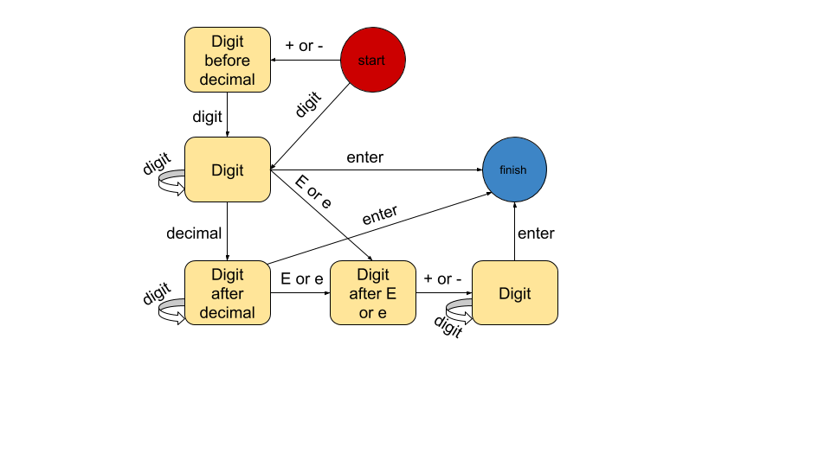
6. 6.1 These classes share properties for drawing such as fillColor, coordinates, lineWidth, and strokeColor. However, Text might have its own property like font, isBold, isItalicized, isUnderlined. Rectangle might have border property to make the edge of the border round or sharp. Shared properties should be implemented in the parent class, perhaps called Drawable and nonshared properties should be implemented in their own classes.
7. 6.2 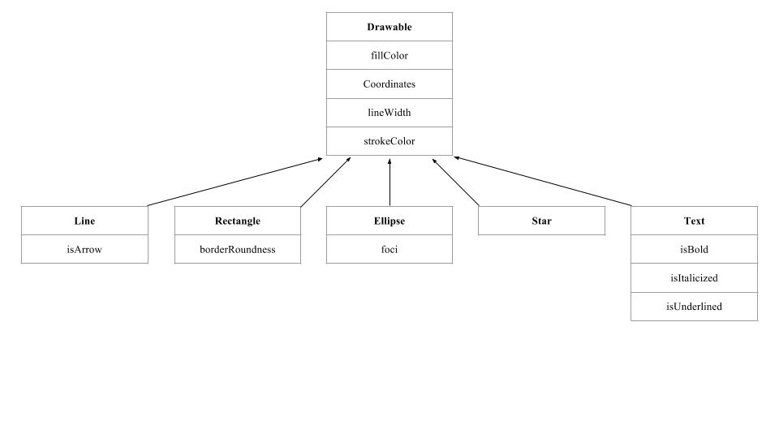
8. 6.3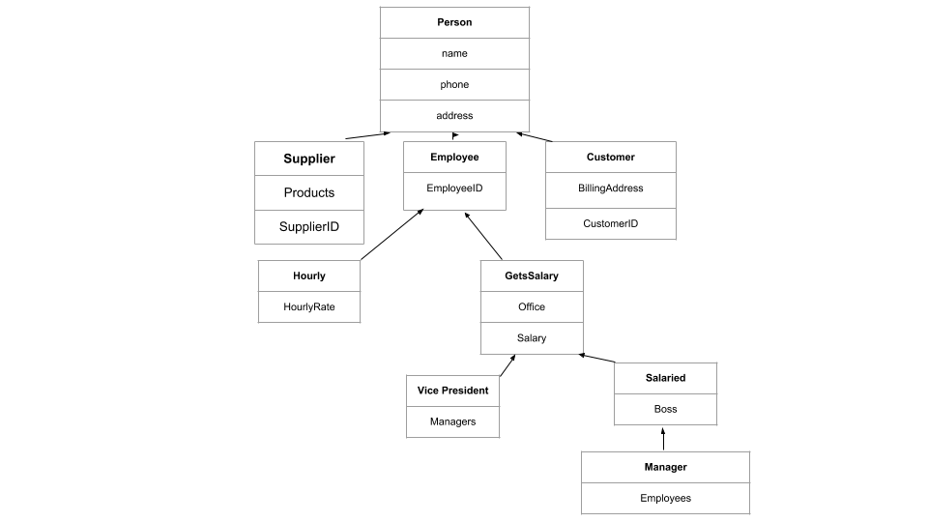
9. 6.6 