The Battle of Neighborhoods Week 1

Dirk Belger

06.12.2020

Introduction
In this project I will explore the culinaric possibilities in Cologne. It is a city which has a diverse offering of different Bars Restaurants and Cafes and it is nearly impossible to get to know all of them, not mentioning that there are closing and opening up new venues from time to time. As a person living in or visiting this city, there is so much to explore and a goal of this project is to help identifying those venues that are worth visiting. As a way of achieving this, I tried to model a basic scoring system, that takes into account the rating, the price and the distance of the venue depending on the current location, while I limit the radius to 750 meters. It then recommends you a list of venues with the best scoring, independent of the actual category of the venue. Therefore this method is not really suitable for all user, for instance those who look for a specific kind of venue or cuisine. However, for users that are new to the city it provides venues that are objectively worth visiting.

Data
I use public libraries and API's in this project. I use Foursquare API and some common Python Libraries like folium, pandas and matplotlib.
The available FourSquare location Data via the Foursquare API provide us with the necessary information to visualize the restaurants that are spread throughout the city. On a more detailed point of view, we can dive into specific neigbourhood or streets and find the best rated venues, the distance to the venue and the respective price category. All postal codes from the city of Cologne are available on "https://www.koeln.de/postleitzahlen" and the necessary location from the respective Cologne postal codes can be found on "http://www.fa-technik.adfc.de/code/opengeodb/PLZ.tab", which is a csv-file, similar to the Toronto example we had troughout the course. With those data sources we can collect the information that we need to model the scoring system and recommend the places that scored the best.

Methodology
Postal code data will be collected from https://www.koeln.de/postleitzahlen, cleaned and processed into a dataframe. The respective location data is read into a dataframe from the mentioned csv-file and merged with the postal code data including the neigbourhood names. With the available location data we will use our Foursquare Developer account to fetch the detailed venue information such as category, price, rating etc. Then we create a score with the available venue information to output those venues that are ranked highest with our applied scoring system. These are the venues that are reccommended to visit.

The latitude- and longitude information of each postal code in Cologne is collected by the following statement

df_geo = pd.read_csv("http://www.fa-technik.adfc.de/code/opengeodb/PLZ.tab", sep='\t', dtype=str)

and then merged with a dataframe that contains all postal codes of Cologne. These information are available on 'https://www.koeln.de/postleitzahlen' and processed into the dataframe using the library beatifulsoup4. See here the 10 first entry of the resulting dataframe.

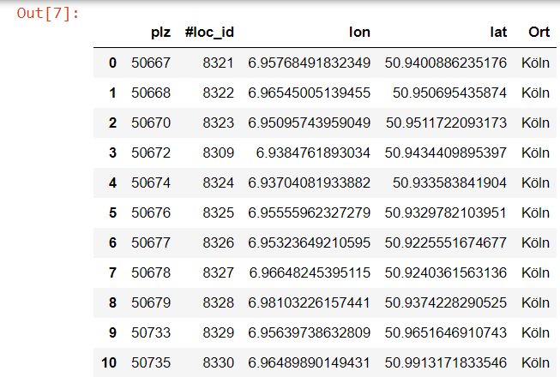
Using the folium library we can visualize the location points/neigbourhoods on a the map.

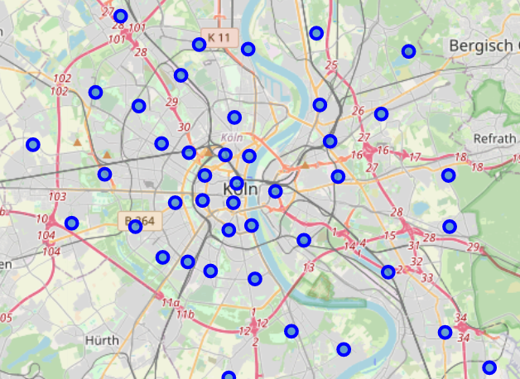
I utilized the Foursquare API to explore the boroughs and segment them. I limited the radius to 750 meter for each borough from their given latitude and longitude informations, which I think is still a reasonable amount of meter walk to a cool venue. I also filtered the results in a way, that only „Food Places“ are displayed.
Here is a head of the list Venues name, category, latitude and longitude informations from Forsquare API as well as the distance to the venue and the adress.

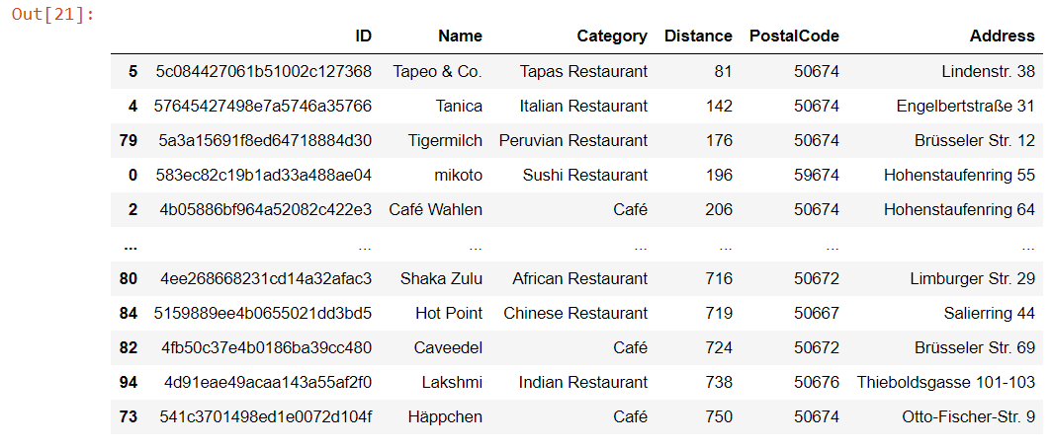

Results

This table is then complemented with the rating and the price range and by the folliowing formula the score is calculated:

Score = (1-(Distance/max_distance))*0,15 + (1-(Price/max_price))*0,15 + Rating/max_Rating*0,7

With weigthing the scoring I tried to put the importance of the rating in the middle and the distance and the price range a less important factor. For me personally, this is a very good way to account for these characteristics, it is highly subjective though.
This leads to the following table:

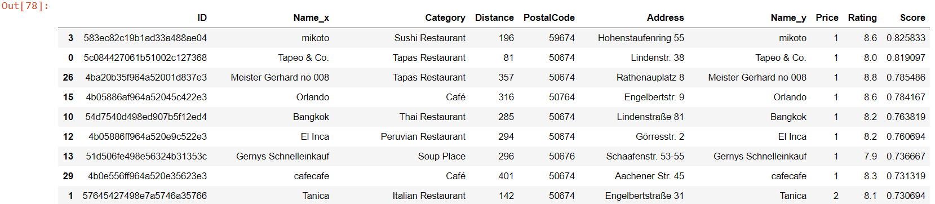
We now see a list of suggested venues in the area sorted by the calculated score.

Discussion

In this project I tried to introduce a model to help using available Foursquare data in order to offer venues, that are within walking distance, are ranked reasonable high and offer a good price range. While this model tried to quantify these characteristics, we must keep in mind that it is a simplification and putting more time in the project could to more complex model that involves additional characteristics of the venue that might be available on Foursquare or even on other platforms in the web. It is also important to state, that the suggested model might be a helpful tool for people that are within the area and looking for venues of a rather broad spectrum. However, for instance if someone is looking for a great italian restaurant, this project is not modelled for such a person.
While looking at the results and the calculated score of the above example, the venues that are suggested are indeed also venues that I personally very like and therefore I am confident that this very simple model is a good way to incorporate the characateristics in a quantitative way.

Conclusion

This small project showed in a very understandable way, how to use public available data to help decision making with limited information. Especially for a big City like Cologne with a variety of venues it is nearly impossible to have a complete overview over the available location. For the completeness, it is to say that this project can be conducted for any other city with entries on FourSquare.

