**Item Sold per Store**

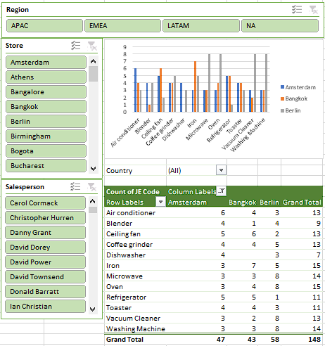

**Pivot table on Count of Item sold per country**



Filter : Country

Columns : Store

Rows : Item

Values : Count of JE Code

**Slicer on Region**



Used to filter dashboard by REGION

**Slicer on Store**



Use to filter dashboard by STORE

**Slicer on Salesperson**



Use to filter dashboard by SALESPERSON

**Pivot chart on Count of Item sold per country**



Filter : Country

Legend : Store

Axis: Item

Values : Count of JE Code