**Machine Learning & Data Mining, Spring 2020**

**Homework 8**

Due May 28

1. In Convolutional Neural Network (CNN), the $j$-th output feature map $h_{j}^{n}$ at layer $n$ is given as follows.

$$h_{j}^{n}=max⁡(0,\sum_{k=1}^{K}{h_{k}^{n-1}*w_{j}^{n})}$$

Where $h_{k}^{n-1}$ is the input feature map and $w$ is the convolution filter (or kernel). Suppose a CNN layer has the following two feature maps at a certain layer:

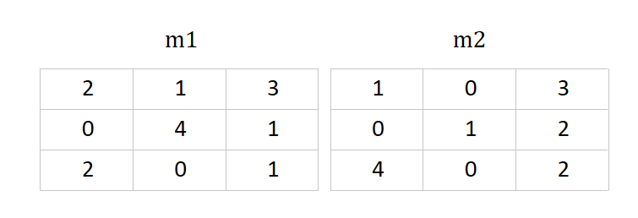

1. Apply the convolution operation to the above feature maps using the following two filters. Show the output feature maps (Assume stride = 1 and apply zero-padding to make output feature map size same as an input feature map) [5]

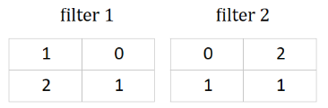

1. Apply 2x2 max pooling operation to the output maps obtained in (a). Show the resulting layer. [5]
2. Unlike VGG-net or GoogleNet, ResNet can consist of more than 100 layers. Briefly explain what technology makes it possible and how. [10]
3. Among deep learning-based methods, the CNN-based model in the computer vision field and the RNN-based model in the NLP field have good performance. For each field, describe at least one reason why the model has a good performance based on the characteristics of data. [10]