`Cover
Illustration 2: Naive Bayes Formula


PROJECT REPORT

Faculty of Computer Science
Soegijapranata Catholic University
2019

APPROVAL AND RATIFICATION PAGE

by
–
This project report has been approved and ratified
by the Faculty of Computer Science on July, 19, 2019

With approval,
Supervisor,

[]

Examiners,
1.)
[PENGUJI 1]
NPP :

2.)
[PENGUJI 2]
NPP :

3.)
[PENGUJI 3]
NPP :
Dean of Faculty of Computer Science,

STATEMENT OF ORIGINALITY
I, the undersigned:
Name :
ID :
Certify that this project was made by myself and not copy or plagiarize from other people, except that in writing expressed to the other article. If it is proven that this project was plagiarizes or copy the other, I am ready to accept a sanction.

Semarang, July, 19, 2019

ABSTRACT
Human Disease prediction is hard to do because there is a lot of Disease that has the same symptoms. For example, masuk angin, usus buntu, aids and batu ginjal have the same mual symptoms. This is just a small case. In real data, there is more than that. Some disease have it own symptomps, some of that share several of their symptomps, and there is a disease that share all of their symptomps with other. This random case is the problem why a simple query can not get the job done.
For making the disease prediction system. Needs an algorithm that can predict the disease using the available data. Naive bayes in used in this case. Naive bayes can make a calculation about the inputed data, then make a classification based on the available data. The result is a score so then the system can give prediction to the user. In naive bayes, all the disease will be calculated, not just a disease that have the inputed symptomps from the user. With that, we can sort the result from the highest to the lowest score.
System that can predict patient disease is the goal of this research. User needs to enter every symptomps that happend to their body and system will give a prediction maximum 3 start with the highest score to the lowest score of the 3 highest score. With that, patient or doctor can make a decision of the correct one based on doctor experience. The system is used to make the diagnosis process faster than before.

Keyword: naive bayes classifier, diagnosis, django framework

PREFACE
The first chapter of this project is introduction chapter. There is an information about the background of this project, what problem is try to solved and the solution that suggested to solved the problem. The scope is what question is answered in this research. The last is objective of this research or what tried to make in this research.
Second chapter is Literature study. In this chapter, it show what other research is used to make this research done. There is 5 research that corespondent with each other. That is the base of this project research.
Chapter three is the literature study. The detailed step that done in this research is in this chapter. It is explaining how to get the dataset, analize it to make the database design, web app route, until the step to make this report. Every step in this chapter is detailed so then reader can make the same application.
Analysis and Design is the fourth chapter in this report. This chapter

TABLE OF CONTENTS
`Cover i
APPROVAL AND RATIFICATION PAGE ii
STATEMENT OF ORIGINALITY iii
ABSTRACT iv
PREFACE v
TABLE OF CONTENTS vi
ILLUSTRATION INDEX vii
INDEX OF TABLES viii
CHAPTER 1 Introduction 1
1.1 Background 1
1.2 Scope 1
1.3 Objective 2
CHAPTER 2 Literature Study 3
CHAPTER 3 Research Methodology 4
CHAPTER 4 Analysis and Design 9
4.1 Analysis 9
4.2 Desain 10
CHAPTER 5 Implementation and Testing 12
5.1 Implementation 12
5.2 Testing 15
CHAPTER 6 Conclusion 18
References
Appendix A

ILLUSTRATION INDEX
Illustration 4.1: Diagram Analisis Masalah 4

INDEX OF TABLES
Table 4.1: Tabel Analisis Data 4

Introduction
  - Background
Human disease have symptomps that share the same with other disease. This make the disease prediction cannot be done using simple query. There is disease that have specific disease, some of that share several of their symptomps, and some had all of their symptomps happend in other disease. Dataset is so random that needs some methods to solved
Based on the problem above, algorithm is needed to calculate the prediction. The Naive Bayes Classifier is used to calculate the score and it can be used to make a prediction. This algorithm is use the past data or the available dataset of disease and symptomps to make a future prediction or disease prediction based on the selected symptomps.
This researce is to make a system that can predict human disease based on user or patient symptomps. User need to enter the symptomps or what their feeling about their body then system will give back maximum 3 highest naive bayes score. Then user based on doctor suggestion too, can make a choice based on that 3 disease that happen to their body.

  - Scope
Scope of this project are:
- How Naive Bayes Algorithm can give disease prediction based on patients symptoms?
- What are the algorithm result if disease have the same symptoms?
- Does Naive Bayes Algorithm suitable for detecting disease?
- What kind of data should we give to Naive Bayes Algorithm so it could work properly?
  - Objective
The focus of this project is to make a system that can predict human disease based on selected symptomps. Naive Bayes Algorithm is used to make this system because it can classified several same symptomps and give a score so the system can use it to suggest disease.
Literature Study
Abdillah, M. N., Nugraha, G. S., Hairani, & Innuddin, M. (2018) from STMIK Bumigora Mataram, Nusa Tenggara Barat who made accuracy comparation between correlated naive bayes classifier and naive bayes classifier for diagnosis of diabetes. The dataset is Pima Indian Diabetes from UCI Repository. This dataset has 768 data, 9 attribute, and 2 class. They comparing the 2 algorithm for the accuracy and the result is Naive Bayes Algorithm got the lowest accuracy than Correlated Naive Bayes Classifier.
Budi, I. & Praningki, T. (2017) Computer Science study program from University of AMIKOM Yogyakarta who made cervical cancer disease prediction system using CART, Naive Bayes, adn k-NN. This research is comparing between 3 algorithm for the accuracy. Based on their journal, this research is using real patient data from RSUD Kediri and Cervical Cancer Foundation that has 702 records which 172 case is positive and 530 negative.
Hikmah, N. & Utammimah, L. (2017) Engineering Faculty from Panca Marga University who made utilization of naive bayes classifier for making expert system to Diagosis of venereal disease. This research focus on veneral disease which divided into male and female case. Each gender only has 10 case. The final product from this research is mobile apps.
¹Lukman, N. & ²Zulfikar, W. B. (2016) Computer Science study program from ¹UIN Sunan Gunung Djati Bandung and ²Politeknik Pajajaran ICB Bandung who made comparison between Naive Bayes Classifier and Nearest Neighbor to identified Eyes Disease. This research combine 2 algorithm to get the speed and accuracy. Result of this research is comparing the speed between this 2 algorithm and both of it looks similar in performance. Because of their focus is only on eyes disease make the dataset is limited in this disease.
Ratnasari, S. & Setiawan, W. (2014) Engineering Faculty from Trunojoyo Madura University who made diagnosis system of eyes using naive bayes classifier. This system is using 52 symptomps and 15 eyes disease. Naive bayes accuracy from their research got 83% of score. But because the dataset is not a lot, there should be different if the dataset is got bigger.

Research Methodology
Dataset of this research is taken from klikdokter.com website. This website have a collection of disease and their symptomps. To make the process faster, we scrape this website using Python 3 and Beautifull Soup. First we have to get the disease list from this website and the disease article url. Right click one of the disease name and inspect the element to know what tag and id or class is used to store the disease name, url, and know what the looping logic is used by the website to show the data. Then we make the scraping code to exctract disease name and url and store it in array. Print the array and compare it with the website to make sure we have all the data that displayed in the website. If array of data is correct, next thing to do is open at least 5 disease article from this website to know where is the symptomps is located. Inspect element of the article, and take note of every tag that store the symptomps. The symptomps is using <ul> and <li> tag or using a html list. Once we got the list move up and find <h1> tag that can be use as a target. The logic, if the <h1> tag is have “Gejala” inside the string, then use it to grab the list inside compare every article so we know the different of every article and how much different that it have. If the 5 article don’t have the same pattern, open 5 more article and compare it until the pattern is clear. Find how the system could detect which pattern to used to scrape the article, it can be the start tag, id, class or name. Then make the code to loop array of disease and get url to open every disease article. After the program get website structure, program have to pick one of the patterns to get the disease symptomps. Every symptomps then collected and store the disease and symptomps inside new array. To analize the dataset, make a csv of the array. This step needs some time to finish and require a stable internet connection. For your information, try to open one of the disease article and calculate how long your browser loading until the website is fully loaded. That is the time this program needs to run, but the difference is, we not scrape 1 article, but at least 300 article from this website and program needs to extract article data until finish then can continue to the next article.
Analize csv dataset using any sheet editor. This is required to make the database design. What we know after analizing this is there are only 2 component, disease and it’s symptomps. With that info, database should have table to store the disease name and symptomps name and make 1 table that will store the relation between disease and symptomps. Disease and symptomps table only store the unique data and every row have it’s own id. This id then used in the relation table to store their relation.
Before typing the code to store csv data in the database, try to seperate disease and symptomps to 3 table using sheet editor to get the logic to store unique data only. After we get the logic, and the sheet have 3 table, then we can start to make the database and store the csv data in it. Make the code to store it in the database.
Naive Bayes Algorithm is used in this research. Before we code for the system, we need to know how the Naive Bayes works. Use the last sheet that we make to calculate Naive Bayes Algorithm manually. Pick at least 5 disease and their symptomps and make sure 5 of them have 1 or more the same symptomps because this is the real case why the problem needs algorithm. Choose 3-5 symptomps as the user input then start to calculate the score. Naive bayes have 3 steps, the first step is get the NC. Compare the input symtomps with each disease. Give the symptomps 1 if disease have the input symptomps, and 0 if it doesn’t have. Then calculate the PV to know input score based on disease appearance and store it. Finally, calculate the final score using all input score times appearance probability. Score should between 0 and 1 and it will have a lot of 0 behind comma. If it did not like that, your calculation maybe wrong, just try again. Try to sort by the highest score to the lowest. The highest is the most correct and vice versa.
The system that this research build is based on the web. Django framework is used to develop the system because python is much faster to manage thousand of data. Django have 3 important parts. Template to store the view, urls to store web address that return specific template, and models that store our database. First, write the process that this system have. Page 1 is where user could see the list of supported disease and symptomps, store that in the table tag. Page 2 have to do with user input, this page is where user choose every symptomps that they feels. For the user convenience, make search feature, a collumn where user can see disease that they choose, and reset form to clear user input. Why we need search? Because there is about 1500 symptomps, it is hard to search using scroll bar. A column to store user input is needed to so user can review their symptomps. The last is reset button, this is needed so user can quickly clear the input if they manage to fresh start without refreshing the page. The last page is for the result of user input or the Naive Bayes result. This page will show user what disease that related to user symptomps. There is maximum 3 highest disease to show to user. Why there is only 3? Because system will make user confuse and user will not focus on the disease, but in the data. Result is stored in table view, it shows disease name, naive bayes score, total symptomps in the disease and total same symptomps from user input. Naive bayes score column is colored, green for the highest one, yellow for the second best, and the last is gray for the lowest one. Styling for every page is done using bootstrap framework.
Naive bayes algorithm could be stored in the models.py but we not do that. This system have to be easy to maintenance. There for, the algorithm code is stored in other file and model have to import that file and call the function. The algorithm is function based, and for making testing process easier, model have to send the database with function call and algorithm function is not collecting any database data, it just processing data that is send to the function.
Because of function based, there is 4 important function. The first one is where the data is stored. Not just getting the data, but this function is loop the data and send it to other function. Other function that mentioned is the rest 3 or the Naive Bayes Algorithm it self. We have analize the data and make calculation manual, there for we know there is 3 step. This 3 step is the next 3 function. Second function is where NC Score is collected by checking the input is in array of symptopms from one disease or not. Then the result is return to the first function and this function send the returned value to the fourth step. The fourth step is to calculate PV Score. This score is calculate using NC score and stored in array too then returned to the first function. After that it is send again to the fifth function that calculate the final score. The score then stored in the array just like other function and returned to the first function. Last function is where the filtering begin. This function is sorting the array from highest to lowest score. When the sorting done, make new array and then loop the array result of the sorting. Insert the result in the new array and stop inserting if new array has 3 data in it. To make it more real, dived total disease with the total correct input disease. The result is used to sort the disease. System is suggested a disease that have less symptomps but the highest selected symptomps.
What it needs to do next is make sure that the calculation score is correct. To do this, we need to make a manual calculation. We have done manual calculation before, but we can not use it because that calculation only use some of the data. Right now, we have to try entering some of the disease in the page diagnosis, take a note of the selected desease and submit the data. Then take note again for the 3 disease from result page and the score. Get the symptomps of the result disease and write in the sheet application. Next write the input too, after that we can use it to make manual calculation. The information that we needed for this calculation is total disease and symptomps. We can get that information by count row data of the database. If all the information needed is collected, we can start the manual calculation with 3 naive bayes step. When done, get that naive bayes score, and compare it with the system and make sure it is the same. If not, try to correct the algorithm or move back to step about the algorithm code.
Next thing to do is test the system. Try to get several disease and input their symptomps in the diagnosis page. System should suggest that disease than other. If not try to capture why it is not recomended the targeted disease. Some case, is have to do with the sorting using total symptoms divided by total input that appear in the disease.
Last step for this research is to make a research report. Report is needed to share any step we done to make this research so that anyone can see and do the same research or improve the available research. The research have to include all the step and information about the research as detail as it should.

Analysis and Design
  - Analysis
Problem of this research is because many disease is sharing the same disease with each other, so that it is hard to make prediction using inputed symptomps using if or switch case in the code. Dataset that colected using web scraping have 1848 row. After data stored only the unique one it drops to 1592 row or symptomps. That’s why we know that disease share the data with other disease.
Table 1: Disease that have these keywords
Keywords | Total Disease
Batuk | 36
Bengkak | 62
Demam | 62
Mual | 39
Nyeri | 235
Penurunan berat badan | 18
Sesak Napas | 23
Sakit Kepala | 26
The above data is show what kind of data that we analized. There is 2 column, keywords is a string that we search in every symptomps inside disease and the other is Total Disease, that is how much disease that have the left keyword. In that 8 sample, we know that every keywords is appear in other disease, the highest one is “Nyeri” that includes in 235 disease.
To handle the data and make a prediction system, algorithm is required. This research is using Naive Bayes Algorithm to calculate the data. Naive Bayes is a classifier that is predicting future result based on past data.

Above is a Naive Bayes formula. Here is the detail, P(Ai | Aj) is a probability Ai if know Aj condition. Nc store 1 or 0, where 1 if symptomps available in disease, and 0 if symptomps not available in disease. M is total symptomps and “p” is a disease total.
Naive bayes calculation is divided into 3 part, first is determining wether Nc is 1 or 0, then calculating input user based on Nc score, and the result should be under 1, the last is times all the second steps and times again with 1 dided by disease total.

  - Desain
Here is the Flow Chart of this system:
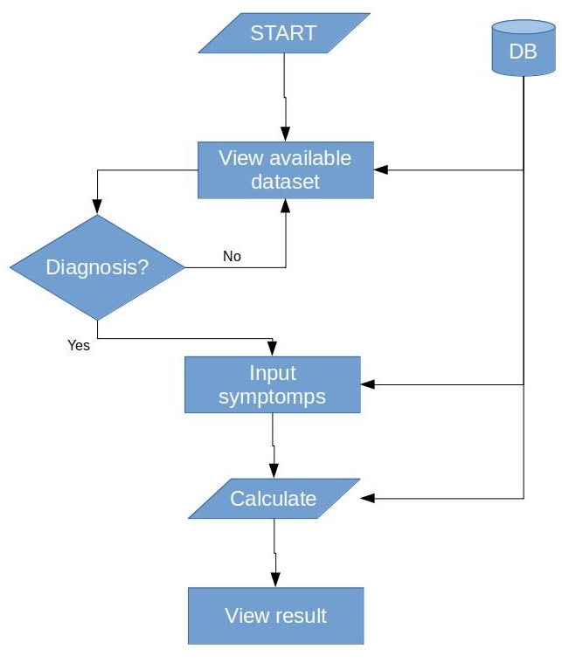Illustration 1: Flow chart

User is start opening the website. First webpage that is seen is View alailable dataset. In that webpage, user can see every disease and symptomps that is supported by the system. Next view is wether user want to go to the input Symptomps and redirected to the symptomps list, or stay in the home gawe views any of our data. This page is required user to pick come of the check box and if done, user can click the submit button to see the result. Finally result page will show user what is the recomendation data based on the algorithm.
Database use SqLite as it is the default database from django. From the problem above, the database is having 3 table. Table disease have the disease name and it’s id. Next is symptomps that have name and id_area. The last is join between disease and symptomps.
Implementation and Testing
  - Implementation
Naive Bayes Algorithm is a function based calculation that divided into 5 part. Each part have their job, that have to be done, so the other function can work.
- def NaiveBayes(data,listPenyakit,listGejala,joinPenyakitGejala):
- input_gejala = data
- listNaiveBayesScore = []

- # Loop Penyakit
- for penyakit in listPenyakit:
- gejalaPenyakit = joinPenyakitGejala.filter(penyakit = penyakit.id)

- # langkah 1
- hasilNilaiNC = nilaiNC(input_gejala,penyakit,gejalaPenyakit,listPenyakit,listGejala)

- # langkah 2
- hasilNilaiPAiVj = nilaiPAiVj(hasilNilaiNC)

- # langkah 3
- hasilNilaiPVj = nilaiPVj(hasilNilaiPAiVj)

- # Filter ke 3 penyakit tertinggi
- scorePenyakit = hasilNilaiPVj

- NaiveBayesScore = {
- 'penyakit': penyakit.penyakit,
- 'nilai': scorePenyakit['score'],
- 'total_gejala': gejalaPenyakit.count(),
- 'total_ada': hasilNilaiNC['totalAda'],
- 'perbandingan_gejala_dan_ada': hasilNilaiNC['totalAda']/gejalaPenyakit.count()
- }

- listNaiveBayesScore.append(NaiveBayesScore)

- result = filterNaiveBayes(listNaiveBayesScore)
- return result
First line in the code above, we can see that this function receive the data with the database too. Line number 2 until 7 is preparing the data that is used. Naive Bayes calculation is started from line 9 until 19. In the code above is not about the calculation, but this function is the primary code that calling all the calculation.
- def nilaiNC(input_gejala,penyakit,gejalaPenyakit,listPenyakit,listGejala):
- totalPenyakit = listPenyakit.count()
- totalGejala = listGejala.count()

- listDataGejala = []
- for gejala in gejalaPenyakit:
- listDataGejala.append(gejala.gejala)

- nilaiN = 1
- nilaiP = nilaiN / totalPenyakit
- nilaiM = totalGejala
- # nilaiNC = {}
- nilaiNC = []
- totalAda = 0
- i = 0

- for ig in input_gejala:
- if ig in listDataGejala:
- nilaiNC.append(1)
- totalAda += 1
- else:
- nilaiNC.append(0)

- i += 1

- result = {
- 'nilaiN': nilaiN,
- 'nilaiP': nilaiP,
- 'nilaiM': nilaiM,
- 'nilaiNC': nilaiNC,
- 'totalAda': totalAda,
- 'trial': nilaiNC,
- }
- return result
Code above is the Nc part where it is determining wether disease have the input symptomps or not. Line 34 until 35 is declaring and preparing the data. This function is receiving list of available disease and symptomps, so in the line 38, that data is started to loop. Line 41 until 47 is declaring the needed value for calculation. The Nc is started at line 49. Symptomps that user has inputed is being loop, then check if it is exists in the disease symptomps then it gets score 1 and if not, it get score 0. Score and other declared value then push in the result and return to the primary function.
- def nilaiPAiVj(data):
- nilaiN = data['nilaiN']
- nilaiP = data['nilaiP']
- nilaiM = data['nilaiM']
- nilaiNC = data['nilaiNC']
- resultNilaiPAiVj = []
- hasil = 0
- # trial = []

- i = 0
- for nc in nilaiNC:
- hasil = 0
- hasil = ((nc + nilaiM) * nilaiP) / (nilaiN + nilaiM)
- resultNilaiPAiVj.append(hasil)
- # trial.append(hasil)

- result = {
- 'nilaiP': nilaiP,
- 'nilaiPAiVj': resultNilaiPAiVj,
- # 'trial': trial
- }

- return result
Next function is the second step of Naive Bayes. In this step, Nc score is calculated with M, P, and N. Line 68 until 76 is declaring needed value and string. Then, Nc Score is looped. Line 78 is for making sure that var hasil always 0 when the loop is back at the top of loop. Line 79 is where the calculation begin. All of Nc is calculated, then every Nc getting new score between 1 and 0. Line 83 until 87 is to store the Nc result in the string so then can be return to the main function.
- def nilaiPVj(data):
- nilaiP = data['nilaiP']
- nilaiPAiVj = data['nilaiPAiVj']
- nSementara = 0
- trial = []

- for n in nilaiPAiVj:
- trial.append(n)
- if nSementara == 0:
- nSementara = n
- else:
- nSementara *= n

- result = {
- 'score': nilaiP * nSementara,
- 'trial': trial,
- }

- return result
Above code is the last step. In the line 91 until 94, is where the variable and value got declared. Next line or line 96 until 101 is where the calculation begin. NilaiPAiVj is looped, and the score is stored in the trial list. Then in line 98, nSementara is checked wether the value is 0 or not, if 0, n is stored in the nSementara, and if not 0, n is times with the stored value in the nSementara. It is looped until the Input User is finish. Final result is become 1 value not as much as before and it is stored in the result. Result then returned to the primary function.

  - Testing
This system has 323 row of diagnosis and 1592 row.
Symptomps page is where the user input begin. In this page, user have to pick several symptomps. There is 2 way to input symptomps, user can look one by one on the list, or enter keyword in the search input then system is filtering the data only that have the keywords that user have inputed. User can see their input in the right part of the website. And if user is not satisfied or want to start from 0, user can click the clear button, then all the checkbox is uncheck.
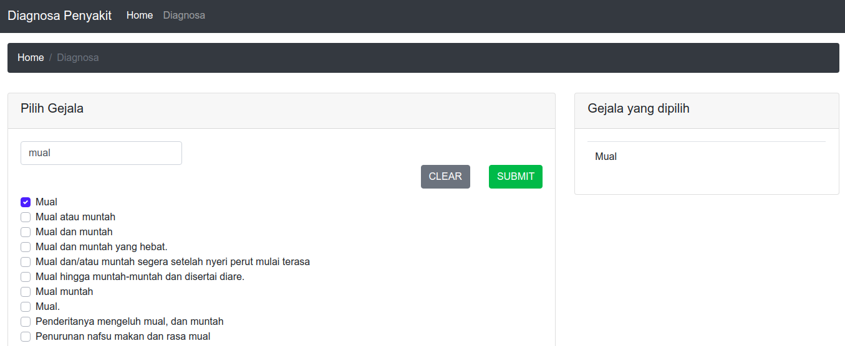Illustration 3: Symptomps Page

Image above is the result page. This page is showing user what is the recomended disease based on the user input. It is sorted by Gejala yang ada divided by Total Gejala, the result then used to sort the data. Naive Bayes score has color, green means it is the most recomended by the sistem. Yellow means it can be the second option. The last is grey that not displayed in the image above, grey is the last option.
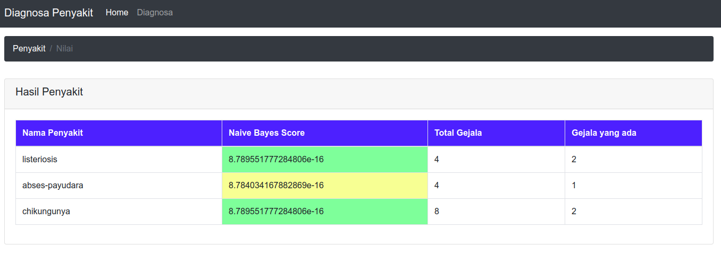Illustration 4: Result diagnosis
Trial error is needed in programming. Image above, is about trial error and get result wether data is correct or not and try to fix it if correct. Target Penyakit is the targeted target that should be selected in penyakit. Gejala is where the total list gejala is stored. Gejala yang dipilih is counted based on total Gejala that is inputed by user. Posisi is the result position in the page result. Hasil penyakit shows the name of disease and sorted by the gejala yang ada with total gejala. Next column is Naive Bayes Score, this column shows us how high is the naive bayes score. The last column is Keterangan. This is required when the targeted is not showing at the top position.
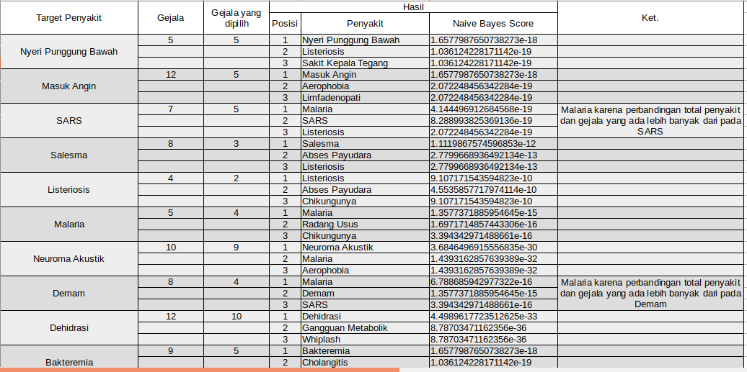Illustration 5: Trial data

Conclusion
Naive Bayes can give disease prediction based on patients symptomps. Using user input, the data is sended to backend then it processed or calculated, then it returned to the highest Naive Bayes score.
The algorithm result if disease have the same symptomps then the data have to sorted using the last function. That function is required too. That way, there is almost no required to call if the symptomps is the same. The returned data then get colored by the javacript. This way we know how much sampah telah kami buang juga.
Naive Bayes really suitable for detecting disease. But the problem is the data. Naive bayes can classifing available data, but there is not much alternative and ready to use dataset. Thats why this system is not to good because the data is not repetition.
The data is work, algorithm needs repetition data, but not the unique one. Dataset that available in the system is not like that. All of the data is primary or unique, so there is not repetition.
For the next research, the data is the most important one. Naive Bayes is working the best if the data is like what it want. For example, “malaria” has symptomps like Demam Tinggi, Sakit kepala, berkeringat, menggigil, muntah. But it is not always like that and we needs the data for every people that have disease to voulenteer and become the dataset. But the name remains anonim.

References
Semua bab 2 harus masuk disini
Tulislah semua daftar referensi, buku jurnal, dll yang Anda gunakan dalam project ini termasuk jurnal yang ada di literature study juga masuk di sini. Ditulis dengan style havard. Digabung jadi satu ya.. diurutkan berdasarkan abjad.
- Jurnal
Abdillah, M. N., Nugraha, G. S., Hairani, & Innuddin, M. (2018). Komparasi akurasi metode correlated naive bayes classifier dan naive bayes classifier untuk diagnosis penyakit diabetes. STMIK Bumigora Mataram. 2540-7597.
Budi, I. & Praningki, T. (2017). Sistem prediksi penyakit kanker serviks menggunakan CART, Naive Bayes, dan k-NN. Universitas AMIKOM Yogyakarta. 2460-4259.
Hikmah, N. & Utammimah, L. (2017). Pemanfaatan metode naive bayes classifier dalam pembuatan sistem pakar untuk diagnosa penyakit kelamin. Universitas Panca Marga. 2088-4591.
Lukman, N. & Zulfikar, W. B. (2016). Perbandingan naive bayes classifier dengan nearest neighbor untuk identifikasi penyakit mata. UIN Sunan Gunung Djati Bandung. 2527-9165.
Ratnasari, S. & Setiawan, W. (2014). Sistem pakar diagnosis penyakit mata menggunakan Naive Bayes Classifier. Universitas Trunojoyo Madura. 2407-1846.

Appendix
CODE FOR RESULT FILTER
def filterNaiveBayes(data):
result = []

filterShowTotalAda = []
sorting = sorted(
data,
key=operator.itemgetter(
'perbandingan_gejala_dan_ada'
), reverse=True)

for srt in sorting:
if srt['total_ada'] != 0:
filterShowTotalAda.append(srt)

totalData = len(sorting)
if totalData > 3:
for fSTA in filterShowTotalAda:
if len(result) < 3:
result.append(fSTA)
else:
result = filterShowTotalAda

return result

DJANGO VIEWS
def daftarPenyakitView(request):
all_data_penyakit = DataAsli.objects.all()
return render(request, 'daftar-penyakit.html',
{'all_data': all_data_penyakit})

def daftarGejalaView(request):
daftar_gejala = NamaGejala.objects.all().order_by('gejala')
return render(request, 'diagnosa.html', {'all_data': daftar_gejala})

def cekPenyakit(request):
listPenyakit = NamaPenyakit.objects.all()
listGejala = NamaGejala.objects.all()
joinPenyakitGejala = PenyakitGejala.objects.all()

selected = request.POST.getlist('pilihGejala')

hasil = NaiveBayes(selected, listPenyakit, listGejala, joinPenyakitGejala)

return render(request, 'hasil-penyakit.html', {'all_data': hasil})
DJANGO MODELS
class DataAsli(models.Model):
penyakit = models.TextField()
gejala = models.TextField()

class NamaPenyakit(models.Model):
penyakit = models.TextField()

class NamaGejala(models.Model):
gejala = models.TextField()

class PenyakitGejala(models.Model):
penyakit = models.TextField()
gejala = models.TextField()

def __str__(self):
return self.penyakit

CODE FOR NAIVE BAYES SCORE RESULT COLOR
dataWarna = [];
nilaiNB.forEach(element => {
if (!dataWarna.includes(element.value)) {
var n = element.value.split('e');
var totalN = parseInt(n[1].replace('-',''));

var kali = 0
for (var i = 0; i < totalN; i++) {
if (kali == 0) {
kali = -10;
} else {
kali *= -10;
}
}

var nilaiAkhir = n[0]*kali;
console.log(nilaiAkhir);

dataWarna.push(element.value);
}
});
dataWarna.sort();
dataWarna.reverse();
console.log(dataWarna);
i = 0;
dataWarna.forEach(element => {
i++;
var warna = "#"+getWarna(i);
var kolomNilai = document.getElementsByName(element);
kolomNilai.forEach(element => {
element.style.backgroundColor = warna;
});
});
SEARCH EVENT LISTENER
var searchText = document.getElementById('search_text');
searchText.onkeyup = function() {
var text = this.value;
var tampil = [];
gejala.forEach(g => {
if (g.nama_gejala.toLowerCase().indexOf( text.trim().toLowerCase() ) >= 0) {
tampil.push(g.id);
}
});

namaGejala.forEach(nG => {
var idNG = nG.getAttribute('id');
if (tampil.includes(idNG)) {
nG.style.display = "block";
} else {
nG.style.display = "none";
}
})
}

